**General info**

***GLOBE Annual Meeting for Europe and Eurasia 2015***

*Warsaw, Poland*

**Accommodation**

We propose accommodation in a small hotel with family atmosphere at Warsaw Youth Sport Centre “Agrykola”. It is located in quiet, green area, near to the Royal Gardens “Łazienki”. It has good connection to the city centre and the airport.

**Please notice: after the deadline (June 28th) we cannot guaranty a room in the hotel “Agrykola”.** If the hotel is fully booked, we would help to find some other accommodation.

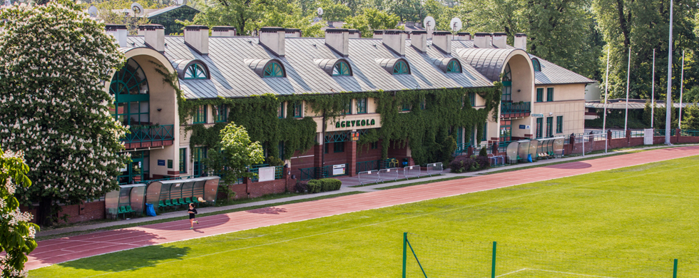

Contact details:  
Mysliwiecka street 9

Warsaw

tel. +48 22 622 91 10/11

fax: +48 22 622 91 05

e-mail: [recepcja@agrykola-noclegi.pl](mailto:recepcja@agrykola-noclegi.pl)

<http://www.agrykola-noclegi.pl/en/accommodation/hotel-standard.html>

Detailed location of the hotel can be found here: <http://www.agrykola-noclegi.pl/en/lokalizacja.html>

***Types of room***. There are 11 single, 11 double and 2 triple rooms available in the hotel. If you want to have a double or triple room you can indicate your roommate(s) in the registration form.

***Cancelling***. When you cancel your reservation you will have to pay part of the costs depending on how long before the meeting you cancel: 20% 2 months before, 40% 1 month before, 100% 7 days before or less.

**Venue**

The whole event will take part in three places:

* Country Coordinators meeting (23-24th November) will be organized in the conference room at “Agrykola” hotel
* “Motivate and Attract Students to Science” workshop and training will be organized in the Conference Centre “Wilcza” (25-26th November), <http://www.centrumwilcza.pl/kontakt.html> and Copernicus Science Centre (27th November), <http://www.kopernik.org.pl/en/visit-us/how-do-i-get-there/>

**Costs**

|  |  |  |  |
| --- | --- | --- | --- |
|  | Single room | Double room (per person) | Triple room (per person) |
| Hotel (per night per person, including breakfast): | €47 | €31 | €25 |
| Conference fee per day | €40 | | |
| Working Dinner on Tuesday  Working Dinner on Thursday | €20  €15 | | |

**What is included in the conference fee?**

* local transport during event;
* coffee breaks (coffee, tea and refreshments);
* lunch;
* Working Dinner on Monday and Wednesday;
* educational tour in the Copernicus Science Centre (Friday);
* printed materials.

**What is not included in the conference fee?**

* sightseeing activities;
* dinner on Tuesday and Thursday.

**Payments**

After registering you will receive an invoice (unless you are funded as a GLOBE country coordinator, see Guidelines for financial support). We kindly request to pay before the meeting.

**Travelling to Warsaw**

You can get to Warsaw in several different ways: by plane, train or bus. You will find detailed information at: <http://www.warsawtour.pl/en/warsaw-essentials/getting-to-warsaw-1642.html>

We will send details upon registration.