**Analyzing Microplastic Distributions in Urban and Industrialized Locations along the Rouge River**

**Student Researchers:**

Sally Nasserdine, Huda Yaseen, Nour Abu Alaywa, and Yasmin Abu Alaywa

**School:**

Crestwood High School, Dearborn Heights, MI 48127

**Science Teacher:**

Diana Johns

March 5, 2025

**Table of Contents**

1. Abstract ..............................................................................................................................3
2. Research Question and Null Hypothesis............................................................................4
3. Introduction and Review of Literature............................................................................4-6
4. Research Methods and Materials...................................................................................6-13
5. Data Summary.............................................................................................................13-15
6. Data Analysis and Results...........................................................................................15-17
7. GLOBE Data Analysis................................................................................................17-20
8. Discussion....................................................................................................................20-21
9. Conclusions..................................................................................................................21-22
10. Acknowledgments.......................................................................................................22-23
11. Bibliography......................................................................................................................24
12. Appendix...........................................................................................................................25
13. Submitting GLOBE Data Verification..............................................................................25
14. Badges.........................................................................................................................25-26

**Abstract:**

This research examined the impact of a wastewater treatment plant on microplastic accumulation by comparing concentrations at two sites in the Detroit, Michigan area: Ford Field Park and Goudy Park. Ford Field, situated downstream of the wastewater treatment plant, offers insight into how proximity to waste water discharge influences microplastic levels. In contrast, Goudy Park offers insight into how urban areas affect microplastic levels. Over a four-month period, a total of 14 water samples were collected, one from each site per sampling session. GLOBE protocols such as water temperature, air temperature, conductivity, turbidity and total solids were measured using Vernier sensors, Hach 2100N turbidimeter, Hach utility oven, and the Ohaus Pioneer analytical balance. The data suggests variations in microplastic concentrations between the two sites, with potential influences from wastewater discharge. This research study found microplastic concentrations were higher near locations of industrialization and factories. While there was not enough data to draw concrete conclusions between the relationship between microplastic quantities and GLOBE hydrological parameters, there was an inverse relationship between total solids and microplastic concentrations. This research contributes to understanding the role of wastewater discharge in freshwater ecosystems and supports the development of effective pollution management strategies. Further analysis will be necessary to create definite conclusions about the long-term impact of wastewater treatment plant discharge on microplastic accumulation.

**Key words:** Microplastics, Rouge River, Wastewater Treatment Plant, Industrial, Urban

**Research Questions:**

1. Will increased proximity to suburban areas lead to an increase in microplastics?
2. Will microplastic distribution differ upstream from downstream?
3. How are turbidity, electrical conductivity, total solids, water and air temperatures affected by microplastic concentrations?

**Null Hypotheses:**

1. Proximity to suburban areas has no impact on microplastic quantities.
2. Microplastic distribution will not differ from upstream to downstream.
3. Turbidity, electrical conductivity, total solids, water and air temperature will not be affected by the presence of microplastics.

**Introduction and Review of Literature:**

Plastics are a dominant material, commonly used in production due to their durability and versatility. As the use of plastics has increased in popularity, there has been growing discussion about their environmental impact. Plastics don’t degrade easily and withstand harsh environmental conditions. There are currently no environmentally conscious solutions for disposing of plastics, since their combustion releases negative greenhouse gases into the atmosphere. As such, plastics have begun piling up in oceans and other bodies of water. This results in exposure to weathering from wind, waves, and transport across rough materials like rocks. As these plastics break down they introduce microplastics into water flow that are difficult to filter out. These microscopic particles are harmful to marine organisms if ingested (Bajit, 2021). However, very few studies have been conducted on the negative health effects of microplastics, making it difficult to understand their true impact. Rivers serve as a key transporter of microplastics, since they’re able to introduce the polluted water into a variety of other bodies of water due to their branched structure. Microplastic pollution is introduced to rivers via urban runoff, and industrial effluent (Prata, 2021). Microplastics are also commonly introduced from household tasks such as washing laundry and dishes, as well as vacuuming. As a result, countless microplastics are introduced to the environment daily per household. This results in numerous particles accumulating in bodies of water, magnifying bioaccumulation in marine organisms like plankton, resulting in even further bioaccumulation as the affected organisms are ingested (Frias et. al 2014). While proposed solutions for microplastic pollution include preventing the degradation of plastics into smaller particles, this solution is technologically not viable. Instead, current technology focuses more on managing and preventing the introduction of microplastics into water sources. Currently, wastewater treatment plants (WWTPs) are being explored as a potential source of microplastic introduction, and transport. WWTPs utilize a three-step filtration system. The primary cycle is the first phase and involves screening, grit removal, and sedimentation. This phase works to remove large objects and sedimentation such as sand and stones. Afterwards, secondary treatment uses biological factors, such as microbes and bacteria, to break down organic waste in the water. Following this phase, the water may be subject to filtration by sand or gravel, as well as disinfection through the use of ultraviolet light. The polymer composition and particle size of microplastics influence their ability to be effectively filtered. Studies have found that between 88% of microplastics were removed in WWTPs that stopped at secondary treatment and 94% of microplastics were removed from WWTPs that utilized tertiary treatment (Iyare et. al 2020). While WWTPs remove a majority of microplastics, up to 1.2 particles/liter remain unfiltered and enter aquatic environments (Alibekov et. al 2025). A single WWTP can process up to 400 million liters of water a day, resulting in countless microplastics entering aquatic environments and posing significant harm to marine organisms. This emphasizes the importance of maintaining and upgrading WWTPs whenever possible to continue improving filtration of microplastics.

Currently, there's no absolute method for microplastic filtration. Researchers continue to develop solutions to improve filtration processes and reduce the number of plastics entering aquatic ecosystems. Further solutions may also include regulations on plastics products to limit the amount of plastic waste able to enter treatment plants.

**Research Methods and Materials:**

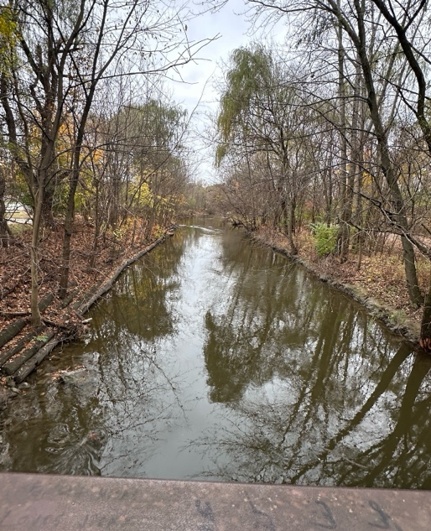**Figure 1a. and Figure 1b. Ford Feild Park Sampling Site.** The satellite image on the left shows the surrounding area of the sampling site. This site is located near a river trail, open-park area, and residential homes. The image on the right is a close-up of the site where we collected our water samples. This site was tested seven times.

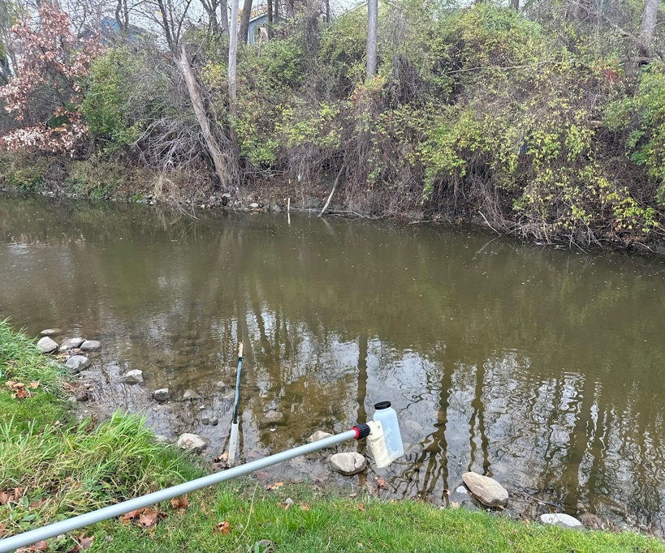**Figure 2a. and Figure 2b. Goudy Park Sampling site.** The image on the right shows a satellite view of where we took our water sample. The image on the right is a close-up shot of the study site. This site was sampled seven times as well.

Throughout the Fall and Winter of 2024, a variety of water quality and air temperature data were collected from two sites along the Rouge River in the Detroit, Michigan area: Ford Field Park and Goudy Park. Ford field was selected due to its location upstream from a wastewater treatment plant allowing for comparison of microplastic accumulation between an urbanized area and a site influenced by a wastewater discharge. Both sites were chosen because they were popular areas and are exposed to urban environmental stressors. Data collection occurred between late August 2024 with sampling continuing into late December. To minimize contamination and ensure reliable results, 100% cotton-based materials were used during all sampling and testing procedures. After collecting the samples, all samples were taken back to Crestwood High School in Dearborn Heights, MI, for further filtration and analysis. To maintain consistency, samples were collected in the morning, with Ford Field Park sampled first at 8:00 AM, followed by Goudy Park at 8:30 AM. Using a Nasco Swing Sampler (12ft) that held a 500 mL bottle, researchers gathered water samples at both sites. Researchers wet the bottle in the river first and re-immersed it in the body of water, keeping it about 10 cm below the water surface. These samples were then tested for water temperature and air temperature on site. Later at the school lab, researchers tested turbidity, conductivity and total solids. Since samples may have settled between the time of collection and analysis, samples were shaken for 30 seconds before continuing with testing. Water temperature was measured using Vernier LabQuest 2 with a temperature probe, while conductivity was assessed with a Vernier web conductivity probe. Turbidity was analyzed using a Hach 2100N Turbidimeter. To measure total solids, 2 40-mL samples of river water at each site were placed in the Hach utility oven that heated the samples overnight. Once the water had fully evaporated, the remaining solid particles were weighed in the Ohaus Pioneer precision balance and calculated for total solids.

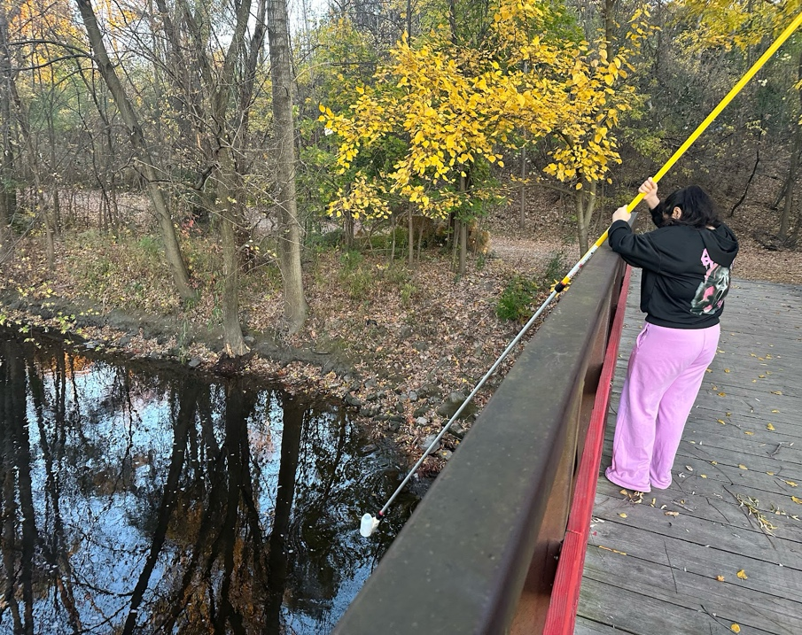 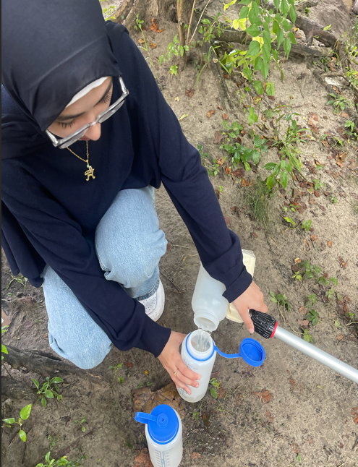

**Figure 3a and Figure 3b. Collecting Samples.** The image on the left shows a student researcher collecting a 500 mL (about 16.91 oz) sample of Rouge River water from Ford Field Park. In the picture on the right, a student researcher is collecting a 500 mL sample from Goudy Park.

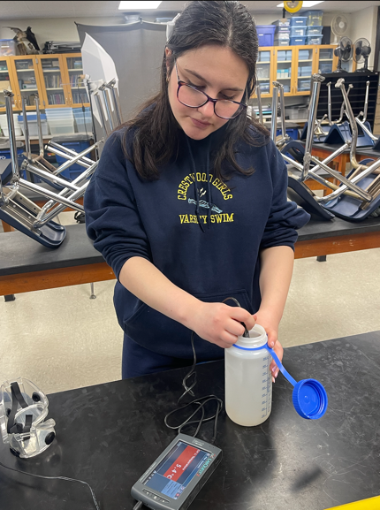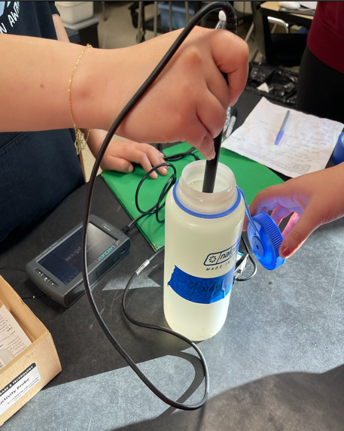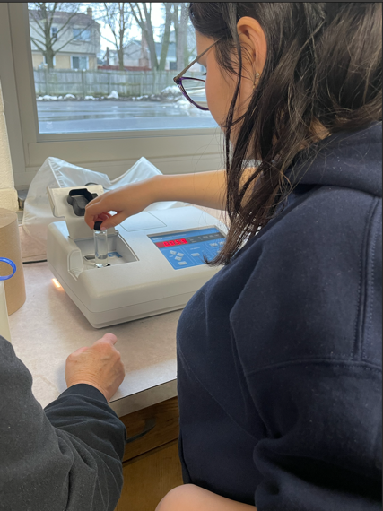

**Figure 4a. Figure 4b. Figure 4c. Testing Electrical Conductivity and Turbidity.** The image on the far left shows a student researcher measuring the Rouge River water sample for electrical conductivity. The image in the middle is a close-up of a student researcher measuring the sample for electrical conductivity using a conductivity probe. The image on the far right demonstrates a student researcher inputting the Rouge River water sample into the Hach 2100N Turbidimeter to analyze turbidity.

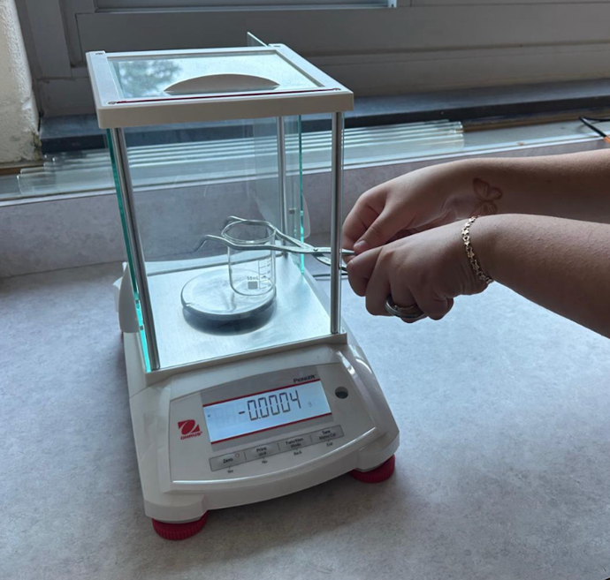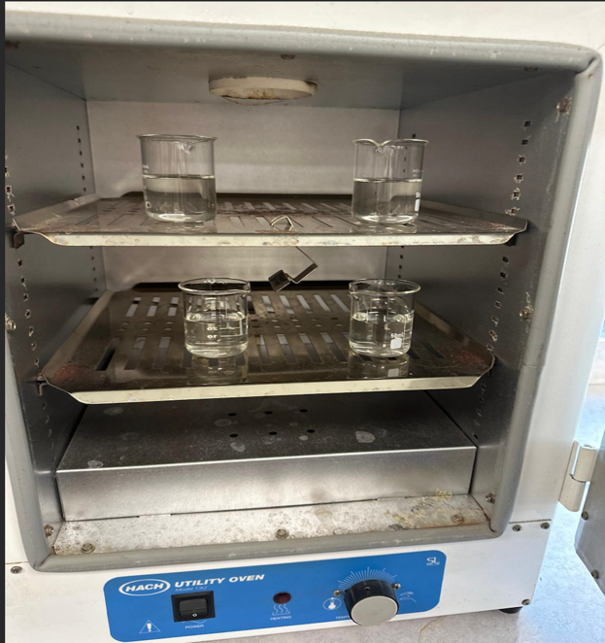

**Figure 5a and Figure 5b. Total Solids.** The image on the left shows a student researcher measuring the mass of an empty beaker using the OHAUS Pioneer Analytical Balance, which measures to the nearest milligram. The researcher then adds 40 mL of the Rouge River water sample where it is heated in the Hach utility oven for 24 hours shown in the right image.

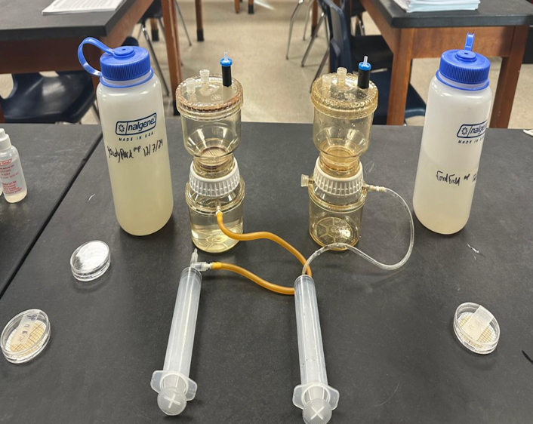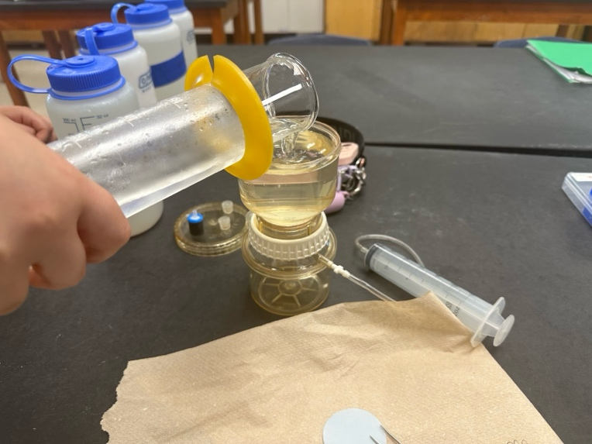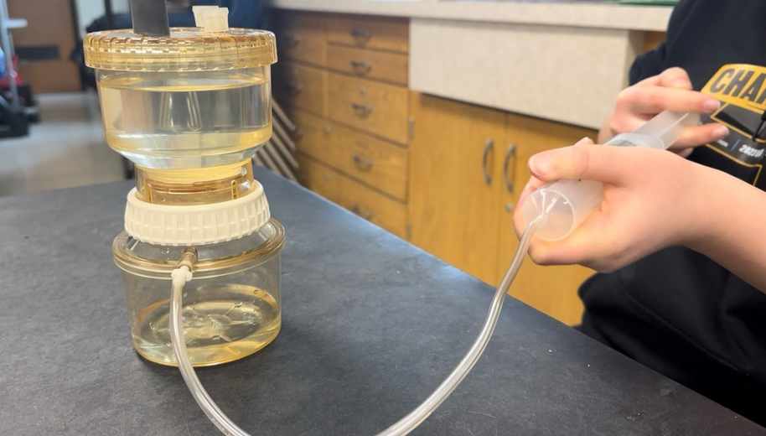

**Figure 6a. Figure 6b. and Figure 6c. Filtration System.** The image on the upper left shows the inclusion of two filtration systems, allowing for samples to be processed simultaneously and efficiently. The image on the upper right shows a student researcher measuring 250 mL of both the Goudy Park and Ford Field sample using a graduated cylinder and transferring it into the filtration system. The image below captures a student researcher releasing air pressure from the Nalgene filtration vacuum using a syringe to complete the filtration process.

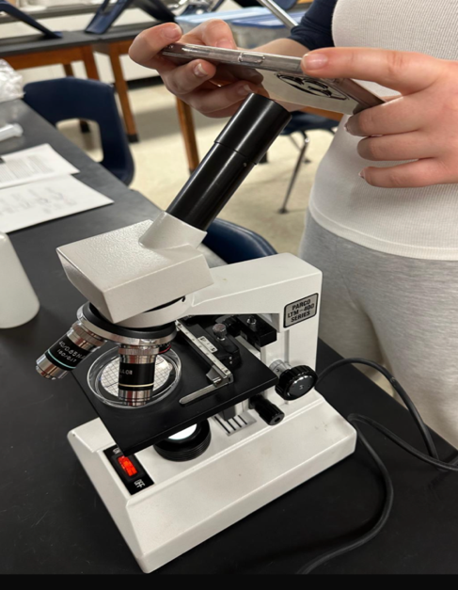

**Figure 7. Microplastic Analysis.** This image shows a student researcher taking pictures of the filtered microplastics using a Parco LTM-400 series compound microscope, preparing to analyze.

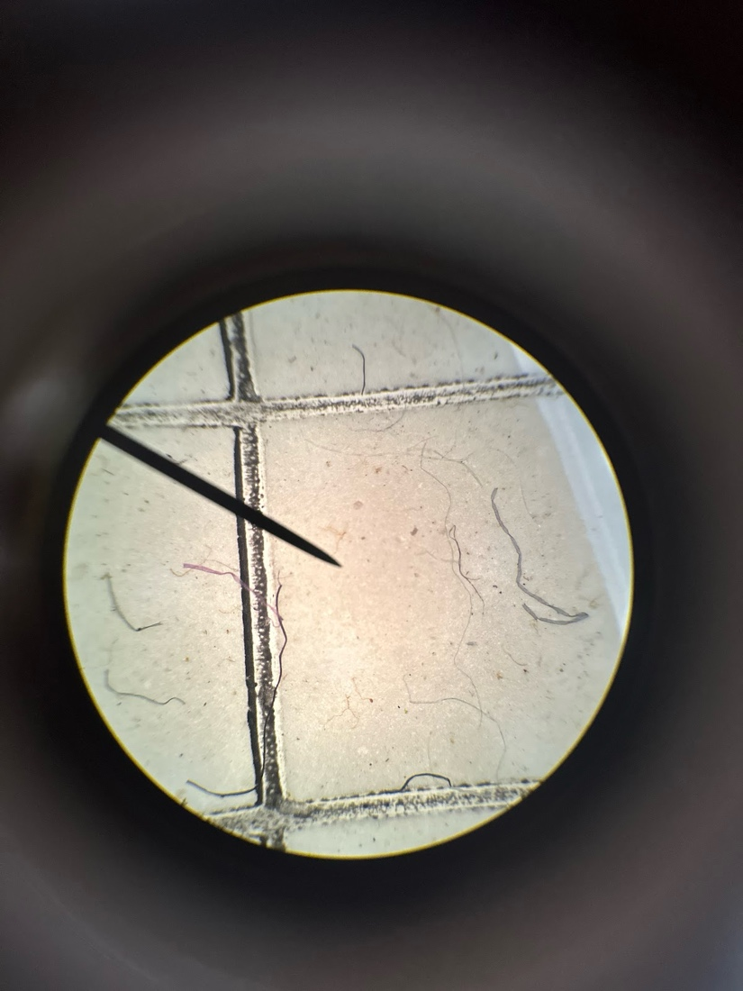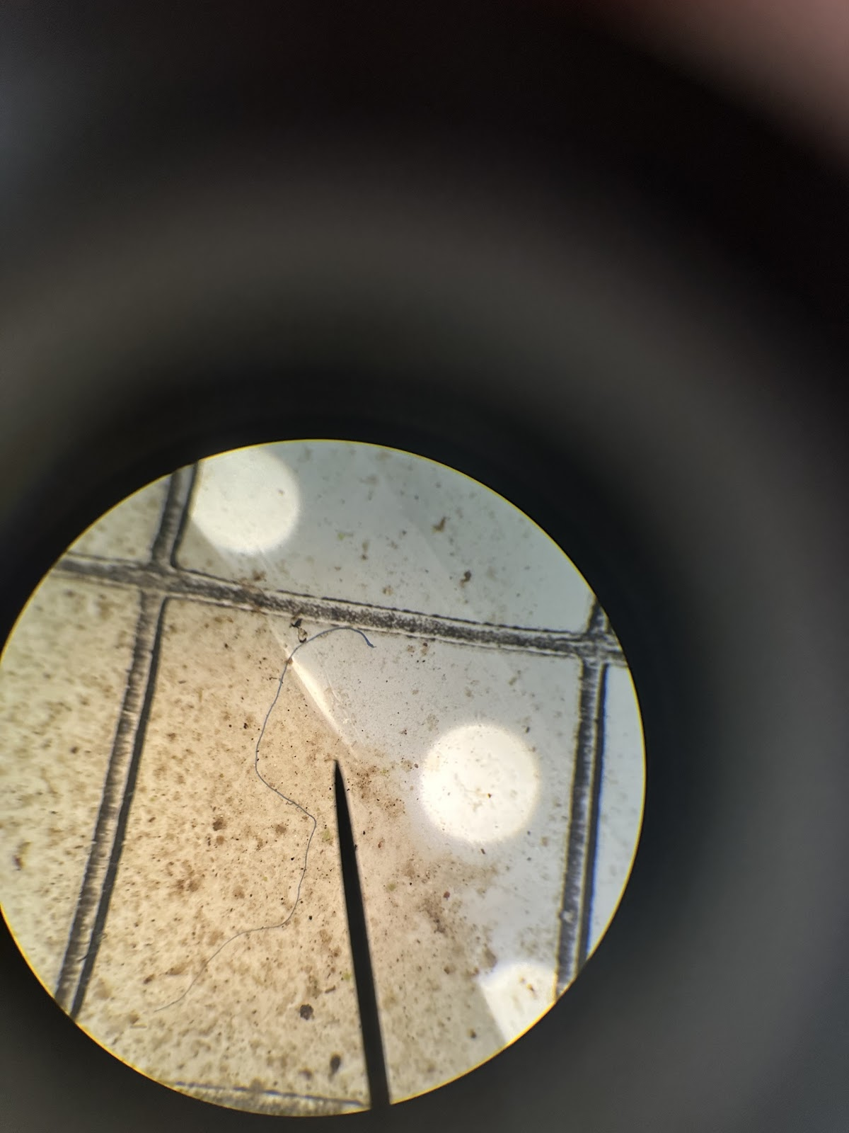

**Figure 8a. and Figure 8b. Microplastic Identification.** The left image displays microscopic images of the Ford Field sample taken on 11/16. There are visible concentrations of cellulose and man-made textile fibers. The right image is a Goudy Park sample from 10/19 that displays lots of sediment but a clear cellulose fiber.

When filtering for microplastics, a 250-mL Nalgene filtration system and MF-Milipore 0.45 membrane filters were used. Considering our original sample was taken in a 500-mL polyethylene bottle, the filtering process was repeated twice. To prevent sample settlement, each sample was shaken for 30 seconds before testing. Initially researchers used a single, 250-mL Nalgene filtration system to filter the sample. However, to increase efficiency and reduce time consumption, a second filtration system was built, allowing for the filtration of both samples simultaneously. To transmit the water through the filtering body, a vacuum was created in the lower compartment using a syringe. Researchers pulled the piston of the syringe and ejected the air. This process was repeated until all 500-ml of the water sample was passed through the filter paper. After filtration was completed, the MF-Milipore filter paper was removed and transferred to a petri dish. Researchers analyzed all four quadrants of the filter paper through a Parco LTM-400 series compound microscope and took images of each corresponding sector. The data from all measurements were recorded in an Excel spreadsheet for analysis. Statistical comparisons were made between the two sites to assess the influence of wastewater discharge on microplastic accumulation in the Rouge River.

**Data Summary:**

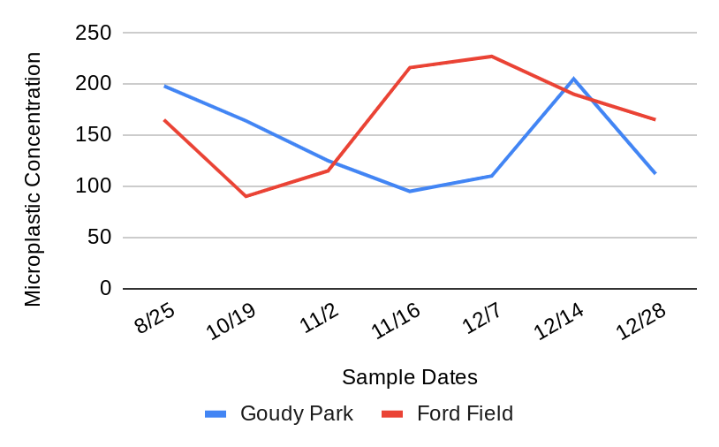

**Figure 9. Total Microplastics per 500-mL Goudy Park Vs. Ford Field.** The line graph shows a comparison of total microplastic concentration between Goudy Park and Ford Field across a 4-month period.

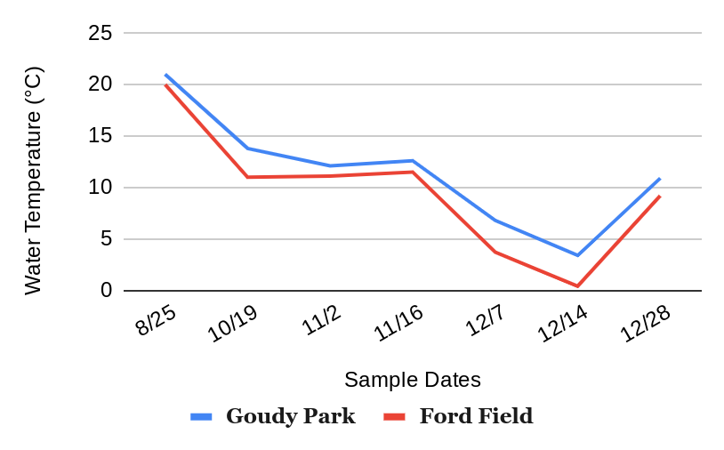

**Figure 10. Water Temperature (°C) between Goudy Park and Ford Field.** The line graph above shows the comparison of water temperature Goudy Park and Ford Field.

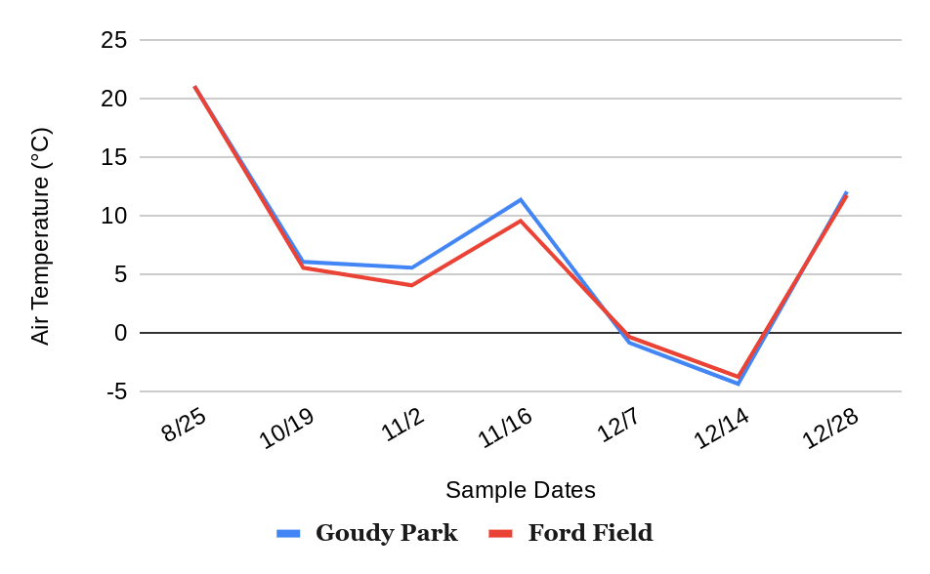

**Figure 11. Air Temperature (°C) between Goudy Park and Ford Field.** The line graph above shows the comparison of air temperature Goudy Park and Ford Field.

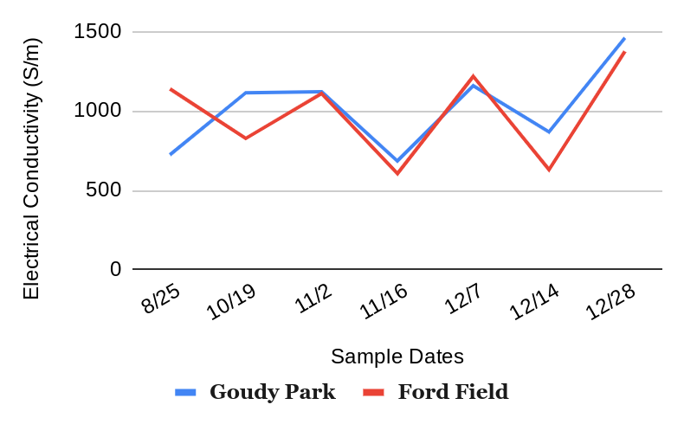

**Figure 12. Electrical Conductivity (S/m) between Goudy Park and Ford Field.** The line graph above shows the comparison of conductivity among Goudy Park and Ford Field Samples.

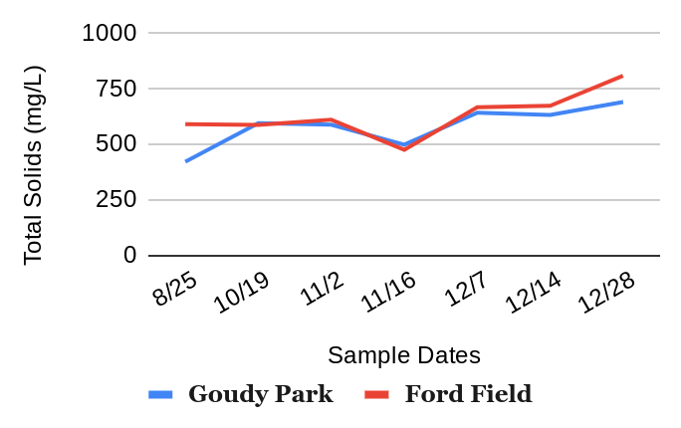

**Figure 13. Total Solids (mg/L) between Goudy Park and Ford Field.** The line graph above displays total solid measurements across Goudy Park and Ford Field samples.

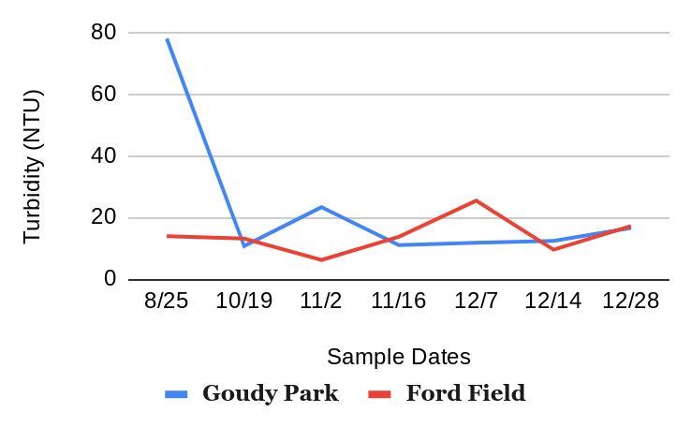

**Figure 14. Turbidity (NTU) between Goudy Park and Ford Field.** The line graph above shows the comparison of turbidity across Goudy Park and Ford Field.

**Data Analysis and Results:**

Our research aimed to investigate the impact of environmental factors, such as suburban and industrial proximity, on microplastics concentration and the potential differences in microplastic distribution upstream and downstream. The data collected showed a direct correlation between environmental factors and microplastic concentrations. Ford Field Park, located near the Schaefer Road Area Wastewater Treatment Plant and the Dearborn Stamping Plant (industrial areas), generally exhibited higher total solids and microplastics compared to Goudy Park. This can be attributed to the industrial surroundings, which contribute to microplastics through wastewater discharge, runoff, and atmospheric deposition. Conversely, turbidity levels were generally higher in Goudy Park. Turbidity in water is influenced by various factors, not just microplastics. The higher turbidity levels in Goudy Park, despite having fewer microplastics, could be attributed to several potential reasons: Atop the river that flows through Ford Feild is a bridge with no easy access to the body of water, while Goudy Park is in an open-area location that is easily accessible to the public. Bridges see less direct human interaction with the water, reducing the amount of particulate matter stirred up compared to open areas. Recreational activities and human interactions around Goudy Park can increase the amount of suspended particles in the water, leading to higher turbidity. The study also found that electrical conductivity was higher in Goudy Park, indicating greater levels of dissolved ions and substances. However, there was no correlation between microplastic quantities and electrical conductivity. Microplastics themselves do not directly affect electrical conductivity, as they are solid particles and do not dissolve in water to release ions, but they do have similar sources. Thus, the high electrical conductivity in Goudy Park, despite low microplastic quantities, can be attributed to natural mineral deposits, agricultural runoff, and urban influences, due to Goudy Park’s proximity to surrounding houses.

Interestingly, there was an inverse relationship between total solids and microplastics concentrations for the most part, suggesting that in areas with higher total solids, microplastics might settle more quickly due to interactions with other particles. The inverse relationship means that when total solids are high, suspended microplastics in the water column might be lower, and vice versa. However, this doesn't mean that higher total solids necessarily reduce the overall presence of microplastics. Instead, it affects their suspension in the water column. For instance, Ford Field had higher measures of total solids than Goudy Park but also a higher quantity of microplastics. In this case, the environment surrounding Ford Field is key to note as higher total solids can be due to runoff from industrial area and debris. Consequently, these solids can increase the overall particle load in the water. Additionally, the transition from August to October showed a decrease in microplastic quantities, which could be influenced by the drop in water temperature. Colder temperatures can cause microplastics to become less buoyant and settle to the bottom, reducing their concentration in the water column. Additionally, higher temperatures may increase biological activity like algae, leading to more interaction with microplastics in which more microplastics would break down.

**GLOBE Data Analysis:**

Our GLOBE data analysis explored comparable student research, including reports from Notre Dame School in the Dominican Republic and a microplastics monitoring study from Feng Yuan Senior High School in Taiwan. These studies revealed critical insights while complementing our own research methods. Both studies emphasize the importance of microscopic particle analysis and environmental factors. Student researchers at Notre Dame School measured microplastic in the Haina and Isabela rivers to compare contamination levels, focusing on how human interactions impacted microplastic concentrations in both rivers. The Haina and Isabela rivers are key bodies of water in the Dominican community that often faces pollution from local wastewater discharge. The Lower Haina River Basin has many industries which contaminate the region, including solid and liquid wastes generated by the communities. The Isabela River, on the other hand, contamination comes primarily from single-use plastics like water bottles and straws which eventually breakdown into small microplastics becoming harmful for aquatic and human life. The researchers hypothesized that the Hania River would contain more microplastics which was proven to be correct. This was likely influenced by its proximity to a textile factory located closer to the Haina River which may have secreted various synthetic fabrics and some residents in the area tend to take showers inside the river leaving behind any particles from their clothes or stuck on their skin. In contrast, the research in Taiwan investigated the Wu River and Dajia River in central Taiwan that analyzed microplastic distributions from upstream and downstream locations. We qualitatively compared observations and results to our own data. This study provided valuable insights highlighting how microplastic concentrations vary based on factors such as water depth, tidal conditions, proximity to urban centers, and river characteristics. Their research sites spanned five distinct sampling points along the river with sixteen water samples, capturing variations in microplastic concentrations across different locations. The Dajia River samplings demonstrated a dramatic increase in microplastic concentrations, moving from 30 items/L in the most upstream site to 190 items/L in the downstream Gaomei Wetlands. Enviromental factors are key to note as the most upstream site was taken in a mountainous area where the population is small, and the environment is relatively clean. In contrast, the Gaomei Wetlands are formed by the siltation of rivers. However, researchers believed such high concentration may have been because the tide was low and dry the day they sampled. Either way, each site was primarily influenced by its environment. For example, Site 3 in the Dajia River was located close to the city center and therefore had large amounts of man-made fibers than any other site. The Wu River also demonstrated a gradual upstream to downstream increase, though it was complicated by tidal influences. The microplastic content was found to be very high with 310 items/L in high tide, but was 60-65 items/L in low tide, suggesting content was influenced by the entrainment of the river water. Additionally, the depth of the collection site also affected microplastic content in the water. When water depth was higher, the surface was relatively clean because the overall density of microplastics would increase when algae and other objects are attached to them and sinks, resulting in more microplastics at the river bottom. Most notably though, was that there was a larger quantity of microplastics in the lower level of the river than in the upper level of the Wu River and Dajia River. Both studies illuminated the complex interactions between human activities, geographical contexts, and microplastic distributions, providing crucial insights into investigating long-term ecological impacts.

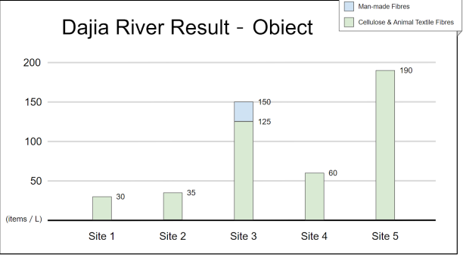**Figure 15. Content of microplastics in the Dajia River.** Site 1 is the most upstream. Site 1 and Site 2 are located on the upper branches of the river and in a mountainous area. Site 3 is in the middle branch of the river and located in a place with high population density in Dongshi. Site 4 is also located in the middle and lower branches of the river and in a low population dense area. Site 5 is the most downstream of the river and is located in the Gaomei Wetlands.

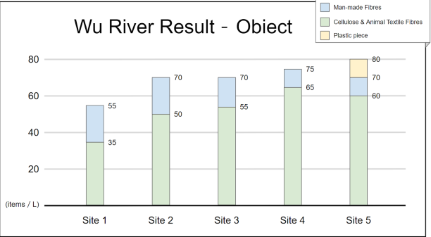F**igure 16. Content of Microplastics in the Wu River.** Site 1 is between mangroves and fishin ports. Site 5 is close to an estuary and is a fishing port. Site 1 and Site are similar locations but are at different tide levels with Site 1 being a dry tide and Site 5 a high tide. Site 2 is a puddle with shallow water.

**Discussion:**

The goal of this research was to compare microplastic accumulations between an urban area (Goudy Park) to a more industrialized location (Ford Field). Over the four months of data collection, there were significant changes in temperature, turbidity, and total solids. During late summer, the water temperature was higher, and turbidity at Goudy Park was notably elevated. As the seasons transitioned into fall and winter, water temperature, turbidity, and total solids fluctuated. Goudy Parks high turbidity may have been influenced by Urban Runoff, as it includes lots of impervious surfaces like parking lots. So, these surfaces may have carried sediments and pollutants into the river. The parks riverbanks are also very susceptible to erosion due to natural wear and man-made activities that lead to greater sediment levels. However, the data collected is insufficient to conclusively determine the influence of seasonal changes on these parameters. Another error that may have impacted the analysis of microplastics is the possibility that some microplastics were not visualized. This could have been due to the increased sediment in Goudy Park, which hindered the visibility of microplastics, resulting in a decreased quantity being documented. Additionally, some microplastics may have become trapped at the top of the filtration system, as proper dilution was not performed. Without flushing the samples, the microplastics may not have been fully directed to the filter paper, leading to an incomplete capture of all microplastics present.

To improve this study, a longitudinal study would be preferable as it would account for the potential correlation between seasonal changes and microplastic densities which in turn can affect concentrations. A larger data sample would allow a more comprehensive and statistically significant conclusion as it will reduce standard error and outliers. In addition, the researchers would also like to expand testing locations, having made plans to test the lower Rouge River near Lilley Road bridge in Canton, Michigan. Expanding testing locations to include other branches of the Rouge River allows us to conclusively analyze the distribution of microplastics and the possible source of these microplastics. With all these modifications, the researchers know that the project can be monumental for their community.

**Conclusions:**

The researchers conducted experiments to determine the impact of proximity to wastewater treatment plants along the Rouge River influenced microplastic distribution. While some trends were observed, the results did not draw sufficient evidence to draw conclusions that environmental factors significantly affect microplastic concentrations, indicating the need for further research to draw more certain conclusions. The null hypotheses stated that proximity to suburban areas would not impact microplastic concentrations. The results suggest no significant correlation between the proximity to wastewater treatment plants and microplastic distribution, supporting the null hypothesis regarding proximity to suburban areas. Additionally, the distribution of microplastics did not show clear differences between upstream and downstream locations, meaning the null hypothesis remains unchallenged. The analysis of water quality parameters did not reveal a clear relationship between microplastic presence and changes in turbidity, conductivity, total solids, or temperatures, reinforcing the null hypothesis for these variables. However, the limited data and sampling size indicate that further research is needed to establish more definitive conclusions. Future studies with expansion of sampling locations, increasing the frequency of data collection, and consider more environmental factors to better evaluate the relationship between wastewater treatment processes, environmental factors, and microplastic concentrations in the Rouge River.

**Acknowledgments:**

The researchers would like to thank Ms. Tracy Ostrom, Co-Program coordinator and trainer at the University of California Berkely, for guiding them through their research. She provided them with the materials needed such as complete filtration units, training manuals and guides, and online resources to complete their research. She also trained them in the identification of microplastics and the filtration processes. With her support researchers were able to clarify questions and continue with their research. They would also like to thank the Friends of the Rouge for their financial support, which helped them with equipment needed for their research. Finally, the researchers would like to give big thanks to Mrs. Diana Johns for her guidance and great support as they continued to pursue their research.

**Bibliography:**

Alibekov, A., Meirambayeva, M., Yengsebek, S., Aldyngurova, F., & Lee, W. (2025). Environmental impact of microplastic emissions from wastewater treatment plant through life cycle assessment. The Science of the Total Environment, 962, 178378. <https://doi.org/10.1016/j.scitotenv.2025.178378>

Bajt Oliver, “From plastics to microplastics and organisms”, 2021 Apr;11(4):954-966, <https://pubmed.ncbi.nlm.nih.gov/33595903/>

Browne Anthony Mark, “Accumulation of Microplastic on Shorelines Woldwide: Sources and Sinks”, September 6, 2011 Environ. Sci. Technol. 2011, 45, 21, 9175–9179 <https://pubs.acs.org/doi/abs/10.1021/es201811s>

Carr, S. A., Liu, J., & Tesoro, A. G. (2016). Transport and fate of microplastic particles in wastewater treatment plants. Water Research, 91, 174182. <https://doi.org/10.1016/j.watres.2016.01.002>

Cheng-Hua Wu, Cyuan-You Syu, “Microplastics Monitoring in Two Main Rivers of Central Taiwan", 2022 March 11, <https://www.globe.gov/documents/10157/0/10754848/6fbae67d-d5f1-c3e2-1ad0-09c5a3218fb3>

Daniela De Jesus Rodriguez, Luis David Lugo Guzman, “Comparing the Amount of Microplastics in the Isabela and Haina Rivers”, 2023 April 28, <https://docs.google.com/document/d/10yw7YS3kACeBg_cC9m2XYEawGfUJXrzh/edit>

J.P.G.L. Frias, V. Otero, P, “Sobral Evidence of microplastics in samples of zooplankton from Portuguese coastal waters”, Volume 95, April 2014, Pages 89-95 <https://www.sciencedirect.com/science/article/abs/pii/S0141113614000099>

**Appendix:**



**Figure 16. Data Visualization of Central Taiwan Samples**

**Submitting GLOBE Date Vertification:**

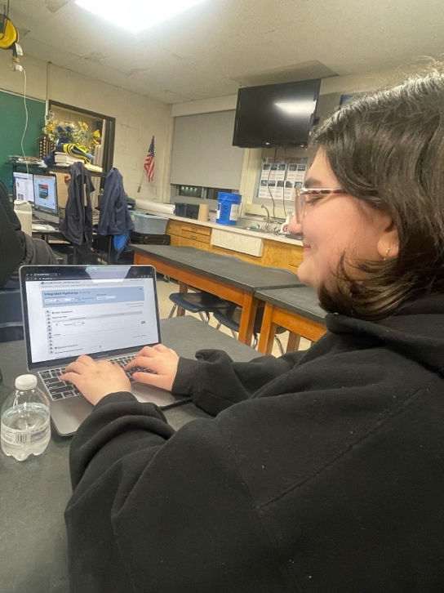

**Figure 17. Data Entry.** Student researcher submits data to a GLOBE database for GLOBE verification.

**Badges:**

**I Am a Data Scientist:**

The researchers hope to receive the “I Am a Data Scientist” badge for their data collection. Over the course of four months the researchers collected and analyzed 14 samples (7 samples from each site) and carefully tested multiple protocols, analyzed water samples for microplastics microscopically, and individually inputted data on to an Excel spreadsheet. This document was used to organize the data we gathered to create graphs. The team then created and analyzed these graphs to draw conclusions on the research they did

**I Make an Impact:**

The researchers hope to receive the “I Make an Impact” badge as the future implementation of this research can make both a local and global difference. The team hopes to direct this research to Rogue River Watershed Council and the Michigan Environmental Council as this council was the first to standardize methods for determining the concentration of microplastics in water. Despite this, the research will be able to illuminate the importance of acting against microplastics and highlight potential harmful sources of these microplastics. The researchers’ data can assist in the development of more effective methods of microplastic identification and quantification within the Rouge River.

**I am a STEM Storyteller:**

The researchers hope to receive the “I Am a STEM Storyteller” badge. The researchers have documented their journey on Instagram under the username “microplastic.counters.” Through the Instagram page, the researchers have shared their experience and research, as well as using it as a platform to educate their community on the impacts of microplastics both in the Rouge River and in waterways as a whole. The page’s focus on the research methods used by the team crafts a compelling story, hoping to inspire others to pursue GLOBE research.