**Analyzing Ground Depth Freezing Variability During a La Niña Winter: The Frost Tube Method**

**Student Researchers:**

Mohamad Abouzenni, Fatimah Alrishood, Hannah Darwiche, Jawad Hamade, Hashem Saleh

**School:**

Crestwood High School, Dearborn Heights, MI 48127

**High School Science Teacher:**

Mrs. Diana R. Johns

March 5, 2025

**Table of Contents**

Abstract...........................................................................................................................................3

Research Question and Null Hypothesis.........................................................................................3

Introduction and Review of Literature............................................................................................4

Materials and Methods....................................................................................................................5

Data Summary................................................................................................................................8

Data Analysis and Results............................................................................................................10

Conclusions...................................................................................................................................12

Discussion.....................................................................................................................................1

GLOBE Data Analysis...................................................................................................................

Acknowledgements.....................................................................................................................

Bibliography.................................................................................................................................14

Appendix...............................................................................................................................

Badges...........................................................................................................................................15

**Abstract:**

This study investigates the relationship between atmospheric conditions and **soil freezing** depth in Southeast Michigan during the winter of 2024-2025. Conducted at two locations in Dearborn Heights, MI, the research aimed to compare frost tube data collected during a **La Niña** winter to data from the previous year’s **El Niño** winter. Using GLOBE protocols, air temperature was recorded nightly, and ground freezing depth was measured using the **frost tube** method. Results indicated an inverse correlation between air temperature and **freezing depth**—colder temperatures led to deeper ground freezing, while warmer temperatures resulted in shallower freezing. The study also compared Crestwood test site data with that of other GLOBE schools, particularly the University of Alaska Fairbanks. Findings revealed significant differences, likely due to variations in frost tube design, data collection methods, and geographic location. Additionally, factors such as soil composition and snow cover influenced freezing patterns. The study emphasizes the importance of continued frost depth monitoring, especially as climate patterns shift. Understanding its importance is crucial for assessing the impact of ground freezing on plant survival, insect populations, and infrastructure stability. Future research should focus on multi-season data collection, incorporating additional atmospheric variables, and refining measurement techniques to enhance accuracy and reliability.

Key words: **El Niño, La Niña, soil freezing, frost tube, and freezing depth.**

**Research Questions:**

1. What atmospheric parameters affect the rate and depth of soil freezing in Southeast Michigan this winter?
2. How does data from our Crestwood test sites during the winter of 2024-2025 compare with data taken at the Crestwood test sites during the 2023-2024 winter season?
3. How does frost tube data taken from Crestwood test sites the past two winters (2023-2024 and 2023-2025) compare with data submitted by other GLOBE Schools?

**Null Hypotheses:**

1. There is no significant difference between ground depth measurements taken at different atmospheric parameters.
2. There is no significant difference between ground depth measurements taken at Crestwood High School during last year’s El Niño winter and this year’s La Niña winter.
3. There is no significant difference between the frost tube data taken at Crestwood test site and the data submitted by other GLOBE schools.

**Introduction and Review of Literature:**

In regions such as Southeastern Michigan with four (4) distinct seasons, understanding ground freezing levels is imperative to fully understand when evaluating potential plant and animal survival as well as human construction constraints such as pipe freezing vulnerability. The killing of pest insects is especially important if they affect the spread of disease or adversely affect vegetable yields and fruit formation. Studies have shown that locations experiencing temperatures below -20°C saw significant insect mortality (MacQuarrie et.al, 2024). The study confirmed that severe cold spells, though unpredictable, can have substantial effects on population dynamics, influencing both short-term survival and long-term range expansion of cold-sensitive species. As for plant survival, studies show that frost stress affects both aboveground and belowground organs. Cold acclimation improves resistance, but reduced snow cover leads to deeper soil freezing, increasing root mortality (Ambroise et al., 2020). Fine roots are highly vulnerable, and frost damage disrupts water and nutrient uptake, reducing plant productivity. This could affect perennial crops like asparagus.

Furthermore, the effects of ground freezing are not limited to plants and animals. Ground freezing can have a detrimental effect on our underground pipe structures. Studies show that frost heave, caused by soil expansion as temperatures drop below freezing, can deform and damage buried pipelines. Soil moisture content and proximity to the pipeline influence the severity of the heaving, increasing the risk of structural failure (PMC, 2022). It is essential that engineers know how deep to bury water pipes for example, otherwise there could be potentially damaging and costly water main breaks.

Last year’s GLOBE frost tube researchers took their data throughout an El Nino winter. This year much of the United States has weather affected by a late arriving La Nina. El Niño is when the Pacific Ocean warms up, causing warmer winters and less precipitation in Michigan. La Niña is the opposite—cooler ocean temperatures lead to different weather shifts, like more rain in some regions and dryness in others. During a La Niña winter, conditions include drier and warmer temperatures in the Midwest, with notable extreme cold spells (Suran & Ellis, 2021). On the other hand, El Niño conditions include wetter, snowier conditions. With this year’s late arriving La Niña bringing dry weather but also extreme cold, it’s hard to predict how frost levels will play out. That’s why ongoing research is crucial—it helps us prepare for challenges and adapt before problems arise.

**Figure 1.** Map illustrating sea surface temperature anomalies (red) during an La Niña event. Source: NOAA 2020.

**Materials and Methods:**

This research was conducted at two locations in Dearborn Heights, MI, a city located in the Southeastern part of the state. Site 1 was located in an unutilized portion of our campus beyond the football field and Site 2 as in the backyard of a local home. In the winter of 2023-2024 our state was affected by an El Nino event. During the winter of 2024-2025, the weather was influenced by a La Nina event that arrived late. As a result of La Nina Michigan experienced unusual temperature fluctuations between warm and cold periods along with delayed snowfall. Temperatures remained too warm to measure the frost depth until the beginning of 2025. Frost depths were recorded for just a month between January 15 - February 15, 2025. Following GLOBE protocols, air temperature was measured each evening, and ground freezing depth was assessed using a frost tube. Three temperature readings were taken at each site and averaged to ensure accuracy.

A previous frost tube research group from our school received a frost tube from Dr. Czajkowski of NASA Mission Earth–University of Toledo, which served as a template for constructing the device we made. To measure ground freezing levels, two frost tubes were assembled using the following materials: a 2-meter, 20-millimeter diameter PVC tube, two PVC caps, PVC cement, a 2-meter, 7-millimeter diameter clear tube, a lighter, water, and food coloring. The systematic process outlined on the GLOBE website was followed throughout construction.

First, the below-ground length of the frost tube was estimated based on frost depth in the research area. An additional meter was added to this estimate to determine the total tube length. The bottom of the outer PVC tube was sealed with a cap using PVC cement. The clear inner tube was then filled with colored water, leaving approximately 15 cm at the top, and both ends were sealed using a gas burner. After marking the inner tube every centimeter from ground level downward, it was carefully inserted into the outer PVC tube, ensuring it reached the bottom. The cap was then secured on top of the outer tube, and the frost tube was installed at the estimated depth, with the soil surface marked for reference.

To prevent external interference, the top cap was tightly sealed, and the cap at the ground end was reinforced with PVC cement. This process ensured accurate measurement of ground freezing levels, improving upon the previous design while utilizing the same materials. Data was collected by removing the cap on the PVC pipe and measuring the frozen liquid that was located in the inner tube. The frozen liquid stood out from the dye telling us the freezing depth. Once data collection was complete, the measurements were compiled into a spreadsheet and uploaded to the GLOBE website database. The data was then analyzed and interpreted to identify trends and patterns.

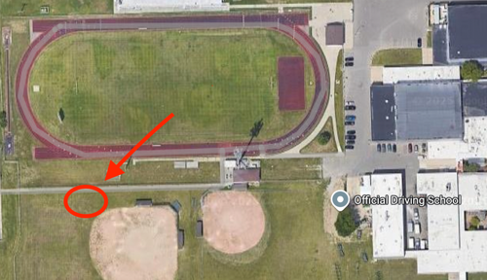

**Figure 2 (left) and 3 (right); Aerial visualization of each site.** The image on the left shows the location near Crestwood High School (42°20' 21"N -83°18'27"W) where one frost tube was installed. Figure 3 shows the other site, in a local backyard (42°19'18"N -83° 17' 45"W) where the frost tube data was collected. Proximity to buildings and any vegetation can be seen. The exact locations of the sites are circled above.

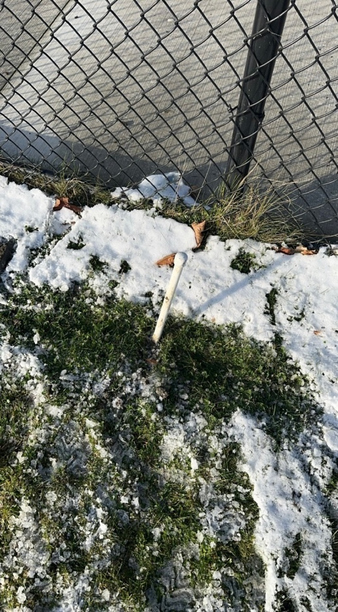 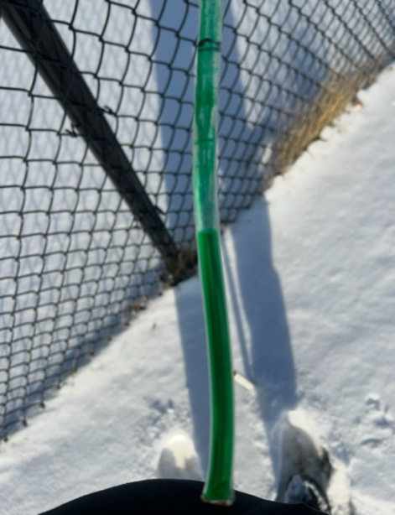

**Figure 4 (left) and 5 (right); Frost Tubes.** Figure 4 on the left shows an installed frost tube at the Crestwood High School location. Figure 5 on the right shows the clear tube used to measure ground freezing depth. The black line indicates ground level, and the green liquid shows freezing depth.

**Data Summary**

**Figure 6 Air Temperature vs. Freezing Depth (Location 1).** The graph above displays Air temperature (blue line) versus Freezing depth (orange line) in centimeters. The graph displays depth in cm, and temperature in degrees Celsius. In the graphs, freezing depth and air temperature displayed clear inverse correlation. Typically, as air temperature decreased, freezing depth levels increased.

**Figure 7. Air Temperature vs Freezing depth (Location 2).** The above graph displays Air temperature (blue line) versus freezing depth (orange line). The graph displays depth in centimeters. Freezing depth and air temperature showed an inverse correlation.

**Figure 8. Freezing Depth Location 1 vs. Freezing Depth Location 2.** The graph above displays freezing depth (in cm) for Location 1 (blue line) and Location 2 (orange line) over time. The graph indicates that freezing depths at both locations follow a similar trend, with fluctuations occurring simultaneously. Generally, as freezing depth increased at one location, it also increased at the other, suggesting parallel environmental conditions affecting both sites.

**Figure 9. This Year’s Data vs. Last Year’s Data.** The graph above displays freezing depth (in cm) for this year at location 1 (Orange line) and location 2 (Green Line) versus last year (Blue line) over time. The data indicate that freezing depths in both years follow a similar pattern, with fluctuations occurring at corresponding time points. Generally, freezing depth trends remain consistent between years, suggesting comparable environmental conditions.

**Data Analysis and Results:**

The graphs regarding air temperature versus freezing, for both locations, show that there is an inverse correlation between the parameters. In general, when temperature decreases, freezing depth increases, and vice versa. This relationship is consistent between both locations. This draws the conclusion that colder air temperatures result in a larger portion of the ground freezing over, which fits the expectation.

When the freezing depths of the two sites are compared, they follow almost identical trends, with Site 2 (backyard) being slightly higher on average. This could be accounted for by the fact that there is more vegetation present at Site 2 (backyard), which could potentially shield the ground from sun exposure. This would in turn result in higher freezing depths recorded as it would take longer to melt.

Comparing the data acquired from frost tubes this year to that of last year shows similar patterns, but the data from last year fluctuates more aggressively. The difference in data fluctuations could be attributed to last year’s El Niño year in contrast to the La Niña year experienced this year. Furthermore, the site at which data was collected last year differs from the sites used this year, which could further account for variation. The similarities, on the other hand, could likely be because measurements were taken during similar time periods and in the same city.

**Conclusions:**

This study emphasizes the relationship between atmospheric conditions and soil freezing depth in Southeast Michigan. Data collected from frost tubes at two locations during the Winter of 2024-2025 show a clear inverse correlation between air temperature and ground freezing depth. While being in a La Niña year introduced variability in temperature patterns, freezing depth trends remained generally consistent with those recorded during the previous El Niño winter. This suggests that while seasonal weather patterns influence soil freezing, other factors such as soil composition, snow cover, and site-specific conditions may also play a role. When comparing data from Crestwood test sites to the University of Alaska Fairbanks, however, results showed significant differences. These differences can likely be attributed to geographic location, variations in frost tube design, and differences in data collection methods. The lack of correlation between the two data sets highlights the importance of regional environmental conditions in ground-freezing patterns. This study demonstrates the importance of continued monitoring of frost depth, particularly as climate patterns shift. Future research should focus on collecting data over multiple winter seasons, incorporating additional atmospheric variables, and refining measurement techniques to improve accuracy and consistency. Understanding frost depth trends is essential for assessing impacts on plant survival, insect populations, and structural stability.

**Discussion:**

Based on the observed correlation between air temperature and freezing depth measurements, the researchers reject the null hypothesis that there is no significant difference between ground depth measurements taken at certain atmospheric parameters. The researchers found that as air temperature varied, there was a significant difference in the measured ground freezing depth. Observing the graphs for the two locations, it appears that there is an inverse relationship between air temperature and freezing depth. When air temperature rises, the freezing depth decreases, and when air temperature drops, the freezing depth increases. This is due to the fact that colder temperatures lead to deeper ground freezing. While on the other hand, warmer temperatures lead to melting and a shallower freezing depth. The researchers reject the null hypothesis that there is no significant difference between ground depth measurements taken during last year's El Niño winter and this year's La Niña winter. Based on the graph, noticeable differences in the data measurements in freezing depth between last year’s El Niño winter and this year’s La Niña winter leads the researchers to conclude that there is in fact a significant difference. The differences in freezing temperatures between last year’s El Niño winter and this year’s La Niña winter align with expected climate patterns. La Niña’s colder, drier conditions lead to deeper and more variable freezing, while El Niño’s warmer, wetter conditions result in more stable freezing depths. There are other factors that contribute to ground freezing that the researchers couldn’t account for. Soil type is one of those factors.

There are other factors that contribute to ground freezing that the researchers couldn’t account for. One of those factors is soil type. Soil type plays a significant role in how quickly and deeply the ground freezes. Different soil types, such as clay, sand, and silt, have varying abilities to retain moisture. This in turn affects their freezing capacity. Clay, for example, holds more water and freezes more solidly than sandy soil, which drains water quickly and is less prone to deep freezing.

However, while the researchers did all they could, perfect results are close to impossible to achieve. One possible source of error would be the difference in size between the frost tubes used at the two different sites. The frost tube placed at Site 1 (high school) was a foot shorter than the frost tube placed in Site 2 (backyard). This difference in size could have impacted the accuracy of the measurements, as a shorter frost tube may not have captured the full extent of ground freezing compared to a longer one. Additionally, variations in placement conditions—such as differences in soil composition, shade, or exposure to wind—could have further influenced the results. While these factors introduce some level of uncertainty, the researchers took care to ensure consistency in their methodology, minimizing the potential impact of such discrepancies on their overall findings.

**GLOBE Data Analysis:**

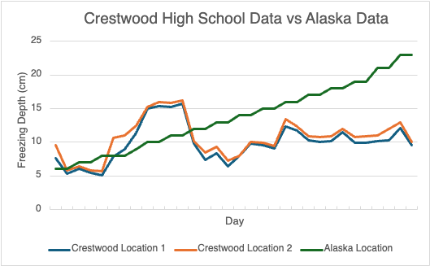

**Figure 10. Shows a comparison between Crestwood High School Data and University of Alaska Data**

The researchers compared their data to data collected from the University of Alaska Fairbanks. While the researcher’s data was collected between January 15, 2025, and February 15, 2025, the University of Alaska has been collecting data since 2000. The researchers compared their data to freezing depths collected from October to November of 2008. Similar to 2025, 2008 was known as a La Niña year, leading the researchers to this decision.

As seen in the graph above, there seems to be no correlation between freezing depths collected by the researchers and those collected by the University of Alaska Fairbanks. This could be due to several factors. Firstly, the frost tubes used by the University of Alaska were 300 centimeters each, while those used by the researchers were 122 and 152 centimeters. Furthermore, the University of Alaska collected data at 9 pm each night, whereas the researchers’ collected data at 7:30 pm.

The geographic differences between the locations likely impacted the results as well. The location of the frost tube installed by the University of Alaska was at coordinates (64°50' 43" N -147° 47' 23"W). The Crestwood sites were located at (42°20' 21" N -83° 18' 27" W) and (42° 19 '18"N -83° 17' 45"W). Alaska is considerably further north than Michigan, meaning the environmental conditions, such as temperature fluctuations, soil composition, and local climate patterns, could differ significantly, which may have contributed to the lack of correlation between the two data sets.

**Acknowledgments:**

Thank you to Dr. Kevin Czajkowski of the University of Toledo Mission Earth, who provided a sample frost tube. Thank you to Rami Eter, Youssuf Hassan, Mohamad Nasser, and Rawad Rahal for offering guidance and instruction on how to install the frost tubes. Lastly, thank you to Mrs. Diana Johns and Ms. Lina Abbas for providing constant support and knowledge throughout the research process.

**Bibliography:**

Ambroise, V., et al. (2020). “Effects of soil freezing on fine roots in a northern hardwood forest.” *The Roots of Plant Frost Hardiness and Tolerance, Plant and Cell Physiology*, 61(1), 3–20. <https://doi.org/10.1093/pcp/pcz196>

MacQuarrie, C. J. K., Derry, V., Gray, M., Mielewczyk, N., Crossland, D., Ogden, J. B., Boulanger, Y., & Fidgen, J. G. (2024). “Effect of a severe cold spell on overwintering survival of an invasive forest insect pest.” *Current Research in Insect Science*, 5, 100077. <https://doi.org/10.1016/j.cris.2024.100077>

Cleavitt, N. L., Fahey, T. J., Groffman, P. M., Hardy, J. P., Henry, K. S., & Driscoll, C. T. (2008). “Effects of soil freezing on fine roots in a northern hardwood forest.” *Canadian Journal of Forest Research*, 38(1), 82-91. <https://doi.org/10.1139/X07-133>

Mauget, S. A., & Upchurch, D. R. (1999). “El Niño and La Niña related climate and agricultural impacts over the Great Plains and Midwest.” *Journal of Production Agriculture*, 12, 203-215. <https://doi.org/10.2134/jpa1999.0203>

Photo “La Nina diagram” NOAA 2020 Copyright.

**Appendix:**

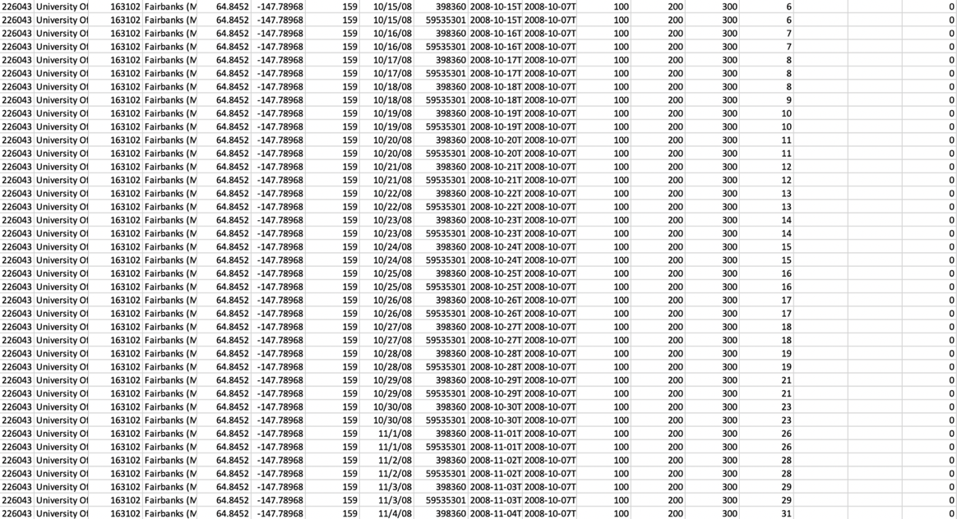

**Figure 11. University of Alaska Fairbanks Raw Data.** This sheet shows the data collected by the University of Alaska Fairbanks, which was used in comparison to the data collected by the researchers. It contains the location and date measurements that were taken, size of frost tube, day frost tube was installed, and the freezing depth that was retrieved.

**Badges:**

***I Am a STEM Storyteller***

The researchers hope to receive the "I am a stem storyteller" badge for their efforts to inform others on ground freezing variability and its importance. To share their findings, the 5 researchers created an Instagram account dedicated to educating their classmates on The Frost Tube Method and ground freezing variability. The account name is @frosttubes25. Through engaging posts and infographics, the researchers hope their account will make information on this topic readily accessible and interesting.

***I Am a Collaborator***

The researchers built on the work of their classmates Rami Eter, Youssuf Hasan, Mohamad Nasser, and Rawad Rahal, who studied ground freezing during an El Niño winter. Each member of the team collected data and compiled the information they found to create a research paper and poster. This year, the researchers focused on ground freezing during a La Niña winter and created a graph to compare their data to that of the previous study. Rami Eter, along with the other members of his group, taught the researchers how to properly install and use frost tubes, ensuring accurate data collection. This collaboration helped them understand the differences in ground freezing between the two winters and the importance of proper research methods. By building on last year’s project, the researchers continued studying how various weather patterns affect the ground and expanded on previous findings. Their teamwork strengthened their project immensely and demonstrated the value of collaboration.

***I Am a Data Scientist***

The researchers aim to earn the “I Am a Data Scientist” badge for their detailed collection, organization, and analysis of frost tube data. Over the course of a month, they recorded data from two distinct sites: one near Crestwood High School and another in a local backyard. After compiling the data in Microsoft Excel, the researchers created graphs that enabled them to identify trends and correlations between the frost depths across different times and locations. These visualizations helped the researchers draw conclusions about the factors influencing frost penetration, such as temperature and soil conditions. The researchers then compared their data with similar data collected by the University of Alaska. After comparing, the researchers determined that there was no correlation between the frost tube data collected at Crestwood High School/local backyard and the University of Alaska Fairbanks. The researchers believe that there was no correlation between these two locations because of the geographic conditions in Alaska during the data collection period (2008) and the conditions in Dearborn Heights, MI (2024).

With these findings, they hope to contribute valuable insights that could inform future studies on frost depth and support the development of more effective environmental monitoring strategies. For future studies, the researchers would like to find more sources where frost tube data is being collected. By making comparisons to more recent data, the researchers hope to find a correlation between El Niño and La Niña year effects on freezing depth.