Report on the Use of the GLOBE Program
in Monitoring Torrential Rains and Flood Prevention
Instituto S do Saber
Heitor César
Teancher Jeane de Fatima Moreira Branco
1. Abstract
This report discusses the importance of the GLOBE (Global Learning and Observations to Benefit the Environment) program in monitoring torrential rains that can lead to flooding. GLOBE is a global network that enables the collection of environmental data through observations made by citizens, aimed at studying and monitoring natural phenomena such as heavy rainfall. Using specific tools from the program, it is possible to identify and anticipate the risks of flooding, contributing to preventive and mitigative actions. This report presents the role of GLOBE in predicting and monitoring torrential rains, focusing on its application in the city of São Paulo.
2. Introduction
The increasing frequency of extreme weather events, such as torrential rains and flooding, requires new approaches for monitoring and forecasting. The city of São Paulo, due to its geographic location and urban characteristics, is highly vulnerable to these phenomena, which cause significant damage to infrastructure and the population. The GLOBE program, through its network of observers, provides an efficient platform for collecting meteorological data that can be used to identify and predict intense rains, allowing for preventive measures to be taken.
3. Objectives
- Explore how GLOBE can be used to monitor torrential rains in real time.
- Demonstrate how data collected by the program aids in forecasting and preventing flooding.
- Analyze the applicability of GLOBE for monitoring in urban areas like São Paulo.
4. Methodology
GLOBE offers several tools for climate monitoring, including precipitation and atmospheric condition monitoring. For this study, the following methods were analyzed:
- Meteorological Data Collection: Daily observations of precipitation, humidity, temperature, and atmospheric pressure made by trained observers on the GLOBE platform.
- Use of Local Weather Stations: Installation of sensors and weather stations to directly measure precipitation levels and other relevant meteorological conditions.
- Climate Data Analysis: Processing of collected data to identify climatic patterns that may indicate the likelihood of torrential rains.
- Integration with Meteorological Alerts: Association of collected data with real-time alert systems, such as those issued by INMET (National Institute of Meteorology) and Civil Defense, to anticipate possible floods.
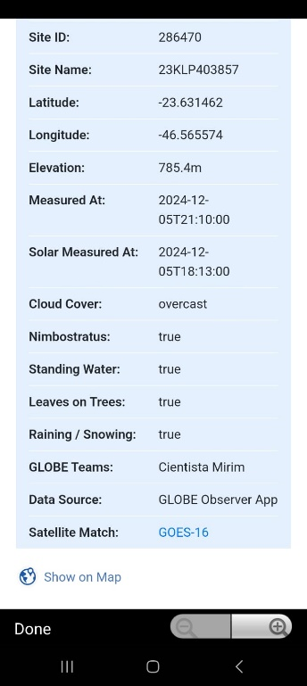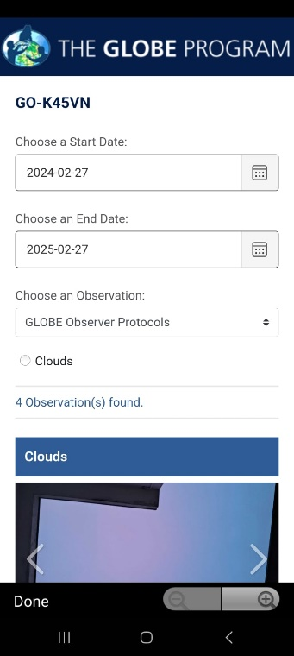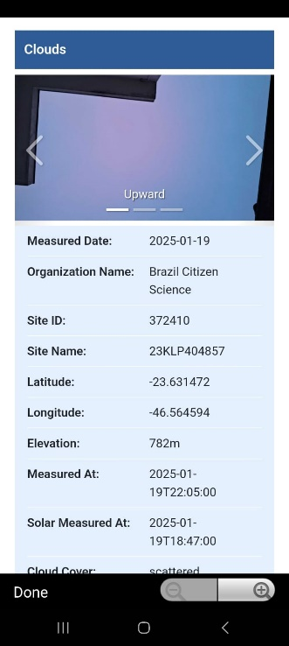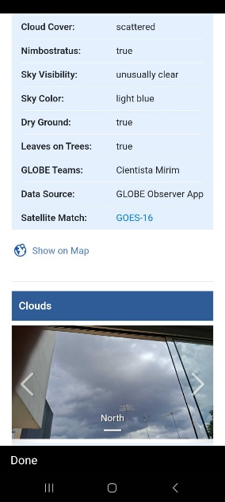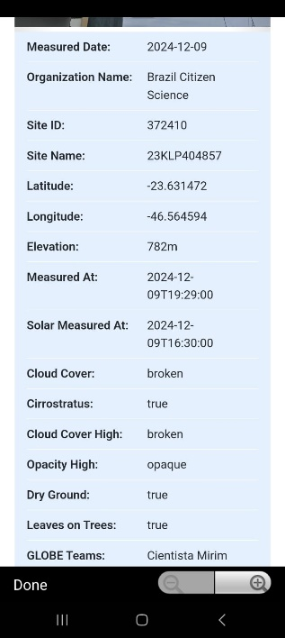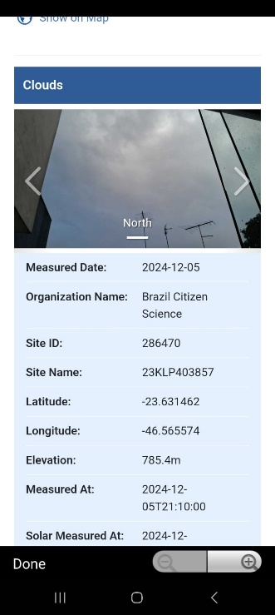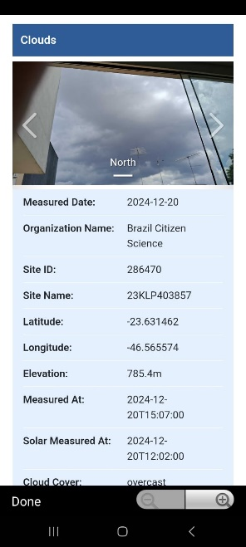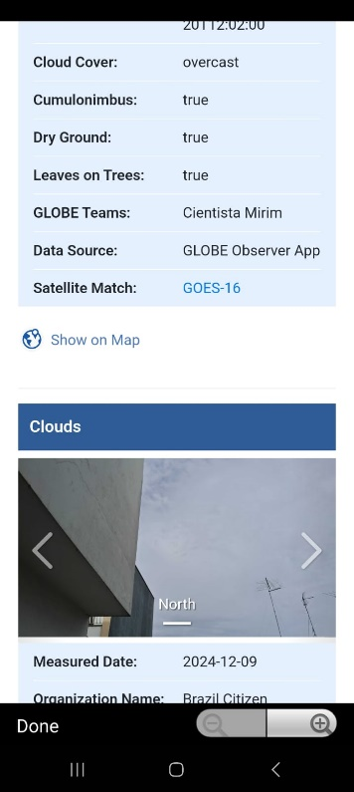
5. Expected Results
It is expected that the application of GLOBE will help identify climatic patterns and critical points where torrential rains could lead to flooding. Real-time meteorological data collection will allow for a faster response to extreme conditions, aiding in the evacuation of high-risk areas and damage mitigation.
6. Discussion
By integrating data provided by GLOBE with official weather forecasts, the program can serve as an additional support for local authorities in identifying intense rains. Moreover, the participation of the community in data collection strengthens social involvement in climate monitoring, promoting awareness and preventive actions.
7. Conclusion
The GLOBE program is a valuable tool in monitoring torrential rains and anticipating extreme weather events such as floods. Its collaborative approach and use of local data make it an effective solution for forecasting and preventing natural disasters. Expanding the GLOBE network of observers, especially in vulnerable urban areas like São Paulo, can significantly contribute to reducing risks and impacts caused by intense rains.
8. References
- GLOBE Program. (2025). Global Learning and Observations to Benefit the Environment. Available at: https://www.globe.gov
- INMET - National Institute of Meteorology. (2025). Climate Monitoring and Meteorological Alerts. Available at: http://www.inmet.gov.br
- DEFESA CIVIL SP. (2025). Guidelines on Floods and Torrential Rains. Available at: https://www.defesacivil.sp.gov.br

