 

**Research Report**

**Comparison of Soil Quality Affecting Latex Yield in Rubber Plantations During the**

**Summer and Rainy Seasons Na Khao Sia Subdistrict, Na Yong District, Trang**

**Province**

**Conducted by**

**Miss Thapanee Ontuk**

**Miss Thanchanok Sengsi**

**Advisors**

**Ms. Khwanjai Kanjanasrimek**

**Ms. Sutheera Thacheen**

**Wichienmatu School**

**Mueang Trang District, Trang Province**

**Secondary Educational Service Area Office, Trang-Krabi**

**Abstract**

**Research Title:** Comparison of Soil Quality Affecting Latex Yield in Rubber Plantations During the

Summer and Rainy Seasons

**Location:** Na Khao Sia Subdistrict, Na Yong District, Trang Province

**Researchers:** Miss Thapanee Ontuk, Miss Thanchanok Sengsiang

**Grade Level:** Matthayom 5

**Advisors:** Ms. Sutheera Thacheen, Ms. Khwanjai Kanjanasrimek

**School:** Wichienmatu School, Trang Province

This study aimed to compare soil quality factors affecting latex yield in rubber plantations during the

summerand rainy seasons in Na Khao Sia Subdistrict, Na Yong District, Trang Province. The research was

conducted by measuring soil quality parameters based on GLOBE protocols, including soil temperature, pH,

moisture content, and fertility.The findings indicated that latex yield in rubber plantations was higher during the

rainy seasoncompared to the summer. The average soil temperature was higher in summer, while soil

moisturelevels were greater in the rainy season. The soil pH in the rainy season was higher than in the summer.

Regarding soil fertility, potassium levels increased during the rainy season compared to the summer, while

nitrogen and phosphorus levels remained relatively stable across both seasons.

**Keywords:** Soil quality, Latex concentration, pH value, Moisture content, Soil fertility

**Introduction**

Rubber trees are an important economic crop that significantly contributes to the country’s economy. Rubber

plantations generate substantial income for farmers (Rubber Research Institute, 2012). Rubber cultivation covers

approximately 90% of the suitable land area in Thailand (Land Development Department, 2000) and can be

grown in all regions of the country. However, soil quality and fertility vary by location and season.Soil quality is a

key factor indicating soil fertility in rubber plantations and plays a crucial role in determining latex yield.

Understanding how soil conditions impact latex production can help improve soil management practices to

maximize yield. Natural rubber serves as a raw material for various industrial applications, from major

manufacturing sectors to smaller industries. Processed rubber can be categorized into two main groups:

1.Solid Rubber, such as block rubber, air-dried sheet rubber, and smoked sheet rubber.2.Liquid Rubber, which is

used in products like adhesives, tire production, and everyday rubber-based items.Currently, rubber production is

in high demand. However, studies show that latex yield varies among rubber trees, and soil conditions are one of

the key factors influencing this variation. Planting rubber trees in unsuitable or infertile soil can negatively impact

latex production. This research aims to study the impact of soil quality on latex yield in rubber plantations,

providing insights that can help improve soil conditions for optimal rubber production.

**Research Question**

Does soil quality affect latex yield in rubber plantations during the summer and rainy seasons in Na Khao Sia

Subdistrict, Na Yong District, Trang Province?

**Research Hypothesis**

Differences in soil quality affect latex yield in rubber plantations during the summer and rainy seasons in Na Khao

Sia Subdistrict, Na Yong District, Trang Province.

**Related variables**

**Hypothesis:** Different soil quality affects the latex yield in rubber plantations during the summer and rainy seasons.

**Independent variable:** Soil quality

**Dependent variable:** Latex yield

**Control variables:** Rubber plantation, soil quality testing

**Materials and Equipment**

1.Thermometer

2.Soil Fertility Test Kit (N, P, K)

3.Soil Moisture Meter

4.Soil pH Test Kit

5.Beaker

6.Erlenmeyer Flask

7.Filter Paper

8.Glass Stirring Rod

**GLOBE Measurement Protocol**

Pedosphere (Soil): Soil Measurement Protocol

**Study Area Location**

The study area is located in the rubber plantation area of Na Khao Sia Subdistrict, Na Yong District, Trang

Province (Latitude 7.54631, Longitude 99.69145).

**Research Methodology**

1.Preparation Phase

1.)Identify the research topic and select the focus of the study.

2.)Conduct a literature review and gather relevant knowledge and theories related to the research.

3.)Define the objectives of the study.

2.Implementation Phase

1.)Develop a research work plan.

2.)Measure soil quality using the GLOBE methodology by assessing soil temperature, pH, moisture

content, and soil fertility (N, P, K) during the rainy season (November to December) and summer season

(January) as follows:

1.)Measure soil temperature at three points using a thermometer, record the temperature readings three

times, and calculate the average.

2.)Measure soil moisture using a moisture meter, record the moisture readings three times, and

calculate the average.

3.)Measure soil pH using litmus paper:

Take 20 ml of soil and place it in a beaker, then add water to the beaker until the total volume reaches

50ml. Mix the water and soil thoroughly.Fold filter paper and place it in a funnel. Put the funnel with the

filter paper into an Erlenmeyer flask, then pour the water-soil mixture onto the filter paper in the funnel

without overflowing.Use litmus paper to measure the pH of the filtered water in the flask by dipping the

litmus paper into the water, then compare the pH using a pH scale.

4. Measure soil fertility (N, P, K) using a soil N, P, K meter to record the nutrient levels in

the soil.

**Research Results**

**Table 1: Geographic Coordinates of the Study Area**

| **Study area** | **Geographicalcoordinates** | |
| --- | --- | --- |
| **Latitude (N)** | **Longitude (E)** |
| The river plantation area in Na Khao Sia Subdistrict, Na Yong District, Trang Province. | 7.54631 | 99.69145 |

**Table 2: Comparison of Soil Texture, Soil Structure, and Soil Color during the Summer and Rainy Seasons**

| **Soil sample** | | **Summer season** | | | **Rainy season** | | |
| --- | --- | --- | --- | --- | --- | --- | --- |
| **Clay** | **Soil**  **color** | **Soil structure** | **Clay** | **Soil color** | **Soil structure** |
| Spot 1 | | loamy | brown | round-shaped | loamy | brown | round-shaped |
| Spot 2 | | loamy | brown | round-shaped | loamy | brown | round-shaped |
| Spot 3 | | loamy sandy soil | brown | round-shaped | loamy sandy soil | brown | round-shaped |

From Table 2, it was found that the clay texture, soil color, and soil structure during the summer and rainy seasons were similar.Point 1: The soil texture is loam, the soil color is brown, and the soil structure is granular.Point 2: The soil texture is loam, the soil color is brown, and the soil structure is granular.Point 3: The soil texture is sandy loam, the soil color is brown, and the soil structure is granular.

**Table 3 shows the soil temperature values during the summer and rainy seasons.**

| **Soil sample** | **Soil temperature (Celsiusdegrees)** | | | | | | | |
| --- | --- | --- | --- | --- | --- | --- | --- | --- |
| **Summer season** | | | | **Rainy Season** | | | |
| **Trial 1** | **Trial 2** | **Trial 3** | **Average** | **Trial 1** | **Trial 2** | **Trial 3** | **Average** |
| Spot 1 | 30.1 | 29.7 | 30.0 | 29.93 | 26.0 | 26.0 | 26.0 | 26.0 |
| Spot 2 | 29.8 | 30.1 | 29.7 | 29.87 | 26.0 | 27.0 | 26.0 | 26.3 |
| Spot 3 | 29.8 | 30.0 | 29.8 | 29.87 | 26.0 | 26.0 | 26.0 | 26.0 |

From Table 3, it was found that the average soil temperature at all three points during the summer was higher than the average soil temperature during the rainy season.

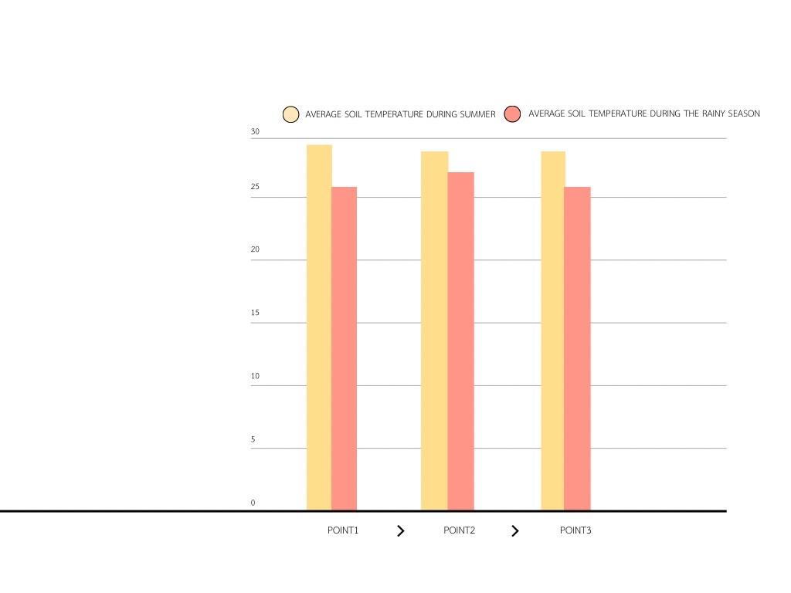

**Table 4 shows the soil moisture values during the summer and rainy seasons.**

| **Soil sample** | **Soil moisture (percentage)** | | | | | | | |
| --- | --- | --- | --- | --- | --- | --- | --- | --- |
| **Summer season** | | | | **Rainy season** | | | |
| **Trial 1** | **Trial 2** | **Trial 3** | **Average** | **Trial 1** | **Trial 2** | **Trial 3** | **Average** |
| Spot 1 | 2.0 | 3.0 | 3.5 | 2.83 | 2.0 | 2.5 | 2.0 | 2.17 |
| Spot 2 | 3.0 | 3.0 | 2.5 | 2.83 | 2.5 | 4.0 | 2.5 | 3.00 |
| Spot 3 | 2.0 | 3.5 | 2.0 | 2.50 | 4.0 | 3.0 | 6.0 | 4.33 |

From Table 4, it was found that the area with the highest soil moisture was Point 3 during the rainy season, followed by Point 1 and Point 2 during the summer, and Point 2 during the rainy season. Next was Point 3 during the summer, while the area with the lowest soil moisture was Point 1 during the rainy season.

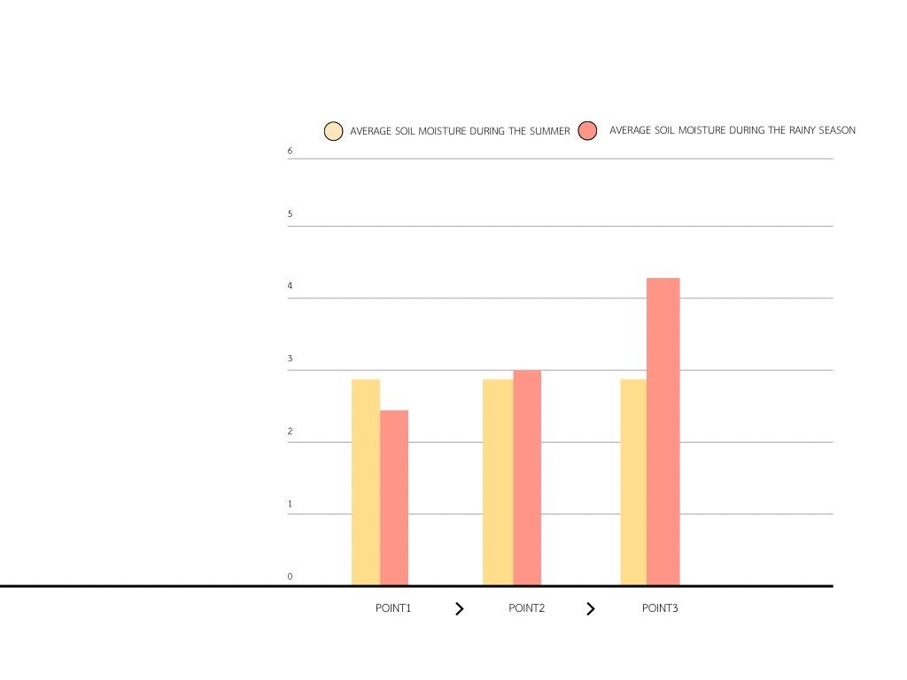

**Table 5 shows the soil pH values during the summer and rainy seasons.**

| **Soil sample** | | **Soil pH** | | | | | | | |
| --- | --- | --- | --- | --- | --- | --- | --- | --- | --- |
| **Summer season** | | | | **Rainy season** | | | |
| **Trial 1** | **Trial 2** | **Trial 3** | **Average** | **Trial 1** | **Trial 2** | **Trial 3** | **Average** |
| Spot 1 | | 7 | 6 | 6 | 6.67 | 6 | 6 | 6 | 6.00 |
| Spot 2 | | 6 | 6 | 5 | 5.67 | 4 | 5 | 5 | 4.67 |
| Pot 3 | | 7 | 6 | 7 | 6.67 | 6 | 7 | 6 | 6.33 |

From Table 5, it was found that the average pH values at all three points during the rainy season were higher than the pH values during the summer.

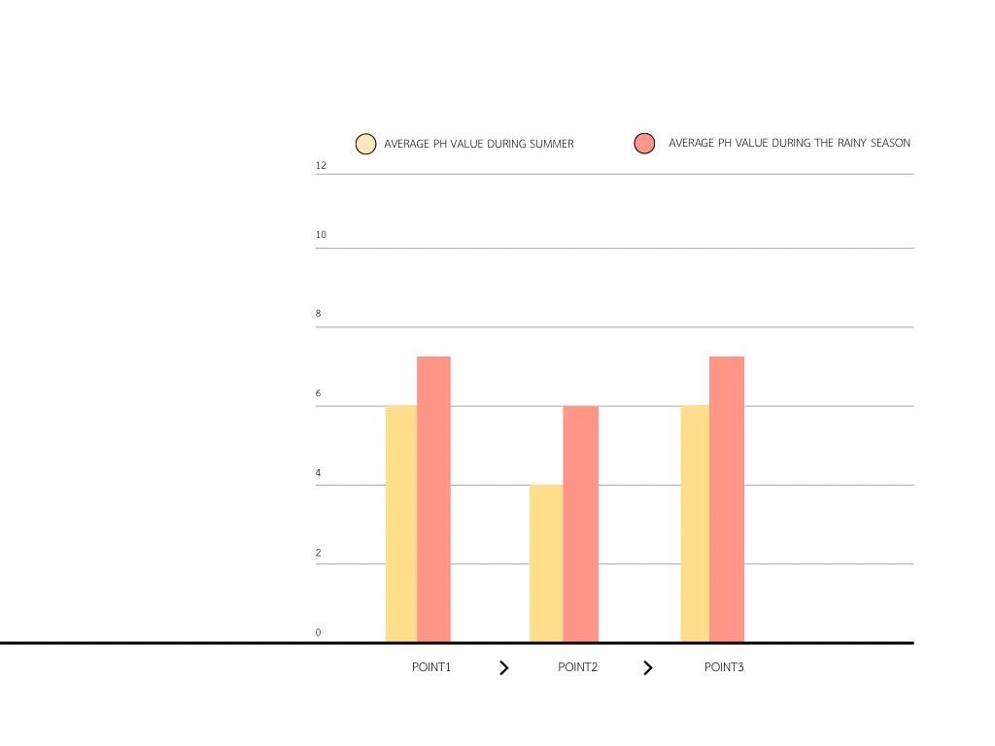

**Table 6 shows the soil fertility values during the summer and rainy seasons.**

| **Soil sample** | **Soil nutrient levels of N,P,K** | | | | | |
| --- | --- | --- | --- | --- | --- | --- |
| **Summer season** | | | **Rainy season** | | |
| **N** | **P** | **K** | **N** | **P** | **K** |
| Spot 1 | 2 | 2 | 7 | 2 | 2 | 14 |
| Spot 2 | 0 | 0 | 2 | 1 | 0 | 2 |
| Spot 3 | 0 | 0 | 1 | 0 | 0 | 2 |

From Table 6, it was found that during both the summer and rainy seasons, Point 1 had equal nitrogen and phosphorus values of 2, and during the rainy season, the potassium value was higher than in the summer. For Point 2, nitrogen was higher during the rainy season than in the summer, while phosphorus values were the same (0) in both seasons, and potassium values were also the same (2). For Point 3, nitrogen and phosphorus values were both 0 during both the summer and rainy seasons, and potassium was higher during the rainy season than in the summer.

**Table 7 shows the latex production values during the summer and rainy seasons.**

| **Area** | **Latex yield in rubber plantations** | | | | | | | |
| --- | --- | --- | --- | --- | --- | --- | --- | --- |
| **Summer season** | | | | **Rainy season** | | | |
| **Trial 1** | **Trial 2** | **Trial 3** | **Average** | **Trial 1** | **Trial 2** | **Trial 3** | **Average** |
| Rubber plantation | 38.5 | 48 | 39.5 | 42 | 50.5 | 51 | 49 | 50.17 |

From Table 7, it was found that the latex production during the rainy season was higher than in the summer. The average latex production during the rainy season was 50.17, while the average during the summer was 42.

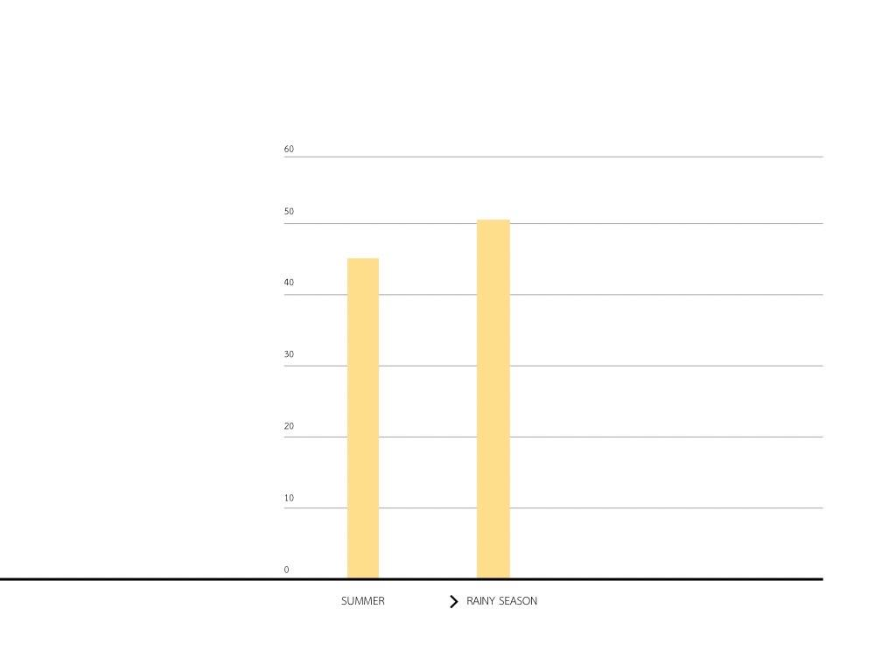

**Conclusion and Discussion of the Research Findings**

From the study comparing soil quality and its effect on latex production in rubber plantations during the summer and rainy seasons, it was found that the temperature during the summer was higher than during the rainy season. The moisture content was higher during the rainy season due to the increased rainfall. The pH value was also higher during the rainy season compared to the summer. Regarding soil fertility, the potassium content significantly increased during the rainy season and was higher than in the summer, while nitrogen and phosphorus levels remained relatively constant in both seasons. Latex production during the rainy season was higher than in the summer. It can be concluded that soil quality affects latex production, and the soil quality during the rainy season is better than in the summer, leading to higher latex production in the rainy season.

**Recommendations**

It is recommended to study the relationship between air quality and latex production.

**Acknowledgements**

The research titled “Comparison of Soil Quality Affecting Latex Yield in Rubber Plantations During the Summer

and Rainy Seasons in Na Khao Sia Subdistrict, Na Yong District, Trang Province” has been successfully

completed thanks to the generous guidance and support from several individuals.First, I would like to express my

sincere gratitude to Mr. Sakda Paisomboon, the Director of Wichienmatu School, for approving the budget for this

research project. I also wish to thank Teachers Sutheera Thachin and Khwanjai Kanjanasrimek for their valuable

advice, suggestions, and assistance in improving and correcting the research with great attention to detail.My

heartfelt thanks go to Wichienmatu School for providing the necessary equipment and laboratory facilities for

conducting the research, which contributed significantly to the success of this project.

This research is dedicated to all those who have supported and guided me, including those who authored

the textbooks and documents referenced in this study. I am deeply grateful to all of them.

**References**

(Soil Measurement Principles)GLOBE THAlLAND

Pimpanth Jermsawasdi. 2006. Handbook of Basic Pedology and Soil Science. 11th edition. Department of

Pedology, Faculty of Agriculture, Kasetsart University, Bangkok.

Wirot Impithak. 1980. Soil Fertility Conditions in the Research Area. Issue 4, Department of Pedology, Faculty of

Agriculture, Kasetsart University, Bangkok.

[**https://km.raot.co.th/uploads/dip/userfiles/7**](https://km.raot.co.th/uploads/dip/userfiles/7_%E0%B8%81%E0%B8%B2%E0%B8%A3%E0%B8%88%E0%B8%B1%E0%B8%94%E0%B8%81%E0%B8%B2%E0%B8%A3%E0%B8%AA%E0%B8%A7%E0%B8%99%E0%B8%A2%E0%B8%B2%E0%B8%87%E0%B8%AD%E0%)