**Comparison of the chemical properties and water temperature of the drainage canal and the reservoir lake of HPP Dubrava**

Students: Antonija Stančin, Rea Pongrac, Ivan Horvat

Mentor: Valentina Pirc Mezga

Srednja škola Prelog, Prelog

The Drava River plays an important role in the lives of the people who live along its valley. The hydroaccumulation lake of the HPP Dubrava and the drainage channel of the HPP Dubrava are the habitat of many plant and animal species. The chemical properties of water, dissolved oxygen and water temperature influence the life and reproduction of organisms in the water. Therefore, the question arises as to how the chemical properties of the water (oxygen, nitrites, nitrates, pH, phosphates) and the water temperature differ between the drainage channel and the lake of the HPP Dubrava, and whether the water flow through the drainage canal affects the concentration of dissolved oxygen and temperature compared to the lake HPP Dubrava. Over a period of more than six months, water samples are collected weekly from the drainage channel and lake of HPP Dubrava. The chemical properties of the water (nitrates, nitrites, phosphates, pH), dissolved oxygen concentration and water temperature were measured using the GLOBE protocols. The research results indicate that a higher water flow through the drainage canal can lead to more favorable chemical properties of the water, especially lower nitrate concentrations and slightly lower temperatures . It is confirmed that the nitrate concentration and water temperature in the drainage channel are lower compared to the HE Dubrava lake. The drainage channel has higher oscillations and amplitudes of dissolved oxygen in the observed period. Comparing the data provided by Hrvatske vode and GLOBE measurements for pH and phosphates, significant deviations are visible, which are the result of different measuring kits.

**Abstract**

Students of Prelog High School frequently conduct field research and measurements along the Drava River, as well as in the drainage channel and lake of HPP Dubrava, leading to a comparison of certain physico-chemical parameters (Figure 1). The focus is on the drainage channel, which is believed to have a higher water flow than the HPP Dubrava lake, suggesting that it may have a lower water temperature and thus a higher dissolved oxygen concentration. The drainage channel is influenced by wastewater inflows, yet it is home to brown trout. Trout are fish of various genera belonging to the Salmonidae family, inhabiting clean, fast-flowing freshwater bodies, and are recognizable by their distinctive body spots. They inhabit the drainage channel thanks to the Međimurje Fishing Association, which holds fishing rights for the channel and is responsible for annually restocking it with trout in accordance with the management plan (Freshwater Fisheries Act, NN 63/19).

This research builds upon a previous study conducted by Prelog High School in 2010, which confirmed that the water temperature in the drainage channel was lower compared to the lake. Despite this, the "Glavatica" Fishing Society from Prelog has been unsuccessfully attempting to introduce brown trout into the drainage channel for several years. Although the water temperature in the drainage channel is favorable for trout, it is suspected that the issue may be related to low oxygen content. During maintenance work at the hydroelectric power plant, some trout from the main discharge channel enter the drainage channel (GNP, 2018).

The HPP Dubrava Lake is an artificial lake located near Donja Dubrava, Croatia. It was created by the construction of the hydroelectric power plant, which harnesses hydropower to generate electricity. Additionally, the lake serves various purposes, such as recreational activities like fishing, boating, or simply enjoying nature through walking or cycling (Sraka et al., 2010). Adjacent to the HPP Dubrava Lake is the drainage channel. Drainage channels, such as those in the city of Prelog, play a crucial role in agricultural production, especially in areas prone to water retention, such as wetlands or low-lying regions. These channels enable controlled water drainage from agricultural land through pipes, helping to maintain soil quality, prevent erosion, and create optimal conditions for crops (Prišlić, 2016).

Furthermore, the drainage channel itself is an artificially created ditch designed to collect and regulate groundwater levels, which rose due to the filling of the accumulation lake, keeping them within acceptable limits. The seepage water from the lake is relatively small in volume, leading to a low flow rate in the drainage ditches. However, over time, groundwater levels increased, prompting the use of artesian wells to reach deeper underground water layers and thus reduce pressure. Water from these artesian wells further supplies the channel, and it is very clean, consistently cold, oxygen-poor, and slightly alkaline (Režek, 2003).

The drainage channel has a flow rate of approximately 22 m³/s. The water is seepage-derived, remains cold throughout the year, and experiences minimal temperature fluctuations. It contains a significant amount of aquatic vegetation, particularly an abundance of amphipods, which serve as food for trout (GNP, 2018). Amphipods of the genus Gammarus inhabit clean freshwater environments (Vuković, 2021).

Key words: dissolved oxygen, lake, drainage canal

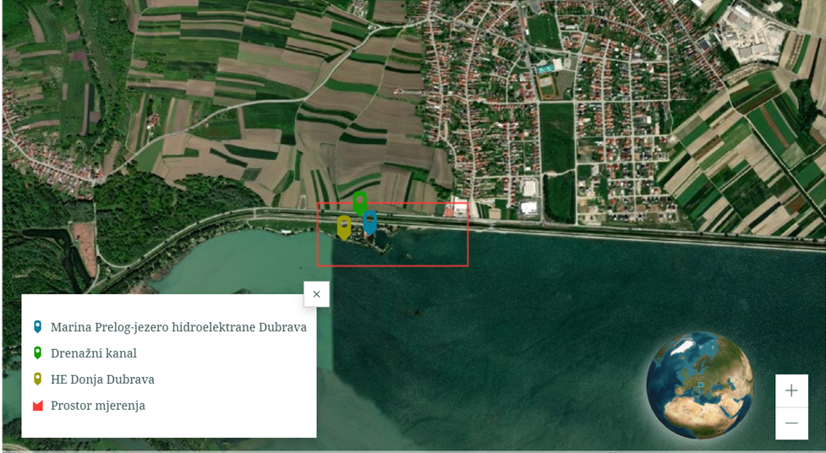

Figure 1. Srednja škola Prelog's GLOBE Hydrological measuring stations (source: ArcGIS SS Prelog)

**Research Questions, Objectives, and Hypotheses**

The research was guided by the following questions:

1. How do the concentrations of nitrites, nitrates, phosphates, pH values, and water temperature differ between the drainage channel and the HPP Dubrava lake?
2. Does the water flow through the drainage channel affect the concentrations of dissolved oxygen, nitrites, nitrates, phosphates, pH values, and temperature compared to the HPP Dubrava lake?

The research objectives are to determine the chemical properties of water in the drainage channel and HPP Dubrava lake, investigate differences in dissolved oxygen concentration and water temperature between the two, and identify potential causes of differences in chemical properties and water temperature.

It is hypothesized that the drainage channel will have a higher water flow, leading to a higher concentration of dissolved oxygen and lower water temperature compared to the HPP Dubrava lake. Additionally, due to wastewater inflows into the drainage channel, the amount of dissolved nitrates and nitrites is expected to be higher than in the lake, as nitrates and nitrites are chemical compounds used as fertilizers, rodenticides, or preservatives in surrounding fields (Nujić, Habuda-Stanić, 2017). A high level of phosphates in spring water can accelerate algae and plant growth ([Hach, phosphorus parameters](https://hr.hach.com/parameters/phosphorus)), and since the drainage channel is rich in aquatic vegetation, it is assumed that the amount of dissolved phosphates in the channel is higher than in the lake.

**Research Methods**

During the research period, from August 6, 2023, to January 28, 2024, measurements were conducted weekly at two locations: the drainage channel and the HPP Dubrava lake. A digital thermometer (*Checktemp* by HANNA Instruments) was used to measure water temperature in both samples. The *VISOCOLOR - School Reagent Case* by MACHEREY–NAGEL was used for testing nitrates, nitrites, pH, and phosphates, while dissolved oxygen was measured using the *HANNA Instruments – Dissolved Oxygen Test Kit*. The measurement results were recorded in a field journal and presented in tabular form. The flow rate of the drainage channel was measured using a table tennis ball, a water level rod, and a stopwatch.

**Data Presentation and Analysis**

The highest nitrate concentrations in the HPP Dubrava lake were 5 mg/L, recorded in mid-November and January. The minimum nitrate concentration in the lake was 1 mg/L, which was the most frequently measured value. In the drainage channel, nitrate concentrations were lower compared to the HPP Dubrava lake. The highest nitrate concentration recorded in the drainage channel was 2 mg/L, observed during the summer months. The minimum nitrate concentration was 0 mg/L, recorded only once (Figure 2).

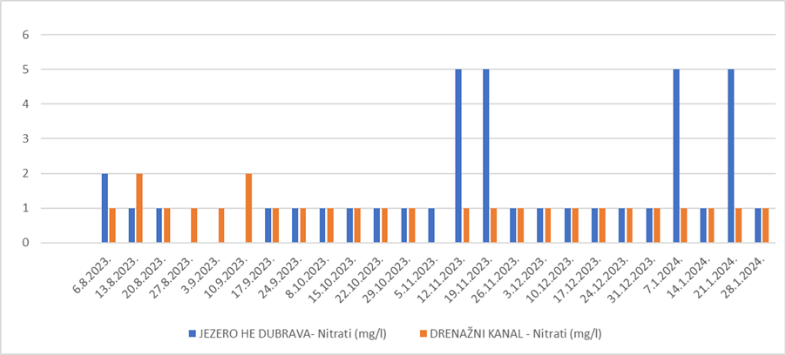

Figure 2. Nitrate concentration at the Dubrava HPP site and the drainage channel

Due to regular maintenance and repairs, the HPP Donja Dubrava lake was drained for a certain period (August 27, 2023, to September 10, 2023.), and measurements were not conducted at that location during this time.

Regarding nitrites, the lowest recorded concentration in the lake was 0.3 mg/L, while the highest was around 1 mg/L. In the drainage channel, the highest recorded nitrite concentration was 0.5 mg/L, while the lowest was 0.1 mg/L (Figure 3).

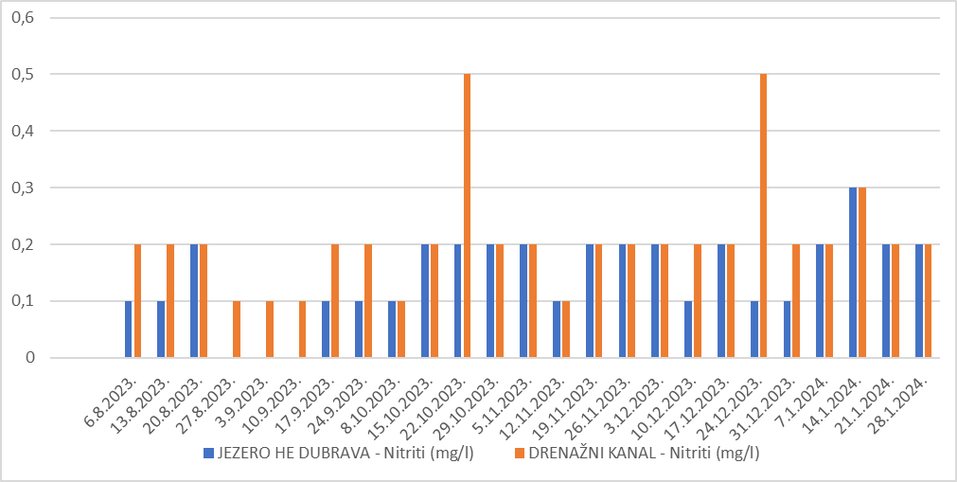

Figure 3. Nitrite concentration at the location of HPP Dubrava and the drainage channel

In the HPP Dubrava lake, the most common phosphate concentration was 0.5 mg/L. In several measurements, slightly higher values were recorded. The minimum phosphate concentration of 0 mg/L was observed in the lake. Phosphate concentrations in the drainage channel were similar to those in the lake, with a few exceptions. The highest phosphate values, 1.5 mg/L, were recorded during the winter months (Figure 4).

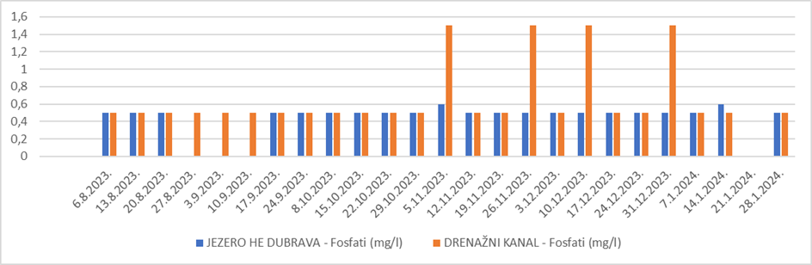

Figure 4. Phosphate concentration at the location of HPP Dubrava and the drainage channel

The pH values of the water in the drainage channel did not show significant deviations. The most frequently measured value was neutral, pH 7. The highest measured value was slightly neutral, pH 8, while the lowest measured value was slightly acidic, pH 6. In the HPP Dubrava lake, pH values of 7 were also common, with the highest measured value being pH 8, and the lowest value recorded was pH 4 (Figure 5).

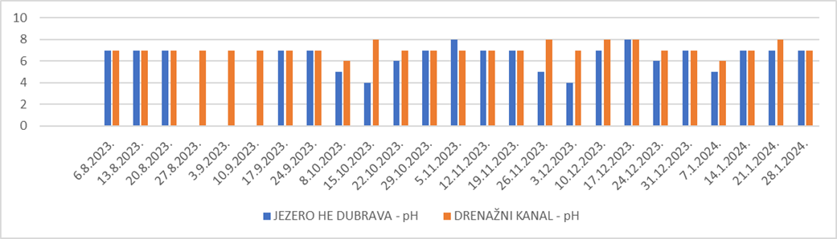

Figure 5. pH values at the location of HPP Dubrava and the drainage channel

The highest recorded temperature in the lake was 24.1 ºC, while the lowest was 2.5 ºC. In the drainage channel, the highest recorded temperature was 22.9 ºC, and the lowest was 3.1 ºC (Figure 6).

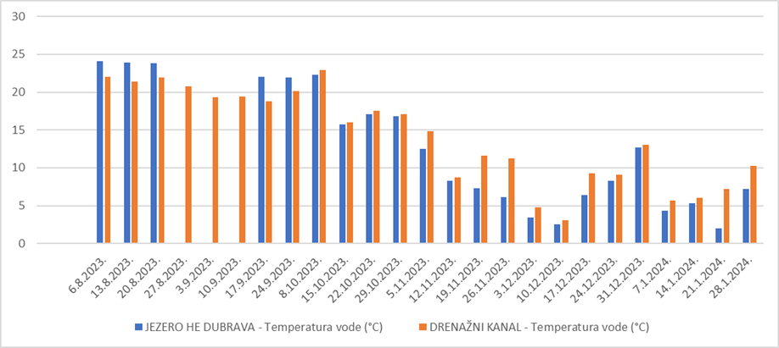

Figure 6. Water temperature at the location of HPP Dubrava and the drainage channel

In the HPP Donja Dubrava lake, the highest recorded dissolved oxygen concentration was 10 mg/L, observed in mid-December. The average concentration was 7 mg/L, and the lowest measured concentration was 5 mg/L. In the drainage channel, the dissolved oxygen concentration was lower than in the lake. The highest measured concentration was 6 mg/L, the average was 4 mg/L, and the lowest recorded concentration was 1 mg/L. The drainage channel exhibited greater fluctuations and amplitudes in dissolved oxygen during the observed period (Figure 7).

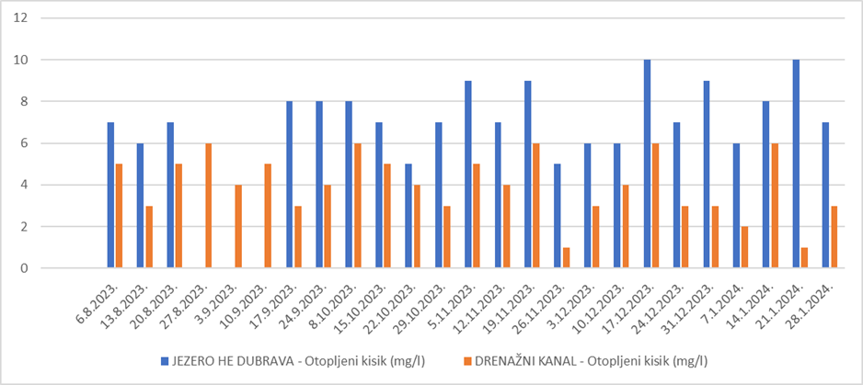

Figure 7. Dissolved oxygen concentration at the location of HPP Dubrava and the drainage channel

By comparing the data provided by Hrvatske vode for the same period in 2022, it is evident that some measurements taken according to GLOBE protocols are similar, while others show deviations. The values for dissolved oxygen, according to the analyses by Hrvatske vode, average 10 mg/L, which matches the measurements taken according to the GLOBE protocols (Table 1).

Table 1. Data for HPP Dubrava from Hrvatske vode

|  |  |  |  |  |  |
| --- | --- | --- | --- | --- | --- |
| Datum: | Nitrati (mg/l) | Nitriti (mg/l) | Fosfati (mg/l) | pH | Otopljeni kisik (mg/l) |
| 25.8.2022. | 1,1 | <0,07 | 0,05 | 8 | 8 |
| 26.9.2022. | 0,6 | <0,07 | 0,03 | 7 | 10 |
| 24.10.2022. | 1,1 | <0,07 | 0,03 | 8 | 10 |
| 14.11.2022. | 0,6 | <0,07 | 0,04 | 7 | 10 |
| 05.12.2022. | 0,6 | <0,07 | 0,06 | 8 | 11 |

**Discussion and Conclusions**

Given the lack of similar research and literature references, it is possible to compare only with the data from Hrvatske Vode for HPP Dubrava, and for the drainage channel, comparisons can be made with our previous measurements for dissolved oxygen, temperature, and water flow from 2010 (Sraka et al., 2010). The values of nitrites, nitrates, and phosphates measured in this study differ significantly from those measured by Hrvatske Vode, which may be due to the different measurement instruments and water kits used.

**Based on the collected data and analysis, the following conclusions can be drawn regarding the research hypothesis:**

Flow Rate: The flow rate in the drainage channel was measured at 22 m³/s, while the flow rate for HPP Dubrava on the same day was recorded at 284 m³/s (Hrvatske Vode, 2024). This does not support the hypothesis that the drainage channel has a greater flow rate, and consequently, it also rejects the assumption that the flow leads to a lower temperature and higher dissolved oxygen concentration in the drainage channel. The average annual flow rate at HPP Dubrava is 325 m³/s (Režek, 2003), while no continuous measurements of the water flow in the drainage channel are available. Due to the low gradient of the channel, the water flow velocity is relatively low. The channel lacks natural or artificial barriers that could cause water splashing, which would help oxygenate the water further.

Nitrate Concentration: It was confirmed that the nitrate concentration in the drainage channel is lower compared to the HPP Dubrava lake, which aligns with the official data from Hrvatske Vode. Compared to the data from the 2009 study, the nitrate levels were significantly higher at that time, which was attributed to the increased use of agricultural chemicals in surrounding fields that reached the channel and caused water pollution (Sraka et al., 2010). It is believed that the lower nitrate concentration during this study period is due to the reduced use of chemicals in the spring.

Nitrite Concentration: Nitrite concentrations in the lake and drainage channel were generally similar, with only minor deviations. Therefore, there was no noticeable difference to confirm our hypothesis.

Phosphate Concentration: Although phosphate concentrations in the drainage channel were similar to those in the lake, with some exceptions, there was no difference to support the hypothesis of higher water flow and lower phosphate concentration in the drainage channel. Slightly elevated phosphate values in the channel are likely the result of human activities on surrounding fields.

Water Temperature: The results showed that water temperatures in the drainage channel were lower compared to those in HPP Dubrava lake, which corresponds with official data from Hrvatske Vode. The channel was warmer during winter, while the lake had higher water temperatures during the summer months. The measurement results reject the hypothesis that the drainage channel would have lower water temperatures due to higher flow rates. When comparing the water temperatures in the drainage channel to GLOBE measurements from 2008 and 2009, a rise in average water temperature during both summer and winter months is evident (Sraka et al., 2010).

Dissolved Oxygen: The concentrations of dissolved oxygen were lower in the drainage channel compared to the HPP Dubrava lake, which may be related to the lower water flow in the drainage channel. One of the reasons could be that the channel is primarily fed by groundwater, which is low in oxygen (Sraka et al., 2010). The hypothesis regarding dissolved oxygen concentration was not confirmed, as significantly lower values were recorded than expected. Some of these values (1 mg/L) were extremely low and are unsuitable for trout life (Hrvatske Vode, 2024).

**Conclusion**

By comparing the data provided by Hrvatske Vode and the GLOBE school group, significant discrepancies were observed in measurement results, especially for pH and phosphates, which indicates the unreliability of the water kits. Data for dissolved oxygen did not deviate significantly, and the reason for the minor deviations could be the scale of the kit used, which is likely designed to give less precise results. Hrvatske Vode utilize more sensitive equipment that provides more accurate measurement results.

In general, the measurement results suggest a complex interaction between water flow, chemical composition, and temperature in the drainage channel and HPP Dubrava lake. These conclusions provide a foundation for further research and water resource management in the area.

**Bibliography/Citations**

1. Barić Tominac, M., Liber SD., Bajić D. 2020- Kemija 3- udžbenik kemije za treći razred gimnazije, PROFILKlett, Habuš A., Zagreb.
2. Medjimurski.hr 2024., pristupljeno 20.1.2024.
3. Matoničnik Kepčija, R. Istraživanje vode. Program GLOBE- Priručnik za mjerenja [https://drive.google.com/file/d/13LGxYsxoxapZb9Siun9lJahBMoS6epxI/view pristupljeno 2.10.2023](https://drive.google.com/file/d/13LGxYsxoxapZb9Siun9lJahBMoS6epxI/view%20pristupljeno%202.10.2023).
4. GLOBE Dissolved Oxygen. The GLOBE Program. <https://www.globe.gov/web/hydrosphere/protocols/dissolved-oxygen>, pristupljeno 26.9.2023.
5. GLOBE Nitrates. The GLOBE Program. <https://www.globe.gov/web/hydrosphere/protocols/nitrates>, pristupljeno 26.9.2023.
6. GLOBE Water Temperature. The GLOBE Program. <https://www.globe.gov/web/hydrosphere/protocols/water-temperature>, pristupljeno 26.9.2023.
7. GLOBE pH. The GLOBE Program. <https://www.globe.gov/web/hydrosphere/protocols/ph>, pristupljeno 26.9.2023.
8. GLOBE Resouces. The GLOBE Program. <https://www.globe.gov/do-globe/resources/learning-activities>, pristupljeno 3.10.2023.
9. Sraka I., Lukačić L., Bauer B., Vadlja H. Neuspješno poribljavanje pastrvom drenažnog kanala rijeke Drave. GLOBE sažetak. 2010.
10. HE Dubrava <https://www.hep.hr/proizvodnja/hidroelektrane-1528/pp-he-sjever/he-dubrava/1534>, pristupljeno 31.1.2024.
11. Sustav odvodnje i pročišćavanja otpadnih voda aglomeracije

Podbrest ‐ Prelog ELABORAT ZAŠTITE OKOLIŠA. travanj, 2016. <https://mingor.gov.hr/UserDocsImages/ARHIVA%20DOKUMENATA/ARHIVA%20---%20OPUO/2016/elaborat_zastite_okolisa_585.pdf>, pristupljeno 31.1.2024.

1. Hrvatske vode <https://voda.hr/sites/default/files/2023-07/PLAN%20UPRAVLJANJA%20VODNIM%20PODRUCJIMA%20DO%202027..pdf> pristupljeno 13. 02. 2024.
2. Režek, D., (2003.): Hidroelektrane na Dravi. Građevinar 55.
3. Vuković, N., (2021.): Makrozoobentos kao pokazatelj ekološkog potencijala umjetnih stajaćica, disertacija,Sveučilište u Zagrebu, Prirodoslovno – matematički fakultet

(Biološki odsjek).