**Analysis of biometry measurements in Karlovac Promenade**

Students:

Esma Šabanović

Zoea Benković

Lana Blažan

Mentors: Snježana Marković-Zoraja, Kristina Fratrović

**Abstract:**

Karlovac Promenade is an alley located next to the Karlovac Star. The aim of the research project was to present the local community with the importance of the Promenade's trees in the carbon cycle.

In the field, students conducted biometric measurements on 190 trees along the Promenade. The circumference of all the trees was measured, and their age was calculated. Using the GLOBE Observer application, the height of each tree was calculated, and their location was determined. For all trees, breast diameter, green weight and dry weight, stored carbon, and absorbed carbon dioxide were calculated. The results showed that the Promenade is a significant carbon storage area, with old trees being particularly important. In the era of climate change, it is essential to preserve stored carbon because its release into the atmosphere (through decay or burning) increases the amount of carbon dioxide, which intensifies the greenhouse effect.

The measured tree heights from the Promenade were compared with database data on the Earth Engine Apps and Open Altimetry platforms. The analysis conducted on the Earth Engine Apps platform showed no data on cover dynamics in the researched area from 2000 to 2020. The analysis conducted on the Earth Engine Apps platform, which displays data from the GEDI satellite (Global Ecosystem Dynamics Investigation), showed incomplete data on canopy height in the research area, so a comparison could not be made. Additionally, the existing data, show the average height of trees within a pixel, while the height of individual trees cannot be read. The analysis conducted on the Open Altimetry platform, which displays images from the ICE-SAT 2 satellite, showed no data because the satellite's paths did not pass over the researched Promenade area.

In an international webinar, NASA scientist Brian Campbell explained to students that their field research on vegetation cover is very important because satellites still cannot capture all canopy heights and can’t record the height of each tree on Earth, especially in urban environments.

**Introduction**

In Dubovac Elementary School, GLOBE protocols are applied in classes in different subjects. Extracurricular teaching is often conducted in which STEM subjects are integrated with the application of the GLOBE protocol. For several years now, we have been presenting examples of good practice that integrate STEM and the GLOBE program to the public or holding workshops for students during various events in the city, such as "Karlova carousel" organized by the society "Naša djeca". During the aforementioned event in May 2023, a tree biometrics workshop was held in the most famous city alley, which the people of Karlovac call the Karlovac Promenade. Together with the teacher, the workshop was led by the 8th grade students included in the GLOBE group. During workshops for the students of Karlovac, the students of the GLOBE group of Dubovac Primary School suggested to the professor that biometric measurements be carried out on all the trees in Karlovac's Promenade in order to investigate the mass of stored c9arbon and absorbed CO2.

During the 2024, students took biometric measurements in the Karlovac Promenade. After measuring the height and circumference of all the trees, they calculated the age of all the trees, the amount of carbon stored and the amount of CO2 absorbed during the life of the existing trees.

The tree line of the Promenade on the south side of Karlovac Star consists of chestnut trees (*Aesculus hippocastanum* L.) and several linden trees (*Tilia* sp.). The chestnut grows naturally in Southeastern Europe (although the species originates from Persia), and is often planted in city gardens. [1] Today, the Karlovac Promenade is the site of important city events and a gathering place for citizens who enjoy the greenery of the city.

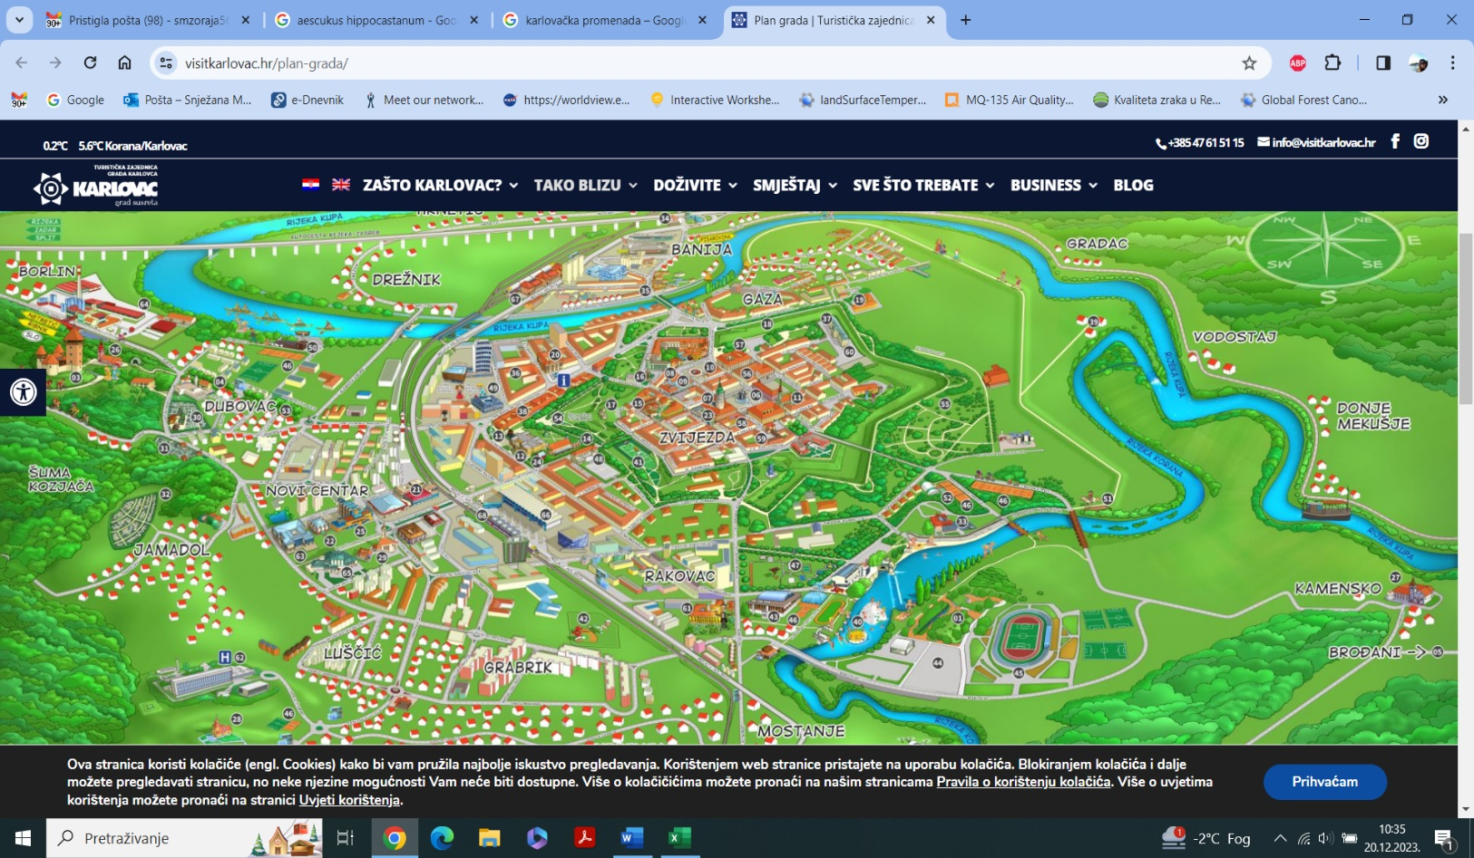

Figure 1: Location of alley „Karlovac Promenade“, visitkarlovac.hr/plan.grada/

Figure 1 shows the geographical location of the Promenade and its position in relation to the Star of Karlovac.

The GLOBE group of students searched the available databases on the Earth Engine apps [2] and Open Altimetry [8] satellite platforms in order to be able to compare the measured height of trees in the field with the data of satellite measurements.

**Research questions and hypothesis:**

* Can we read the height of the trees in the satellite measurement databases?
* How old are the trees in the Karlovac Promenade and when were they planted?
* How much carbon did the trees in the Karlovac Promenade store?
* How much CO2 did the trees in Karlovac Promenade absorb?

**Research metods:**

The students searched databases on the Earth Engine apps satellite platform (GEDI satellites) for the research area of ​​the Karlovac Promenade. [2] They determined that only part of the cover (trees) of the Karlovac Promenade was recorded on the satellite image, and that only the average height of the cover at a certain pixel could be read. (Figure 2)

Slika na kojoj se prikazuje karta, tekst, snimka zaslona

Opis je automatski generiran

Figure 2: Karlovac promenade, Earth Engine Apps

The Open Altimetry database was also searched. [8] By analyzing the satellite image captured by ICE SAT 2, it was determined that there was no data because the satellite trajectories were further west than the researched area. (Figure 3)

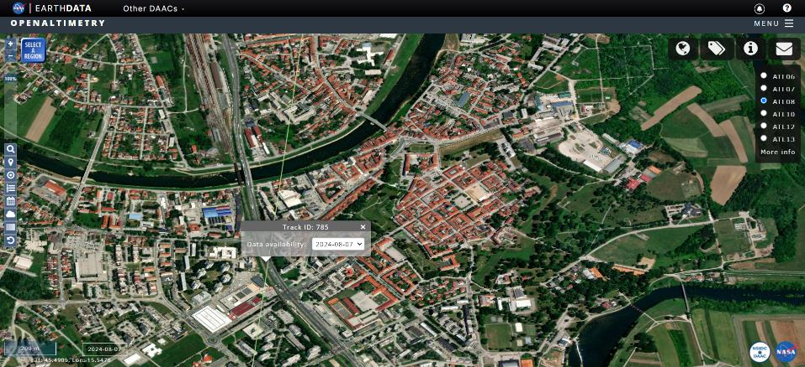

Figure 3: Karlovac promenade, Open Altimetry

The database showing the dynamics of the cover change from 2000 to 2022 was also searched. [2] The analysis of the satellite image determined that there is no data. (Figure 4)

Slika na kojoj se prikazuje tekst, karta, snimka zaslona

Opis je automatski generiran

*Figure 4: Karlovac promenade, the dynamics of the global tree cover 2000.- 2020*

In the field, students conducted biometric measurements on all the trees in Promenada, on 190 trees (Figure 5). The mobile application GLOBE Observer was used to measure tree height and determine the location of each tree. The circumference of the trees was measured with a measuring tape following GLOBE protocols. [3]  
The age of all trees, green weight (GW), dry weight (DW), the amount of stored carbon (carbon storage - C), and absorbed CO2 during the entire lifetime of the plant were calculated.  
The calculations were performed using the following mathematical formulas:

a) age of tree: circumference/ Annual increment in tree [4]

Annual increment in tree – average : 2,5 cm per year

b) GW (green weight) = 0,0346 x d2 x h (ako je d> 28 cm) [5]

Ili GW = 0,0577 x d2 x h (ako je d< 28 cm)

c) DW (dry weight) = GW/2 [5]

d) C (carbon storage) = DW/2 [5]

e) apsorbed CO2 = carbon storage x 3,67

jer je Mr(CO2) / Ar(C) = 3,67 [6,7]

f) diameter cm = opseg /π

Slika na kojoj se prikazuje vanjski, obuća, odijevanje, ljudi

Opis je automatski generiranSlika na kojoj se prikazuje odijevanje, vanjski, osoba, drvo

Opis je automatski generiran

*Figure 5 GLOBE measurement, April 29th, 2024. (author: S. Marković-Zoraja)*

Tree height measurement data were entered into the globe.gov database.

Slika na kojoj se prikazuje tekst, snimka zaslona, softver, karta

Opis je automatski generiran

*Figure 6. globe.gov visualisation*

**Data analysis:**

The amount of stored carbon and absorbed CO2 in Karlovac's Promenada is presented in Table 1, with trees classified into three intervals based on chest diameter size. Table 1 also shows the number of trees within each trunk diameter interval.

Table 1. Number of trees, stored carbon and absorbed CO2 in the intervals given according to the diameter of the tree in Karlovac Promenade

|  |  |  |  |  |  |
| --- | --- | --- | --- | --- | --- |
| Diameter interval /cm | Interval age of trees/years | Numberof the trees | Carbon storage/kg | Apsorbed CO2/kg |  |
| 1 - 50 | 1 - 62,5 | 120 | 12896 | 47328 |  |
| 51 - 100 | 63 - 125 | 66 | 54571 | 200575 |  |
| 101 - 150 | >125 | 4 | 8966 | 32906 |  |
| 190 | 76433 | 280809 | sum |

The results show that most trees in Promenada have a diameter of 1 to 50 cm, while the fewest have a diameter greater than 101 cm. In the diameter range of 51 to 100 cm, there are half as many trees as in the 1 to 50 cm range, but they store approximately four times more carbon and have absorbed approximately four times more CO2.  
There are only four trees with a diameter greater than 100 cm, but they contain significant amounts of carbon. For comparison, 120 trees in the 1 to 50 cm diameter range store only 30% more carbon.

In Promenada, 64% of the trees are up to 62.5 years old, and 34% are between 63 and 125 years old. Trees older than 125 years account for 2%, but their contribution to stored carbon in the entire avenue is 12%, demonstrating that older trees are larger carbon reservoirs.  
The total stored carbon in the 190 trees of Karlovac’s Promenada is 76,433 kg, while the total mass of absorbed CO2 is 280,809 kg.

The amount of absorbed carbon dioxide in a tree increases with its diameter, and the values of diameter at breast height (DBH) and absorbed CO2 are shown in a diagram. [7]

Figure 7 is a diagram showing the relationship between absorbed CO2 and DBH for the 190 trees in the avenue of Karlovac’s Promenada. The results presented in the diagram indicate that as DBH increases, absorbed CO2 also rises. Older trees, with larger DBH, have absorbed more CO2 from the atmosphere. [7]

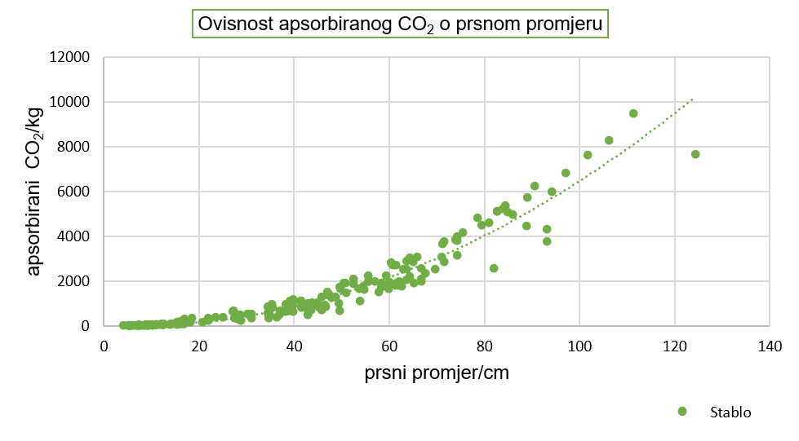

diameter

Dependence of absorbed CO2 on chest diameter

absorbed CO2/ kg

tree

*Slika 4. Dijagram ovisnosti apsorbiranog CO2 o prsnom promjeru stabla*

*Figure 4. Graph of the dependence of absorbed CO2 on the diameter of the tree*

*Figure 7. dependence of absorbed CO2 on chest diameter – trees in the Karlovac promenade*

**Discussion and conclusions:**

The results of the research show the approximate value of the amount of stored carbon in the tree row and the amount of absorbed CO2 during the lifetime of all trees.

The obtained values ​​show that the trees on the Promenade absorbed more than 280 tons of CO2 during their existence and contain more than 76 tons of stored carbon, which removed this amount of carbon from the atmosphere. Tree rows and avenues in cities contribute to reducing the greenhouse effect.

There is a noticeable difference in the share of trees older than 125 years, which are the largest carbon stores.

At the Trees around the GLOBE webinar, in September 2024, where the project was presented, Brian Campbell explained to the students that satellites cannot record all the covers on Earth. (Figure 8.)

Slika na kojoj se prikazuje tekst, karta

Opis je automatski generiran

*Figure 8. Webinar “trees around the GLOBE” – trees in Karlovac promenade*

It was explained that on the GEDI satellite image we only see partial cover and individual pixels with the average cover height, and on the ICE SAT 2 satellite image we cannot make comparisons because the satellite path did not pass the Karlovac Promenade.

In the case of the Karlovac Promenade, which is located in the city center, it is possible that the height of the residential buildings interferes with filming, and he explained that the students' field research is very important.

The project was also presented in the local community in order to make citizens aware of the importance of the alley in the carbon cycle.

**Sources:**

1. Krajnik, D. 2007. Preobrazba bastionskih utvrđenja grada Karlovca. Prostor 15(1): 180-193

<https://www.researchgate.net/publication/27199499_Preobrazba_bastionskih_utvrdenja_grada_Karlovca>

(accessed january 20th 2024.)

1. Earth Engine Apps

https://glad.earthengine.app/view/global-forest-canopy-height-2019

(accessed September 20th 2024.)

1. *The GLOBE teachers guide.* The GLOBE program

<https://www.globe.gov/do-globe/globe-teachers-guide>

(accessed March 10th 2021.)

1. *Carbon storage calculator*: *worksheet*. Natural resources Wales

<https://cdn.naturalresources.wales/media/687190/eng-worksheet-carbon-storage-calculator.pdf>

(accessed December 8th 2021.)

1. *Measuring Carbon In Trees: The Urban Nature Project*. National Museum Wales.

<https://museum.wales/media/52595/measuring-carbon-in-trees.pdf>

(accessed december 8th 2021.)

1. Fransen, Bas. 2019. *How to calculate the CO2 sequestration*. EcoMatcher

<https://www.ecomatcher.com/how-to-calculate-co2-sequestration>

(accessed december 8th 2021.)

1. *Farming carbon* 2020. Queensland Goverment

<https://www.qld.gov.au/environment/plants-animals/habitats/regrowth/regrowth-guides/euc-open/euc-open-carbon>

(accessed december 8th 2021.)

1. Open Altimetry

<https://openaltimetry.earthdatacloud.nasa.gov/data/icesat2/>

(accessed September 20th 2024.)

Appendix 1. Height, circumference, age, GW, DW, C, absorbed CO2 and diameter for all trees located in alley Karlovac Promenade

|  |  |  |  |  |  |  |  |  |
| --- | --- | --- | --- | --- | --- | --- | --- | --- |
| **Number of tree** | **(Circumfe**  **rence)/cm** | **Height of tree/ m** | **Age of tree(O: 2,5)** | **diameter (d/cm)** | **GW - /kg** | **DW/kg** | **Carbon storage /kg** | **Apsorbed**  **CO2/kg** |
| 1 | 210 | 13,94 | 84 | 66,8 | 2146,1 | 1073,05 | 536,53 | 1969 |
| 2 | 30 | 3 | 12 | 9,5 | 15,6 | 7,8 | 3,9 | 14,3 |
| 3 | 270 | 21,1 | 108 | 86 | 5399,5 | 2699,75 | 1349,8 | 4953,8 |
| 4 | 190 | 23,84 | 76 | 60,5 | 3013 | 1506,5 | 753,25 | 2764,4 |
| 5 | 16,5 | 3,61 | 6,6 | 5,252 | 5,8 | 2,9 | 1,45 | 5,32 |
| 6 | 70 | 10,78 | 28 | 22,3 | 309,9 | 154,95 | 77,5 | 284,4 |
| 7 | 16,5 | 5 | 6,6 | 5,25 | 7,95 | 3,9 | 1,95 | 7,15 |
| 8 | 280 | 17,67 | 112 | 89 | 4849,8 | 2424,9 | 1212,45 | 4449,7 |
| 9 | 170 | 11,63 | 68 | 54 | 1170 | 585 | 292,5 | 1073,5 |
| 10 | 265 | 23,5 | 106 | 84,4 | 5792,7 | 2896,35 | 1448,17 | 5314,8 |
| 11 | 255 | 21,8 | 102 | 81,2 | 4972,6 | 2486,3 | 1243,15 | 4562,4 |
| 12 | 260 | 23,53 | 104 | 82,8 | 5574,2 | 2787,1 | 1393,5 | 5114,1 |
| 13 | 210 | 18,02 | 84 | 66,9 | 2788,2 | 1394,1 | 697,05 | 2558,2 |
| 14 | 40 | 8 | 16 | 12,7 | 74,4 | 37,2 | 18,6 | 68,3 |
| 15 | 25 | 6,5 | 10 | 7,9 | 23,4 | 11,7 | 5,85 | 21,5 |
| 16 | 28 | 8 | 11,2 | 8,9 | 36,5 | 18,25 | 9,125 | 33,5 |
| 17 | 247 | 24,61 | 99 | 78,6 | 5259,5 | 2629,75 | 1314,88 | 4825,3 |
| 18 | 250 | 22,17 | 100 | 79,6 | 4866,3 | 2433,15 | 1216,6 | 4464,9 |
| 19 | 225 | 22,8 | 90 | 71,6 | 4044,7 | 2022,35 | 1011,2 | 3711,1 |
| 20 | 285 | 23,79 | 114 | 90,7 | 6773,5 | 3386,75 | 1693,4 | 6214,8 |
| 21 | 200 | 18,69 | 80 | 63,7 | 2625,5 | 1312,75 | 656,4 | 2048,9 |
| 22 | 165 | 23,5 | 66 | 52,5 | 2241,9 | 1120,95 | 560,5 | 2057 |
| 23 | 350 | 23,9 | 140 | 111,5 | 10279,4 | 5139,7 | 2569,85 | 9431,3 |
| 24 | 125 | 23,85 | 50 | 39,8 | 1309,7 | 654,85 | 327,4 | 1201,6 |
| 25 | 280 | 22,69 | 112 | 89,2 | 6242,5 | 3121,25 | 1560,6 | 5727,4 |
| 26 | 172 | 18,57 | 68,8 | 54,7 | 1925,1 | 962,55 | 481,28 | 1766,3 |
| 27 | 188 | 14,68 | 75,2 | 59,9 | 1824,3 | 912,15 | 456 | 1673,5 |
| 28 | 89 | 12 | 35 | 28,3 | 332,4 | 166,2 | 83,1 | 304,98 |
| 29 | 109 | 13 | 43 | 34,7 | 540,8 | 270,4 | 135,2 | 496,2 |
| 30 | 193 | 15 | 77 | 61,5 | 1963,5 | 981,75 | 490,88 | 1801,5 |
| 31 | 143 | 12 | 57 | 45,5 | 859,2 | 429,5 | 214,75 | 788,13 |
| 32 | 30 | 5 | 12 | 9,5 | 26 | 13 | 6,5 | 23,8 |
| 33 | 147 | 12 | 58,8 | 46,8 | 909,6 | 454,8 | 227,4 | 834,56 |
| 34 | 108 | 23 | 43,2 | 34,4 | 940,7 | 470,35 | 235,18 | 863,11 |
| 35 | 160 | 23 | 64 | 50,9 | 2060,8 | 1030,4 | 515,2 | 1890,8 |
| 36 | 111 | 23,3 | 44,4 | 35,4 | 1011,2 | 505,6 | 252,8 | 927,77 |
| 37 | 189 | 17 | 75,6 | 60,2 | 2131,8 | 1065,9 | 532,95 | 1955,9 |
| 38 | 32 | 8 | 12,8 | 10,2 | 48 | 24 | 12 | 44,04 |
| 39 | 184 | 17 | 73,6 | 58,6 | 2019,6 | 1009,8 | 504,9 | 1852,9 |
| 40 | 24 | 8 | 9,6 | 7,6 | 26,6 | 13,3 | 6,65 | 24,4 |
| 41 | 191 | 23 | 76,4 | 60,8 | 2921 | 1460,5 | 730,25 | 2680 |
| 42 | 224 | 22,5 | 89,6 | 71,3 | 3957,7 | 1978,85 | 989,43 | 3631,2 |
| 43 | 159 | 23 | 63,6 | 50,6 | 2037,8 | 1018,9 | 509,45 | 1869,68 |
| 44 | 264 | 23,2 | 105,6 | 84 | 5663,1 | 2831,55 | 1415,78 | 5195,9 |
| 45 | 123 | 22 | 49,2 | 39,2 | 1168,2 | 584,1 | 292,05 | 1071,8 |
| 46 | 22 | 3 | 8,8 | 7 | 8,5 | 4,25 | 2,125 | 7,8 |
| 47 | 19 | 3 | 7,6 | 6 | 6,2 | 3,1 | 1,55 | 5,69 |
| 48 | 23,5 | 3 | 9,4 | 7,5 | 9,7 | 4,85 | 2,43 | 8,91 |
| 49 | 23 | 3 | 9,2 | 7,5 | 9,7 | 4,85 | 2,43 | 8,91 |
| 50 | 33 | 3 | 13,2 | 10,5 | 19 | 9,5 | 4,75 | 17,43 |
| 51 | 29 | 3 | 11,6 | 9,2 | 14,6 | 7,3 | 3,65 | 13,4 |
| 52 | 49 | 9,99 | 19,6 | 15,6 | 140,4 | 70,2 | 35,1 | 128,82 |
| 53 | 175 | 20,14 | 70 | 55,7 | 2156,7 | 1078,35 | 539,18 | 1978,8 |
| 54 | 22 | 3 | 8,8 | 7 | 8,5 | 4,25 | 2,13 | 7,87 |
| 55 | 85,5 | 15,32 | 34,2 | 27,2 | 653,1 | 326,55 | 163,28 | 599,24 |
| 56 | 17 | 2,5 | 6,8 | 5,4 | 4,2 | 2,1 | 1,05 | 3,85 |
| 57 | 22,5 | 3 | 9 | 7,1 | 8,7 | 4,35 | 2,17 | 7,96 |
| 58 | 13 | 2 | 5,2 | 4,1 | 1,9 | 0,95 | 0,475 | 1,76 |
| 59 | 37 | 4 | 14,8 | 11,8 | 32,1 | 16,05 | 8 | 29,36 |
| 60 | 20 | 3 | 8 | 6,4 | 7 | 3,5 | 1,75 | 6,42 |
| 61 | 183 | 15,8 | 73,2 | 58,3 | 1858,1 | 929,05 | 464,53 | 1704,82 |
| 62 | 193 | 22,4 | 77,2 | 61,5 | 2931,4 | 1465,7 | 732,85 | 2689,56 |
| 63 | 86,5 | 8,5 | 34,6 | 27,5 | 370,9 | 185,45 | 92,73 | 340,31 |
| 64 | 69 | 12,98 | 27,6 | 22 | 363 | 181,5 | 90,75 | 333,05 |
| 65 | 131 | 19,95 | 52,4 | 41,7 | 1203,3 | 601,65 | 300,83 | 1104,06 |
| 66 | 120 | 20,65 | 48 | 38,2 | 1045,1 | 522,55 | 261,28 | 958,89 |
| 67 | 150 | 16,9 | 60 | 47,8 | 1336 | 668 | 334 | 1225,78 |
| 68 | 125 | 17,82 | 50 | 39,8 | 975,6 | 487,8 | 243,9 | 895,11 |
| 69 | 108 | 15,44 | 43,2 | 34,4 | 630,5 | 315,25 | 157,63 | 578,5 |
| 70 | 110 | 13,4 | 44 | 35 | 568 | 284 | 142 | 521,14 |
| 71 | 23,5 | 3,58 | 9,5 | 7,5 | 11,7 | 5,85 | 2,93 | 10,75 |
| 72 | 95 | 18,2 | 38 | 30,2 | 574,3 | 287,15 | 143,58 | 526,94 |
| 73 | 59 | 7 | 19 | 18,7 | 383,4 | 191,7 | 95,85 | 351,77 |
| 74 | 49 | 4 | 19 | 15,6 | 56 | 28 | 14 | 51,38 |
| 75 | 35 | 3,5 | 14 | 11,1 | 24,8 | 12,4 | 6,2 | 22,75 |
| 76 | 135 | 7,9 | 54 | 43 | 505,4 | 252,7 | 126,35 | 463,7 |
| 77 | 91 | 9 | 36,4 | 29 | 261,8 | 130,9 | 65,45 | 240,2 |
| 78 | 137 | 11,5 | 55 | 43,6 | 756,4 | 378,2 | 189,1 | 693,99 |
| 79 | 66 | 6,8 | 26 | 21 | 173 | 86,5 | 43,25 | 158,73 |
| 80 | 156 | 8,3 | 62 | 49,7 | 709,4 | 354,7 | 177,35 | 650,88 |
| 81 | 198 | 20 | 79 | 63 | 2746,5 | 1373,25 | 686,63 | 2519,93 |
| 82 | 27 | 3 | 10 | 8,6 | 12,8 | 6,4 | 3,2 | 11,74 |
| 83 | 33 | 4 | 13 | 10,5 | 25,4 | 12,7 | 6,35 | 23,3 |
| 84 | 35 | 4 | 14 | 11,1 | 28,4 | 14,2 | 7,1 | 26,06 |
| 85 | 35 | 4 | 14 | 11,1 | 28,4 | 14,2 | 7,1 | 26,06 |
| 86 | 35 | 4 | 14 | 11,1 | 28,4 | 14,2 | 7,1 | 26,06 |
| 87 | 35 | 5 | 14 | 11,1 | 35,5 | 17,75 | 8,88 | 32,59 |
| 88 | 35 | 5 | 14 | 11,1 | 35,5 | 17,75 | 8,88 | 32,59 |
| 89 | 117 | 15 | 47 | 37,3 | 722 | 361 | 180,5 | 662,44 |
| 90 | 69 | 10 | 27 | 22 | 279,3 | 139,65 | 69,83 | 256,28 |
| 91 | 53 | 7 | 16 | 16,9 | 263,7 | 131,85 | 65,93 | 241,96 |
| 92 | 125 | 12 | 50 | 39,8 | 657,7 | 328,85 | 164,43 | 603,46 |
| 93 | 40 | 5 | 16 | 12,7 | 46,5 | 23,25 | 11,6 | 42,57 |
| 94 | 157 | 21 | 63 | 50 | 1816,5 | 908,25 | 454,13 | 1666,65 |
| 95 | 115 | 9 | 46 | 36,6 | 417,1 | 208,55 | 104,28 | 382,7 |
| 96 | 225 | 17,5 | 90 | 71,6 | 3104,1 | 1552,05 | 776 | 2847,92 |
| 97 | 172 | 17 | 69 | 54,8 | 1766,4 | 883,2 | 441,6 | 1620,6 |
| 98 | 109 | 9 | 43 | 34,7 | 375 | 187,5 | 93,75 | 344,06 |
| 99 | 258 | 12 | 103 | 82,1 | 2798,6 | 1399,3 | 699,5 | 2567,17 |
| 100 | 18 | 3 | 7 | 5,7 | 0,6 | 0,3 | 0,15 | 0,55 |
| 101 | 155 | 13 | 62 | 49,4 | 1097,7 | 548,85 | 274,43 | 1007,16 |
| 102 | 51 | 6,6 | 20 | 16,3 | 101,2 | 50,6 | 25,3 | 92,85 |
| 103 | 46 | 7,4 | 18,5 | 14,6 | 91 | 45,5 | 22,75 | 83,49 |
| 104 | 56 | 7,2 | 22,5 | 17,8 | 131,6 | 65,8 | 32,9 | 120,74 |
| 105 | 47 | 7 | 19 | 15 | 90,8 | 45,4 | 22,7 | 83,3 |
| 106 | 135 | 12,3 | 54 | 43 | 786,9 | 393,45 | 196,73 | 721,99 |
| 107 | 144 | 10,5 | 57 | 45,9 | 765,4 | 382,7 | 191,35 | 702,25 |
| 108 | 194 | 15,5 | 77 | 61,8 | 2048,3 | 1024,15 | 512,07 | 1879,3 |
| 109 | 204 | 21 | 81 | 65 | 3069,9 | 1534,95 | 767,48 | 2816,65 |
| 110 | 53 | 6,5 | 21 | 16,9 | 107,1 | 53,55 | 26,78 | 98,28 |
| 111 | 53 | 6,5 | 21 | 16,9 | 107,1 | 53,55 | 26,78 | 98,28 |
| 112 | 51 | 6,6 | 20 | 16,2 | 99,9 | 49,95 | 24,97 | 91,64 |
| 113 | 57 | 7,5 | 23 | 18,2 | 143,3 | 71,65 | 35,83 | 131,5 |
| 114 | 44 | 6,5 | 17,5 | 14 | 73,5 | 36,75 | 18,38 | 67,45 |
| 115 | 38 | 6 | 15 | 12,1 | 50,7 | 25,35 | 12,68 | 46,54 |
| 116 | 27 | 5 | 11 | 8,6 | 21,3 | 10,65 | 5,33 | 19,56 |
| 117 | 391 | 15,5 | 156 | 124,5 | 8312,8 | 4156,4 | 2078,2 | 7626,99 |
| 118 | 49 | 6 | 19,5 | 15,6 | 84,2 | 42,1 | 21,05 | 77,25 |
| 119 | 146 | 13 | 58 | 46,5 | 972,6 | 486,3 | 243,15 | 892,36 |
| 120 | 182 | 14 | 73 | 58 | 1629,5 | 814,75 | 407,38 | 1495 |
| 121 | 187 | 19,8 | 75 | 59,5 | 2425,4 | 1212,7 | 606,35 | 2225,3 |
| 122 | 48 | 7,2 | 19 | 15,3 | 97,2 | 48,6 | 24,3 | 89,18 |
| 123 | 122 | 13,5 | 49 | 38,9 | 706,8 | 353,4 | 176,7 | 648,49 |
| 124 | 120 | 12,9 | 48 | 38,2 | 651,3 | 325,65 | 162,83 | 597,58 |
| 125 | 45 | 7 | 18 | 14,3 | 82,6 | 41,3 | 20,65 | 75,78 |
| 126 | 195 | 16,3 | 78 | 62,1 | 2174,9 | 1087,45 | 543,73 | 1995,48 |
| 127 | 51 | 13,5 | 20 | 16,2 | 204,4 | 102,2 | 51,1 | 187,54 |
| 128 | 90 | 19,5 | 36 | 28,7 | 555,7 | 252,85 | 126,43 | 463,99 |
| 129 | 49 | 5,5 | 19,5 | 15,6 | 77,23 | 38,615 | 19,31 | 70,87 |
| 130 | 219 | 16,3 | 88 | 69,8 | 2747,7 | 1373,85 | 686,5 | 2519,45 |
| 131 | 210 | 14,5 | 84 | 66,9 | 2245,4 | 1122,7 | 561,35 | 2060,15 |
| 132 | 205 | 13,9 | 82 | 65,3 | 2050,7 | 1025,35 | 512,68 | 1881,54 |
| 133 | 40 | 12 | 16 | 12,7 | 111,7 | 55,85 | 27,93 | 102,5 |
| 134 | 98 | 10,2 | 39 | 31,2 | 343,5 | 171,75 | 85,88 | 315,18 |
| 135 | 231 | 16 | 92 | 67,8 | 2544,8 | 1272,4 | 636,2 | 2334,85 |
| 136 | 17 | 5 | 6,8 | 5,4 | 8,5 | 4,25 | 2,13 | 7,81 |
| 137 | 38 | 11 | 15 | 12,1 | 92,9 | 46,45 | 23,23 | 85,25 |
| 138 | 17 | 5 | 7 | 5,4 | 8,5 | 4,25 | 2,13 | 7,81 |
| 139 | 54 | 18 | 21 | 17,2 | 307,2 | 153,6 | 76,8 | 281,85 |
| 140 | 200 | 19,6 | 80 | 63,7 | 2751,8 | 1375,9 | 687,95 | 2524,78 |
| 141 | 197 | 14 | 79 | 62,7 | 1904,3 | 952,15 | 476 | 1746,92 |
| 142 | 293 | 15,6 | 117 | 93,3 | 4698,5 | 2349,25 | 1174,63 | 4310,89 |
| 143 | 153 | 17 | 61 | 48,7 | 1395 | 697,5 | 348,75 | 1279,91 |
| 144 | 69 | 10,7 | 28 | 22 | 298,8 | 149,4 | 74,7 | 274,15 |
| 145 | 169 | 17,8 | 68 | 53,8 | 1782,6 | 891,3 | 445,65 | 1635,53 |
| 146 | 139 | 15 | 56 | 44,3 | 1018,5 | 509,25 | 254,63 | 934,49 |
| 147 | 116 | 10,8 | 46 | 37 | 511,5 | 255,75 | 127,87 | 469,29 |
| 148 | 179 | 19,3 | 72 | 57 | 2169,6 | 1084,8 | 542,4 | 1990,6 |
| 149 | 237 | 23 | 95 | 75,5 | 4536,3 | 2268,15 | 1134 | 4161,78 |
| 150 | 175 | 22,5 | 70 | 55,7 | 2415,3 | 1207,65 | 603,83 | 2216,05 |
| 151 | 296 | 21 | 118 | 94,3 | 6461,3 | 3230,65 | 1615,33 | 5928,26 |
| 152 | 223 | 19,3 | 89 | 71 | 3366,3 | 1683,15 | 841,58 | 3088,6 |
| 153 | 110 | 12,3 | 44 | 35 | 521,3 | 260,65 | 130,33 | 478,31 |
| 154 | 49 | 9,2 | 20 | 15,6 | 129,2 | 64,6 | 32,3 | 118,54 |
| 155 | 260 | 23,5 | 104 | 82,8 | 5574,5 | 2787,25 | 1393,63 | 5114,62 |
| 156 | 144 | 18,7 | 58 | 45,9 | 1363,2 | 681,6 | 340,8 | 1250,73 |
| 157 | 79 | 11,5 | 32 | 25,1 | 418 | 209 | 104,5 | 383,51 |
| 158 | 234 | 17,8 | 94 | 74,5 | 3418,3 | 1709,15 | 854,58 | 3136,3 |
| 159 | 29 | 6,3 | 11,5 | 9,2 | 30,7 | 15,35 | 7,67 | 28,15 |
| 160 | 141 | 16,5 | 56,5 | 44,9 | 1150,9 | 575,45 | 287,73 | 1055,97 |
| 161 | 334 | 23 | 133,5 | 106,4 | 9009,2 | 4504,6 | 2252,3 | 8265,94 |
| 162 | 150 | 17,5 | 60 | 47,8 | 1383,5 | 691,75 | 345,88 | 1269,38 |
| 163 | 131 | 14,8 | 52,5 | 41,7 | 890,5 | 445,25 | 222,63 | 817,05 |
| 164 | 202 | 16,5 | 81 | 64,3 | 2360,4 | 1180,2 | 590,1 | 2165,67 |
| 165 | 234 | 21,5 | 93,5 | 74,5 | 4128,8 | 2064,4 | 1032,2 | 3788,18 |
| 166 | 156 | 21,5 | 62 | 49,7 | 1837,5 | 918,75 | 459,38 | 1685,93 |
| 167 | 320 | 23 | 128 | 101,9 | 8263,3 | 4131,65 | 2065,83 | 7581,6 |
| 168 | 305 | 22,7 | 122 | 97,1 | 7405,3 | 3702,65 | 1851,33 | 6794,38 |
| 169 | 293 | 13,5 | 117 | 93,3 | 4066 | 2033 | 1016,5 | 3730,55 |
| 170 | 202 | 23,2 | 81 | 64,3 | 3318,8 | 1659,4 | 829,7 | 3044 |
| 171 | 267 | 22 | 107 | 85 | 5499,7 | 2749,85 | 1374,93 | 5045,99 |
| 172 | 207 | 22,4 | 83 | 65,9 | 3365,9 | 1682,95 | 841,48 | 3088,23 |
| 173 | 232 | 22,1 | 93 | 73,9 | 4175,9 | 2087,95 | 1043,98 | 3831,4 |
| 174 | 183 | 17,3 | 73 | 58,3 | 2034,5 | 1017,25 | 508,63 | 1866,67 |
| 175 | 234 | 22,5 | 93,5 | 74,5 | 4320,9 | 2160,45 | 1080,23 | 3964,44 |
| 176 | 138 | 16,7 | 54 | 43,9 | 1113,6 | 566,8 | 283,4 | 1040 |
| 177 | 135 | 17,2 | 54 | 43 | 1100,4 | 550,2 | 275,1 | 1009,6 |
| 178 | 39 | 8 | 14 | 12,4 | 70,9 | 35,45 | 17,7 | 64,96 |
| 179 | 74 | 12,8 | 29 | 23,6 | 411,3 | 205,65 | 102,83 | 377,38 |
| 180 | 86 | 16,2 | 36 | 27,4 | 701,7 | 350,85 | 175,43 | 643,82 |
| 181 | 200 | 22,3 | 80 | 63,7 | 3130,8 | 1565,4 | 782,7 | 2872,5 |
| 182 | 98 | 16,1 | 37 | 31,2 | 542,3 | 271,15 | 135,58 | 497,58 |
| 183 | 165 | 20,8 | 66 | 52,5 | 1983,6 | 991,8 | 495,9 | 1819,95 |
| 184 | 39 | 8,1 | 15 | 12,4 | 71,8 | 35,9 | 17,95 | 65,88 |
| 185 | 149 | 19,4 | 64 | 47,5 | 1514,5 | 757,25 | 378,63 | 1389,57 |
| 186 | 160 | 17,5 | 59 | 51 | 1574,9 | 787,45 | 393,73 | 1444,99 |
| 187 | 148 | 21,6 | 64 | 47,1 | 1657,9 | 828,95 | 414,48 | 1521,14 |
| 188 | 112 | 20,3 | 45 | 35,7 | 895,2 | 447,6 | 223,8 | 821,35 |
| 189 | 130 | 20,3 | 52 | 41,4 | 1203,9 | 601,95 | 300,98 | 1104,6 |
| 190 | 53 | 7,2 | 21 | 16,9 | 118,6 | 59,3 | 29,65 | 108,82 |
|  | average | average | average | average | average | average | average | sum |
|  | 130,2 | 13,6 | 52 | 41,4 | 306485 | 153227 | 76613,21 | 280808,5 |