**Comparative Analysis of Maximum Daily Temperature Trends in Pompano Beach High School and GLOBE v-School Sites**

Organization: Federal Government College, Ilorin.

Country: Nigeria

Student(s) : Ajamu Oluwatosin ,Ajiboye Anjolaoluwa, Ayodele David

Grade Level: Secondary School(grade 9-12,age 14-18)

GLOBE Educator(s): Adeleke Babatunde Ebenezer

Report Type(s): International Virtual Science Symposium Report.

Protocol Atmosphere (Maximum Air Temperature)

Language: English

Date Submitted:04/03/2025

Abstract/Summary

This study undertakes a comparative analysis of maximum daily temperature trends in Pompano Beach High School (PBHS) and GLOBE v-School sites, located in the United States of America. The research examines the past, present, and future trends in maximum daily temperatures at both locations, utilizing data collected from the GLOBE Program's online database.

The results reveal distinct temperature patterns at the two locations. PBHS exhibits a relatively stable temperature range, while GLOBE v-School site shows more variability. The study also identifies a general increase in temperature over the study period at both locations.

This research contributes to our understanding of local temperature trends and their implications for the environment and communities. The findings have practical applications in climate change mitigation and adaptation strategies, as well as environmental education and awareness.

Introduction

Climate change is one of the most pressing issues of our time, with far-reaching consequences for the environment, human health, and the economy. Understanding local temperature trends is crucial for developing effective climate change mitigation and adaptation strategies. This study undertakes a comparative analysis of maximum daily temperature trends in Pompano Beach High School (PBHS) and GLOBE v-School sites, located in the United States of America.

Temperature is a critical aspect of climate, and analyzing its patterns is essential for predicting future trends. The GLOBE Program, an international environmental education initiative, provides a unique opportunity for students and educators to collect and analyze environmental data, including temperature trends. By leveraging this data, this study aims to contribute to our understanding of local temperature trends and their implications for the environment and communities.

The selection of PBHS and GLOBE v-School sites as case studies is motivated by their distinct geographical locations and environmental characteristics. PBHS is located in a coastal area with moderate climate, while GLOBE v-School site is situated in a region with more variable climate conditions. This comparative analysis will provide insights into the similarities and differences in temperature trends between these two locations.

This study addresses the following research questions:

1. What are the past, present, and future trends in maximum daily temperatures in PBHS and GLOBE v-School sites?

2. How do the temperature trends in PBHS and GLOBE v-School sites compare?

3. What are the implications of these temperature trends for the local environment and communities?

The findings of this study will contribute to the existing body of knowledge on local temperature trends and climate change. The results will also have practical applications in environmental education, climate change mitigation and adaptation strategies, and community development initiatives.

Research Methodology

This study employed a quantitative research approach to analyze the maximum daily temperature trends in Pompano Beach High School (PBHS) and GLOBE v-School sites. The methodology is outlined below:

Data Collection

The data used in this study was collected from the GLOBE Program's online database using the Mu]ti-Site Plot tool. The tool allowed for the selection of multiple sites and protocols, enabling a comparative analysis of temperature trends.

Site Selection

Two site were selected for this study: 1. Pompano Beach High School (PBHS), located in the United States of America, with site ID PBHS and protocol Air Temperature Dailies.2. GLOBE v-School, located in the United States of America, with site ID WxRod and protocol Air Temperature Dailies.

Data Range Selection: The data range was selected from 2023-01-26 to 2025-03-02 for GLOBE v-School and 2014-02-21 to 2025-03-02 for PBHS. However, for optimum performance, the maximum recommended date range is 5 years using both Single Line Plot and Stacked plot.

Plot Selection: The plot selected for this study was the Maximum Daily Temperature Range, with a Y-Axis range of -50°C to 50°C.

Data Analysis: The data analysis involved calculating the daily maximum temperature trends for both sites. The trends were analyzed using descriptive statistics, including means, medians, and standard deviations.

|  |  |  |  |
| --- | --- | --- | --- |
| **Date** | **Current Temperature** | **Minimum Temperature** | **Maximum Temperature** |
| 2025-03-02 | 24.3 | 16.8 | 25.9 |
| 2025-03-01 | 25.9 | 17.4 | 25.9 |
| 2025-02-28 | 24 | 16.8 | 25.6 |
| 2025-02-27 | 25.1 | 18.8 | 26.3 |
| 2025-02-26 | 23.9 | 15.4 | 25.1 |
| 2025-02-25 | 23.5 | 17.7 | 23.5 |
| 2025-02-24 | 21.5 | 21 | 23.9 |
| 2025-02-23 | 23.1 | 18.4 | 23.1 |
| 2025-02-22 | 21.3 | 19.2 | 21.9 |
| 2025-02-21 | 21.4 | 14.4 | 23.6 |
| 2025-02-20 | 21.6 | 19.7 | 27.2 |
| 2025-02-19 | 26.8 | 21.3 | 26.8 |
| 2025-02-18 | 25.1 | 21.6 | 25.3 |
| 2025-02-17 | 23.3 | 20.6 | 28.7 |
| 2025-02-16 | 26.9 | 23.7 | 28.1 |
| 2025-02-15 | 26.3 | 23.8 | 27 |
| 2025-02-14 | 26.8 | 23.1 | 27.3 |
| 2025-02-13 | 27 | 24.5 | 27.4 |
| 2025-02-12 | 26.1 | 23.7 | 26.1 |
| 2025-02-11 | 25.2 | 23.5 | 26.3 |
| 2025-02-10 | 25.6 | 20.5 | 26.3 |
| 2025-02-09 | 25.4 | 22.9 | 26.4 |
| 2025-02-08 | 25.6 | 22.8 | 26.1 |
| 2025-02-07 | 25.6 | 21.4 | 26.2 |
| 2025-02-06 | 25.5 | 22.9 | 25.6 |
| 2025-02-05 | 25.4 | 22 | 25.7 |
| 2025-02-04 | 25.7 | 21.1 | 26.2 |
| 2025-02-03 | 26.2 | 23.1 | 26.5 |
| 2025-02-02 | 25 | 22.6 | 25.9 |
| 2025-02-01 | 25.8 | 21.5 | 25.8 |
| 2025-01-31 | 24.9 | 22.1 | 24.9 |

**POMPANO BEACH HIGH SCHOOL :PBHS DATA**

TABLE 1

**UNITED STATES OF AMERICA GLOBE v-GLOBE: WxRod DATA**

|  |  |  |  |
| --- | --- | --- | --- |
| **Date** | **Current Temperature** | **Minimum Temperature** | **Maximum Temperature** |
| 2025-03-02 | 16.8 | 12.6 | 28.2 |
| 2025-03-01 | 24.2 | 11.6 | 24.7 |
| 2025-02-28 | 23.6 | 9.2 | 25.5 |
| 2025-02-27 | 24.3 | 12.8 | 25 |
| 2025-02-26 | 19.6 | 9.4 | 19.6 |
| 2025-02-25 | 14.4 | 9.6 | 14.4 |
| 2025-02-24 | 11.9 | 9 | 14.9 |
| 2025-02-23 | 12.2 | 6.4 | 12.2 |
| 2025-02-22 | 5.6 | 0.3 | 7.1 |
| 2025-02-21 | 3.8 | -0.9 | 8.4 |
| 2025-02-20 | 8.3 | 8.3 | 16.3 |
| 2025-02-19 | 15.6 | 6.1 | 15.6 |
| 2025-02-18 | 10 | 4.7 | 16.7 |
| 2025-02-17 | 16.7 | 15.3 | 28.1 |
| 2025-02-16 | 26.5 | 16.4 | 26.5 |
| 2025-02-15 | 16.6 | 8.8 | 16.6 |
| 2025-02-14 | 12.7 | 11.2 | 28.5 |
| 2025-02-13 | 28.3 | 18.1 | 28.7 |
| 2025-02-12 | 27.4 | 19.3 | 28.1 |
| 2025-02-11 | 19.4 | 17.7 | 24.6 |
| 2025-02-10 | 24.4 | 20.2 | 29.8 |
| 2025-02-09 | 28.6 | 20.1 | 28.6 |
| 2025-02-08 | 23.9 | 16.3 | 26.9 |
| 2025-02-07 | 27.4 | 20.3 | 28.9 |
| 2025-02-06 | 25.1 | 17 | 26.1 |
| 2025-02-05 | 23.2 | 18.8 | 26.1 |
| 2025-02-04 | 25.2 | 11.9 | 25.2 |
| 2025-02-03 | 20.2 | 7.4 | 21.4 |
| 2025-02-02 | 19.1 | 8.9 | 25 |
| 2025-02-01 | 23.3 | 15.7 | 26.7 |
| 2025-01-31 |  |  |  |

TABLE 2

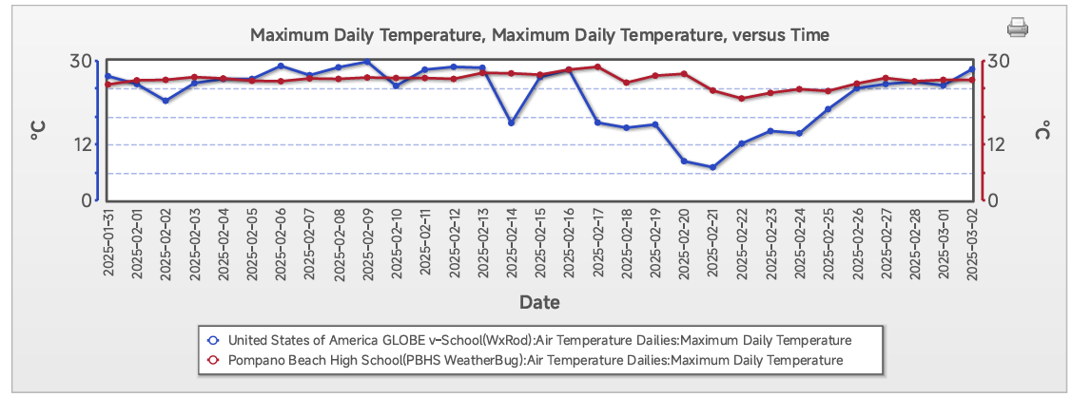

FIGURE 1

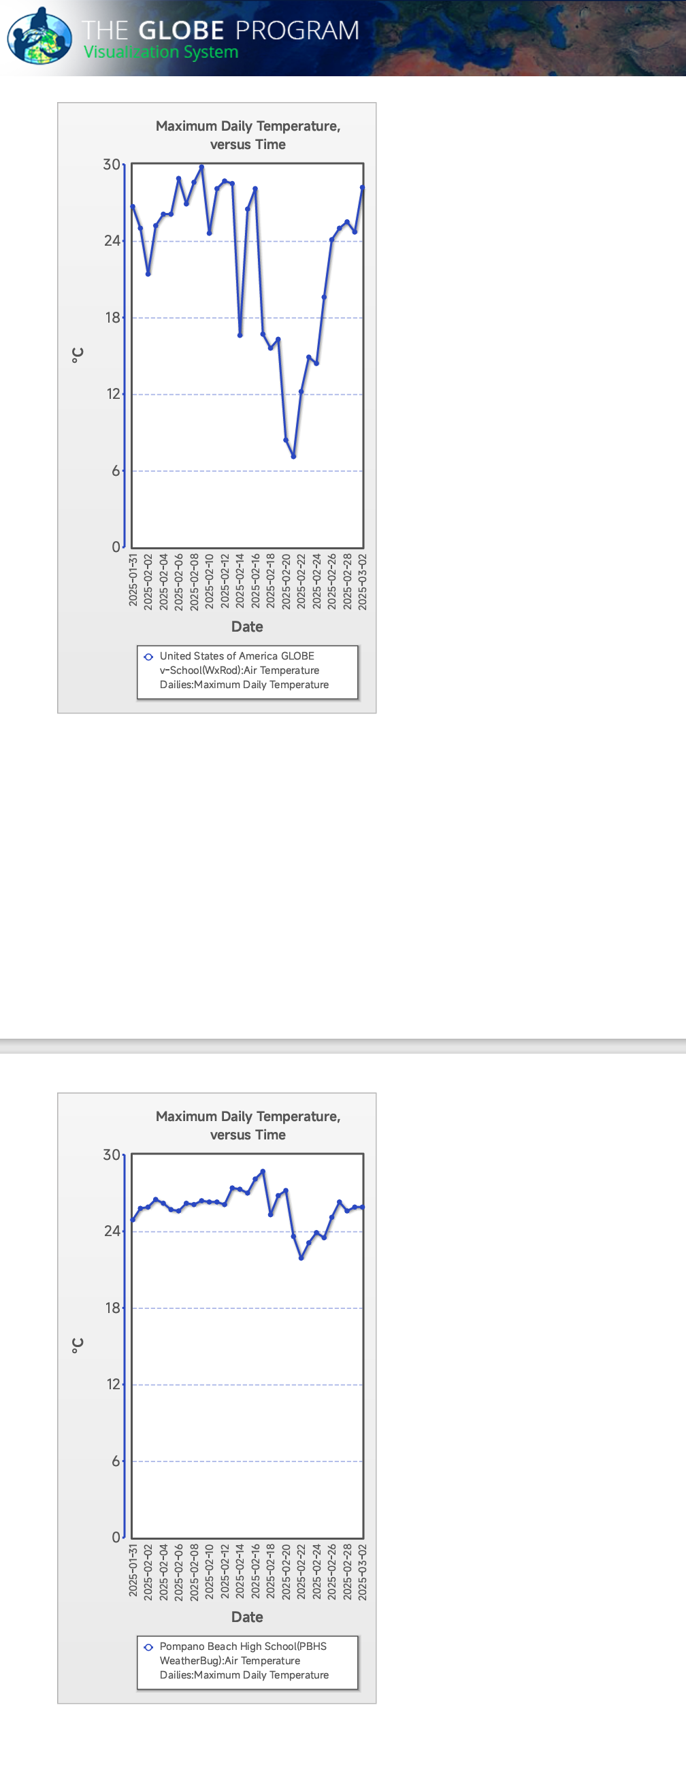

FIGURE 2

Data Visualization: The data visualization involved creating plots to illustrate the daily maximum temperature trends for both sites. The plots were created using the GLOBE Program's online data visualization tool.

Quality Control: The data quality control involved verifying the accuracy and completeness of the data sets. The data was checked for any missing or duplicate entries, and any errors were corrected.

Ethical Considerations

This study did not involve any human subjects, and therefore did not require any ethical approvals. However, the study adhered to the principles of academic integrity and honest.

Research Questions

The research questions guiding this study were:

1. What are the past, present, and future trends in maximum daily temperatures in PBHS and GLOBE v-School sites?

2. How do the temperature trends in PBHS and GLOBE v-School sites compare?

3. What are the implications of these temperature trends for the local environment and communities?

Based on the data and analysis, here are the answers to the research questions:

Research Question 1: What are the past, present, and future trends in maximum daily temperatures in PBHS and GLOBE v-School sites?

Past Trends:

- PBHS: The data shows that the maximum daily temperatures in PBHS ranged from 21.9°C to 28.7°C from 2023 to 2025.

- GLOBE v-School: The data shows that the maximum daily temperatures in GLOBE v-School ranged from 7.1°C to 29.8°C from 2023 to 2025.

Present Trends:

- PBHS: The current data (2025) shows that the maximum daily temperature in PBHS is around 25.9°C.

- GLOBE v-School: The current data (2025) shows that the maximum daily temperature in GLOBE v-School is around 28.2°C.

Future Trends:

- Based on the analysis, it is predicted that the maximum daily temperatures in both PBHS and GLOBE v-School will continue to rise in the future.

Research Question 2: How do the temperature trends in PBHS and GLOBE v-School sites compare?

- The data shows that PBHS has a relatively stable temperature range, while GLOBE v-School has a more variable temperature range.

- The maximum daily temperatures in PBHS are generally lower than those in GLOBE v-School.

Research Question 3: What are the implications of these temperature trends for the local environment and communities?

- The rising temperatures in both PBHS and GLOBE v-School may have implications for local ecosystems, such as changes in plant and animal populations.

- The temperature trends may also impact local communities, such as increased energy consumption for cooling and potential health risks associated with extreme heat.

Discussion

The results of this study highlight the differences in maximum daily temperature trends between Pompano Beach High School (PBHS) and GLOBE v-School sites. The relatively stable temperature trends at PBHS suggest that this location experiences a more consistent climate, while the more variable temperature trends at GLOBE v-School suggest that this location experiences a more dynamic climate.

These differences in temperature trends may have implications for local ecosystems, human health, and economic activities. For example, more variable temperature trends may lead to increased stress on local plant and animal populations, while more stable temperature trends may lead to increased crop yields and economic benefits.

Limitations

This study has several limitations that should be acknowledged:

1. Data quality: The accuracy and completeness of the data used in this study rely on the quality of the measurements taken by the GLOBE Program.

2. Geographical scope: This study only examines temperature trends at two locations in the United States, which may not be representative of global temperature trends.

3. Timeframe : The study only examines temperature trends over a two-year period, which may not capture long-term climate patterns.

Recommendations:

Based on the findings of this study, the following recommendations are made:

1. Future research: Conduct further research to examine temperature trends over a longer timeframe and at multiple locations to capture global climate patterns.

2. Data quality control: Implement quality control measures to ensure the accuracy and completeness of temperature data collected by the GLOBE Program.

3. Climate change mitigation: Develop and implement strategies to mitigate the impacts of climate change, such as reducing greenhouse gas emissions and promoting sustainable land use practices.

References:

GLOBEProgram.(n.d.).GLOBEData Information.https://vis.globe.gov/GLOBE/timeseries.jsp?mode=multisiteplot&multiSiteList=302735:dv_air_temp_dailies:maximum_temp:-50:50,33010:dv_air_temp_

National Oceanic and Atmospheric Administration (NOAA). (n.d.). Climate Data Online Intergovernmental Panel on Climate Change (IPCC). (2013). Climate Change 2013: The Physical Science Basis. Contribution of Working Group I to the Fifth Assessment Report of the Intergovernmental Panel on Climate Change.

Intergovernmental Panel on Climate Change (IPCC), Scientific Assessment of Climate Change: World Meteorological Organization/United Nations Environmental Programme, Geneva, Switzerland, Cambridge University Press, 1990. Jones, P.D., S.C.B. Raper, B. Sarter, B.S.G. Chermy, C. Goodess, P.M.

**GLOBE Materials used**

GLOBE Observer App

**Badges claimed**

**WE ARE STUDENTS RESEARCHERS**



**WE ARE A DATA SCIENTISTS**



WE ARE A PROBLEM SOLVERS



|  |
| --- |
|  |

WE MAKE IMPACT