**A Seasonal Study Comparing How Cloud Coverage Affects Surface Temperature on Student Practice Fields**

**Student Researchers:**

Zayna Ashkar, Deanna El-Saghir, Alaa Selman

**School:**

Crestwood High School

Dearborn Heights, MI 48127

**High School Teacher:**

Diana Johns

March 5th, 2025

**Table of Contents**

Abstract………………………………………………………………………………….3

Research Question and Null Hypothesis…………………………………………………….4

​​Introduction and Review of Literature………………………………………………..5-6

Materials and Methods……………………………………………….7-8

Data Summary………………………………………………………………………………9-10

Data Analysis and Results………………………………………..………………………….11-12

Conclusion………………………………………………………………………………….12-14

Discussion………………………………………………………………………………….14-15

Acknowledgments……………………………………………………………………………16

Bibliography………………………………………………………………………………….16-17

Appendix………………………………………………………………………………….17

Badges………………………………………………………………………………….…….17-18

**Abstract**

The relationship between various surface temperatures and cloud coverage is essential for schools that value outdoor activities to understand fully. These researchers collected surface temperature data using the **Etekcity Lasergrip 774 Infrared Thermometer** and cloud coverage data using the GLOBE Observer app cloud protocols. This data allowed the researchers to assess how different cloud conditions, seasons, and different surface types (**natural grass, synthetic turf**, and asphalt track) affect **surface temperatures**. A negative correlation was found between **cloud coverage** and **surface temperature**, a higher percentage of cloud cover resulted in lower **surface temperatures**. The researchers found that the different surface types had different heat retention, the track; which is made of asphalt, usually had the highest temperatures, while the **synthetic grass** on the turf had lower temperatures than the band practice field; made of **natural grass**, which consistently had higher temperatures in comparison to the turf. Different seasons led to different results; In the summer there was less **cloud coverage**, leading to an increased **surface temperature**, and in the fall there was a higher percentage of **cloud coverage** which led to lower temperatures. The researchers highlighted the importance of understanding the relationship between **cloud coverage** and **surface temperature** on student practice fields for the safest and most comfortable conditions.

**Key Words:** surface temperature, cloud coverage, synthetic grass, Etekcity Lasergrip 774 Infrared Thermometer, natural grass

**Research Questions:**

1. To what extent does cloud coverage correlate with surface temperature at various sites?
2. In what way does the overcast condition affect surface temperatures compared to the other cloud conditions?
3. How do different types of clouds affect surface temperature in different seasons?
4. Do the temperatures differ from the Band Practice Field (Site 1) and the New CHS Athletic Complex (Site 2 and 3)?
5. Would the surface temperature be lower for natural grass or for synthetic grass?

**Null Hypothesis:**

1. There is no significant difference between cloud coverage and surface temperatures at various sites.
2. There is no significant difference between the correlation of the overcast condition and other cloud conditions and surface temperature.
3. There is no significant difference between the cloud coverages affecting surface temperatures in different seasons.
4. There is no significant difference between the temperatures for the Band Practice Field and the New CHS Athletic Complex.
5. There is no significant difference between temperatures for natural grass and synthetic grass.

**Introduction & Review of Literature**

Researchers collected surface temperatures daily on the Band Practice Field and new CHS Athletic complex, track and turf field located in Crestwood High School in Dearborn Heights, MI. The researchers performed their tasks in order to inform Crestwood High school athletes and students about the effects cloud coverage has on surface temperature and how that affects the performative qualities and comfortableness of users of practice fields. Students use these locations for different activities such as athletics, band, and clubs during the fall and summer seasons. During the summer months, with more students exercising at the different facilities, concerns regarding heat exposure affecting overall performance and safety arise. High surface-level temperatures on synthetic fields may lead to dehydration, burns and blisters if exposed skin comes into contact with the hot surface, as well as heat stroke (Myrick, 2019). Physiologically, high surface temperatures can lead to heat stress, affecting the performance of athletes. A review of synthetic turf surfaces shows that these surfaces may elevate both air and surface temperatures, increasing the risk of heat related illnesses. (Singh et. al, 2024). Heat stress is mainly present to humans on synthetic grass and can lead to serious issues such as dizziness and strokes (Jastifer et. al, 2019). Grass fields were shown to retain less heat than synthetic turf fields. Grass leaves transpire and the evaporation of that water vapor leads to cooling, grass fields rarely get above 100° F. Turf fields, in comparison, regularly rise well above 100° (Myrick, 2019). A key factor that can affect surface temperature is cloud coverage, it could affect the amount of solar radiation that reaches the earth's surface. Low altitude clouds reflect sunlight which causes them to project cooler temperatures, however high altitude clouds tend to trap outgoing heat, increasing surface temperatures. (Sellers & McGuffie, 2012) The extent of this application also bases on other factors such as hour of day, and seasonal changes. Cloud coverage also has a big impact on people's behavior and whether they choose to attend sports games. In a study by Paul, Ehrlich, & Losak, the researchers found that participation associated with certain cloud types were not the only factor related to clouds that affected attendance at sporting events. An increase of cloud coverage, itself, was associated with less attendance at sporting events and With less attendance, and support, sports teams are shown to have lowered performance. (Paul, Ehrlich, & Losak, 2020). This issue is important for athlete performance, and most importantly safety, especially during the hot summer months. Heat and cloud coverage may reduce performance in direct ways like heat related illness or indirectly like a smaller support audience. Synthetic turf, which is most commonly used among high schools in the US, significantly contributes to presenting many heat related health risks that are important for coaches, athletes and athletic directors to understand in order to create safer environments for athletes. The findings of the study are very important to the Crestwood community area with an increasing number of people participating in athletic events and extracurricular activities, especially during the summer months, health risks arise. Athletic directors and activity administrators are aware of these health risks and are able to make informed decisions regarding students performance, and most importantly health. Administrators can benefit from awareness on heat exposure around different facilities in the Crestwood community to ensure the safety of students and people involved with athletic and extracurricular activities.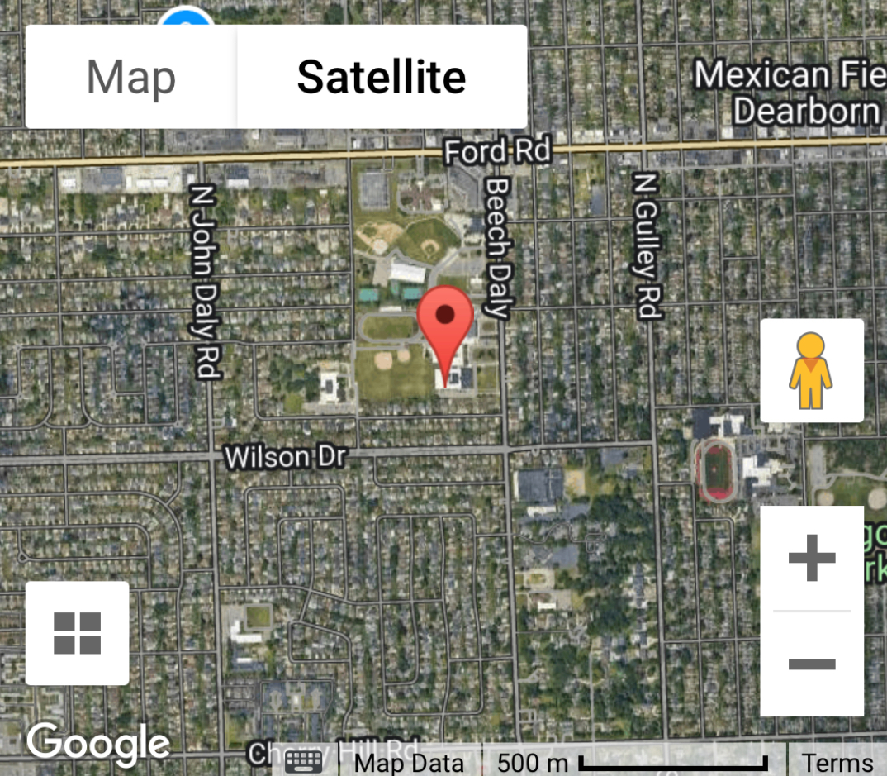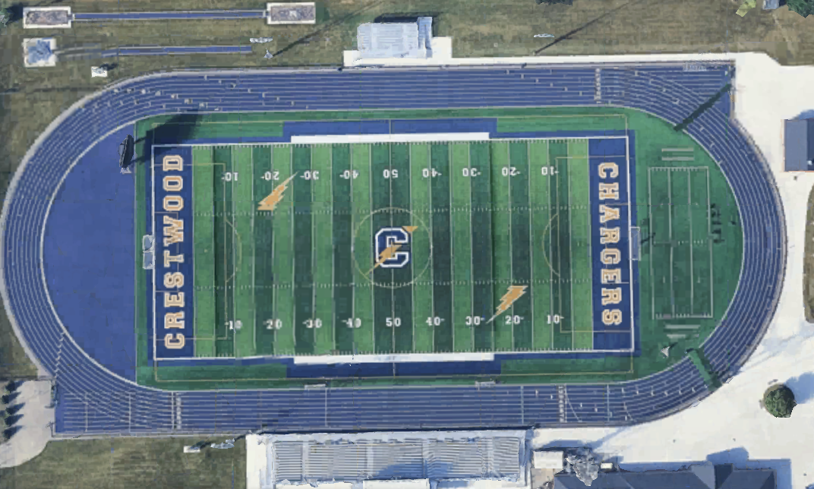

**Figure 1 (left) and 2 (right). Site Visualization.** The location on the left displays the band practice field at Crestwood High School. This is the first site that the researchers took data around Solar Noon throughout the months of July-November. The image on the right displays the new CHS athletic complex on a larger scale, the second area the researchers obtained their data.

**Materials and Methods**

The researchers used the Etekcity Lasergrip 774 Infrared Thermometer from July to early November to measure surface temperature. The researchers took their data at Solar Noon, when the sun reaches its highest point in the sky. The researchers also used the GLOBE Observer app to manually identify types of clouds, using the cloud protocol to record cloud and sky conditions. The researchers collected and graphed the data to determine the relationships between cloud coverage and surface temperatures. The researchers used the Etekcity Lasergrip 774 Infrared Thermometer to determine various surface temperatures on three different sites at Crestwood High School. The Infrared Thermometer was used by being held up to shoulder height. Then, the researchers pressed on the recording button to record the temperature for about 10 seconds at nine different areas on each site. The average surface temperature was recorded by adding all nine temperatures and dividing by the amount of times recorded. 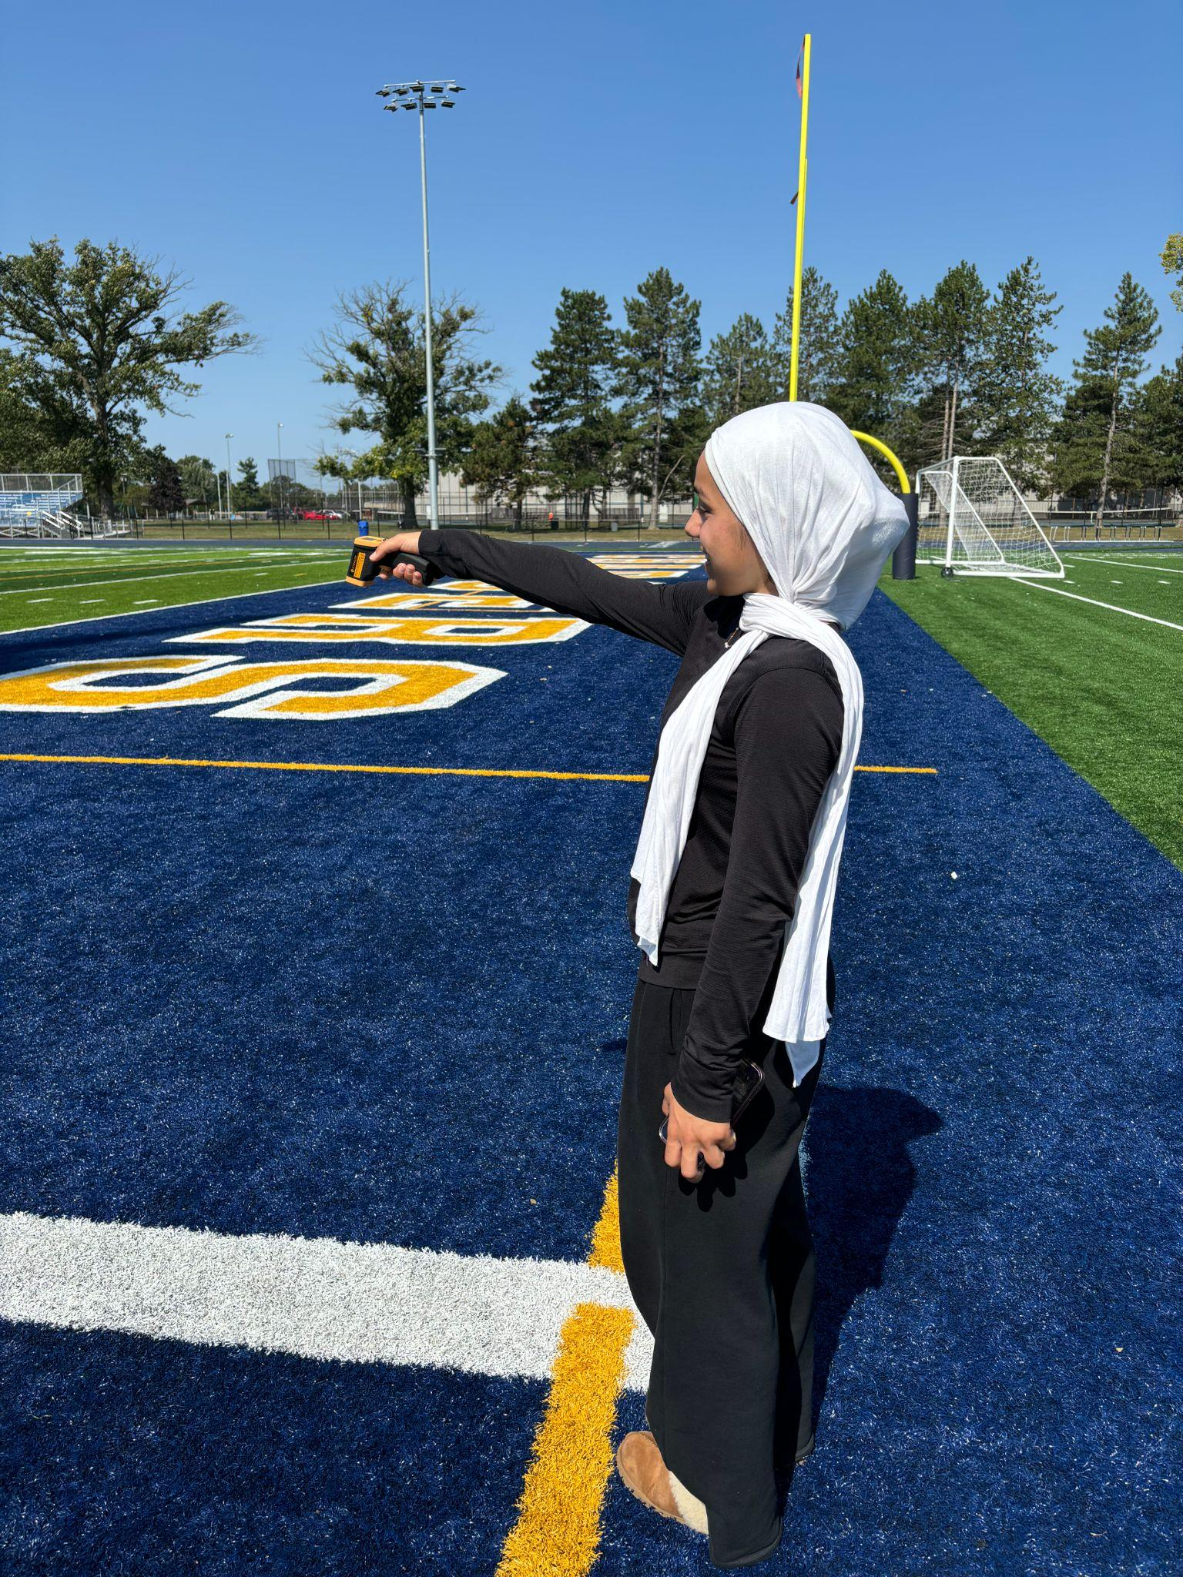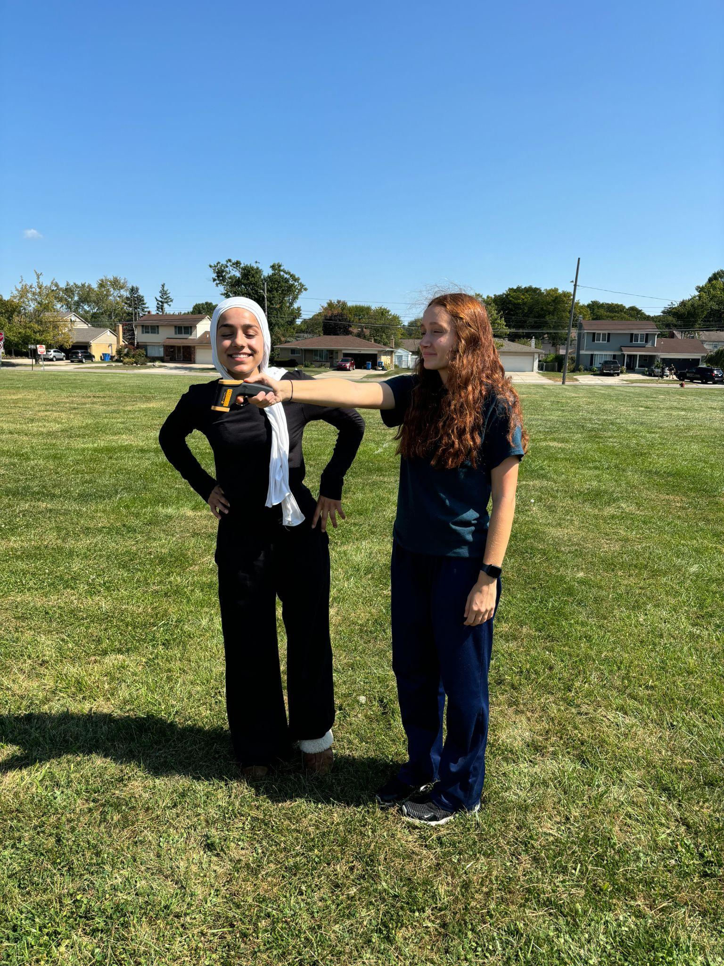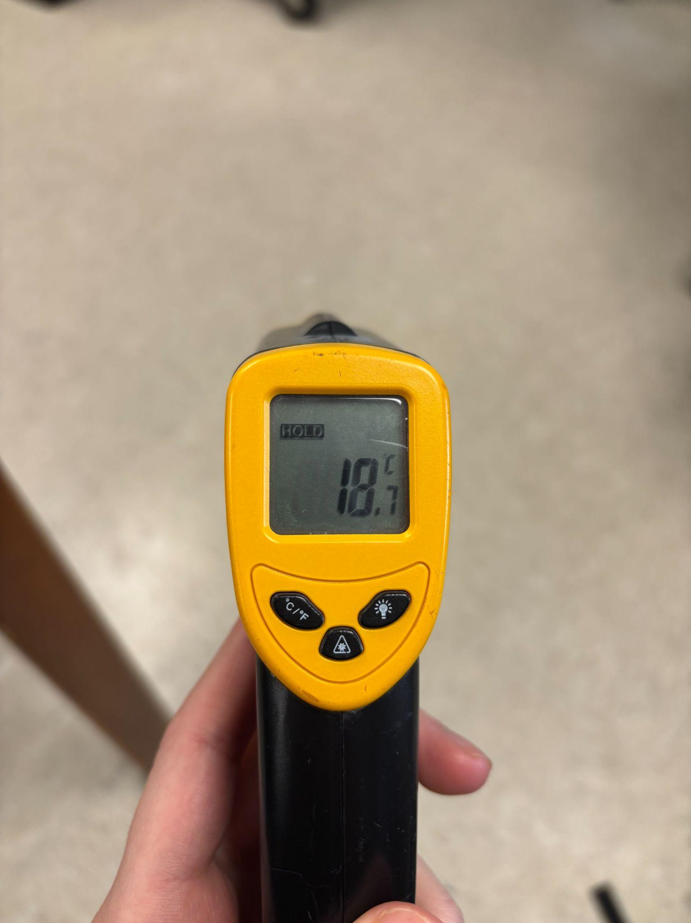

**Figure 3-5. The Etekcity Lasergrip 774 Infrared Thermometer** is a device that measures surface temperature. The researchers held it up at shoulder height for about 10 seconds to obtain accurate measurements (left). Then, the researchers read the data that was recorded in degrees Celsius (right).

At all three sites (band field, track, and turf), the researchers also collected cloud data where they obtained the surface temperatures. They did this by following the GLOBE Observer app protocols.

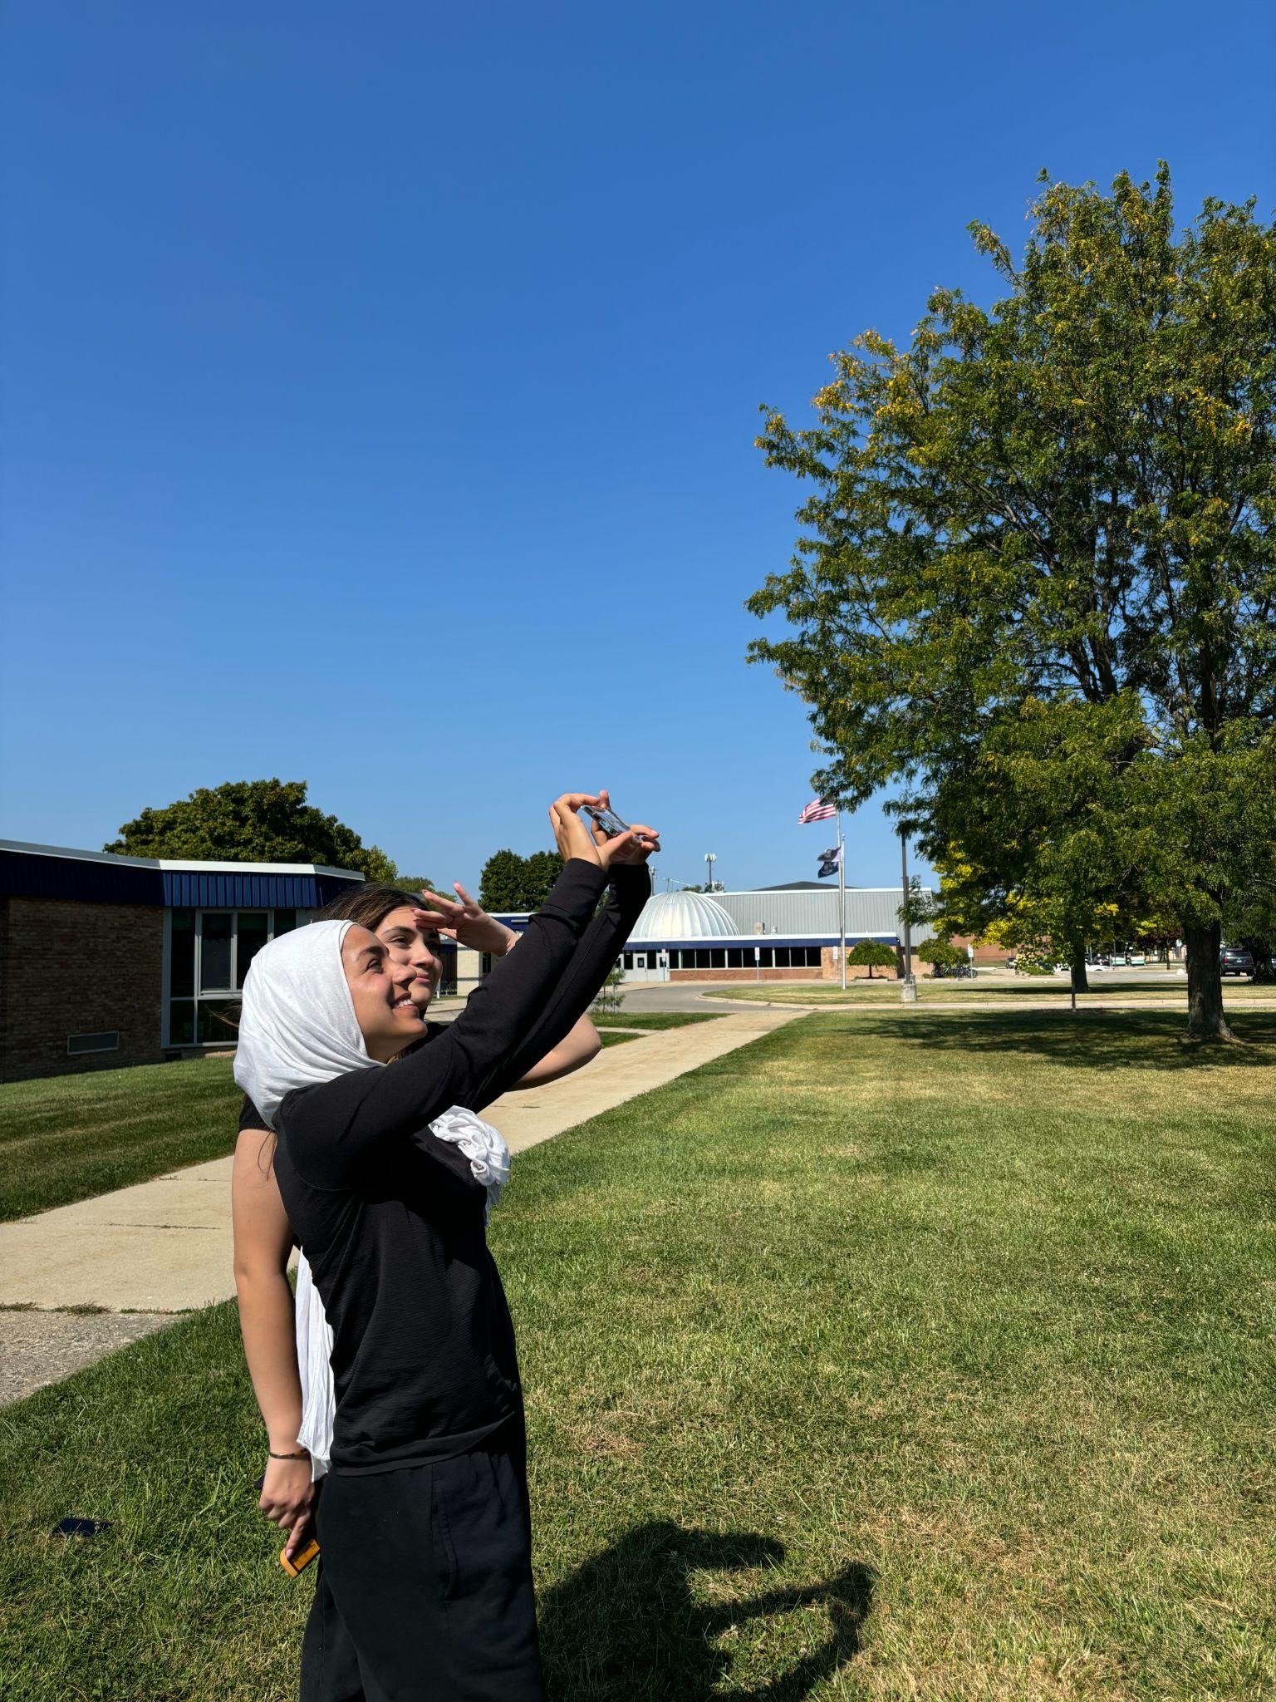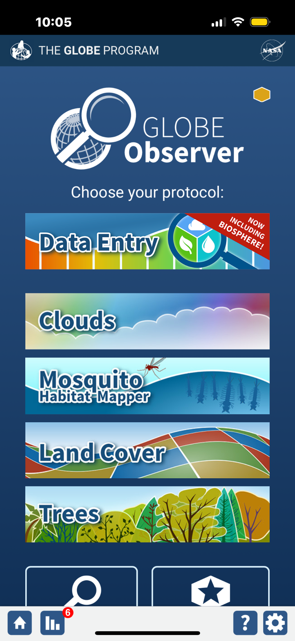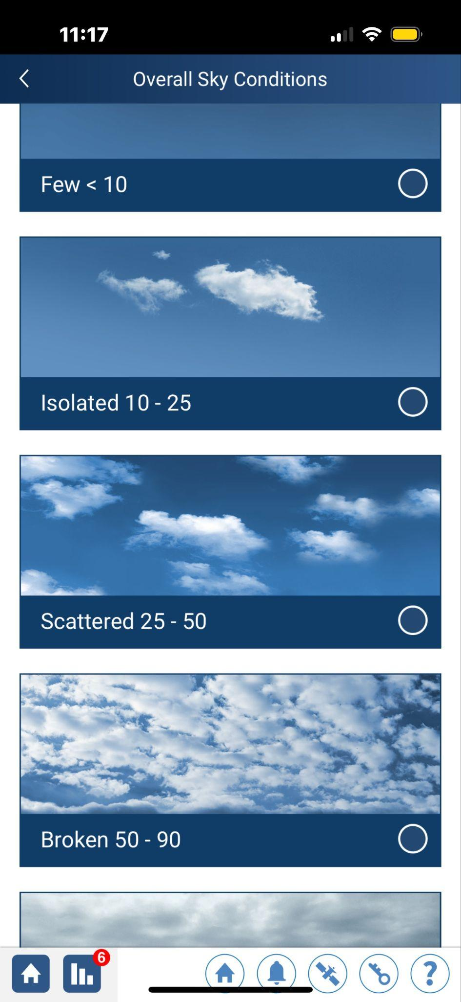

**Figure 6-8. The GLOBE Observer app** was used by the researchers in order to identify the types of clouds in the sky. The researcher looked up at the clouds and followed the step by step manual provided by the GLOBE Observer app (left). First, the overall amount of cloud coverage in the sky was chosen (few, isolated, scattered, broken, or overcast), then the type of clouds (right).

**Data Summary**

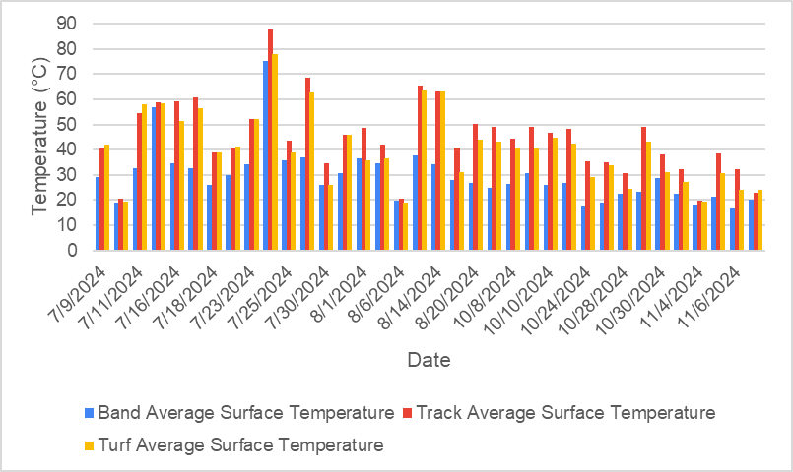

**Figure 9. A comparison between the Surface Temperature data obtained at Crestwood High School’s Band Practice field vs track vs turf.** Data collected from three sites was taken within an hour of solar noon. The track averaged the highest temperatures while the band averaged the lowest temperatures. Despite the differences between the two sites, the track and turf often appear to report closely related temperatures. The band practice field, which is made up of natural grass, has lower average surface temperatures than the track and turf. Grass tends to have a higher albedo so it reflects solar radiation that hits it, resulting in a cooler surface. The track and turf surfaces, on the other hand, have a lower albedo that causes them to absorb solar radiation.

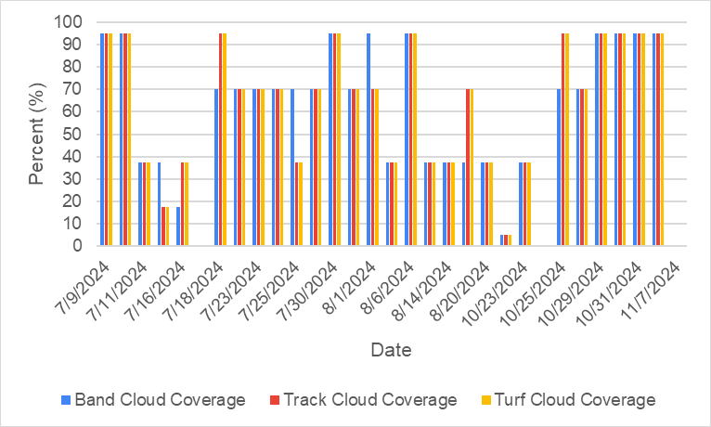

**Figure 10. Cloud coverage within three sites (track, turf, band practice field) obtained by the Clouds Protocol in the Globe Observer app.** The researchers observed the cloud coverage at solar noon at all three locations to ensure consistency. The cloud coverage between the three sites is the same the majority of the time, proving the researchers to be efficient. The researchers did not waste time between data collection. By comparing the data provided in the graph, it was found that the cloud coverage between the track and the turf were exactly similar. The data taken at the band practice field was similar most of the days, however this site happened to have a higher cloud coverage than the other two sites on days that they were not identical.

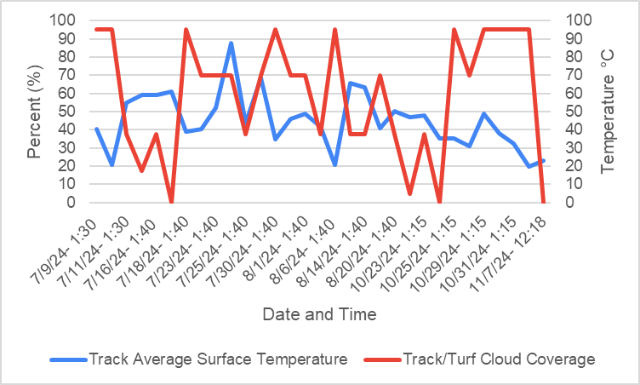

**Figure 11. Comparing the Etekcity Lasergrip 774 Infrared Thermometer and the Cloud Protocol on the GLOBE Observer App data taken on the track.** The surface temperatures measured on the track proves to have an inverse relationship with the cloud coverage shown at the same location. As the cloud coverage increases, the surface temperature shows a significant decrease. Throughout the summer months of July-September, the surface temperature on the track was found to be notably higher than the surface temperatures in the fall months of October and November. When there are conditions such as overcast which is represented by the peaks shown in this graph, it is difficult for solar radiation to warm temperatures on the surface.

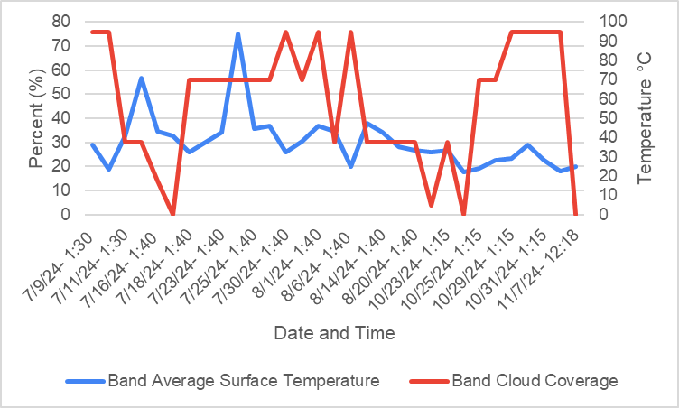

**Figure 12. A comparison between the Surface Temperature and the Cloud Coverage taken at the Band Practice Field.** The researchers measured cloud coverage and surface temperature at the band practice field at solar noon consistently. The data measured on the band field proves that there is an inverse relationship between cloud coverage and how it affects the surface temperature. This trend is similar to that of the track site; as cloud coverage increases, surface temperature decreases. The surface temperature data taken at the band field was consistently lower than the two other sights.

**Data Analysis and Results:**

Between early July and early November, researchers collected data on three different sites at Crestwood High School, including the Band Practice Field and the New CHS Athletic Complex. The New CHS Athletic Complex includes both the turf, which consists of synthetic grass, and the track, which is primarily made of asphalt. The data was collected using the Etekcity Lasergrip 774 Infrared Thermometer and the GLOBE observer app cloud protocol. The researchers found there is a negative correlation between cloud coverage and surface temperature because they have an inversely proportional relationship. When the cloud coverage is high, the surface temperature is lower, therefore causing the researchers to reject the null hypothesis. There was a correlation found between overcast, other cloud conditions, and surface temperature as when there is a higher percentage of cloud cover, the surface temperature decreases, which allows the researchers to reject the null hypothesis. The different colors on the track affect the surface temperatures. The track and its several different colors have higher surface temperatures. The lighter colors on the track -yellow, green, and white- have a lower albedo while the darker colors like blue and navy have a higher albedo, which increases their heat absorption. This allowed the researchers to reject the null hypothesis. The relationship between the temperatures for the Band Practice Field and the New CHS Athletic Complex is apparent, throughout July-November the New CHS Athletic Complex’s surface temperatures averaged the highest and have identical trends. This leads them to reject the null hypothesis. Cloud coverage affects the surface temperature in different seasons because there is generally a higher percentage of cloud coverage in the fall months where the average temperature is lower in comparison to the summer months where the clouds have less coverage. School athletic complexes generally consist of synthetic grass turfs on the practice fields; the researchers found that the average temperature on the band practice field is higher than the surface temperatures on the turf. The grass on the band practice field is made of natural grass and the turf is made of synthetic grass, this led the researchers to reject the null hypothesis as the turf’s surface temperature was consistently lower than the band practice field.

**GLOBE Data Analysis:**

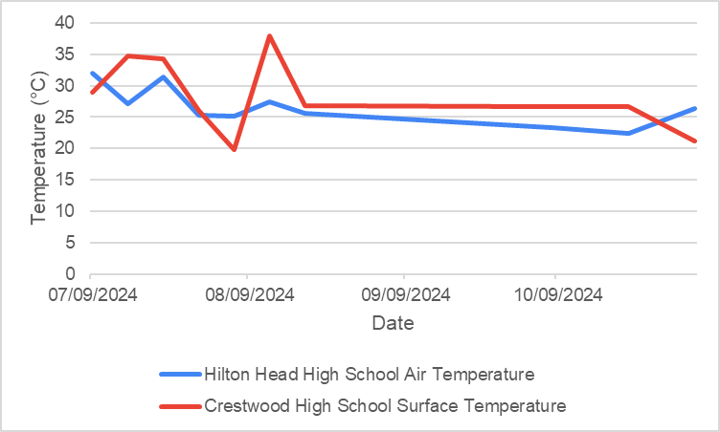

**Figure 13. A comparison between Hilton Head High School air temperature and Crestwood High School surface temperature on the band practice field.** Air temperatures taken at Hilton Head High School in South Carolina are much higher than the surface temperatures taken on the same exact days at Crestwood High School. The climate in Hilton Head seems to be hotter than that of Crestwood. The data fluctuates throughout summer months August but then levels out in fall months. Surface temperatures tend to be higher than air temperatures, but the overall climate depends on the air temperatures.

**Conclusion:**

The researchers concluded that there is an inverse relationship and a negative correlation between surface temperature and cloud coverage at Crestwood High School’s Band Practice Field, and New CHS Athletic complex track and turf field. The Band Practice Field, which is made up of natural grass, consistently reported cooler surface temperatures than the synthetic turf field in the New CHS Athletic Complex. It was found that with more cloud coverage, came lower surface temperatures due to the low albedo of clouds. Conditions including Stratus clouds resulted in the lowest surface temperatures, while conditions that had cirrus clouds were found to lead to significantly higher surface temperatures. Across the seasons, cloud coverage was shown to increase in the fall, leading to lower temperatures. The researchers’ conclusions were derived from data collection across the three sights between the months of July and November. The data was collected using the Etekcity Lasergrip 774 Infrared thermometer and the GLOBE Observer app. The GLOBE observer app was simple to operate and readily accessible. The Infrared Thermometer had similar attributes, with the help of the researchers’ mentor, Mrs. Diana Johns. The Infrared Thermometer allowed the researchers to quickly measure surface temperature across the three sites, allowing the researchers to ideally gather large amounts of data. The researchers reported issues that could have influenced data like potential calibration errors on the Infrared Thermometer. Nearby pollution may have been a nearby external factor that could have hindered the researchers’ data. Another factor that may have affected data includes albedo. Albedo refers to the ability of a surface to reflect. Darker objects tend to have lower albedo, meaning they absorb more heat, while lighter-colored objects have high albedo and reflect heat better. In the New CHS Athletic complex, the track facility being a dark navy color, tends to absorb more heat due to its low albedo. The synthetic turf facility, although it is made up of mostly a neutral green color, includes large portions of navy, a low albedo color, contributing to higher heat absorption. The researchers made sure to vary data on the different blocks of colors on the synthetic turf to ensure all parts were accounted for. The synthetic turf is also made up of tiny black fibers, contributing to higher heat absorption due to their low albedo. The Band

Practice Field is made up of natural grass which tends to have higher albedo, leading to cooler surface temperatures. Future research may include additional surfaces to measure such as the metal stands. Also, factors that affect surface temperature such as wind or humidity could be included. These additional factors could provide a better understanding of the relationship between cloud coverage and surface temperature. Working with mentor, Mrs. Diana Johns, the researchers were able to successfully ensure the accuracy of data and results. Her support, guidance, and availability ensured expert feedback and strengthened the researchers’ findings. Future research may contribute to understanding cloud coverage, and its relations to surface data across different surfaces, and through different seasons by building on the results.

**Discussion:**

There was found to be a significant correlation between cloud coverage and surface temperature taken at Crestwood High School’s Band Practice Field and the new CHS Athletic Complex. At all three sites (band track and turf), there was a negative relationship between these two variables. Clouds have a high albedo, which causes them to reflect the sunlight that comes down to Earth. When there are a great amount of clouds in the sky such as the overcast condition, the surface temperature at all three sites is lower than if there is a condition such as cirrus clouds. This is because cirrus clouds trap heat and warm the surface. Within all three sites, the track had the highest surface temperatures every time data was measured. The track at Crestwood High School is primarily made of asphalt. Asphalt absorbs the heat reflected onto the surface and stores it. Its high heat retention capacity is what leads to higher surface temperatures near Solar Noon. Conversely, the Band Practice Field always had the lowest surface temperatures. This is because the natural grass on this field makes it easier for heat to be evaporated. The cloud data collected from the track and the turf were closely related, however the surface temperatures varied. The track had higher temperatures than the turf. The researchers also found that the data varied throughout the seasons. The researchers took measurements throughout the summer and fall in order to see how seasonal changes affect their data. As the months of October and November approached, there were more consistent overcast conditions due to incoming precipitation such as snow. The overcast weather condition was most often associated with stratus clouds in the sky, which are known for reflecting sunlight and cooling the surface.

There are other factors that affect surface temperature that the researchers could not account for. The population in Dearborn Heights, Michigan is extremely large, reaching 60,000 people. The data taken by the researchers was near this highly populated area on Beech Daly Rd. The vehicles release an immense amount of pollution and heat. Nitrous oxide and carbon dioxide are potent greenhouse gases that are emitted from these vehicles, which are a vital cause of climate change which lead to higher surface temperatures. Another potential source of error is that there may have been calibration errors with the Etekcity Lasergrip 774 Infrared Thermometer device used to measure the surface temperature. Despite this, the researchers did the best they could to obtain accurate data as they took nine measurements at each site each day, then found the average value. Also, even though the researchers tried hard to take data when there were no students on the field, this was difficult some days as solar noon conflicted with practice times for sports in the summer. A large number of people on the fields may cause the surface temperatures to be higher than they actually are due to individual body heat.

The researchers did the best they could to eliminate outside factors that may have caused potential error in the data. The measurements were taken consistently throughout two seasons to provide a variety of data collection.

**Acknowledgements:**

Thank you to Mrs. Diana Johns GLOBE teacher at Crestwood High School for her consistent

availability and support throughout, answering questions, and providing additional resources.

Special thanks also to Mr. David Bydlowski of the GLOBE NASA AREN Project and Dr. Kevin

Czyjkowski of the University of Toledo NASA GLOBE Mission Earth Project for helping

provide us with much needed equipment to carry out our research.

**Bibliography:**

Cross, J., & Uhrig, R. (2023). Do fans impact sports outcomes? A COVID-19 natural experiment. *Journal of Sports Economics, 24*(1), 3–27.<https://doi.org/10.1177/15270025221100204>

Henderson-Sellers, A., & McGuffie, K. (2012). *A climate modelling primer*. Wiley-Blackwell.<https://doi.org/10.1002/9781119943372>

Hsiang, S., & Kopp, R. E. (2018). An economist’s guide to climate change science. *The Journal of Economic Perspectives, 32*(4), 3–32.<https://www.jstor.org/stable/26513494>

Jastifer, J. R., McNitt, A. S., Mack, C. D., & et al. (2019). Synthetic turf: History, design, maintenance, and athlete safety. *Sports Health, 11*(1), 84–90.<https://doi.org/10.1177/1941738118793378>

Paul, R. J., Ehrlich, J. A., & Losak, J. (2020). Expanding upon the weather: Cloud cover and barometric pressure as determinants of attendance for NFL games. *Managerial Finance*, *47*(6), 749–759. https://doi.org/10.1108/mf-06-2020-0295

National Recreation and Park Association. (2019, May). Synthetic sports fields and the heat island effect. *Parks & Recreation Magazine.*<https://www.nrpa.org/parks-recreation-magazine/2019/may/synthetic-sports-fields-and-the-heat-island-effect/>

Singh, G., Peterson, B., Jay, O., & Stevens, C. J. (2024). The effect of synthetic grass sports surfaces on the thermal environment: A systematic review. *International Journal of Biometeorology, 68*(7), 1235–1252.<https://doi.org/10.1007/s00484-024-02679-5>

**Appendix:**

**Figure 14.**

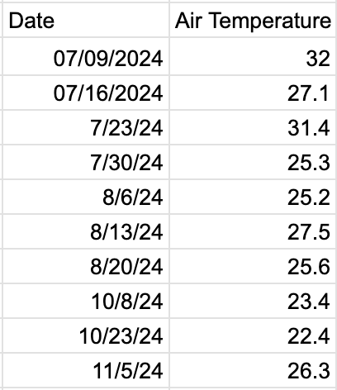

**Badges:**

**I Am A Data Scientist:** The researchers worked to pursue the “I Am A Data Scientist” badge, collecting and analyzing a significant amount of surface temperature and cloud coverage, including temperatures in celsius at solar noon, percentage of cloud coverage, and cloud types from July to November. This data was gathered through devices such as the GLOBE App cloud protocol and the Etekcity Lasergrip 774 Infrared Thermometer.

**I Make An Impact:** The researchers worked to achieve the “I Make An Impact” badge with their primary objective being to inform students, student athletes, and schools who practice on Crestwood High School’s practice fields. The researchers came to the conclusion that lower percentages of cloud coverage increases surface temperature and vice versa. The researchers also used their data to advocate for schools to purchase and build lighter colored athletic complexes. Having lighter colored athletic complexes allows student athletes to be more comfortable and are more likely to perform better.

**I Am A STEM Storyteller:** The researchers make an effort to achieve the “I Am A STEM Storyteller” badge to inform the public on the severe effects that high surface temperatures cause. The three researchers created an Instagram page to raise awareness on cloud coverage and its effects on surface temperatures on the practice fields at Crestwood High School. The username for their account is @coverandclimate. The researchers hope to inform the students at Crestwood and the community in Dearborn Heights which surfaces should be used more for athletics and events. They plan to use the account to persuade coaches to move practice times to when the cloud coverage is greater.

