Effects of Several Atmospheric Parameters on Air Quality in a Metro Detroit Suburb

**Student Researchers**

Hadi Nassereddine, Ali Shulaiba, Mohamed Youssef

**School**

Crestwood High School, Dearborn Heights, MI, 48127

**High School Science Teacher**

Mrs. Diana Johns

March 5, 2025

**Table of Contents**

I. Abstract…………………………...…………………………………………..............2

1. Research Questions & Null Hypothesis………………………………....……...…..2-3

1. Introduction and Review of Literature………….……………....……..............……3-4

1. Materials and Methods…………………………………….......….............……...…4-6
2. Data Summary………………………..……………………...…………...…………7-8

1. Data Analysis and Results…………………………………………..............….…...8-9

1. GLOBE Data Analysis…………………………………………..……….…….….9-10

1. Conclusions…………………………………………..……………………….….10-11
2. Discussion...……………………………………………….…..…......……….……..11
3. Acknowledgements…………………………….……………………...….……........11

1. References/Bibliography………………………….…………....…….……..….........12

1. Appendix………………………………………….…………………………………13

1. Badges………………………………………………………………..….............13-14

**Abstract:**

An aerosol is a tiny solid particle or liquid droplet in the atmosphere. Primary aerosols are injected into the atmosphere directly in many ways: sea spray, mineral dust, smoke, and volcanic ash. Secondary aerosols are emitted in another form such as gases and undergo chemical reactions in the atmosphere. Although aerosols are barely visible to the human eye, they still have impact, factoring into Earth's climate, air quality, and cloud creation. To understand how **Aerosol Optimal Thickness (AOT)**, along with temperature, humidity, and pressure affects air quality, data was collected from Mid-August to Late February. To collect aerosol measurements, skies had to be clear of any clouds, trees, powerlines, or other obstacles preventing a direct viewing of the sun. As close to solar noon as possible, a Calitoo Sun Photometer was pointed directly towards the sun at chest height and operated, providing AOT data to be extracted later on. Subsequently, a cloud observation was taken, and current weather data was recorded. In using the photometer, several recordings, or trials, were taken to assure accuracy. The null hypotheses were to see the correlation between **barometric pressure**, **relative humidity**, AOT, and temperature all had with **air quality**. Results found that AOT had the greatest correlation followed by pressure, humidity, and lastly **air temperatur**e showed little to no effect on harming the air quality. However, more data could be found to further validate the findings of this research.

**Key Words:** Aerosol Optimal Thickness (AOT), air quality, barometric pressure, relative humidity, and air temperature.

**Research Question & Null Hypotheses:**

To what extent do Aerosol Optical Thickness (AOT), air temperature, relative humidity, and barometric pressure measurements correlate with air quality?

**Null Hypothesis 1:** AOT measurements do not correlate with air quality.

**Null Hypothesis 2:** Measurements of air temperature do not correlate with air quality.

**Null Hypothesis 3:** Measurements of humidity do not correlate with air quality.

**Null Hypothesis 4:** Measurements of barometric pressure do not correlate with air quality.

**Introduction and Review of Literature:**

Through this project, the researchers recorded Aerosol Optical Thickness (AOT), barometric pressure, air temperature, air quality, and humidity data over the span of seven months in Dearborn Heights Michigan. One of the potential effects that aerosols may cause is atmospheric degradation. High AOT values indicate an increase in aerosol concentrations leading to atmospheric degradation. Atmospheric degradation can lead to many negative environmental consequences, one of which includes environmental damage by depositing harmful pollutants like sulfur dioxide and nitrogen oxides into the environment. This leads to acid rain which alters soil chemistry and harms aquatic life in lakes and streams, ultimately reducing biodiversity. Through studying and understanding the relationship of AOT and air quality, predictions can be made about pollution events and action can be taken to reduce their impact. This is important for public health, as according to the National Institute of Health, poor air quality is linked to asthma, lung disease, and other health problems (Toby C Lewis, 2005). They also share cities, such as Detroit, which are facing air pollution from factories, traffic, and weather conditions. High Aerosol Optical Thickness (AOT) means more pollution, which causes breathing problems, especially for kids and older people. Humidity can make pollution worse, while temperature and air pressure affect how pollution spreads. Studying AOT, temperature, humidity, and pressure can help predict pollution levels. This allows cities to warn people of air quality and find ways to improve it. According to the Harvard Primary Care, the Detroit area is battling some of the worst air pollution in the country and the University of Michigan School of Public Health states that, “Southwest Detroit, home to a large industrial complex, experiences some of the highest levels of air pollution in the state, leading to significant public health concerns,” (Alexander Restum, 2022). This quote emphasizes that the Metro Detroit area has some of the worst air pollution because of factories and explains why people in this area face more health problems from the polluted air. Some of these pollutants in the atmosphere can lead to global warming and climate change. Some of these particles can reflect sunlight, helping to cool the atmosphere.  According to the United States Environmental Protection Agency, black carbon can absorb most sunlight leading to this atmospheric cooling (Teresa Kuklinski, 2016). However, NASA GLOBE mentions that aerosols are found to have less of a cooling effect over time. This means that there is now an increase in the type of aerosol particles that absorb heat from sunlight. This causes the atmosphere to become warmer which can lead to melting ice caps and natural habitat loss, leading to a decrease in biodiversity. This results in rising sea levels which causes flooding and water damage to our cities.

**Materials and Methods:**

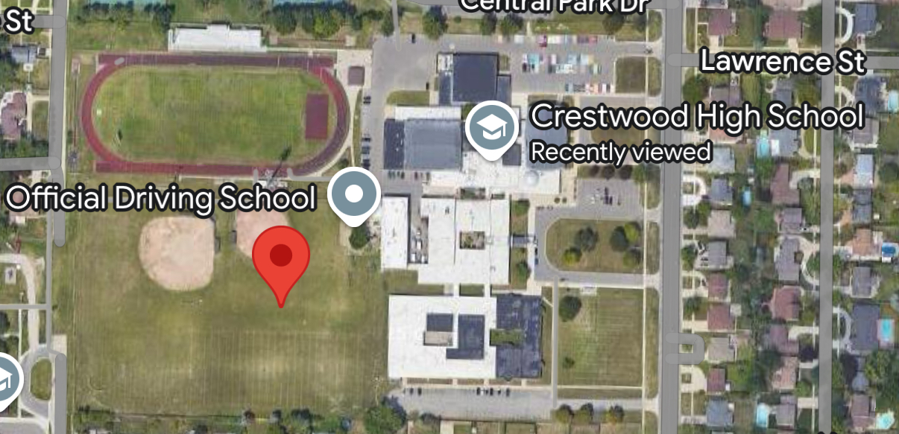

**Figure 1. Research Site.** The image on the top is a satellite view of a research site at the practice field of Crestwood High School (42°19'16"N 83°17'40" W).

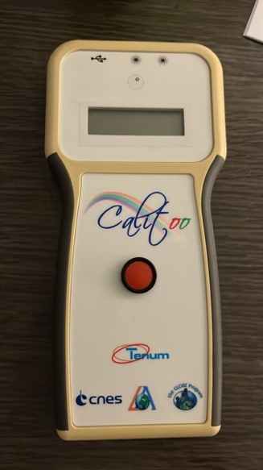

**Figure 2.** This image shows the Calitoo Sun Photometer which was used to measure AOT levels.

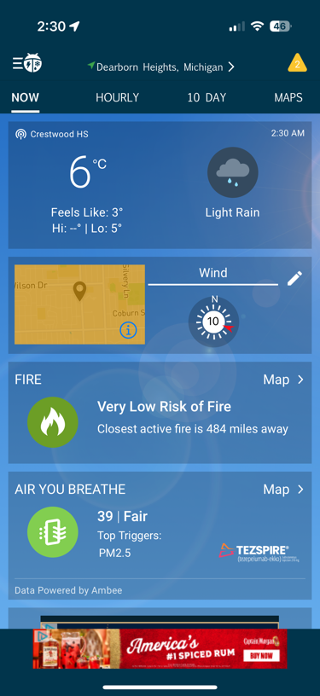

**Figure 3 and 4.** These images above represent WeatherBug, an app that was used to gather data for air temperature, barometric pressure, and relative humidity.

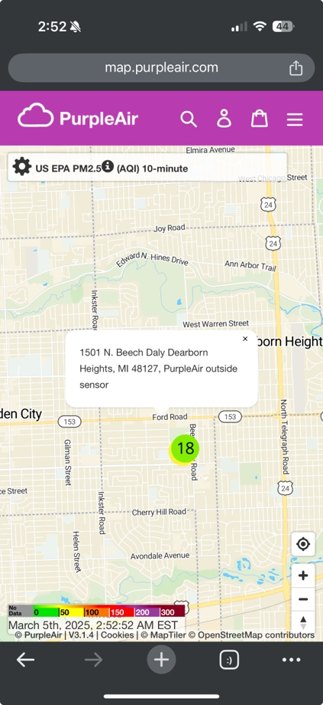

**Figure 5.** map.purpleair.com was the website used to record the PM 2.5 concentrations in the surrounding area.

A team of three researchers came together to measure and record Aerosol Optical Thickness (AOT), barometric pressure, air temperature, air quality, and humidity data for seven months in Dearborn Heights, Michigan. Sites were chosen based both on availability and low cloud coverage. The first site chosen was at Crestwood High School in Dearborn Heights, Michigan and a researcher’s backyard. After choosing an area with low cloud coverage, the researchers would then use the borrowed aerosol photometer from the school and test aerosol measurements by aiming the photometer at the sun at chest height. Three trials were taken measuring the AOT levels each time to ensure they were accurate. After taking AOT measurements, the researchers would use WeatherBug, a mobile app reporting live forecast data to record the current barometric pressure, relative humidity, and air temperature. Lastly, they recorded air quality measurements off purpleair.com using a nearby outdoor installation. All data would then be recorded on paper. While one researcher would be taking AOT measurements another researcher would record cloud observations, and the third researcher would input the data into Globe database. Finally, all data would be recorded on an online spreadsheet.

**Data Summary:**

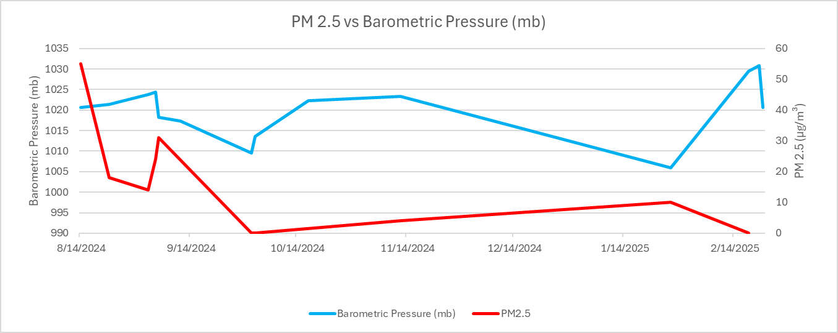

**Figure 6.** When comparing Barometric Pressure with Particulate Matter concentration (PM), a correlation can be observed between the two. Higher levels of PM 2.5 appear alongside elevated barometric pressure.

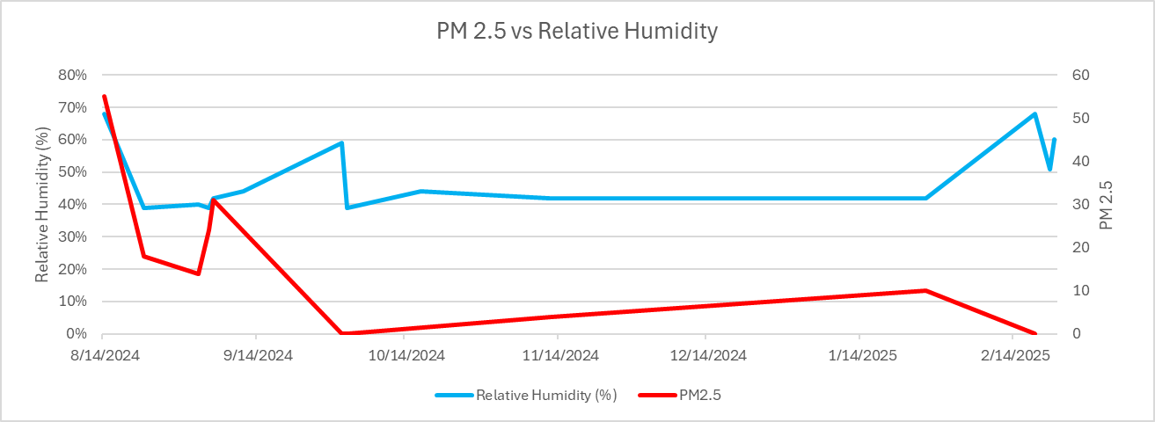

**Figure 7.** There is a slight correlation between relative humidity and PM 2.5 concentration, with lower humidity showing lower PM 2.5 levels, and vice versa. However, due to the small data set, it is difficult to come to a full conclusion.

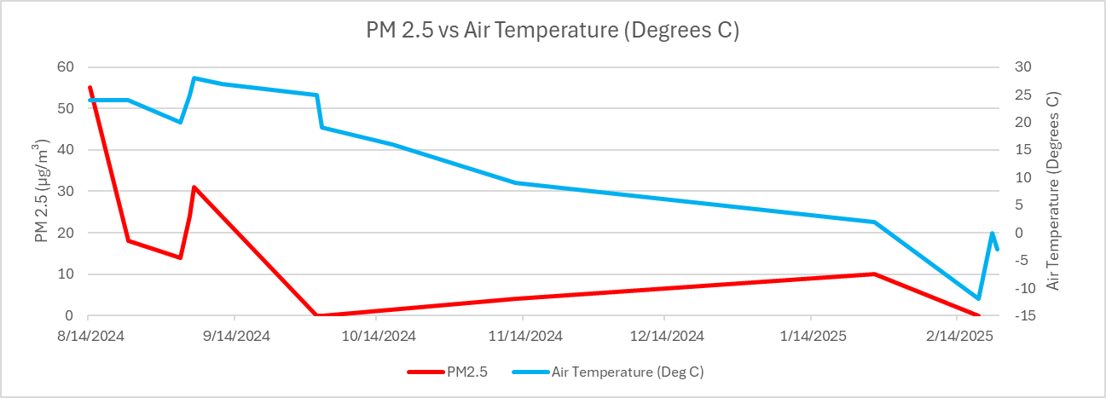**Figure 8.** There is apparent correlation between air temperature and PM 2.5 concentration

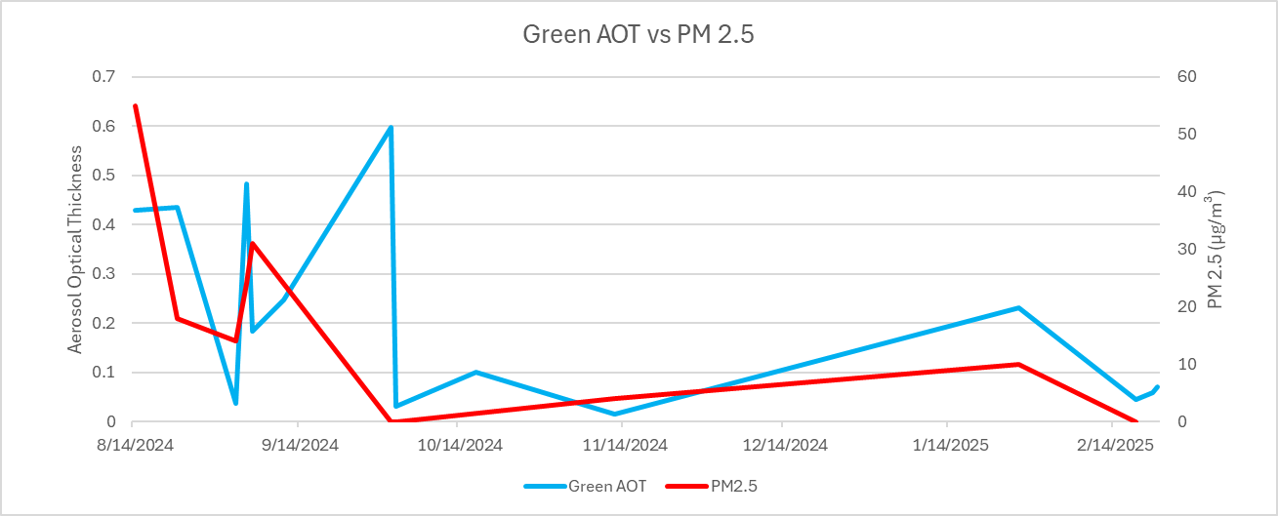

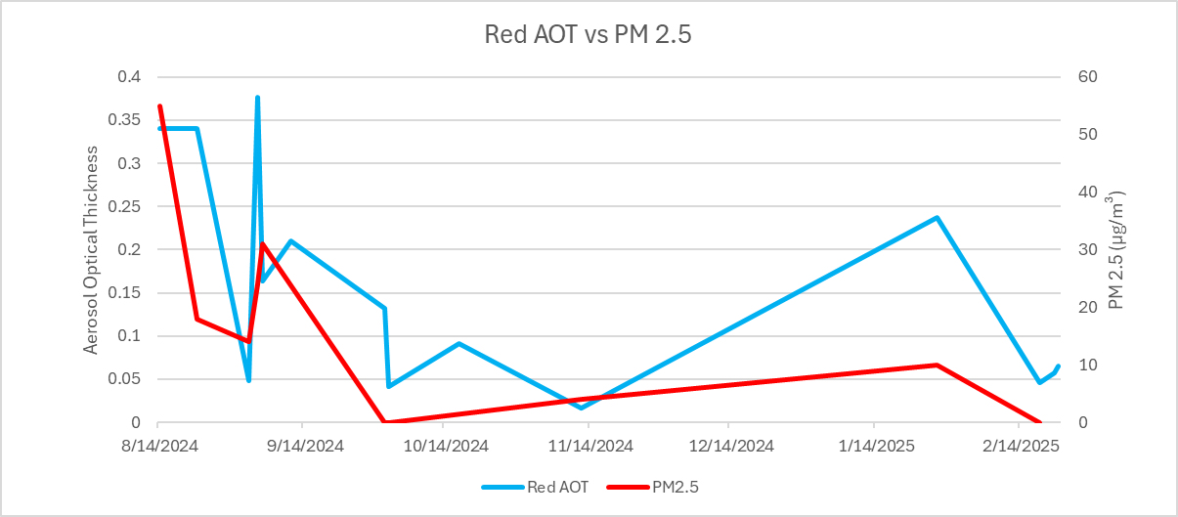  
**Figure 9 and 10.** There seems to be a relatively strong correlation between AOT and PM 2.5 levels. Higher AOT levels exhibit higher PM 2.5 levels in both green and red spectrums.

**Data Analysis and Results:**

The data in the study shows that Air temperature, Barometric Pressure, Relative Humidity, do not closely correlate with PM 2.5 measurement, while Aerosol Optical Thickness seemingly does. Though this distinction has been identified, it does not indicate a true correlation between AOT and PM 2.5, as our sample sizes are too small to reach that conclusion. Additionally, it is possible that our sampling methods themselves were improper due to oversight or human error. The PM 2.5 measurements, for instance, came from a Purple Air website with settings unfamiliar to us, leading to the possibility of having recorded inaccurate results. Therefore, we support three of our four hypotheses.

**GLOBE Data Analysis:**

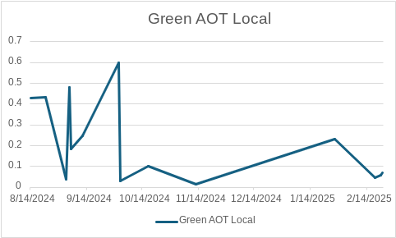

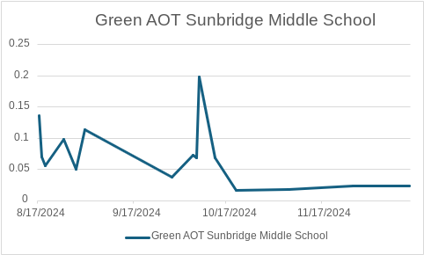

**Figure 11 and 12.** Comparison of Green wavelength AOT data collected locally vs AOT measurements made by other groups in a similar time frame at Sunbridge Middle School.

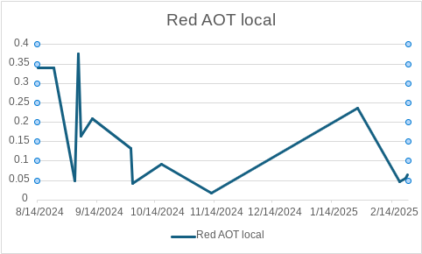

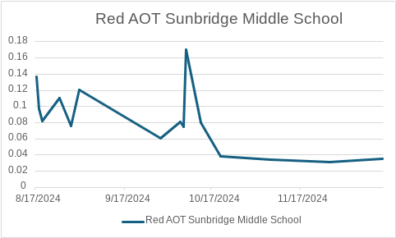

**Figure 13 and 14.** Comparison of Red wavelength AOT data collected locally vs measurements made by another group at Sunbridge Middle School.

When comparing with a separate data set, from Sunridge Middle School in Oregon, it is apparent that we share commonalities in our records, even while the graphs are in different time scales. This helps validate our support for this dataset, as it further proves that our measurements are in fact accurate and not outlying. This also means that they likely have similar air quality compared to that taken at the local sampling site due to having a similar indicating factor. On the other hand, these measurements were taken a long distance away from our own, in a different U.S. state, and therefore several extenuating circumstances could have shown within their data.

**Conclusion:**

The researchers concluded that certain atmospheric conditions affect air quality. A relatively strong, positive correlation was shown between air quality and both red and green AOT measurements. As shown in figures 12 and 13, as the AOT increased, so would PM 2.5 meaning air quality would worsen. This was to be expected as many studies suggested AOT has negative impacts on the air quality. In contrast, air temperature would show little to no correlation with air quality. While it is true data showed little to no correlation between temperature and air quality, it is shown in studies from the World Resources Institute that high temperatures can influence environmental conditions. Some examples are droughts or even wildfires, which in return increase PM levels worsening air quality. Furthermore, the research indicated that barometric pressure had a positive correlation with PM levels. This suggests that high pressures show a decrease in the quality of the air. The Center for Science education supports the data explaining that high pressure leads to dry conditions which increase PM levels like shown in figures 6 and 10. Lastly, small positive correlations were found between relative humidity and air quality. Shown in figures 7 and 11 as the humidity increased so did PM levels. These findings also go along with what Airly Industry suggests. As relative humidity increases, there is less air circulation and particles get trapped in the air decreasing air quality.

**Discussion:**

Within the work towards finding relationships between air temperature, barometric pressure, and relative humidity with air quality, it was found that all three of those metrics had been found with no major correlation with air quality, therefore rendering their null hypotheses true. This left the null hypothesis surrounding the relationship between Aerosol Optical Thickness and Air quality rejected, as they showed a positive correlation with one another. These conclusions, however, should not be taken too seriously, as the research was not large enough in scope to cover enough of its failures. For instance, though the number of metrics recorded was plentiful enough to come up with these conclusions, they were not plentiful enough to be able to prove anything. Had more research been done, more measurements taken, and more time been put into minor details, this project could have taken a different form. This project’s components could have been used for weather analysis or seasonal trends. In its current state, however, it can be used to an extent in furthering the public’s understanding of what air quality is truly about from a different lens.  
  
**Acknowledgements:**

We are grateful for past and current GLOBE researchers from our school who helped us plan an outline of the whole research process. From collecting the data to putting it all together we were mentored throughout the way. We would also like to thank our advisors, Ms. Lina Abbas and Mrs. Diana Johns, who not only inspired us to begin GLOBE research, but has also been willing to spend countless late evenings and numerous days off school to come in and let us work in her classroom with her support. Without the constant knowledge and assistance of everyone, none of this research would have been possible. Thank you also to Dr. Kevin Czajkowski from the University of Toledo GLOBE Mission Earth who provided materials for this research and Mr. David Bydlowski of the GLOBE NASA AREN Project for other equipment we used.

**References/Bibliography:**

Restum, A. (2022, April 19). Air Quality in Southwest Detroit: A Public Health Crisis.

Info.primarycare.hms.harvard.edu

Hankey, S., Marshall, J.D., & Brauer, M. (2012). Health Impacts of the Built Environment: Within-Urban Variability in Physical Inactivity, Air Pollution, and Ischemic Heart Disease Mortality. *Environmental Health Perspectives*, *120*(2), 247–253. <https://doi.org/10.1289/ehp.1103806>

US EPA, O. (2014, March 26). *Black Carbon Diesel Initiative in the Russian Arctic.* Www.epa.gov. <https://www.epa.gov/international-cooperation/black-carbon-diesel-initiative-russian-arctic>

*Identifying air pollution sources in Southwest Detroit | News | University of Michigan School of Public Health | Research | Environmental Health Sciences | Environmental Health | Air Quality | Air Pollution | Pollution | Particulate Matter | Detroit | Southwest Detroit |*. (2023, July 6). Sph.umich.edu. <https://sph.umich.edu/news/2023posts/identifying-air-pollution-sources-in-southwest-detroit.html>

Lewis, T. C., Robins, T. G., Dvonch, J. T., Keeler, G. J., Yip, F. Y., Mentz, G. B., Lin, X., Parker, E. A., Israel, B. A., Gonzalez, L., & Hill, Y. (2005). Air Pollution–Associated Changes in Lung Function among Asthmatic Children in Detroit. *Environmental Health Perspectives*, *113*(8), 1068–1075. <https://doi.org/10.1289/ehp.7533>

Education, U. C. F. S. (n.d.). *How weather affects air quality | Center for Science Education*. UCAR. <https://scied.ucar.edu/learning-zone/air-quality/how-weather-affects-air-quality>

Cardenas, B. (n.d.). *What happens when extreme heat and air pollution collide*. World Resources Institute. <https://www.wri.org/insights/extreme-heat-air-pollution#:~:text=Put%20simply%2C%20air%20pollution%20levels,5>).

*How does humidity affect air quality? All you need to know - Airly WP | Air Quality Monitoring. Monitor in UK & Europe. Airly Data Platform and Monitors*. (n.d.). <https://airly.org/en/how-does-humidity-affect-air-quality-all-you-need-to-know/#:~:text=Decrease%20in%20air%20circulation%20%E2%80%93%20humidity,can%20cause%20many%20health%20issues>.

UCAR. (2024). *How Weather Affects Air Quality | UCAR Center for Science Education*. Scied.ucar.edu. <https://scied.ucar.edu/learning-zone/air-quality/how-weather-affects-air-quality>

**Appendix:**



Sunbridge Middle School, Oregon red and green wavelength AOT data

On a side note, measurements of Aerosol Optical Thickness are unitless, meaning that these aren’t literal physical measurements but rather measures of relative size.

**Badges:**

**I Am a Data Scientist:**

The researchers hope to earn the “I Am a Data Scientist” for their data collection spanning over the past seven months. The researchers took 3 trials for each sample, recorded data onto organized sheets, and compiled the data onto an online spreadsheet. The data was then used to create graphs to help examine how air quality was affected by AOT, pressure, humidity, and temperature.

**I Make an Impact:**

The research hopes to earn the “I Make an Impact” badge for their work on aerosols. Helping people to understand how AOT, humidity, temperature, and pressure affect air quality. We hope to make our findings public, making them available for anyone to read through GLOBE. This way people in our community as well as all over the world can better understand air quality and its related factors.

**I Am A STEM Storyteller:**

Researchers hope to earn the “I Am A STEM Storyteller” for documenting their journey on Instagram under the username “aerosol_thickness.” The team utilized the page to document parts of their research and educate members of the community on how air quality is affected by AOT, humidity, temperature, and pressure.