Relationships Between Bat Activity and Select
Atmospheric Parameters in Two Suburban Habitats

Student Researchers:
Mohamed Ali Baydoun, Adam Bahar, Hussein Abdallah

School:
Crestwood High School
Dearborn Heights, MI. 48127

Science Teacher:
Mrs. Diana R. Johns

March 6, 2025

Table of Contents

Abstract …………………………………………………………………………………………. 3
Research questions and Null Hypotheses……………………………………….…………..……4
Introduction and Review of Literature …………………………………………………....……4-5
Materials and Methods …………………………………………………………………………5-8
Data Summary …………………………………………….…………………………………….. 8
Data Analysis and Results.…………………………………………………………………… 9-11
GLOBE Data Analysis ...……………………………………………………………………….. 12
Conclusion...………………………………………………………………………………… 13-15
Discussions ...………………………………………………………………………………. 15-17
Acknowledgements ………………………………………………………………………….17-18
Bibliography …………………………………………………………………………………… 19
Appendix ……………………………………………………………………………………….. 20
Badges ……………………………………………………………………………………….20-21

Abstract:
This study explores the connection between atmospheric conditions, suburban land use, and bat presence to understand and make sense of how environmental factors influence bat activity and population. The research highlights three key questions and concepts which consist of: how atmospheric parameters such as temperature, wind speed, humidity, and barometric pressure affect bat presence and activity, whether bats can serve as bioindicators of environmental quality, and how habitat variations in suburban environments impact/affect bat diversity. All the data recorded and collected was from two local suburban locations which were Kinloch (Site 1) and Hillcrest (Site 2) Elementary schools park area, using acoustic devices known as the Echo Meter Touch. This device along with GLOBE protocols were used to record bat presence, species frequency/variation, and environmental elements that influence bat activity. Findings in the beginning of the study indicate that activity is higher in areas with a surplus of vegetation and trees, with little to no human disturbance, proving that suburban development and artificial lighting may adversely affect bat populations. Results also suggest and support the idea that changes in bat diversity are directly proportional to quality of the environment, highlighting the bats as true bioindicators. These findings contribute to understanding urban wildlife ecology and provide sufficient insight into how suburban planning can better support and aid bat conservation. Future research could expand and build upon these findings and indications by incorporating additional sites and long term (longitudinal) studies to monitor and assess seasonal trends that occur within the bat habitat.
Key Words: suburban land use, bat activity, atmospheric parameters, bioindicators, conservation.

Research Questions:
1 How do various atmospheric parameters (air temperature, wind speed, dew point, humidity, barometric pressure, and surface temperature) affect the number of bats present?
2. How do differences in the GLOBE MUC land cover classification affect bat feeding and bat diversity?
3. Can bat activity be used as an indicator of environmental quality in suburban areas?

Null Hypotheses:
1. There is no significant difference in bat activity between Site 1 (Hillcrest) and Site 2 (Kinloch).
2. Bat diversity is not affected by the atmospheric parameters measured in this research.
3. Variations in habitat within a suburban environment have no effect on bat diversity.

Introduction and Review of Literature:
Bats are highly sensitive to weather and atmospheric changes, making them potential bioindicators of altering weather conditions due to climate change. Multiple studies have shown that wind speed, humidity, and temperature all impact bat feeding behavior, migration, and roosting routines (O’Shea et al., 2016). Bat activity heavily declines on colder nights because of increased energy costs, and there is also a reduced success rate of bat foraging in the case of high winds (McGuire et al., 2018) as high winds interfere with echolocation. One of the strongest indicators and predictor of bat activity is temperature. Bat activity typically increases significantly when temperatures reach above 15 Celsius in part due to warmer conditions promoting greater insect availability (Frey-Ehrenbold et al., 2013). Other researchers note that wind speeds above 5 meters per second reduce bat’s ability to fly, making it harder to hunt and find prey (Plummer et al., 2021). Atmospheric pressure and humidity also play vital roles. Weller et al. (2016) cited that insect population size is directly proportional to humidity, which indirectly affects bats hunting and foraging efforts. Like this study, Gonsalves et al. (2013) indicated that barometric pressure changes correspond to changes in bat activity. Lower pressures signal to bats that there is a storm approaching, which disrupt their movements. In suburban areas, excess human lighting and habitat destruction further these relationships. Rowse et al. (2016) noted that bats usually avoid highly illuminated areas due to disruption to their sensory abilities and an increased likelihood of the bats being hunted by predators. This study delves into these factors by analyzing bat activity at Kinloch and Hillcrest, two elementary schools in two different suburban areas within our district, to examine how different weather parameters might affect bats behavior and activity in Southeastern Michigan.

Materials and Methods:
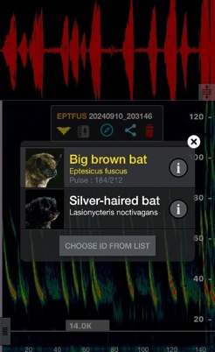
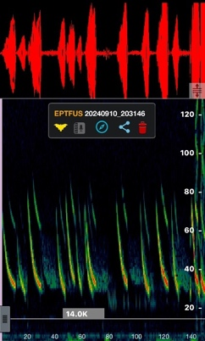
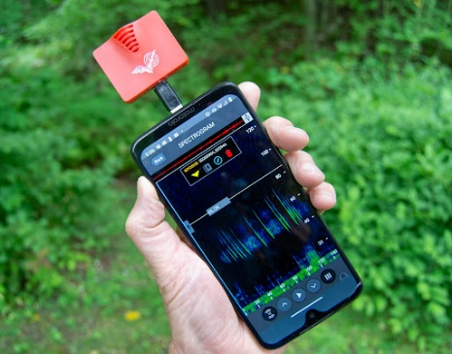
From summer through Autumn of 2024, bat activity data was gathered in two sites: Site K and H. The research focused on comparing the presence of bats, species richness, and activity levels with various weather parameters. Data gathering started 30 minutes past sunset to coincide with the peak bat hunting period. Acoustic bat detectors, the Echo Meter Touch™, served as the recording and processing device for echolocation calls. This Wildlife Acoustics bioacoustics monitoring equipment features a removable Ultrasonic Module that interfaces with a portable device via the Echo Meter Touch software application, which serves as a transducer and microphone. The software translates ultrasonic bat echolocation calls into audible and visual spectrographs, with identification of species using onboard classification algorithms.
Figure 1 (left), 2, (middle) and 3 (right): Equipment used to collect bat data. The Echo Meter Touch™ module connected to the iPhone. These two pieces of equipment were used together for all echolocation data collected in this research. Figure 2 illustrates an example of a recorded feeding buzz, one of the echolocation techniques used by bats during aerial hunting. Figure 3 shows the popup screen that clarified the species of bat found.
Safety protocols were strictly followed at both sites. Insect repellent was applied by researchers, protective gear was worn to protect against poison ivy and mosquitoes, and flashlights were taken along during monitoring. Direct handling of bats or other animals never took place and nocturnal creatures such as coyotes, skunks, and deer were monitored and avoided. For safety reasons, bat monitoring was conducted in a group rather than individually.
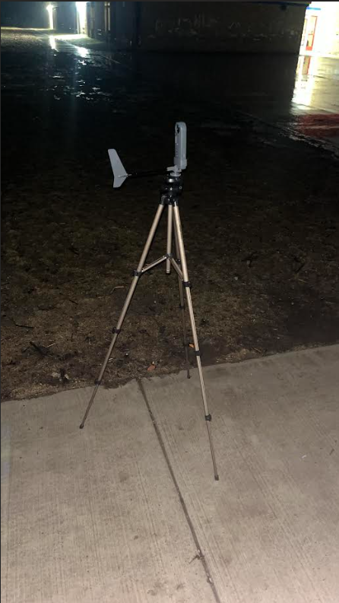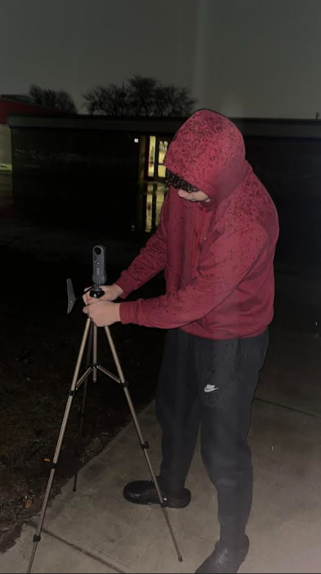
Figure 4 (left) and 5 (right) Equipment set up: The equipment used to collect weather is shown in figure 4. Figure 5 consists of weather data collection set-up.

For greater accuracy in data, a portable Vernier Weather Station was used to connect to our phones with its associated Vernier Graphical Analysis app. Our school’s Earth Network weather station provided real-time data on atmospheric factors such as wind speed, humidity, and temperature. Identification of various bat species was made possible by using an Echo Meter Touch connected to an iPhone.
Collecting spectrogram analysis and field observation allowed a method to identify different species without directly interacting with them. Site 2 had thick fields and trees, was in an area with little artificial lighting, was predicted to have greater bat activity than site 1, an open area with a large amount artificial lighting, sparse vegetation and located in the middle of a large subdivision.
Bat activity was classified as low (Less than 15 bats), medium (15-30 bats), or high (more than 30 bats) depending on the frequency of calls. Each atmospheric parameter was measured using GLOBE protocols and recorded on a data sheet. This data was later entered on the GLOBE website. This approach enabled us to monitor trends, discover possible correlations between atmospheric parameters and bat activity pattern. By having two distinctly different habitats (as identified using the MUC land cover classification system) provided us with data to evaluate the role that habitat might play in bat activity.

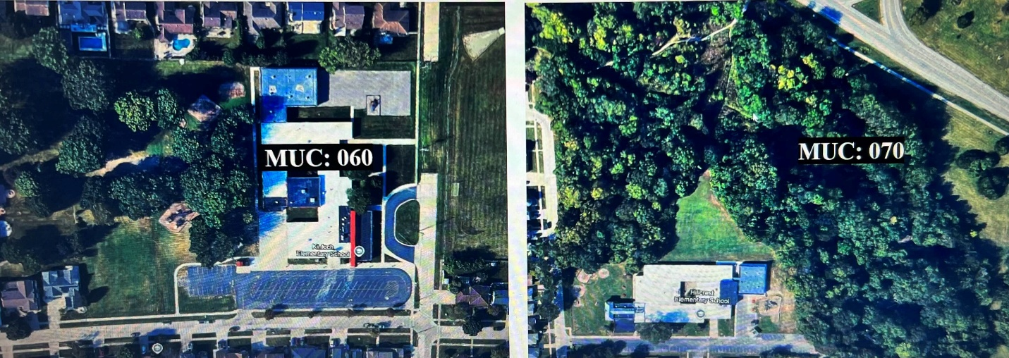
Figures 6 (left) and 7 (right): Satellite view of the two sites where bat activity was monitored. Figure 6 shows site 1 from an aerial view and presents the MUC number of 060. Figure 7 shows Site 2 from an arial view and presents the MUC number of 070.

Data Summary:
Bat frequency was quite different in site 1 versus site 2 primarily due to ground variations and not weather. Daily, however, weather influenced the abundance of bats. This suggests long-term bat distribution is regulated by more extensive environment like landscape and habitat structure but that short-term bat activity will be more immediately influenced by variability in weather. To ensure data consistency, the readings were done at the same time each evening at two different but relatively proximate locations within the same city. Weather readings were also taken 30 minutes after sunset to observe any environmental changes that could influence bat activity. The diversity and abundance of bat species were also observed during the study to look for any trends.

Data Analysis:
Table 1. The table shows the number of bats recorded at two sites, with Site 2 having a significantly higher bat population (604) compared to Site 1 (283). The Big Brown bat was the most common species at both locations, while Silver-Haired bats and hoary bats were observed in smaller numbers, and Northern Long bats, Eastern Red bats, and Little Brown Myotis were only recorded once at Site 2, suggesting environmental differences affecting bat distribution.
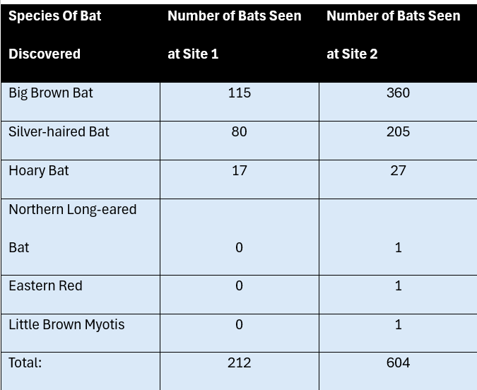

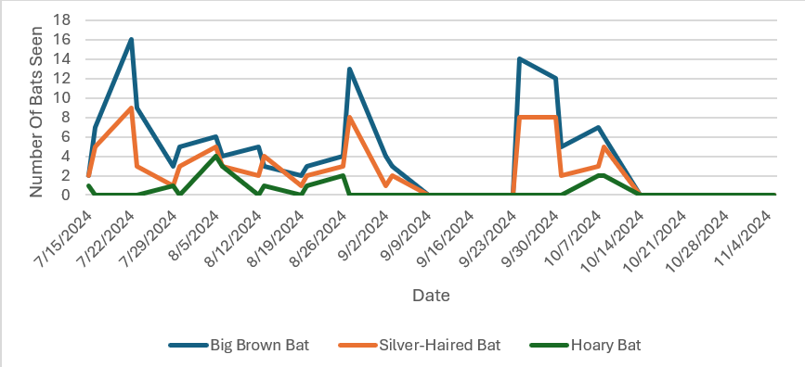
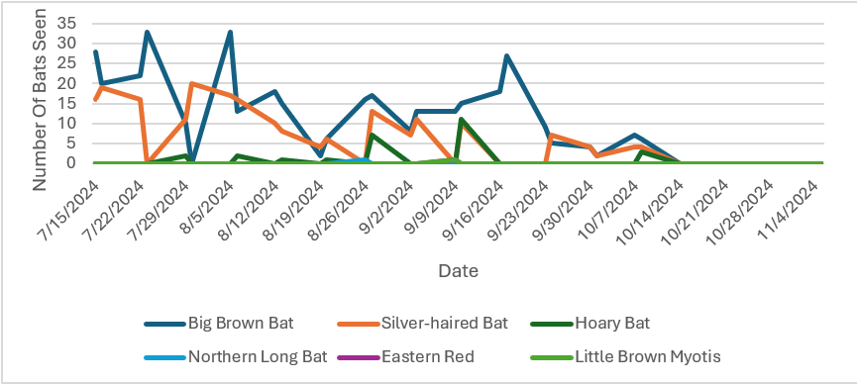
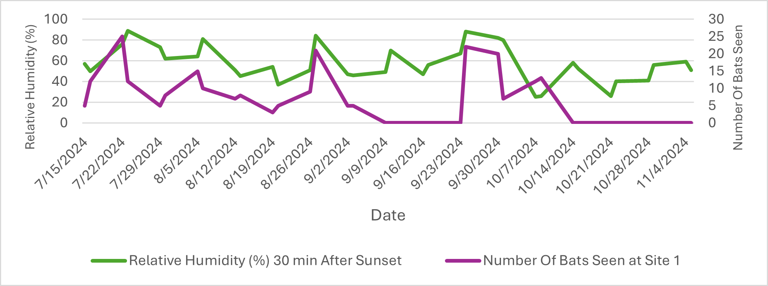
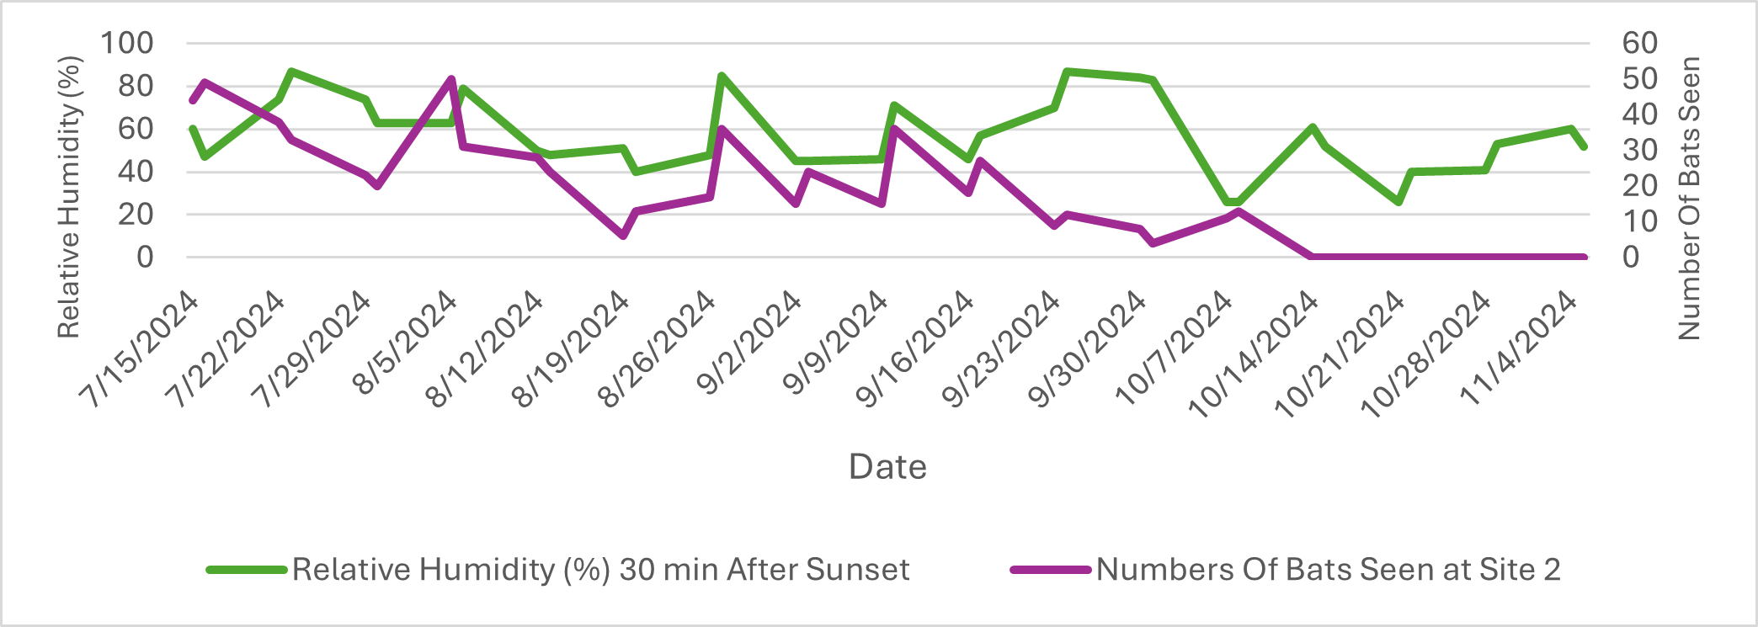
Figures 8 (top) and 9 (bottom). Figures 8 and 9 indicate the bat species composition at Site 1 and Site 2, respectively. There was a larger number of diverse bats at Site 2 with Northern Long Bat, Eastern Red Bat, and Little Brown Myotis being present alongside Big Brown Bats, Silver-haired Bats, and Hoary Bats (Figure 9). Site 1 had a smaller total number of bats, with only three species identified (Figure 8)
Figures 10 (top) and 11 (bottom). Figures 10 and 11 show the relative humidity (%) 30 minutes after sunset alongside bat presence at Site 1 and Site 2, respectively. At both sites, increased humidity correlated with more bats, likely due to higher insect populations providing more food. However, as humidity fluctuated and eventually declined later in the season, bat sightings also
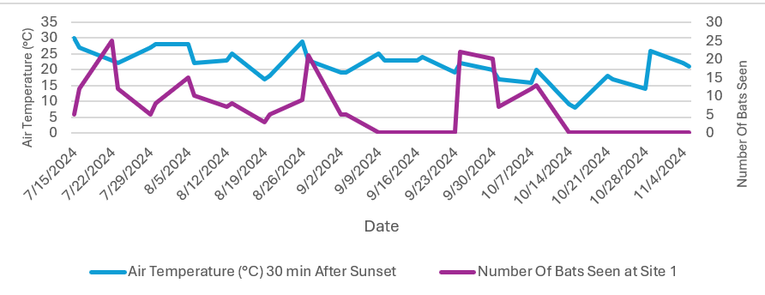
decreased, suggesting a possible seasonal shift or migration pattern.
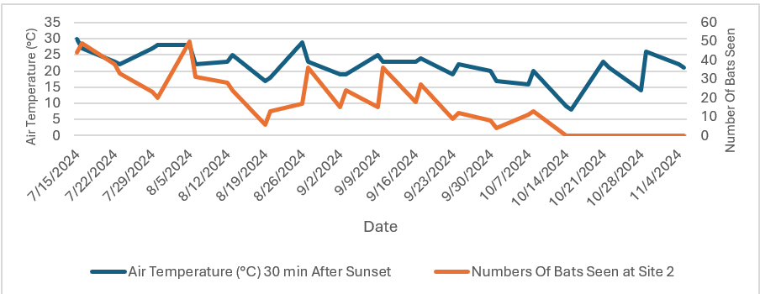
Figures 12 (top) and 13 (bottom). Figures 12 and 13 show the air temperature (°C) 30 minutes after sunset alongside bat presence at Site 1 and Site 2, respectively. At both sites, higher temperatures generally correlated with greater bat activity, likely due to more favorable foraging conditions and increased insect availability. However, as temperatures dropped later in the season, bat sightings decreased, indicating a possible seasonal shift or migration pattern.

GLOBE Data Analysis:
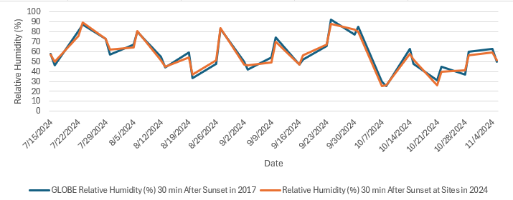
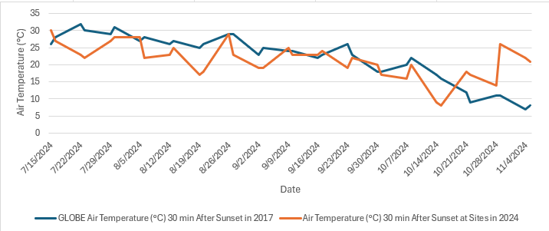

Figure 13 (top) and 14 (bottom). Figures 13 and 14 illustrate relative humidity and air temperature measured 30 minutes after sunset in both 2017 and 2024, highlighting key differences that could impact bat activity. In 2017, night temperatures were generally higher, ranging from 25°C to 32°C, while 2024 temperatures were more variable and often dropped below 25°C, especially in October, making nights noticeably cooler. Since bats rely on warmth for optimal foraging, these cooler nights in 2024 could reduce their activity. Humidity followed a similar trend, with 2017 ranging from approximately 30% to 90%, while 2024 had slightly lower values on some nights, often falling below 60%. Lower humidity can reduce insect populations, making food less available for bats. The increased variability in both temperature and humidity in 2024 suggests less favorable conditions for foraging, roosting, and migration, potentially leading to shifts in local bat populations over time.

Conclusion:
The findings and results of this study indicate that atmospheric parameters and suburban land use influence bat presence and activity drastically, undermining the hypothesis that environmental factors influence and affect bat presence and diversity. When there was greater tree cover and vegetation in addition to a low number of human disturbances, bat presence was at an increased volume, meanwhile bats that experience high amounts of human disturbances and light pollution along with a decreased amount of vegetation, struggle to hunt and show less active behavior. Again, the bats’ ability to serve as a tool for indication of bad environmental conditions makes them truly unique and equally important to the environment. This research is relevant as urban expansion is a current problem today, highlighting the need for conservation efforts to take place that incorporate green spaces and decreased light pollution to help the bat populations thrive and survive. Without these indicators from bats, humans have less of a chance of knowing when the environment is in a poor condition. While these findings were enlightening, future studies can be bettered by extending data collection for a longer duration to assess seasonality patterns and using more advanced acoustic analysis programs to make identification of species more accurate. To have several suburban locations with varied urbanization status would provide a clearer indication of how bats adapt to different surroundings. Future research may also investigate the influence of sources of pollution, noise intensity, or climate variation on bat activity. This project reiterates the necessity of systematic scientific inquiry and collaboration, particularly in the implementation of GLOBE protocols for accurate collection of environmental data. Future research must include community-based conservation approaches to engaging local stakeholders in the conservation of bat habitats.
The findings and results of this study indicate that atmospheric parameters and suburban land use influence bat presence and activity drastically, undermining the hypothesis that environmental factors influence and affect bat presence and diversity. When there was greater tree cover and vegetation in addition to a low number of human disturbances, bat presence was at an increased volume, meanwhile bats that experience high amounts of human disturbances and light pollution along with a decreased amount of vegetation, struggle to hunt and show less active behavior. Again, the bats’ ability to serve as a tool for indication of bad environmental conditions makes them truly unique and equally important to the environment. This research is relevant as urban expansion is a current problem today, highlighting the need for conservation efforts to take place that incorporate green spaces and decreased light pollution to help the bat populations thrive and survive. Without these indicators from bats, humans have less of a chance of knowing when the environment is in a poor condition.

While these findings were enlightening, future studies can be bettered by extending data collection for a longer duration to assess seasonality patterns and using more advanced acoustic analysis programs to make identification of species more accurate. To have several suburban locations with varied urbanization status would provide a clearer indication of how bats adapt to different surroundings. Future research may also investigate the influence of sources of pollution, noise intensity, or climate variation on bat activity. This project reiterates the necessity of systematic scientific inquiry and collaboration, particularly in the implementation of GLOBE protocols for accurate collection of environmental data. Future research must include community-based conservation approaches to engaging local stakeholders in the conservation of bat habitats. Overall, this study contributes to the new field of urban ecology, demonstrating the need for ecologically sound urban planning that can protect wildlife in addition to human life.

This research group would also like to see the elementary school students who attend schools adjacent to the study sites be included in enrichment and education regarding the important roles that bats play in natural ecosystems. This might include, but not be limited to, participation in STEM/STEAM curriculum nights, activities within classrooms, and perhaps even the opportunity to construct bat houses that could be installed in neighborhood backyards. More individuals need to know about the beneficial role that bats play in insect control and pollination. Everyone needs to be concerned about the detrimental effects of white nose syndrome on bat populations, how climate change removes food sources, and how regional light pollution might be limiting food sources.

Discussion:
Findings of the research confirm that there is a large difference in bat activity between Kinloch (Site 1) and Hillcrest (Site 2), with higher bat presence at Hillcrest. This is most likely due to the desirable bat habitat surrounding and within the study site. This supports the idea that habitat features, such as foliage cover, illumination, and total landscape arrangement, are significant factors influencing bat activity. The results strongly support the hypothesis that habitat, along with weather conditions such as humidity, temperature, pressure, and wind speed, influences bat movement and frequency patterns. Relative humidity percentage had the strongest correlation with bat presence at both sites, most likely because it affects insect populations, which are a primary food source for bats. Higher humidity allows insects to develop well, as noted in Williams (1951) in the Proceedings of the Royal Society of London and therefore increases bat foraging opportunities. Wind speed showed some correlation, potentially influencing insect flight and bat movement, but the data was inconsistent, suggesting that additional environmental factors contributed to this relationship. Similarly, barometric pressure was not evenly correlated with bat activity, sometimes aligning with higher bat presence and at other times showing an inverse relationship. This suggests that while barometric pressure may influence bat activity, it likely interacts with other environmental factors, including humidity and wind speed, in more complex ways. Temperature had a minimal immediate effect on bat activity but was significant during winter months, as decreasing temperatures marked the onset of bat hibernation. These findings indicate that short-term bat activity is primarily driven by humidity-related food availability, whereas long-term patterns are dictated by seasonal temperature changes affecting metabolic needs and hibernation cycles. The outcome of these experiments highlights the variability of bat behavior, demonstrating that weather conditions influence short-term fluctuations while habitat characteristics play a more consistent role in their distribution. Though the results align with expectations, potential sources of error must be considered. External factors such as machine malfunctions, human disturbances, and unpredictable weather fluctuations may have introduced variability in data collection. One significant external factor was the scheduling of high school soccer games near Kinloch, which introduced increased noise and artificial lighting. No bats were observed on these nights, reinforcing prior research that human disturbances, particularly excessive illumination and disruptive noise, negatively affect bat activity by altering feeding and flight routines. Compared to similar studies, these results align with broader scientific research on bat behavior and environmental influences. Research consistently shows that undisturbed, wooded areas support higher bat populations, while human-altered environments result in reduced bat activity. This study further supports the argument that preserving natural habitats is essential for maintaining stable bat populations. Locations with less artificial light, minimal noise, and adequate forest canopy provide ideal conditions for bat habitation. In summary, this research underscores the need for conservation efforts to minimize human interference in core bat habitats. Protecting these habitats ensures that bats can continue their ecological roles, such as pest control and pollination, without unnecessary disruption. These findings contribute to a broader understanding of how urbanization and habitat modification impact bat populations, emphasizing the importance of habitat conservation for their long-term survival.

Acknowledgements:
We would like to express our sincere gratitude to our incredible GLOBE Advisers, Ms. Lina Abbas and Diana Johns, for their unwavering support throughout the research process. Their guidance was invaluable, especially as we navigated the protocols for our first ever GLOBE IVSS research project. Our advisers continually sent our team various academic articles and links to sources that helped set up our research questions and give us background on the topic. We also extend our appreciation to our dedicated GLOBE Science Club officers including Hala Komaiha, Noor El Fadl, Aya Soubra, Layal Zbib, and Hannah Darwiche who generously offered their advice and assistance despite managing their own research commitments. Their willingness to help never wavered and their support was instrumental in our success. Finally, we are indebted to Mr. David Bydlowski of the GLOBE-NASA AREN Program that provided our school with the Vernier weather station we used to get weather data at both sites. In addition, the staff of the University of Toledo-Mission Earth were pivotal in providing other hardware resources we utilized in our project. The chance to conduct GLOBE Program research has ignited our curiosity and passion to continue to conduct research between junior and senior years in high school.

Bibliography:
O'Shea, Thomas J., et al. "Multiple mortality events in bats: a global review." Mammal Review, vol. 46, no. 3, 2016, pp. 175-190.
McGuire, Liam P., et al. "Wind speed alters nightly and seasonal patterns of bat activity at a wind farm." Journal of Mammalogy, vol. 99, no. 4, 2018, pp. 749-759.
Frey-Ehrenbold, Annina, et al. "Landscape connectivity, habitat structure and activity of bat guilds in farmland-dominated matrices." Journal of Applied Ecology, vol. 50, no. 1, 2013, pp. 252-261.
Plummer, Katherine E., et al. "The effect of habitat type on bat activity: A multi-year study in a wind farm landscape." Wildlife B0iology, vol. 2021, no. 1, 2021, article wlb.00828.
Weller, Theodore J., et al. "Bat activity rates do not predict bat fatality rates at wind energy facilities." Journal of Mammalogy, vol. 97, no. 6, 2016, pp. 1655-1668.
Gonsalves, Leroy, et al. "Barometric pressure triggers arousal from torpor in hibernating bats." PLOS ONE, vol. 8, no. 7, 2013, article e69207.
Rowse, Elizabeth G., et al. "Dark matters: The effects of artificial lighting on bats." Biodiversity and Conservation, vol. 25, no. 11, 2016, pp. 2153-2175.
Echo Meter Touch EM3+ User Manual: Wildlife Acoustics -http://www.wildlifeacoustics.com/echo-meter-touch/help.pdf

Appendix:
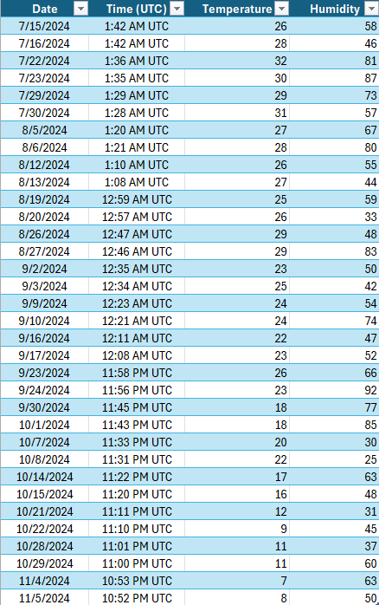
The table contains weather readings at a specific date and time between November and July 2024. It contains columns for the date, time (UTC), temperature (°C), and humidity (%). This data was contrasted between 2017 and 2024 to analyze how the difference in temperature and humidity influenced bat behavior and quantity.

Badges:
I Am a STEM Storyteller
Our group of committed researchers deserve this honorable badge for being committed to presenting our findings in a meaningful and captivating way. With our Instagram page, @batactivitydbh, we have creatively shared our research, spanning international relations and motivating others to pursue scientific study. By sharing our work with everyone and making it interesting, we facilitate knowledge being shared widely and inspire people to act for a cleaner environment.

I Am an Earth Systems Scientist
We have earned this badge through our relentless pursuit of learning about Earth's interdependent systems. Our research is applicable to actual environmental issues, employing scientific concepts and engineering principles to benefit our environment. We have strengthened our analysis through combining many varied approaches in coming together, showing how environmental variables interact and how collective action can solve global challenges.

I Am a Data Scientist
Our team deserves this award for our rigorous data gathering and analysis. We have utilized a data-driven approach in studying environmental concerns, applying logical reasoning and innovative solutions to make meaningful contributions. By sharing our results and interpretations, we not only enhance scientific knowledge but also encourage others to engage with data and research in meaningful ways.

