# Analyzing Relationships Between Tree Coverage and Surface Temperature at Five School Canopies in Dearborn Heights, Michigan.

Student Researchers:

Lamise Achkar, Elizabeth Aljouni, and Maria Amen

School:

Crestwood High School,

Dearborn Heights, MI 48127

Teacher:

Mrs. Diana Johns

March 5, 2025

**Table of Contents**

Abstract ............................................................................................................................... 3

Research Questions & Null Hypothesis .............................................................................. 3-4

Introduction and Review of Literature................................................................................. 4-5

Materials and Methods ........................................................................................................ 5-9

Data Summary ..................................................................................................................... 10-22

Data Analysis and Results ................................................................................................... 22-24

GLOBE Data Analysis ........................................................................................................ 24-25

Conclusions ......................................................................................................................... 25-26

Discussion ........................................................................................................................... 26-27

Acknowledgements ............................................................................................................. 27

Bibliography ....................................................................................................................... 27-28

Appendix ............................................................................................................................ 29-30

Badges ................................................................................................................................ 30-32

### **Abstract**

Urban canopies play a critical role in moderating temperatures and enhancing environmental sustainability. This GLOBE research study investigates the relationship between tree characteristics—species diversity, size, crown width, and Photosynthetically Active Radiation (PAR)—and temperature regulation across five school sites in the Crestwood School District. The study aimed to determine whether these factors impact air and surface temperatures, with the null hypothesis stating that tree characteristics have no measurable effect on temperature reduction. Data collection followed GLOBE protocols, utilizing forestry DBH tapes, the GLOBE Observer app, infrared thermometers, and Vernier probes to measure tree dimensions, temperature variations, and light availability. Multiple readings were recorded at each site to ensure data accuracy. Statistical analyses, such as correlation studies were used to assess the relationships between tree characteristics and temperature differences. Results indicated that areas with greater tree coverage exhibited lower surface temperatures, and trees with larger crowns contributed more significantly to cooling effects. However, correlations between tree height, DBH, and temperature reduction were weak, suggesting additional environmental factors influence temperature moderation. Similarly, weak correlations between PAR and crown width suggest that species composition and canopy density may play a larger role in light absorption. These findings led to the rejection of the null hypothesis, confirming that tree diversity, size, and canopy coverage contribute to urban heat mitigation. This research supports the importance of urban forests in reducing the urban heat island effect and improving climate resilience. By integrating tree planting strategies into urban planning, communities can create cooler, more sustainable environments.

### **Research Questions**

The following research questions guided the investigation of urban tree canopy characteristics and their possible effects on temperature in the Crestwood School District:

1. How do air and surface temperatures vary in different locations within the school district?
2. Does tree species diversity influence temperature regulation in urban environments?
3. Is there a relationship between tree size (DBH and height) and its ability to reduce surface temperature?
4. How does crown width affect the surrounding temperature and the amount of shade provided?

### **Null Hypothesis**

1. There is no significant difference in air and surface temperatures across different locations in the school district.
2. Tree species diversity does not have a measurable impact on temperature regulation.
3. Tree size (DBH and height) does not influence surface temperature reduction.
4. Crown width has no significant effect on temperature moderation or shading capacity.

### **Introduction and Review of Literature**

Urban Trees play a vital role in shaping the health and sustainability of urban environments, particularly in mitigating the effects of elevated urban temperatures and enhancing community well-being. Serving more than just greenery—they're vital components of city life. They play a key role in tackling environmental challenges like rising urban temperatures and declining air quality. This research focuses on the trees at The Crestwood School District, analyzing tree species diversity, tree size, crown width, Photosynthetically Active Radiation (PAR), and surface and air temperature data. By examining these factors, this research sought to uncover how urban trees improve the environment and contribute to healthier, more sustainable communities.

Elevated temperatures in cities, largely caused by the abundance of paved surfaces and built environments, create discomfort and strain for urban areas (Oke, 1982). Trees help cool these spaces by providing shade and releasing water vapor into the atmosphere, making cities more livable and resilient (Akbari et al., 2001). Research also shows that a diverse mix of tree species boosts the ability of urban canopies to withstand threats like pests, diseases, and extreme weather events while supporting local ecosystems (Santamour, 1990). Larger trees with wider crowns, in particular, are especially effective at reducing temperatures, cleaning the air, and capturing carbon dioxide, making them powerful tools in fighting climate-related issues (Nowak et al., 2002).

Measuring PAR helps reveal how sunlight interacts with trees, influencing their growth and ability to photosynthesize. This process not only sustains the trees themselves but also contributes to oxygen production and carbon absorption—both essential for a healthy environment (Niinemets, 1999). Additionally, analyzing temperature data, such as differences between shaded and unshaded areas, gives a clearer picture of how trees contribute to cooling their surroundings.

This study seeks to build on existing research by investigating how the urban canopy at Crestwood School Districts functions as a natural solution to urban environmental challenges. By combining species diversity, canopy structure, and environmental data. The goal is to provide insights that can guide future efforts to make cities greener, healthier, and more sustainable.

**Research Methods and Materials:**

Data was collected at five locations within the Crestwood School District: Crestwood High School, Riverside, Kinloch, Highview, and Hillcrest. To ensure consistency, all measurements followed GLOBE protocols for tree height, surface temperature, air temperature, and Photosynthetically Active Radiation (PAR). Researchers used multiple tools to gather data, including a forestry DBH tape for measuring tree diameter, an infrared thermometer for surface temperature readings, and the GLOBE Observer app for tree height measurements.

Tree species identification was conducted using a combination of the “What Tree is That?” field guide and the Leaf Snap app to verify accuracy. After selecting study trees, their locations were recorded using latitude and longitude coordinates. Each tree’s surrounding land cover type was classified using The University of New Hampshire’s Modified UNESCO Classification (MUC) system through GLOBE.

To assess tree size, researchers measured diameter at breast height (DBH) using a forestry DBH tape at 1.3 meters from the base of the tree. Tree height was recorded using the GLOBE Observer app, with at least two researchers independently taking multiple height measurements each. Crown width was measured using a 50-meter Keson measuring tape in both north-south and east-west directions to determine average canopy spread.

PAR data was collected using a Vernier Probe, with multiple measurements taken per location. To analyze temperature variations, air temperature was recorded following GLOBE protocol, while surface temperature was measured using an infrared thermometer. Multiple temperature readings were taken outside the tree’s canopy and within the shaded area underneath.

Once data collection was complete, all values were uploaded to the GLOBE database for further analysis. Equipment was stored properly to prevent damage from high temperatures or prolonged sun exposure, and no instruments were left inside vehicles.

These procedures allowed for a comprehensive analysis of tree characteristics and their role in urban temperature regulation. By collecting standardized data across multiple locations, the research aimed to quantify the cooling effects of trees and their potential role in mitigating urban heat island effect

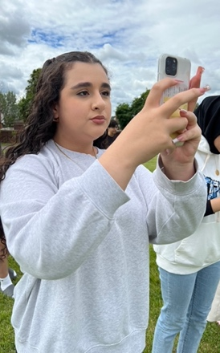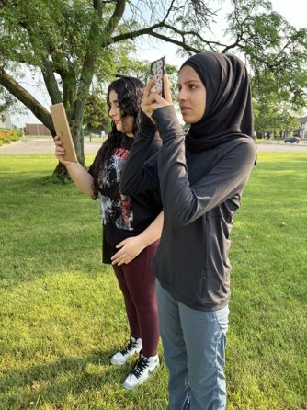

**Figure 1 (left) and Figure 2 (right) Using the GLOBE Observer App to measure tree height.** Standing 25 meters from a tree, photos were taken from base to top measuring height

.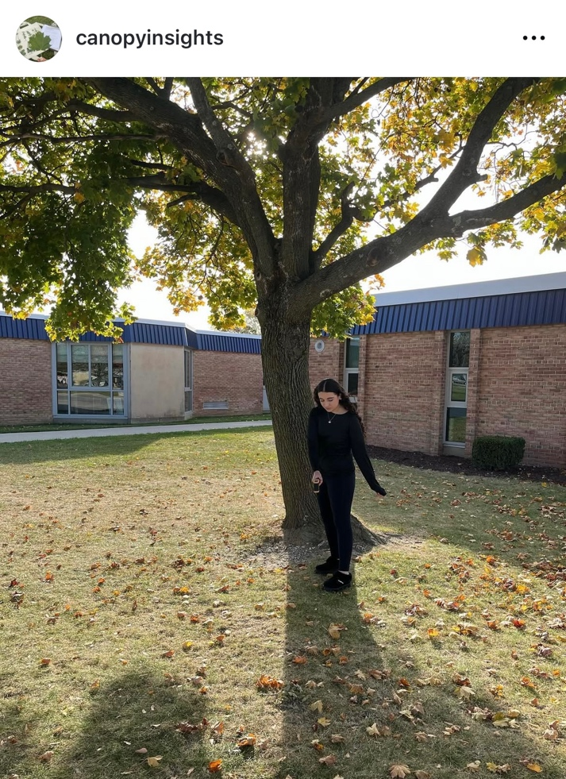

**Figure 3. Using the Infared thermometer to measure surface temperature.** Three measurements were taken inside and outside of the tree canopy gathering surface temperature.

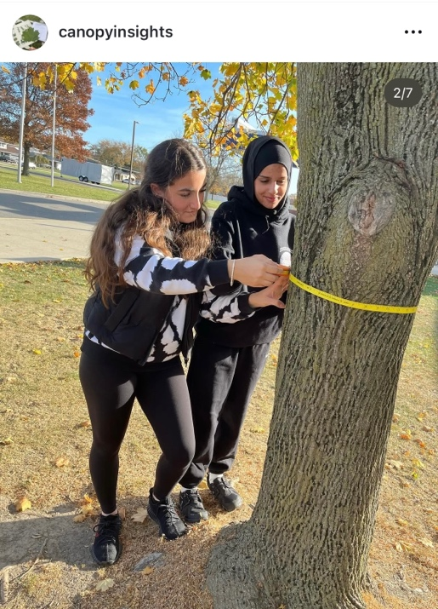

**Figure 4. With a forestry DBH tape measurements were taken of trees DBH.** After measuring 1.3 meters above ground a measure of trees diameter was taken.

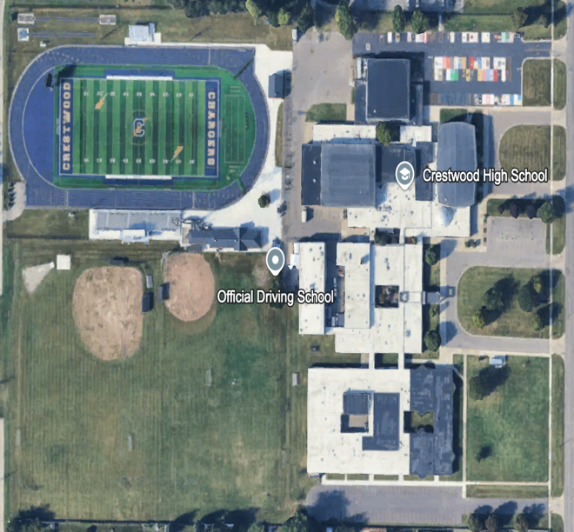

**Figure 5. Site 1 Crestwood High School.** Latitude:42.3196* N, Longitude: 83.2899*W

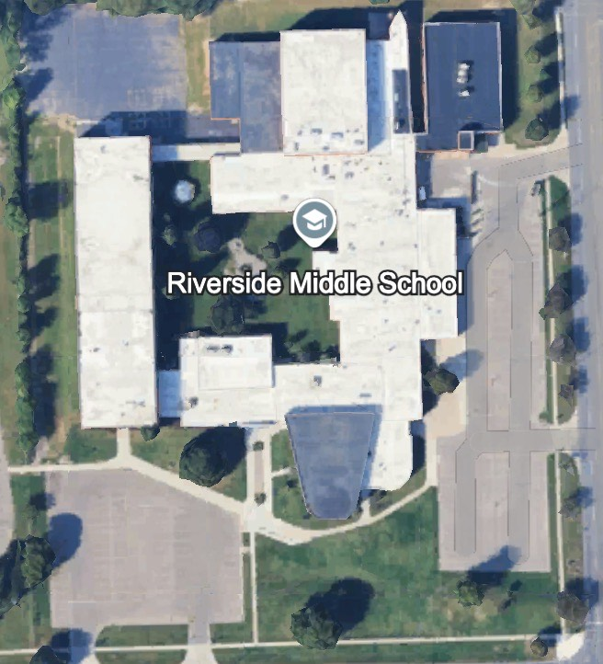

**Figure 6. Site 2 Riverside Middle School.** Latitude:42.3420* N, Longitude: 83.2938*W

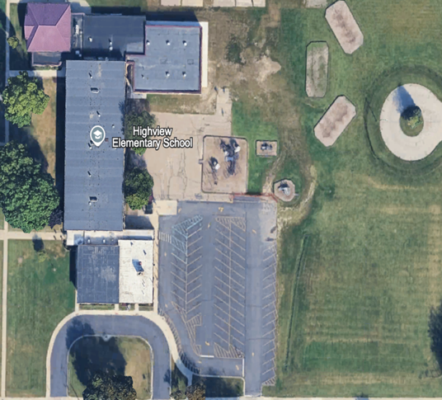

**Figure 7. Site 3 Highview Elementary School.** Latitude:42.3245* N, Longitude: 83.2856*W

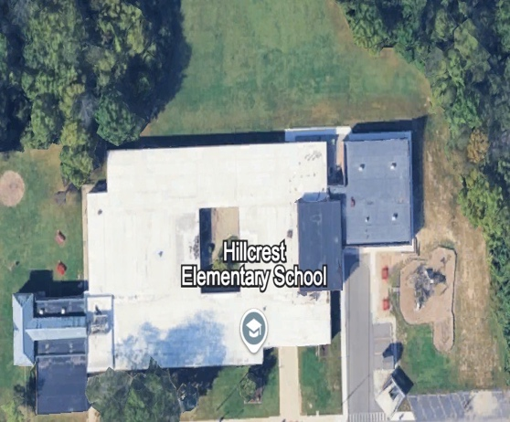

**Figure 8. Site 4 Hillcrest Elementary School.** Latitude:42.3198* N, Longitude: 83.2897*W

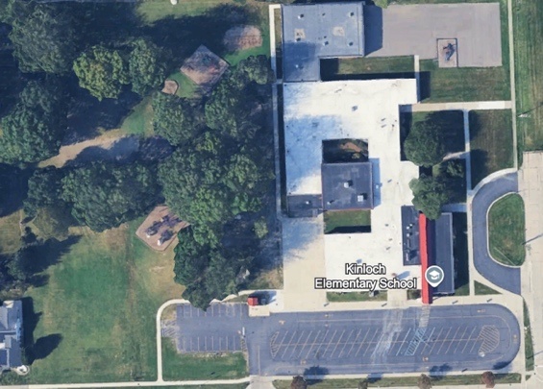

**Figure 9. Site 5 Kinloch Elementary School.** Latitude:42.3500* N, Longitude: 83.2880*W

### 

### **Data Summary**

#### Crestwood High School:

**Table 1**. **Tree Species Count.** This table presents the variety of tree species present at Crestwood High School, highlighting the total number of recorded trees.

|  |  |
| --- | --- |
| Row Labels | Count of Tree(Genus & Species) |
| Pinus *resinosa* (Red Pine) | 12 |
| Acer *platanoides* (Norway Maple) | 10 |
| Quercus *macrocarpa*(Burr Oak) | 6 |
| Gledistia *triqcanthos*(Honey locust) | 3 |
| Fraxinus *pennsylvanica*(Green Ash) | 2 |
| Celtis *occidentails*(Hackberry) | 2 |
| Tailia *americana*(American Basswood) | 2 |
| Acer *saccharinum*(Sliver Maple) | 1 |
| Carya *cordiformis*(Bitternut Hickory) | 1 |
| Quercus *palustris* (Pin Oak) | 1 |
| (blank) |  |

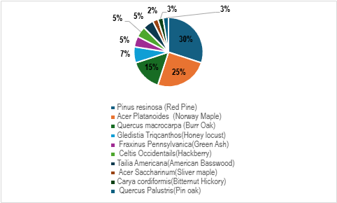

**Figure 10. Total Species Diversity.** This pie chart visually represents the proportion of each tree species within Crestwood High School.

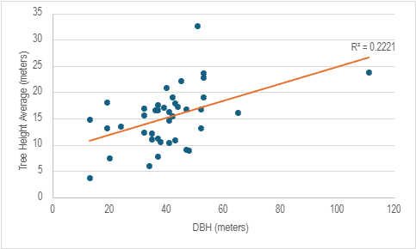

**Figure 11. Scatter Plot of Tree Height vs. DBH. This scatter plot compares tree height with diameter at breast height (DBH),** a common measure of tree size. The purpose of this graph is to analyze whether taller trees generally have larger diameters or if there is no significant correlation between height and DBH.

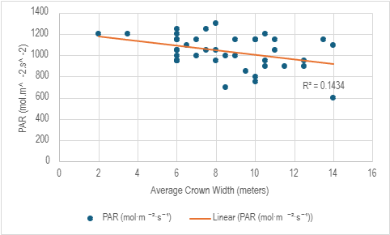

**Figure 12. Scatter Plot of PAR vs. Crown Width. This scatter plot illustrates the relationship between Photosynthetically Active Radiation (PAR) and crown width.** The purpose of this graph is to examine whether larger tree canopies influence the amount of light available for photosynthesis, potentially indicating a correlation between crown size and light penetration.

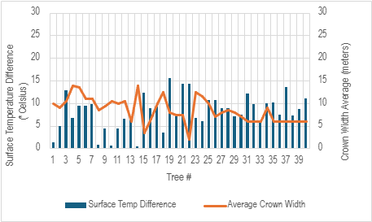

**Figure 13. Column Clustered Line Chart for Crown Width Average vs. Difference in Surface Temperatures (In vs. Out) for different trees**. This chart explores the relationship between crown width (the horizontal spread of a tree’s canopy) and surface temperature differences. By analyzing this trend, an assessment can be made on whether trees with larger crowns provide more shade and contribute more significantly to environmental cooling.

#### **Riverside Middle School**

**Table 2. Tree Species Count.** This table presents the variety of tree species present at Riverside Middle School, highlighting the total number of recorded trees.

|  |  |
| --- | --- |
| Tree(Genus & Species) | Count of Tree(Genus & Species) |
| *Ulmas americana*(American Elm) | 1 |
| *Acer platanoides*(Norway Maple) | 4 |
| *Liriodendron tulipifera*(Tulip poplar) | 1 |
| (blank) |  |
| Grand Total | 6 |

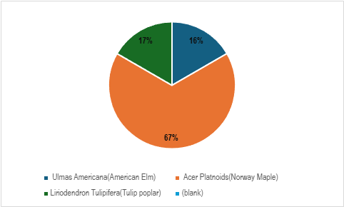

**Figure 14. Total Species Diversity.** This pie chart visually represents the proportion of each tree species within Riverside Middle School.

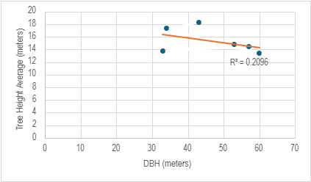

**Figure 15. Scatter Plot of Tree Height vs. DBH.** This scatter plot compares tree height with diameter at breast height (DBH), a common measure of tree size. The purpose of this graph is to analyze whether taller trees generally have larger diameters or if there is no significant correlation between height and DBH.

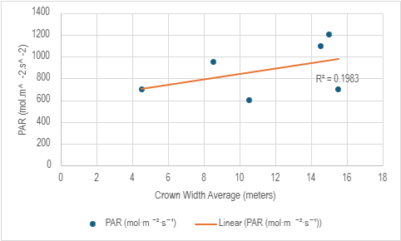

**Figure 16. Scatter Plot of PAR vs. Crown Width**. This scatter plot illustrates the relationship between Photosynthetically Active Radiation (PAR) and crown width. The purpose of this graph is to examine whether larger tree canopies influence the amount of light available for photosynthesis, potentially indicating a correlation between crown size and light penetration.

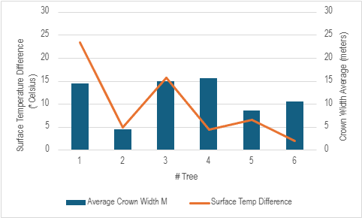

**Figure 17. Column Clustered Line Chart for Crown Width Average vs. Difference in Surface Temperatures (In vs. Out) for different trees.** This chart explores the relationship between crown width (the horizontal spread of a tree’s canopy) and surface temperature differences. By analyzing this trend, an assessment can be made on whether trees with larger crowns provide more shade and contribute more significantly to environmental cooling

#### **Kinloch Elementary School:**

**Table 3. Tree Species Count.** This table presents the variety of tree species present at Kinloch Elementary school, highlighting the total number of recorded trees.

|  |  |
| --- | --- |
| Tree(Genus & Species) | Count of Tree(Genus & Species) |
| *Tilia americana* (American Basswood) | 6 |
| *Acer platanoides*(Norway Maple) | 8 |
| *Quercus rubra*(Red Oak) | 15 |
| (blank) |  |
| Grand Total | 29 |

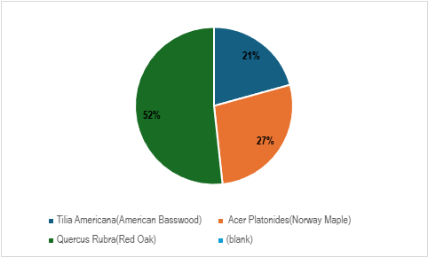

**Figure 18. Total Species Diversity.** This pie chart visually represents the proportion of each tree species within the study area at Kinloch Elementary school.

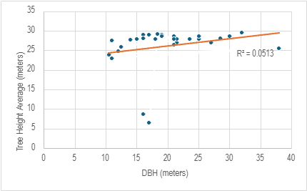

**Figure 19. Scatter Plot of Tree Height vs. DBH.** This scatter plot compares tree height with diameter at breast height (DBH), a common measure of tree size. The purpose of this graph is to analyze whether taller trees generally have larger diameters or if there is no significant correlation between height and DBH.

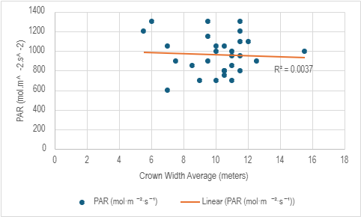

**Figure 20. Scatter Plot of PAR vs. Crown Width.** This scatter plot illustrates the relationship between Photosynthetically Active Radiation (PAR) and crown width. The purpose of this graph is to examine whether larger tree canopies influence the amount of light available for photosynthesis, potentially indicating a correlation between crown size and light penetration.

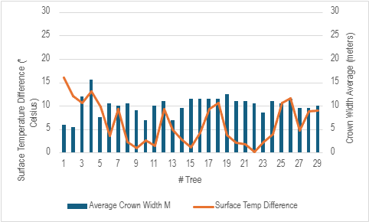

**Figure 21. Column Clustered Line Chart for Crown Width Average vs. Difference in Surface Temperatures (In vs. Out) for different trees**. This chart explores the relationship between crown width (the horizontal spread of a tree’s canopy) and surface temperature differences. By analyzing this trend, an assessment can be made on whether trees with larger crowns provide more shade and contribute more significantly to environmental cooling.

### ***Highview Elementary School:***

**Table 4. Tree Species Count.** This table presents the variety of tree species present at Highview Elementary school, highlighting the total number of recorded trees.

|  |  |
| --- | --- |
| Tree(Genus & Species) | Count of Tree(Genus & Species) |
| *Acer platanoides*(Norway Maple) | 4 |
| *Quercus* *rubra*(Red Oak) | 2 |
| (blank) |  |
| Grand Total | 6 |

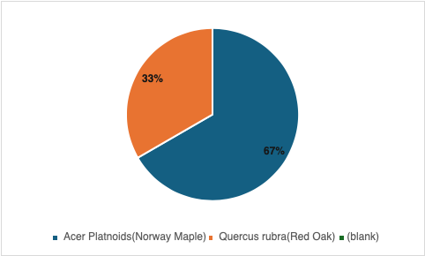

**Figure 22. Total Species Diversity.** This pie chart visually represents the proportion of each tree species within Highview Elementary school.

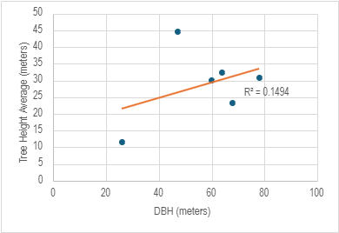

**Figure 23. Scatter Plot of Tree Height vs. DBH.** This scatter plot compares tree height with diameter at breast height (DBH), a common measure of tree size. The purpose of this graph is to analyze whether taller trees generally have larger diameters or if there is no significant correlation between height and DBH.

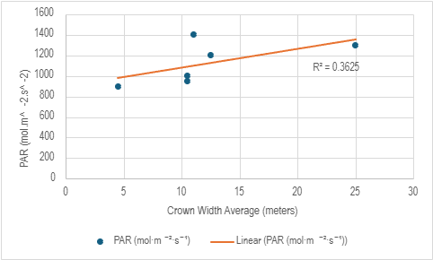

**Figure 24. Scatter Plot of PAR vs. Crown Width. This scatter plot illustrates the relationship between Photosynthetically Active Radiation (PAR) and crown width.** The purpose of this graph is to examine whether larger tree canopies influence the amount of light available for photosynthesis, potentially indicating a correlation between crown size and light penetration.

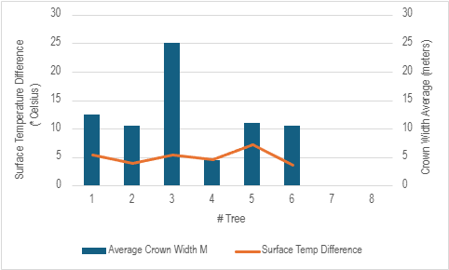

**Figure 25. Column Clustered Line Chart for Crown Width Average vs. Difference in Surface Temperatures (In vs. Out) for different trees.** This chart explores the relationship between crown width (the horizontal spread of a tree’s canopy) and surface temperature differences. By analyzing this trend, an assessment can be made on whether trees with larger crowns provide more shade and contribute more significantly to environmental cooling.

### ***Hillcrest Middle School***

**Table 5. Tree Species Count.** This table presents the variety of tree species present at Hillcrest Elementary school, highlighting the total number of recorded trees.

|  |  |
| --- | --- |
| Tree(Genus & Species) | Count of Tree(Genus & Species) |
| *Celtis occidentalis*(Hackle Berry) | 1 |
| *Pinus resinosa*(Red Pine) | 1 |
| (blank) |  |
| Grand Total | 2 |

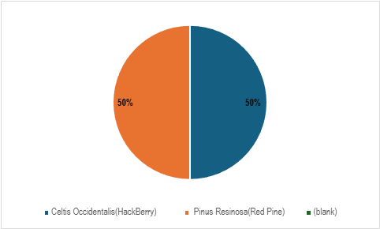

**Figure 26. Total Species Diversity**. This pie chart visually represents the proportion of each tree species within Hillcrest Elementary school.

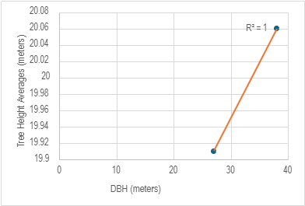

**Figure 27. Scatter Plot of Tree Height vs. DBH.** This scatter plot compares tree height with diameter at breast height (DBH), a common measure of tree size. The purpose of this graph is to analyze whether taller trees generally have larger diameters or if there is no significant correlation between height and DBH.

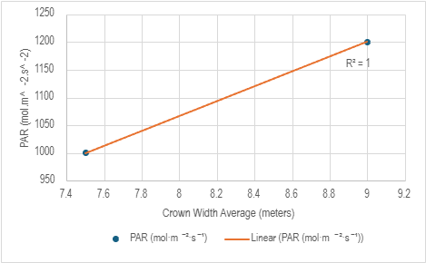

**Figure 28. Scatter Plot of PAR vs. Crown Width.** This scatter plot illustrates the relationship between Photosynthetically Active Radiation (PAR) and crown width. The purpose of this graph is to examine whether larger tree canopies influence the amount of light available for photosynthesis, potentially indicating a correlation between crown size and light penetration.

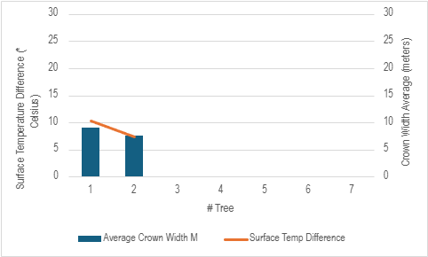

**Figure 29. Column Clustered Line Chart for Crown Width Average vs. Difference in Surface Temperatures (In vs. Out) for different trees.** This chart explores the relationship between crown width (the horizontal spread of a tree’s canopy) and surface temperature differences. By analyzing this trend, an assessment can be made on whether trees with larger crowns provide more shade and contribute more significantly to environmental cooling.

### **Data Analysis and Results:**

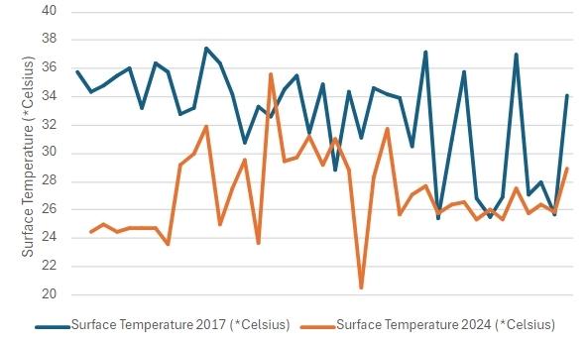

**Figure 30. Visualization: Line graph of surface temperature in two different time periods.** This line graph represents a comparison in trend of summer surface temperature during two time periods of varying tree densities (2024 more dense, 2017 less dense) at Crestwood.

The research aimed to uncover the impact of trees on urban environments within the Crestwood School Districts by examining tree species, size, and temperature effects. At Crestwood, the primary species included *Pinus reinosa* (Red Pine), *Acer platanoides* (Norway Maple), and *Quercus macrocarpa* (Bur Oak). Riverside featured a dominance of *Acer platanoides* (Norway Maple), while Kinloch presented *Quercus rubra* (Red Oak) as the most common species. Highview and Hillcrest highlighted *Acer rubrum* (Red Maple) and *Quercus rubra* (Red Oak). The analysis revealed a moderate correlation between tree height and Diameter at Breast Height (DBH) at Crestwood (R² = 0.221), suggesting that larger trees tend to be taller. This moderate R² value indicates a weak positive correlation, meaning that approximately 22% of the variation in tree height can be explained by DBH. This suggests that while there is some relationship between the two variables, other factors likely influence tree growth as well. In contrast, weaker correlations at Riverside (R² = 0.104) and Kinloch (R² = 0.051) indicated that other factors might be affecting tree growth more significantly than DBH. These low R² values reflect very weak correlations, with only 10% and 5% of the variation in tree height explained by DBH at Riverside and Kinloch, respectively. Such low R² values provide evidence that there is little to no correlation between DBH and tree height, suggesting that other environmental or biological factors are influencing growth beyond just the tree size. Trees with larger DBH values generally correspond to older, more established trees, which offer greater benefits like shade and air quality improvement. However, the weak correlations at Riverside and Kinloch suggest that factors like species, local environmental conditions, or even soil quality might be more influential in these locations. Crown width analysis showed that trees with larger crowns significantly reduced surface temperatures across Crestwood, Riverside, and Kinloch, highlighting the importance of maintaining a diverse and healthy urban canopy to combat urban heat. Temperature data confirmed that areas with dense tree cover exhibited lower air and surface temperatures, emphasizing the role of trees in creating a more comfortable and sustainable urban environment. An examination of Photosynthetically Active Radiation (PAR) data revealed weak correlations between crown width and PAR at Crestwood (R² = 0.104) and Kinloch (R² = 0.030), suggesting that other factors like species and canopy density may influence PAR levels. The low R² values here again indicate weak relationships, supporting the notion that other variables, such as tree species and canopy structure, could be influencing PAR data. Statistical analysis included descriptive statistics such as mean, median, and standard deviation. For example, the R² values provided insights into the strength of correlations between variables, where higher R² values indicate a stronger relationship. The R² value at Crestwood (0.221) suggests a weak correlation between DBH and tree height, but the low values at Riverside (0.104) and Kinloch (0.051) suggest much weaker relationships, meaning that other factors beyond tree size might be affecting tree growth. We used linear regression equations (y = mx + b) to model relationships between variables. In this equation, y represents the dependent variable (tree height), x the independent variable (DBH), m the slope (indicating how much y changes for a change in x), and b the intercept (the value of y when x is 0). The r value helps us understand the strength of these relationships. At Crestwood, the r value of 0.221 shows a weak positive relationship, indicating that as DBH increases, tree height increases, but other factors likely play a role in the variation of tree height. At Riverside and Kinloch, the very low r values suggest that the relationship between DBH and tree height is negligible, supporting the evidence for weak correlations. No correlation was analyzed found when the r² values are very low, indicating weak or no linear relationships. For example, Riverside, with an R² value of 0.104, shows that only about 10% of the variation in tree height is explained by DBH, which suggests that other factors may be influencing the results. Kinloch, with an R² value of 0.051, has an even weaker correlation, indicating that less than 5% of the variation in tree height can be explained by DBH. These low R² values provide evidence that the relationship between the variables is very weak or nearly nonexistent, suggesting the need to account for additional influencing factors not included in the study. Several experimental errors were considered to ensure accuracy in the findings. Measurement error stemmed from the variability in measuring tree dimensions and temperatures. Sampling error resulted from the limited sample size, which might not fully represent the entire urban canopy. Instrumental error related to the calibration and precision of the tools used. Additionally, uncertainties in the data set arose from natural variability (differences in tree growth rates and environmental conditions), measurement accuracy, and data collection methods. This research underscores the critical role trees play in urban environments, highlighting the need for diverse and healthy urban canopies to foster sustainable, resilient cities. By understanding these trends and addressing uncertainties, the study lays a foundation for informed urban planning and green infrastructure development.

**GLOBE Data Analysis:**

The findings from this data demonstrate the significant role that trees play in moderating urban heat within the Crestwood School District, with diverse tree species and larger tree sizes contributing to temperature regulation. Tho disproving the null hypothesis stating tree size and species diversity would not influence temperature regulation. The data aligns with a multitude of previous research, such as that conducted by Crestwood students, Itidal Bazzi and Zeina Jebara (2020), in The Effects of Native Tree Species on Ambient Air and Surface Temperatures in Southeastern Michigan, where trees such as *Tilia americana* (Basswood) were found to be particularly effective in cooling the urban environment. However, the study revealed that other species, like *Quercus macrocarpa* (Bur Oak) and *Acer platanoides* (Norway Maple), also show substantial cooling effects, suggesting that tree species diversity is a key factor in urban canopy performance. In comparison to the previously published research by Crestwood students Itidal Bazzi and Zeina Jebara (2020), and findings support the growing body of evidence highlighting the importance of urban tree canopies in combating heat and improving environmental quality. Further studies could expand on these findings by investigating the synergistic effects of combining trees with other green infrastructure, such as green roofs or permeable surfaces, to enhance urban cooling and sustainability. This research serves as a foundation for future efforts in urban ecology and climate resilience.

### **Conclusion**

Understanding the vital role of urban trees in environmental sustainability, research examined their impact within the Crestwood School District, revealing how species diversity, tree size, and canopy coverage influence temperature regulation and air quality. Findings show that maintaining diverse urban forests significantly mitigates the urban heat island effect, reinforcing the need for strategic urban planning. Crestwood’s predominant species—*Pinus resinosa* (Red Pine), *Acer platanoides* (Norway Maple), and *Quercus macrocarpa* (Bur Oak)—exhibited a moderate correlation between tree height and Diameter at Breast Height (DBH), suggesting that taller trees tend to have larger diameters and thus offer greater environmental benefits. In contrast, weaker correlations at Riverside and Kinloch suggest that external factors influence tree growth. A crown width analysis confirmed that trees with expansive canopies substantially reduced surface temperatures at Crestwood, Riverside, and Kinloch, emphasizing the critical role of urban greenery in mitigating heat stress. Temperature data supported this conclusion, demonstrating significantly lower air and surface temperatures in densely forested areas, while Photosynthetically Active Radiation (PAR) analysis indicated that species composition and canopy density influence light availability more than crown width alone. These findings disprove the null hypothesis, providing concrete evidence that tree diversity, size, and canopy coverage directly affect urban temperature regulation. The conclusions align with foundational studies in urban forestry, including Oke’s (1982) research on the urban heat island effect and Akbari et al.’s (2001) findings on heat island mitigation, both of which affirm that urban vegetation plays a crucial role in reducing heat retention. Santamour’s (1990) principles on tree diversity, Nowak’s (2002) insights on the economic and ecological benefits of preserving large trees, and Niinemets’ (2010) research on photosynthesis further validate results, demonstrating that diverse urban forests provide unparalleled environmental advantages. By proving that trees not only enhance air quality but also serve as natural climate regulators, The study conducted underscores the urgent need for policies promoting urban canopy expansion. These results offer a compelling case for data-driven urban planning, ensuring sustainable and resilient cityscapes. Future research should explore additional variables such as soil quality, long-term temperature trends, and species-specific growth patterns to deepen understanding of urban forestry’s role in climate adaptation and environmental resilience.

### **Discussion:**

This study confirms that urban tree canopies significantly mitigate the urban heat island effect, as demonstrated through data collection on tree species diversity, size (DBH and height), crown width, and coverage, alongside air and surface temperature measurements. The results showed a clear correlation between greater tree coverage and lower temperatures, disproving the null hypothesis that tree characteristics would have no significant impact on temperature regulation. If repeated, improvements such as integrating LiDAR and drone technology for precise canopy mapping would enhance measurement accuracy and minimize human error. Expanding data collection across seasons would provide a more comprehensive understanding of long-term cooling effects, while increasing the sample size across diverse urban environments would improve the generalizability of results. Comparisons with prior research reinforce these findings. Nowak et al. (2017) demonstrated that urban trees play a critical role in temperature regulation and air quality improvement, aligning with this study’s conclusions. Similarly, research conducted by Crestwood High School students Itidal Bazzi and Zeina Jebara found that native tree species in Southeastern Michigan effectively reduce surface and ambient air temperatures, further supporting the observed cooling effects. These findings extend beyond the classroom, emphasizing the necessity of strategic green infrastructure in urban planning to combat rising temperatures and improve public health. Future studies could explore the interactions between tree density, soil composition, and water availability to optimize urban canopy effectiveness. By refining data collection methods and expanding research parameters, this study contributes to the advancement of sustainable, climate-resilient urban environments.

**Acknowledgements:**

This research would not have been possible without the support and guidance of several individuals and institutions. Sincere appreciation is extended to GLOBE instructor Mrs. Diana Johns for her mentorship and expertise, as well as to her advisor, Mrs. Abbas, for providing valuable feedback throughout the research process. Crestwood High School is acknowledged for offering the necessary resources and an environment that fostered scientific inquiry. The GLOBE Program played a crucial role in facilitating data collection and analysis, particularly through the use of the GLOBE Observer App, while the LeafSnap application was instrumental in tree species identification. Additionally, gratitude is expressed to the researchers and institutions whose published studies on urban heat islands, tree canopy diversity, and environmental sustainability provided a strong foundation for data analysis and interpretation. Their contributions continue to advance knowledge in the field and support efforts toward more sustainable urban planning.

### **Bibliography**

Retrieved from Akbari, H., & Rose, L. S. (2008). Urban Surfaces and Heat Island Mitigation Potentials. Journal of the Human-Environment System, 11(2), 85–101. https://doi.org/10.1618/jhes.11.85

Bazzi, I., & Jebara, Z. (2020). The effects of native tree species on ambient air and surface temperatures in Southeastern Michigan. Crestwood High School, Dearborn Heights, MI. Retrieved from the GLOBE website.

Niinemets, Ü. (2010). Ecophysiology of photosynthesis in trees. Scientific Research Publishing. Retrieved from<https://www.scirp.org/reference/referencespapers?referenceid=1975846>

Nowak, D. J. (2002). Environmental and economic benefits of preserving large trees in urban landscapes. USDA Forest Service. Retrieved from<https://www.nrs.fs.usda.gov/pubs/jrnl/2002/ne_2002_nowak_001.pdf>

Oke, T. R. (1982). The energetic basis of the urban heat island. Boundary-Layer Meteorology, 10(1), 29-39. Retrieved from<https://www.patarnott.com/pdf/Oake1982_UHI.pdf>

Santamour, F. S. (1990). Trees for urban planting: Diversity, uniformity, and common sense. DeepRoot Urban Tree Blog. Retrieved from<https://www.deeproot.com/blog/blog-entries/is-the-10-20-30-rule-for-tree-diversity-adequate>

### **Appendix:**

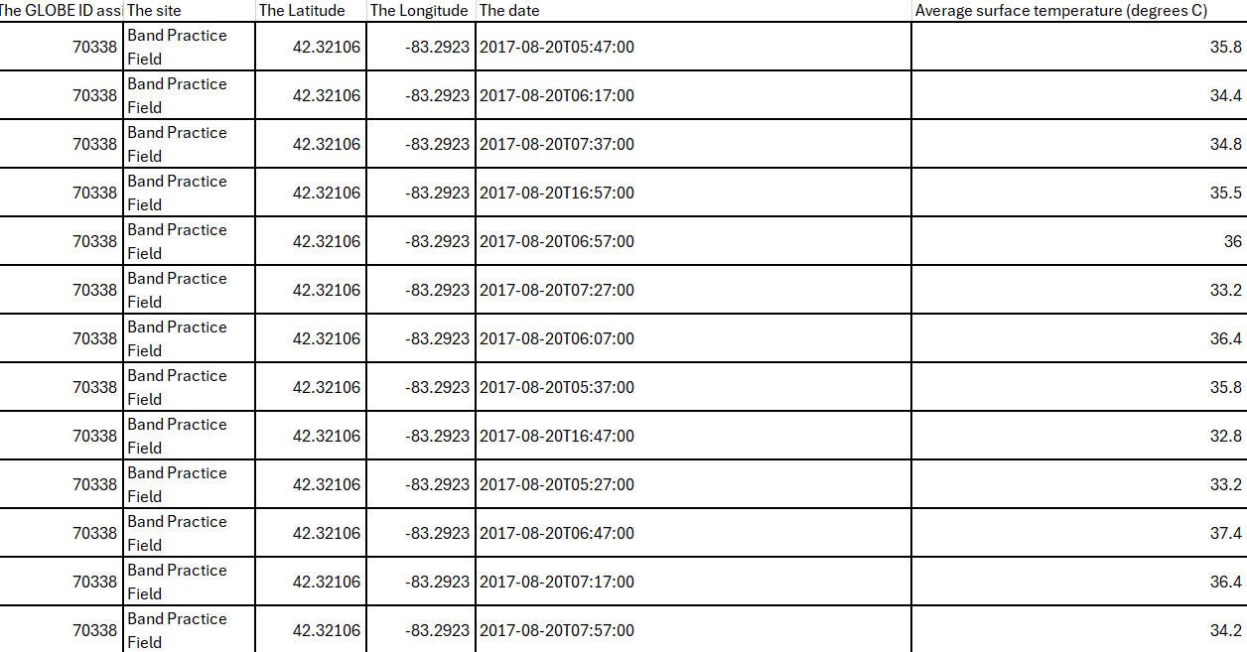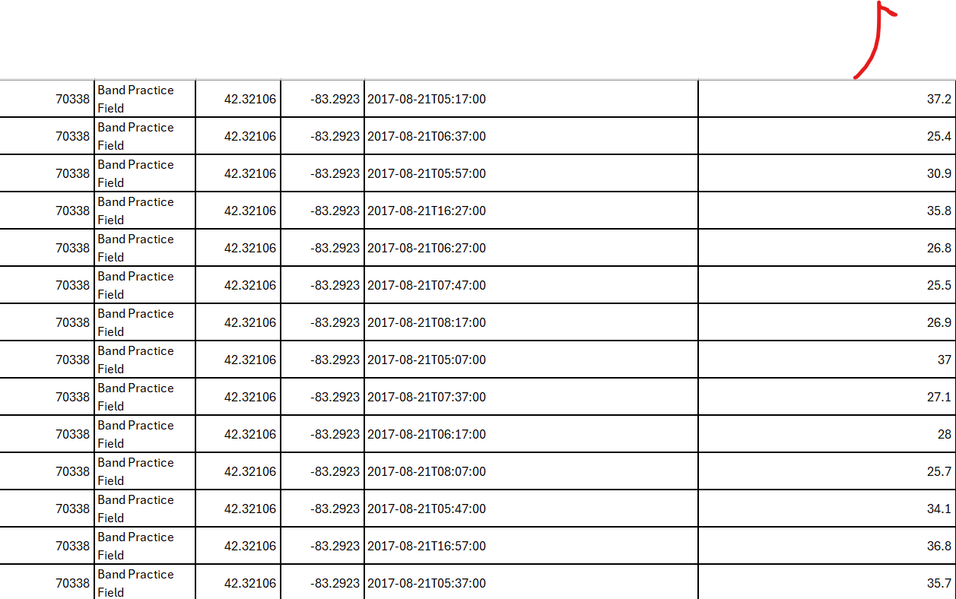 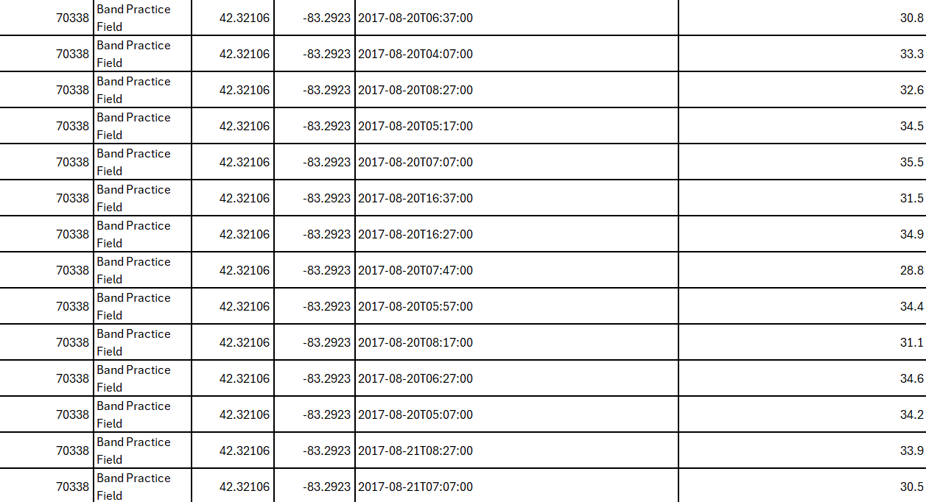￼

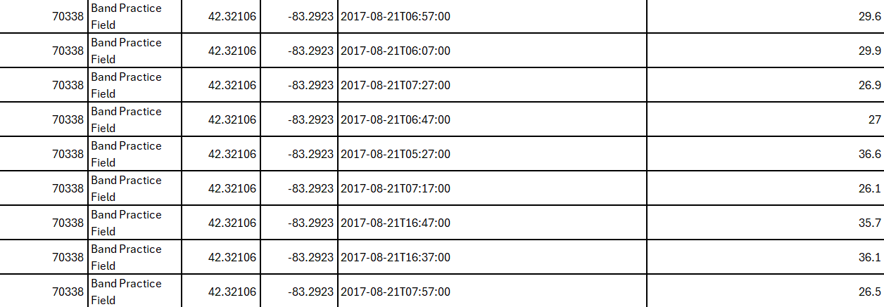

Raw Data of previous Crestwood Surface Average Temperature Values gathered using the Globe Advanced Data Access tool.

### **Badges:**

Based on their research on how trees impact the urban environment, the group is confident that they are deserving of the following GLOBE badges:

**1. I Am a Data Scientist**

The group has demonstrated strong data collection and analysis skills throughout their study on the effects of tree species diversity, tree size, and canopy coverage on urban temperatures. By gathering and analyzing key data on tree size (DBH and height), temperature (air and surface), and photosynthetically active radiation (PAR), they have exhibited an impressive ability to interpret and present meaningful results. Through their use of scatter plots, pie charts, and column charts, they have illustrated the direct impact of tree characteristics on urban heat mitigation. With confidence in their data analysis abilities, they are hopeful to earn the I Am a Data Scientist badge for their outstanding application of scientific data in addressing urban environmental issues.

**2. I Make an Impact**

The group is hopeful that their research will have a lasting impact on both local and global scales. Their study provides valuable insights into how tree species and canopy structures can cool urban environments, offering concrete data that could inform better urban planning and environmental policies. By demonstrating the positive effects of trees in mitigating the urban heat island effect and enhancing urban biodiversity, they are contributing to the movement for greener, more sustainable cities. The group is confident that their findings will not only benefit their local community but will also help advocate for greener infrastructure in cities globally, making them hopeful to receive the I Make an Impact badges.

**3. I Am a STEM Professional**

The group has approached this research with professionalism and dedication, reflecting the true spirit of STEM disciplines. Their thorough methodology in collecting and analyzing data, along with their ability to apply GLOBE protocols in the field, highlights their growing expertise in environmental science. Their collaboration with their instructor, Diana Johns, and advisor, Mrs. Abbas, has further solidified their approach to research and data integrity. Given their commitment to using scientific methods and their growing expertise, they are confident that they have earned the I Am a STEM Professional badge for their high level of professionalism and contributions to the environmental sciences.

**4.I am a Student Researcher**

### This research embodies the principles of student-led scientific inquiry through the formulation of research questions, systematic data collection, and thorough analysis. Investigating the impact of urban tree canopies on temperature regulation, the team followed GLOBE protocols to ensure accuracy and reliability. Using scientific tools such as forestry DBH tapes, infrared thermometers, Vernier probes, and the GLOBE Observer app, they gathered precise measurements across five locations in the Crestwood School District. Statistical analysis, including correlation studies and regression models, revealed that tree coverage significantly reduces surface temperatures, leading to the rejection of the null hypothesis. By following a structured methodology, critically evaluating findings, and contributing meaningful environmental data, this research demonstrates a strong commitment to the scientific process and qualifies for the “I Am a Student Researcher” badge.

**5.I am a Storyteller**

The research team confidently hopes to earn the I Am a Storyteller badge for effectively communicating their findings through an Instagram account dedicated to documenting their research. By sharing data visualizations, temperature analyses, and insights on urban tree canopies, they made complex environmental science accessible to the public. Their posts highlighted the role of tree diversity in cooling cities and improving sustainability, engaging students, educators, and community members. This outreach aligns with GLOBE’s mission of promoting citizen science, demonstrating how research can inspire action beyond academic settings. Through visual storytelling, the team successfully translated scientific data into meaningful discussions, making a strong case for earning this badge.

In conclusion, the group is confident that their rigorous data collection, impact on urban sustainability, professionalism, and collaboration will earn them the I Am a Data Scientist, I Make an Impact, I Am a STEM Professional, I am a Student Researcher badges, and I am a Story Teller. They are hopeful that these badges will reflect their hard work and dedication to advancing environmental science, contributing to the development of greener, more sustainable urban spaces for communities around the world. 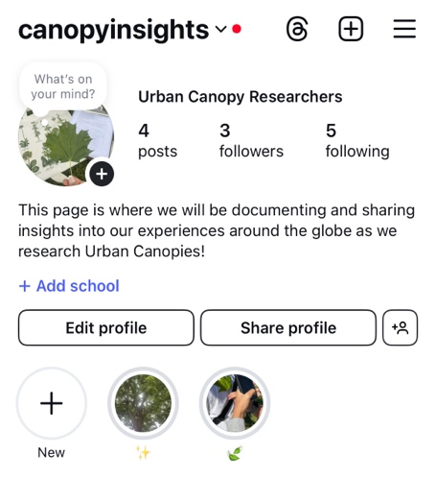 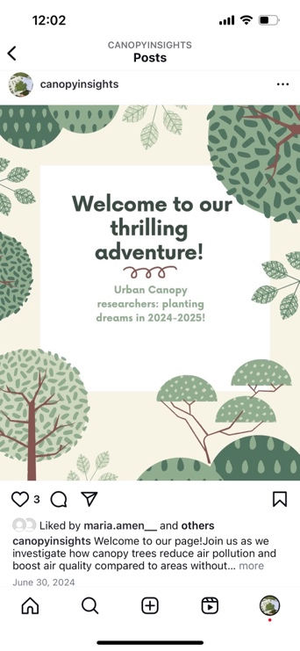 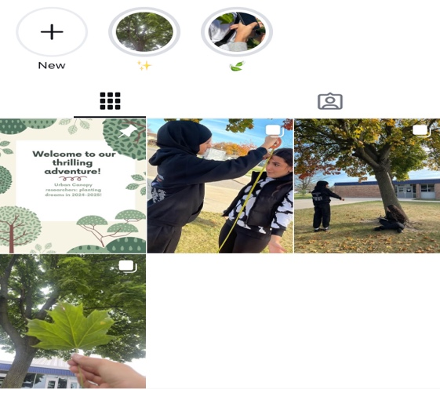

**Figure 31 (left), 32 (middle) and 33 (right). Documentation of Urban Canopy Research.** The team effectively managed to portray their work through a variety of detailed Instagram posts.