**Srednja škola Čakovec**

Čakovec 40 000

Jakova Gotovca 2

040 314 108, [ured@ss-cakovec.skole.hr](mailto:ured@ss-cakovec.skole.hr).

Denis Horvat, prof. 098 934 8270, [denis.horvat3@skole.hr](mailto:denis.horvat3@skole.hr)

Željka Krauthaker, prof.

Students: Luka Forgač (1. d), Nika Kuzmić (2. a), Tia Todorović (2. b)

**Medicinska škola Varaždin**

Varaždin 42 000

Vinka Međerala11

042 492 000, [ured@ss-medicinska-vz.skole.hr](mailto:ured@ss-medicinska-vz.skole.hr)

Marija Krajnik, prof. 091 505 66 23, [marija.krajnik@skole.hr](mailto:marija.krajnik@skole.hr)

Mirela Turk, prof. 097 752 08 56, [mirela.turk3@skole.hr](mailto:mirela.turk3@skole.hr)

Students: Lana Puškadija (3. a), Iva Fadiga (3. b), Luna Rodić (3. b)

**What kind of fertilizer favors the soil quality in Međimurje County for pumpkin cultivation**

**Summary of the work in English language**

With this study we wanted to prove the influence of fertilizers on the growth rate of pumpkin seedlings and young pumpkin plants. We also investigated which type of fertilizer (natural or artificial) is most suitable for the growth rate of pumpkin seedlings and young pumpkin plants. For the study itself, a soil sample was taken in Kotoribain Međimurje County. The sampling was carried out according to the GLOBE protocol for soil sampling. Subsequently, the pumpkin seeds were grown in such a way that we prepared 24 jars with 250 g of soil each. We used 3 jars for each type of fertilizer. The fertilizers we used were: Fertilizer made from nettle, comfrey, chamomile, chicken eggs, banana peels, horse manure, artificial fertilizer (Plantella) and a control group without fertilizer. By setting up control conditions for temperature, humidity, water quantity and sunlight, we investigated how the type of fertilizer affects the growth rate from the appearance of the first true leaves to adulthood by measuring the height of the stem with a ruler three times a week. The study was conducted from January 26 to March 1, 2024. The study showed that natural fertilizer of animal origin (fertilizer from chicken eggshells and horse manure) and artificial fertilizer are the most suitable.

**Introduction**

History teaches us that fertile soil gave people a rich table, and barren land gave them hunger and poverty. The soil has several roles, and one of the most important is supplying the plant with water and minerals dissolved in it, which will contribute to the process of photosynthesis in the production of biomass, i.e. organic substances. In this role, the soil is an irreplaceable abiotic factor of an important branch of the economy, agriculture. (1.) In the area of Međimurje and Varaždin counties, different combinations of clay and loamy soils and humus are primarily alternated. (2.) As this area of Croatia is characteristic for the cultivation of pumpkins (Cucurbita pepo L.), the seeds of which (known as golice) are later used to produce pumpkin oil, the quality and type of soil affect the pumpkin yield itself. (5.) The abiotic conditions necessary for the germination and growth of this species require that the minimum temperature is 14 °C, and the optimum is in the range of 22 °C to 24 °C. Under optimal conditions, seedling growth is observed on the third and fourth day. A large amount of moisture in the soil and a pH value in the range of 6.5 to 7.5 are required. A better pumpkin yield is brought by fertile soil, which is determined based on the proportion of phosphorus, potassium and nitrogen in it... For the cultivation of Cucurbita pepo L., humus soils that retain a large amount of water and air are suitable, such as loamy and loamy-sandy soils, which was confirmed in last year's work. (3.) Soils that retain too much water represent a problem for growing pumpkin seeds. (4.) Within this research, soil characterization was carried out and soil fertility tested before and after treatment with fertilizers for a soil sample from Kotoriba, which last year's research showed to be the most suitable for growing pumpkins in Međimurje County.

**Research questions, research objectives and hypotheses**

**Research questions**

What is the effect of fertilizer on the growth rate of pumpkin seedlings and young pumpkin plants?

What type of fertilizer (natural or artificial) is best for pumpkin seedling growth rate of a young pumpkin plant?

Which natural fertilizer has the most favorable effect on the growth rate of pumpkin seedlings and young pumpkin plants?

**Goal**

With this research, we want to examine how different natural fertilizers (of plant and animal origin) affect soil fertility in Međimurje County and how they compare to artificial ones.

**Hypothesis**

Different fertilizers affect the growth of pumpkin seedlings and young plants and accelerate their development.

Natural fertilizers have a more effective effect than artificial ones.

The most suitable natural plant fertilizer for pumpkin cultivation is nettle, and comfrey has the weakest influence on its cultivation. Natural fertilizer of animal origin has a stronger effect on pumpkin growth than plant fertilizers.

**Research methods**

Soil sampling was carried out according to the GLOBE protocol for soil sampling. Using the GLOBE protocol for soil analysis, the soil was characterized and the amount of potassium, phosphorus and nitrogen determined (6) by the Varaždin Medical School (table 3). This was followed by the cultivation of seedlings from pumpkin seeds, which was carried out in the premises of the Čakovec High School in collaboration with the students at both schools, in such a way that 30 cups with soil were prepared with a volume of 0.5 L (Figure 1.). 250 g of soil from Kotoriba was placed in each glass, then watered with 50 mL of water and three pumpkin seeds were sown, which had previously been soaked in water for 24 hours (Figure 2, 3). Three glasses were used for each type of fertilizer. Fertilizers made from nettles, comfrey, chamomile, chicken eggs, banana peels, horse manure, artificial fertilizer for growing pumpkins and a control group without fertilizers were used for the purposes of the research. The natural fertilizer of nettle and comfrey was prepared from fresh plants that stood in water and in the sun for two weeks, after which they were filtered and sealed in a bottle without the presence of air. Chamomile fertilizer is a preparation with hot water. The hen's eggshells are dried and crushed in a grater. Banana peels stood in water for 24 hours and were then chopped, filtered and used as fertilizer. By establishing controlled conditions of temperature, humidity, amount of water and sunlight, it was tested how the type of fertilizer affects the growth rate from the appearance of the first true leaves to the adult individual in such a way that the height of the stem from ground level to the top and the size of the leaf were determined three times a week using a ruler ( Figure 4.). Twice a week the samples were watered with 20 mL of fertilizer. The research was conducted from January 26 to March 1, 2024. For the purposes of data analysis, the average values of pumpkin growth height were calculated.

**Table 1.** Coordinates of sampling

|  |  |
| --- | --- |
| LOCATION NAME | COORDINATES |
| Kotoriba | 46° 21' 18.00" N  16° 49' 5.02" E |

**Slika na kojoj se prikazuje odijevanje, osoba, u dvorani, traper

Opis je automatski generiran**

**Figure 1.** Labeling of soil samples for the appropriate type of fertilizer

**Slika na kojoj se prikazuje odijevanje, osoba, Ljudsko lice, u dvorani

Opis je automatski generiran**

**Figure 2.**Sowing pumpkin seeds

**Slika na kojoj se prikazuje hrana, žuto, šalica, zdjela

Opis je automatski generiran**

**Figure 3.** Display of sown pumpkin seeds

Slika na kojoj se prikazuje osoba, odijevanje, u dvorani, zid

Opis je automatski generiran

**Figure 4.** Collecting data on the height of the pumpkin plant

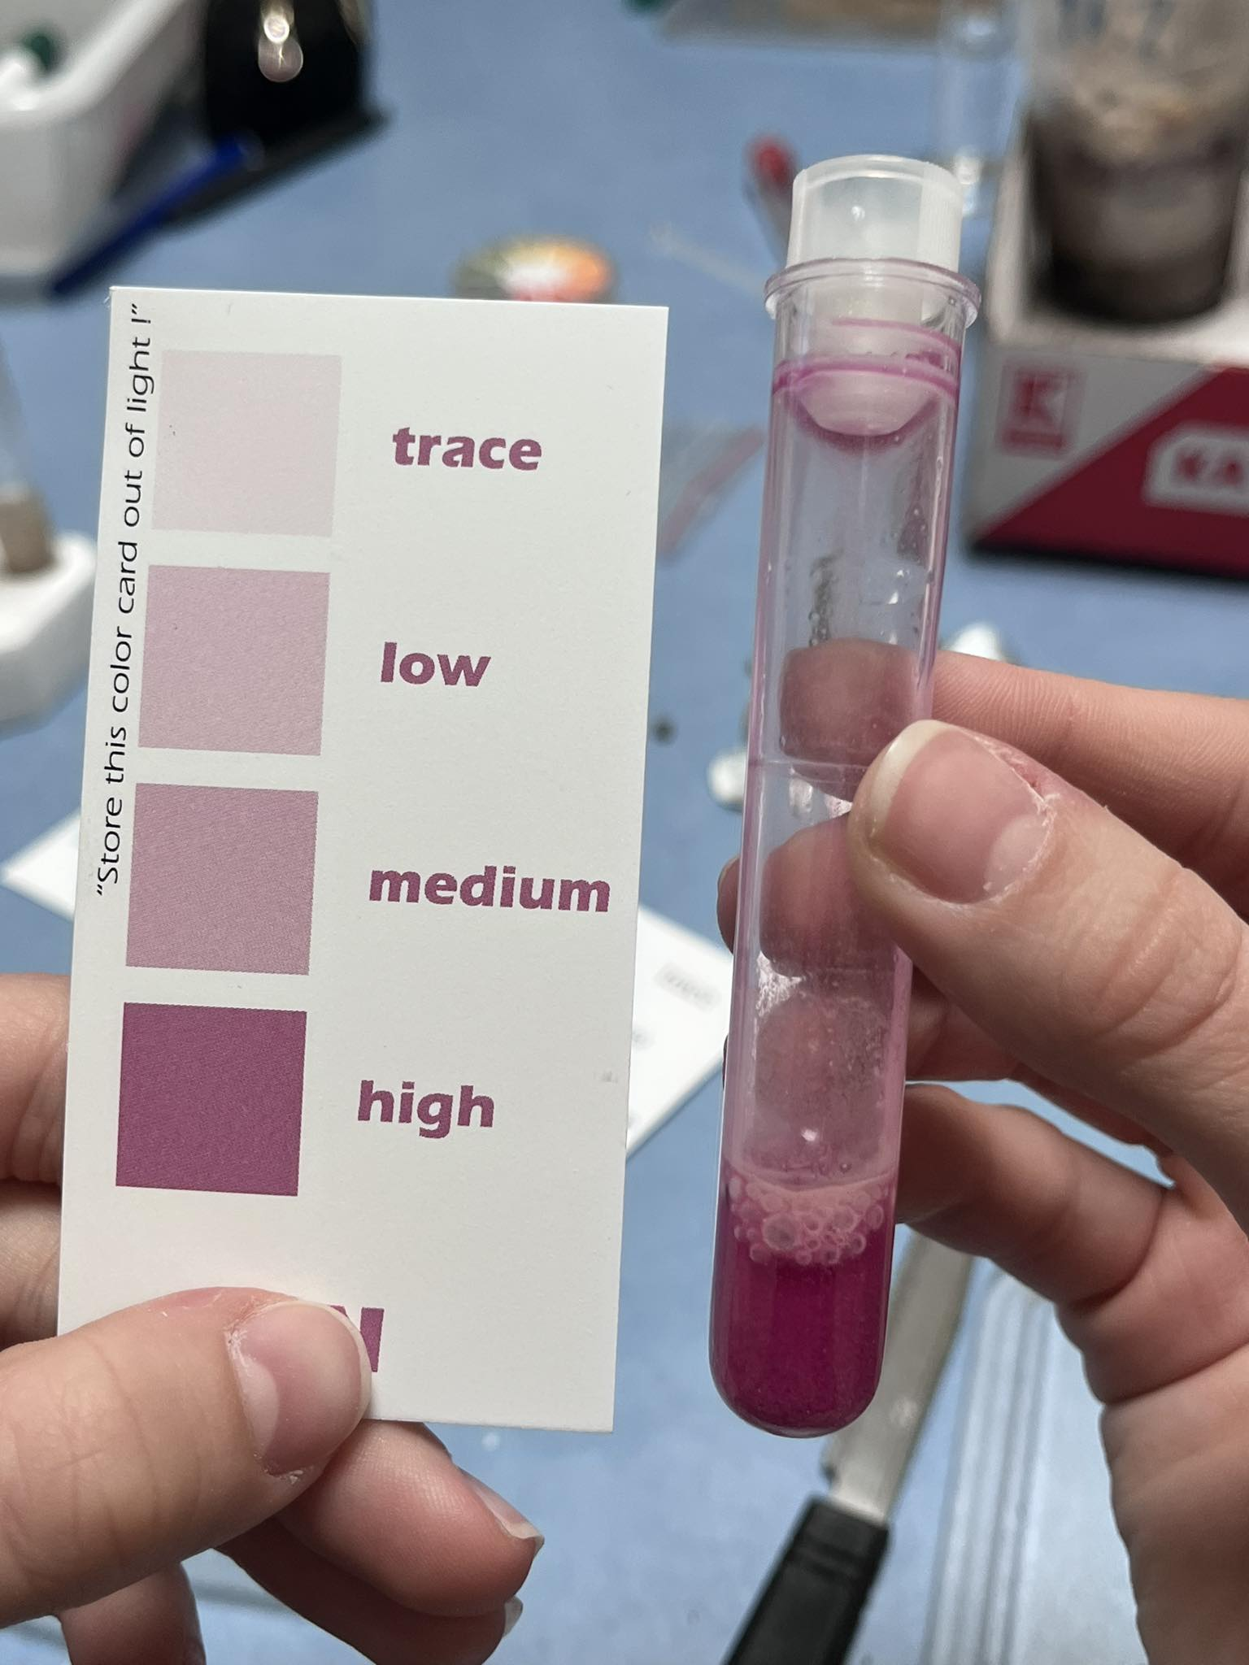

**Figure 5.** Soil fertility analysis

**Display and data analysis**

Based on the conducted research, it is evident that the most germinated plants (table 4) are in the soil with artificial fertilizer Plantella. Then there are plants encouraged by manure, bananas and eggshells. We observed the lowest number of germinated plants with chamomile because we sowed it later. According to the acquired knowledge, we know that fertilizer does not affect the germination of seeds, but the growth of seedlings and the growth of the plant.

Observing the total growth (Fig. 8), we noticed that the plants that grew the most were treated with eggshells, followed by artificial fertilizer Plantella and manure. After sowing the seeds, pumpkins stimulated by banana, comfrey and chamomile did not germinate. Of the plants that we could monitor from the beginning of sowing, the smallest growth was achieved in the control sample.

**Table 2.** Soil characterisation

|  |  |  |  |  |  |  |  |  |
| --- | --- | --- | --- | --- | --- | --- | --- | --- |
| Location | Moisture | Structure | Consistency | Texture | Amount of roots | Amount of stones | Carbonates | pH |
| Kotoriba | dry | lumpy | friable | loamy sand | none | none | no reaction | 7 |

**Table 3.** Soil fertility before the experiment

|  |  |  |  |
| --- | --- | --- | --- |
| **Location** | **Nitrogen** | **Phosphorus** | **Potassium** |
| Kotoriba | traces | a lot | a lot |

Slika na kojoj se prikazuje u dvorani, vaza, gazirano piće, zid

Opis je automatski generiran

**Figure 6.** Developmental stage of pumpkin plants

**Table 4.** The number of germinated plants per type of fertilizer

|  |  |  |  |  |  |  |  |  |
| --- | --- | --- | --- | --- | --- | --- | --- | --- |
| **Type of fertilizer** | control | nettle | chamomile | stable (horse) manure | comfrey | banana | eggshells | Artifficial fertilizer (Plantella) |
| **Number of germinated plants** | 3 | 3 | 1 | 5 | 2 | 5 | 5 | 6 |

Slika na kojoj se prikazuje tegla s cvijećem, sobna biljka, vaza, biljka

Opis je automatski generiran

**Figure 7.** Display of pumpkin growth results depending on the type of fertilizer

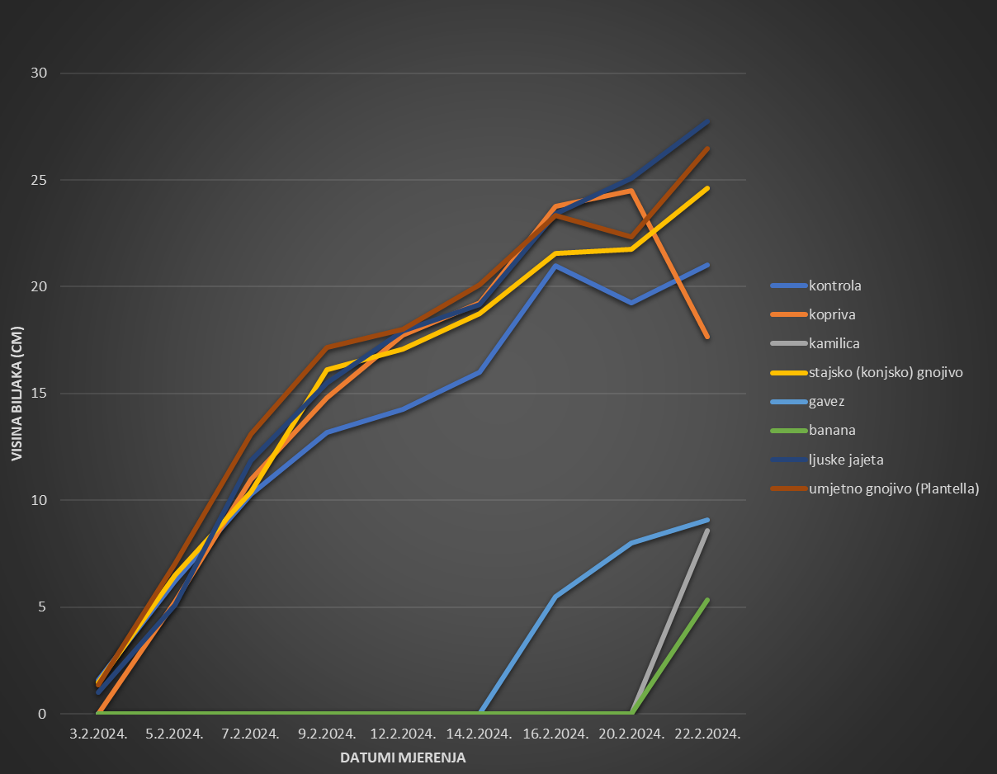

**Figure 8.** Results of plant growth measurements (average plant height in cm)

**Table 6.** Soil fertility after the experiment

|  |  |  |  |  |  |  |  |  |
| --- | --- | --- | --- | --- | --- | --- | --- | --- |
| Fertilizer | control | nettle | chamomile | Stable (horse) manure | comfrey | banana | eggshells | Artifficial fertilizer (Plantella) |
| pH | 7 | 7 | 6 | 7 | 7 | 7 | 7 | 5 |
| nitrogen | traces | a lot | a lot | a little | mean | mean | traces | a lot |
| phosphorus | a lot | mean | a lot | a lot | a lot | mean | a little | a lot |
| potassium | mean | a lot | a little | a lot | traces | mean | traces | a lot |

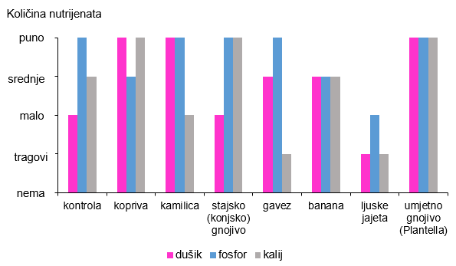

**Figure 8.** Results of soil fertility analys is after the experiment

**Discussion and conclusions**

Plants need macro and micronutrients for growth and development, which enable them to grow and develop normally (7.). Through the conducted research, we found that the used fertilizers enrich the soil with three basic elements that are necessary for the development of plants. Specifically, potassium and phosphorus (7.) are the most important for pumpkin growth, which is in line with our research, because in the control group there was a decrease in these elements, which indicates the need for these elements for pumpkin plant growth.

Nitrogen affects the resistance of plants to high and low temperatures and diseases. Due to the lack of nitrogen, the leaves of the plants are shorter and narrower. The amount of chlorophyll is less, so the leaves are pale green. The result is faster drying and aging of the plant. Phosphorus affects important life processes in plants and energy storage, better use of water, while phosphorus deficiency is expressed by weaker plant and root system growth. The most important element for plant growth is potassium. It plays an important role in the activation of enzymes and the regulation of the permeability of cell membranes. Potassium protects the plant from drought and disease. Due to the lack of potassium, the growth of plants is slowed down (7.). Apart from plant growth, we did not observe other characteristics (such as color, length and width of leaves).

Comfrey, chamomile and banana, despite enriching the soil with nitrogen, phosphorus and potassium, caused excessive soil moisture, which ultimately resulted in delayed germination of pumpkin seeds.

The greatest growth was achieved in eggshells, which is evident from the data on the proportion of nitrogen, phosphorus and potassium, where the consumption of potassium and phosphorus was the highest. Artificial fertilizer Plantella has the highest proportion of all three elements because it is a concentrate. Manure additionally enriched the soil because it had an excess of phosphorus, while it did not take other elements from the soil because it already had enough of them. The nettle enriched the soil with nitrogen, and the pumpkin plant took phosphorus from the soil for its growth.

It has been confirmed that natural fertilizers have a more effective effect, which is visible in eggshells. The hypothesis that the most suitable natural plant fertilizer for pumpkin cultivation is nettle fertilizer was not proven by this research. It has been proven that the most suitable fertilizer is chicken eggshell. It is necessary to do additional research because we think that due to the late germination of the pumpkin that was treated with nettle and comfrey, there was a reduced trend of pumpkin growth. We confirmed our last hypothesis. Natural fertilizer of animal origin has a stronger effect on pumpkin growth than plant fertilizers.

To improve future research, it is desirable to determine the proportion of nitrogen, phosphorus and potassium in prepared fertilizers to be able to connect data on the consumption of elements with their proportion in fertilizers.

**Literary sources**

**1.** Husnjak, S. 2014. Sistematika tala Hrvatske. Hrvatska sveučilišna naknada. Zagreb. (Datum pristupa: 9. 12. 2023.)

**2**. Tomić, F.; Bašić, F.; I Husnjak, S. 2014. Značajke i uloge tala Varaždinske županije sa smjernicama održivog gospodarenja poljoprivrednim zemljištem. Radovi Zavoda za znanstveni rad Varaždin (25), 25-68. Preuzeto s: <https://hrcak.srce.hr/131815> (Datum pristupa: 9. 12. 2023.)

**3.** Jambrošić, N.; Đurčević, A.; Rodek, I.; Puškadija, L.; Fadiga, I.; Hadela, J. 2023. Utvrđivanje kvalitete tla Međimurske i Varaždinske županije za proizvodnju bučinog ulja. Srednja škola Čakovec, Medicinska škola Varaždin.

**4.** Blagus, M. 2016. Kemijska analiza tla na području Međimurja. Završni rad. Međimursko Veleučilište u Čakovcu. <https://urn.nsk.hr/urn:nbn:hr:110:668127> (Datum pristupa: 9. 12. 2023.)

**5.** Ižaković, J. 2017. Studija izvodljivosti za proizvodnju bundeva golica (*Cucurbitapepitas* L.) i razvijanje inovativnih proizvoda na bazi bundeva golica. Diplomski rad. Sveučilište Josipa Jurja Strossmayera u Osijeku. Fakultet agrobiotehničkih znanosti Osijek. <https://urn.nsk.hr/urn:nbn:hr:151:523875> (Datum pristupa: 9. 12. 2023.)

**6.** Smojver, B.; Klubička, S. GLOBE protokol za karakterizaciju tla,

<https://drive.google.com/file/d/1dLpGQuVhfPNdJsJc3IHBoOi_QFyhYvWh/view>

(Datum pristupa: 9. 12. 2023.)

**7.** Anonymous. 2012. Važnost makrohranjiva u ishrani bilja, Prihranom biljaka do većih prinosa. Agroklub. <https://www.agroklub.com/poljoprivredne-vijesti/vaznost-makrohranjiva-u-ishrani-bilja/8377/> (datum pristupa: 10. 4. 2024.)