**Relationships Between Select Atmospheric Parameters**

**and Bird Diversity as Related to Suburban Land Use**

**Student Researchers:**

Zainab Abdulhussein, Taif Al-Janabi, Iya Albeketawi, Ealat Haddad, and Sarah Wazne

**School:**

Crestwood High School

Dearborn Heights, MI. 48127

**Science Teacher:**

Mrs. Diana R. Johns

March 5, 2025

**Table of Contents**

Abstract …………………………………………………………………………………………. 1

Research Questions and Null Hypotheses ……………………………………………………… 1

Introduction and Review of Literature …………………………………………………………. 2

Materials and Methods …………………………………………………………………………. 3

Data Summary ………………………………………………………………………………….. 4

Data Analysis and Results ……………………………………………………………………… 5

GLOBE Data Analysis …………………………………………………………………….…… 6

Conclusions …………………………………………………………………………………….. 7

Discussion ……………………………………………………………………………………… 8

Acknowledgements …………………………………………………………………………….. 11

Bibliography ……………………………………………………………………...……………. 11

Appendix ……………………………………………………………………………………….12

Badges …………………………………………………………………………………………. 13

**Abstract:**

In the Summer of 2024 bird activity was monitored in three different locations in Dearborn Heights, MI (Southeastern Michigan). The sites include the soccer practice field at Crestwood high school (Site 1), a small park behind the city post office (Site 2), and an open field in front of a senior citizen center (Site 3). Data collection took place at 8:00 A.M. three (3) times a week throughout much of the summer. The total number of birds encountered during each data collection was tabulated along with bird species composition. In addition, **weather data** was recorded using both the high school’s Weather Networks weather station (which sends data directly to GLOBE every 5 minutes) and using a Vernier weather station at the two other sites. Each site varied substantially in habitat quality, as determined from the **Shannon wiener index.** Although this is an unexpected result, it is interesting to note what types of birds were found in each location. The high school site was a larger area and less diverse than the other sites, but it attracted many **invasive bird species** rather that **native species**. The post office park (Site 2) on the other hand was the smallest area and had the least number of birds, it surprisingly contained the most **diversity** of all the sites. The open field behind the Berwyn senior citizen center (Site 3) had a moderate amount of birds and not as diverse as the post office park.

**Key Words: weather data, invasive bird species, Shannon wiener index, diversity**

**Research Questions:**

1. How do various atmospheric parameters (air temperature, wind speed, dew point, humidity, barometric pressure, and surface temperature) affect the number of birds present?

2. How do various atmospheric parameters (air temperature, wind speed, dew point, humidity, barometric pressure, and surface temperature) affect bird diversity?

3. How do habitat variations in a suburban environment affect bird diversity?

4. Can bird diversity be used as a measure of environmental quality?

**Null Hypotheses:**

1. There is no difference in the number of birds present and the atmospheric parameters

measured.

2. Bird diversity is not affected by the atmospheric parameters measured by this research.

3. Variations in habitat within a suburban environment do not affect bird diversity.

4. Bird abundance cannot be used as a measure of environmental quality.

**Introduction and Review of Literature:**

Bird diversity has long been used as an indicator of environmental quality in habitats worldwide (Neal and Olstrom, 1974). With changing world weather and climate patterns, continuing bird research must be conducted at many local levels so that a baseline of information is available to benchmark future changes in species abundance and diversity. Less research is available on the impact of specific weather conditions on bird diversity except as it relates to the ranges of individual bird species and climate change (Chen and Khanna, 2024). In a world that is feeling the effects of climate change, more research must be conducted on specific bird populations worldwide so that potential declines due to habitat change can be quantified and future projections can be used to help keep specific species from extinction. Suburban areas are often a mix of housing and light business, which can dramatically affect both the number and types of birds present. The Shannon-Weiner diversity index is a convenient way to compare different habitats within a larger area with bird diversity (Thompson, Tamayo, and Sigurosson, 2022). The city of Dearborn Heights in Southeastern Michigan has seen a significant decline in many tree species and associated habitats in the last 20 years as almost of the city’s ash trees were killed by the invasive Emerald Ash Borer. In addition, many formerly natural areas have been cutover and new homes built. In some cases, two older homes are being demolished, along with all vegetation, and one new, bigger home is replacing them. Less available habitat and fewer potential food sources have changed the numbers and types of birds that frequent our area. This research will be useful to future city planners as they continue to help our city grow, but in a more sustainable manner that promotes both habitat and bird diversity.

**Figure 1 Crestwood Highschool (Site 1: Left), Figure 2 Post Office Park (Site 2: Middle). Figure 3 Berwyn Center Field (Site 3: Left).** These are satellite images of the three sites research was conducted in.

**Materials and Methods:**

Throughout the Summer of 2024, data was collected from three (3) locations: a local suburban high school soccer field (natural grass field surrounded by edge habitat to a park and houses, a small park behind the city post office (natural grass park with large oak trees but is regularly mowed), and an open field in front of a senior citizen center (lush green natural grass but also surrounded by homes and in front of a parking lot). Three (3) times a week data on birds and atmospheric conditions was collected at 8 A.M. The researchers divided into teams so that they could be at each site at the same time. Atmospheric data that was collected included dew point, humidity, barometric pressure, air temperature, surface temperature, and wind speed. The data for these parameters were obtained using both a high school Earth Network weather station (accessed with the WeatherBug app) and a Vernier weather station with data accessed on a phone with Vernier Graphical Analysis. The researchers followed a set route during each sampling period where they walked in the same locations each day to count the number of birds of each species. The Cornell University Merlin ID app was used to identify bird species the researchers were unfamiliar with. The Merlin app is able to identify each bird species by their vocalizations. Approximately twenty plus (20+) days of data was collected from July to September 2024. In order to compare the data from each site, the Shannon-Weiner index was used to compare bird diversity at each site.

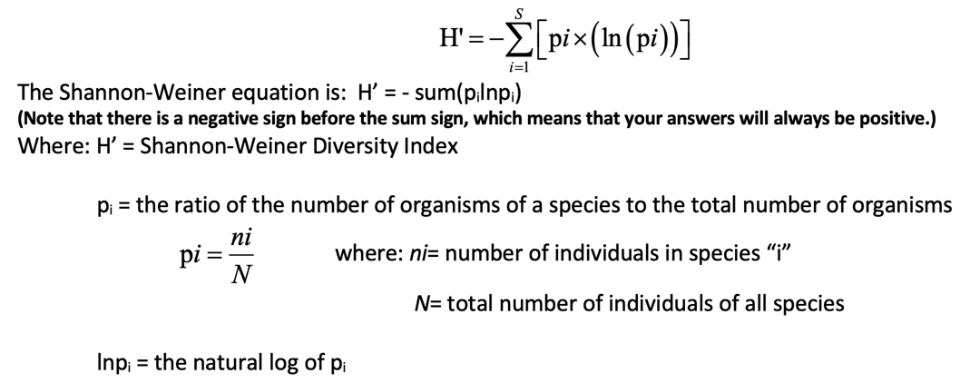

**Data Summary:**

 

**Figure 4 Abundance of Birds at Senior Center along with Air Temperature (Left). Figure 5 Abundance of Birds at Post Office Park along with Air Temperature (Middle). Figure 6 Bird Abundance at Crestwood High School along with Air Temperature (Right)**

Abundance of birds at all three sites correlated to air temperature on the specific day they were collected, showing correlation between weather and bird prevalence

**Table 1 (Left) Berwyn Center Field. Table 2 (Middle) Post Office Park. Table 3 (Right) Crestwood High School.** Species totals by site noting which bird species are invasive/non-native and those that are native species to Michigan.

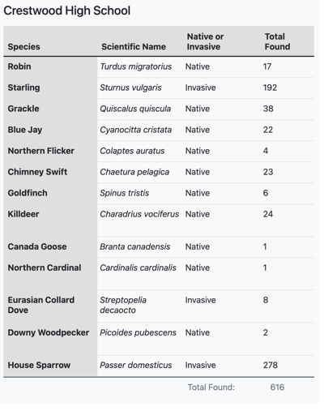

**Analysis and Results:**

Across all locations, an increase in bird activity was observed during warmer air temperatures. The results suggest that the atmospheric parameters measured in this research appear to affect bird abundance. The chart from table 2 (Site 2, post office park) harbors more forest dependent species like Blue Jays, Tufted Titmouse, and White-breasted Nuthatch. These species are all native and serve as positive environmental indicators of habitat health. Based on the Shannon Wiener Index used to identify bird diversity at each location, the Post Office Park had the highest Index value of H’=1.82, indicating moderate biodiversity. In contrast, the Crestwood Soccer Field had the lowest Shannon index with a value of H’=1.13. Higher index means greater species richness and evenness while lower means fewer or one species dominating the area. The results present how human-modified spaces affect bird diversity. Both Crestwood and the Berwyn Center show lower biodiversity compared to the Post office site. This suggests that human activity and differing habitat conditions in suburban areas do play a role in reducing the variety and richness of bird species. The alternative hypothesis was more birds would be found at Site 2 (the park behind the post office) since it seemed like a perfect ecological habitat for birds to thrive, with lots of trees and vegetation. However, after conducting our experiment, the data found that more birds at Crestwood High School, which made less sense to us since it doesn’t seem like it would be an ideal ecological habitat for birds to reside. The high school site may have had more bird abundance but there were large numbers of non-native species.

**Data Globe Analysis:**

**Figure 7 Raw data Unconnected (Left). Figure 8 (Right) Raw Data Connected.** These graphs show the raw data of all three Sites along with Wooster High School’s data.

When comparing the data done throughout the research, Wooster City high school was selected since it was found in the closest proximity to where the data in this research was initially done. The two figures above display the raw data of air temperature collected from each of the locations we conducted our research in as well as the Wooster City high school air temperatures. Figure 7 displays the raw data found while Figure 2 displays the raw data connected at each variable as an estimate of where the air temperatures would have been if the data collected was consistent. The post office was the most consistent with the Wooster data with the Berwyn as a close second. This may be since air parameters measured in Sites 2 and 3 were more exact to the area as a vernier weather device was used to gather data. In contrast the data in Site 1 may have been less specific to the area as it was accessed through the WeatherBug app that collected data from the roof of the high school. Another possible reason could’ve been the fact that Wooster City high school is in Ohio, which is southern to the location in which this data was collected. More southern ward facing states usually experience higher air temperatures which is what could have led to the slightly higher air temperature recorded.

**Conclusion**:

The research confirms that atmospheric parameters play a significant role in bird presence, with lower temperatures correlating with fewer birds in that area and vice versa. As well as affecting how many birds were present in a given area, measured air parameters-most significantly air temperature- also did play a role on the bird diversity found. This is due to the fact that birds have different tolerances and environmental niches. For example, a Puffin bird, whose environmental niche is typically that of a subarctic habitat, wouldn’t survive in southeastern Michigan the way a Blue Jay does. This finding aligns with established ecological principles, as birds tend to reduce activity and seek more sheltered areas in colder conditions to conserve energy. Understanding these patterns is crucial for predicting h

ow climate change and seasonal shifts may impact local bird populations, which in turn affects ecosystem balance and biodiversity.

One of the most unexpected findings was the high bird population at Crestwood High School, despite it not being the most ecologically ideal habitat. This suggests that factors beyond just habitat quality—such as food availability, reduced predation, or lower competition—may be influencing bird distribution. This highlights the complexity of habitat selection and the need for further research into urban ecological niches.

In contrast, the post office and Berwyn Center had significantly lower bird presence. At the post office, we hypothesized that resource completion played a major role. While the area had a high density of trees, indicating a rich and diverse population, the Shannon-Wiener Index suggested that species competition may have limited overall bird numbers. Additionally, the high presence of squirrels, potentially including invasive species not native to Michigan, likely contributed to resource competition, further reducing bird presence. These findings show the importance of studying interspecies interactions in urban environments, as competition from both native and non-native species can influence population dynamics.

**Discussion:**

To increase the accuracy of this research, it would have been better to collect more data over a longer time period. For instance, starting around June would have allowed more data collection that could decrease errors due to chance variation.  This would allow for a more in-depth analysis of select relationships between most measured air parameters and their possible role in affecting bird species diversity and abundance. Confidence in bird identification was essential to the success of this research.  As time went on, researchers became more adept at both visual identification and auditory recognition. If the research was continued the accuracy of bird identification could be increased by installing a recorder that could remotely record bird calls throughout the day and then this data could be analyzed by a software program capable of accurate identification.  This could also be done by adding surveillance cameras or some sort of motion tracking that could better identify birds.

This type of research is important for many reasons, measuring not only bird presence but the presence of animals that serve as environmental indicators, is crucial to ensuring our environment continues to be sustainable. According to Nicole Lee, author of ‘*Conserving Biodiversity In Greater Vancouver: Indicator Species and Habitat Quality VOLUME 1’*, “indicators are used as early warning signs of environmental change and management agencies could use these indicators to prioritize areas of concern and to also monitor the effects of restoration or conservation projects have on improving habitat quality.” Keeping track of birds allows us to be aware of any potential issues the environment is facing so we can improve its conditions.

We reject our first null hypothesis that measured air parameters don't have an effect on bird abundance. The data collected displayed a difference in the trend of bird population as it relates to air parameters. The warmer the weather was, the more birds were present; the colder the weather was, the fewer birds that were present. As you can see in the figures, along with the gradual decrease in air temperature, you can note a gradual decrease in bird population as well. For instance, in Site 3, figure 4, when the temperature had a decrease of 24 degrees Celsius on 8/14 to around 18 degrees Celsius on 8/16, the bird population went from 15 to 0. The second thing to note through the research is the drastic difference in bird population from Site 1 to Site 2 and 3. The reason so many birds may have been attracted to the urban environment so much may be due to street trees. Wood and Esaian write in their research study titled, *‘The Importance of Street Trees to Urban Avifauna’, “*affluent communities harbored a unique composition of street trees which in turn attracted nearly 5 times the density of feeding birds”. In summary they found street trees to be a driving force for the dense population of birds in Los Angeles, California. This could explain the attraction to Site 1 and the high abundance of birds.However, abundance doesn't equate to the health of an environment, a more important consideration is the species. The difference in the data between the sites alluded to be an environmental issue due to the species of birds found between Site 1 (Crestwood) and the other two sites. Site 2 (Post Office Park) had the least amount of invasive species which was two while Site 1 and Site 3 both had 3 invasive species. This is significant especially in the case of Site 1 due to the fact that the bulk of total birds found happened to be invasive, if you refer to table 3 you can see that 77% (478/616) of the total birds found throughout the data were invasive species. While Site 2 and 3 found 19% and 47% of the total population of birds present to be invasive respectively.  This indicates to us that Site 1 has poor environmental health. Another interesting factor independent of the data that could explain the lack of bird abundance in Site 2 could be the squirrels encountered. The abundance of seemingly aggressive squirrels could have created resource competition leading less birds to reside in the park. The shifts of bird species were most likely not attributed to the air parameters. For example, in site 1 sparrows and goldfinch became increasingly populated as the temperature decreased which doesn’t correlate with their tolerances so we accept our null hypothesis that bird species are not affected by the air parameters recorded in this research project. However, we reject our null hypothesis that variations of urban environments don’t influence bird diversity. When creating our Shannon wiener. Index we found that the location with the highest bird diversity was Site 2 (Post Office Park) with an index of 1.82, which is what we suspected due to its abundance of natural resources. Lastly, we reject our null hypothesis that bird abundance isn’t an indicator of environment health. Throughout all sites although Crestwood had the highest population with approximately 600+ birds found throughout the experiment while the other two sites had the combined low bird density of 103, However when comparing the species of birds and what their presence in certain locations means, Site 1 had the largest concentration of invasive species which signifies its poor ecologic health.

**Acknowledgments:**

Thank you to Mrs. Johns, GLOBE teacher at Crestwood High School, for always answering our questions, providing additional resources, for her support throughout the research process, and for helping us refine our work. We would also like to extend our gratitude to Mrs. Abbas for taking the time to help us refine our work alongside Mrs. Johns and for taking the time to read our research project to ensure it’s our best work. We really couldn’t have done it without them; they were always there to assist us when needed.

**References/Bibliography:**

SChen, L., & Khanna, M. (2020). Heterogeneous and long-term effects of a changing climate on bird biodiversity. Global Environmental Change Advances.

Lee, N., & Rudd, H. (2003). Conserving biodiversity in Greater Vancouver: Indicator species and habitat quality (2nd ed.). Douglas College - Institute of Urban Ecology.

Neel, J. L., & Ostrom, E. G. (1973). Birdlife—An indicator of environmental quality (Extension Bulletin E-797). Michigan State University Cooperative Extension Service.

Thompson, R., Tamayo, M., & Sigurósson, S. (2022). Urban bird diversity: Does abundance and richness vary unexpectedly with green space attributes? Journal of Urban Ecology.

Wood, E. M., & Esakian, S. (2020). The importance of street trees to urban avifauna. Ecological Applications, 30(2), p. 1.

**Appendix:**

**Figure 9 Wooster City High School x Crestwood High School Raw Data Simplified.** (simplified version of raw data from Wooster City High School that corroborates with our times since they recorded data in 15 minute intervals)

**Table 2. Raw data from globe website of Wooster City Highschool.** (The data was excessively long so this is a link to access it[**https://vis.globe.gov/GLOBE/?vis_mode=adat&load_filter=2550092092361751822**](https://vis.globe.gov/GLOBE/?vis_mode=adat&load_filter=2550092092361751822) **)**

**Badges:**

**I Am a Data Scientist:**  The researchers worked hard to be awarded the “I Am a Data Scientist” badge for the data they have collected over a 4th month period. Over the 4-month period the researchers have collected and analyzed bird and environmental data by measuring the surface temperature, recording atmospheric conditions with the GLOBE Observer app, and identifying bird species with the Merlin Bird ID app, we gathered important data like the bird species and the amount of birds allowing us to explore patterns. We then organized our findings into graphs and noticed some trends. In warmer temperatures and when barometric pressure is low more birds are often to be seen.  
  
**I Make an Impact:** The researchers believe they can receive the “I Make An Impact” badge as their research can be beneficial to track biodiversity in the area. While the study did not address a specific issue, it contributes to a greater understanding of how climate conditions may influence biodiversity in the community. By documenting temperature, humidity, wind speed, and bird populations, the researchers established an important baseline for future studies and environmental monitoring. Additionally, through these observations, it can help identify long-term trends, providing insights into how the changes in weather patterns may affect local ecosystems. Finally, they plan to speak to governmental officials to discuss if their data is able to contribute to environmental projects.

**I Am A STEM Storyteller:** The researchers hope to receive the “I Am A STEM Storyteller” badge because they shared their research findings on environmental conditions and bird populations through an engaging media platform. They documented their fieldwork by posting pictures on how they used apps like the Merlin Bird ID app to detect and identify different types of species at different sites on their Instagram page called “Sunflowervoyager21.” These posts helped communicate their observations on biodiversity, weather patterns, and how different habitats impact bird activity. By using social media, they made their research accessible to a bigger audience, encouraging community engagement and raising awareness about their local ecosystems.