**what is the relation between the type of surface and the infrared radiation temperature reflected from it?(1)**

**Nazareth Baptist school**

**9th grade students**

**Jude Khatib**

**Aleen Awaad**

**Raya Khamaise**

The Heat is on: Exploring the Impact of Surface Materials on Urban Temperatures

)Context of research2)

We are a group of three scientists measuring the surface temperatures of different types of land and analyzing the reflected heat. our aim of the research is to make an impact to our community to make changes to help better our lives and bring attention to the problem of urban heat.

Research questions:

What is the relation between the type of surface and the temperature reflected from it.

Objectives set:

The importance of the research we are conducting is to check and find out the best surface to have on ground in our community to reduce the effect of urban heat, and reducing the temperature and heat in school and also trying to solve the problem of global warming.

Brief methods description:

First of all, fixed locations were assigned for each surface, then their temperatures were measured by an IRT-2 Infrared at a fixed time daily for a month, and all data was then collected.

results:

surface average temperature

|  |  |
| --- | --- |
| Rock (marble) | 12.7c° |
| granulite | 18.7c° |
| concrete | 20.3c° |
| Asphalt | 21.3c° |

Conclusion:

Based on the results we concluded that marble has the best light reflectivity because it absorbed the least amount of light then followed by granulite which has an okay light reflective ability, on the other hand concrete and asphalt didn’t reflect much light so they absorbed a lot of the suns radiation making the surfaces hotter.

Recommendations

1)Incorporate more reflective materials like marble, light-colored concrete, or granulite in areas where heat retention is a concern (e.g., building facades, sidewalks, roads

2) plant more trees so it provides shades therefore it makes the surfaces cooler

3)creating covers that contain solar cells on the roofs, so that it absorb the light that comes from the sun and turns it into electric power so it benefits us.

Key words:

Solar cells, trees, lighter surfaces

**Research questions. (3)**

**what is the relation between the type of surface and the temperature reflected from it**

understanding the relation between surface type and temperature reflection is crucial for predicting and mitigating environmental issues like climate change, urban heat islands, and energy inefficiency. It also opens the door for practical solutions in sustainable urban planning, agriculture, and energy conservation.

Concern some aspect The relationship between the type of surface and the temperature it reflects is directly tied to global and local climate issues. For example, darker surfaces absorb more heat, contributing to urban heat islands, which exacerbate the effects of climate change. On a global scale, surfaces with different albedos (reflectivity) influence how much solar radiation is absorbed by Earth and how much is reflected back into space, impacting global temperatures and weather patterns. Understanding this relationship can help in managing and mitigating the effects of climate change, making it a crucial environmental issue

.

- Insight into Material Properties: By studying how different surfaces reflect temperature, the research provides insight into the physical properties of materials, such as thermal conductivity, reflectivity (albedo), and emissivity. This knowledge is crucial in fields like materials science, urban planning, and environmental engineering. It could also lead to innovations in creating materials with optimized thermal properties for specific uses (e.g., reducing cooling needs in buildings or urban areas).

- Research Process Insight: The investigation will require careful measurement of temperature on various surface types under controlled conditions. This will provide insight into experimental design, data collection, and analysis in a way that applies not only to this topic but also to broader scientific research processes. Answering them requires an advanced understanding of the subject matter

Workflow: Over 1.5 months, we measured the effect of different surface materials on reflected temperature at four sites: concrete, granite, rock, and asphalt. Using the same device, we took nine measurements per site. Data collection was divided into two periods:

First half: Until the end of January.

Second half: From the beginning of February.

We then calculated the final average of the measurements for analysis.

(4) introduction and review of literature

In today’s society we face a serious problem with global warming which is the long-term increase in the earths average surface temperatures.

Due to human activities like burning fossil fuels like coal and oil. Deforestation, cutting down trees which causes reduction in the earths ability to absorb CO2 agriculture which is a significant contributor to global warming, responsible for about 16%-20% of global greenhouse gas (GHG) emissions, these emissions come from livestock (cows, sheep, goats) -(CH4) Methane.

Another important contributor is urban heat which refers to the phenomenon where urban areas have higher temperatures than surrounding rural areas

Urban heat contributing factors such as heat absorption by buildings and roads (concrete, asphalt, and other man-made materials absorb and retain heat more than natural landscapes) in addition to waste heat from human activities (cars, air conditioners, and industrial processes release additional heat into the urban environment).

So were conducting research to test the affect the global warming has on the urban heat which affects the temperatures of the lands surface

The year 2024 we experienced the warmest year on record.

with world breaking temperatures where earths average surface temperatures reached 15.10C adding to that the past decade has been the warmest on record with 2024 specifically standing out as approximately 1.60c warmer than the pre-industrial era.

Int addition to that as of January 2025 which was recorded the warmest January on record, the global average surface air temperatures were documented 1.75c above pre- industrial levels global-climate-highlights-2024.htm

The importance of the research was conducting is to check and find out the best surface to have on ground in our community to reduce

the effect of urban heat.

The research on surface temperatures is highly relevant to the community as it helps address local climate challenges and promotes sustainable urban development by identifying which materials can retain and reflect heat. So, us as a community would come together and make informed decisions on infrastructure to reduce the urban heat leading to cooler and more livable cities

(5) Research Methods

Study site:

FIGURE ONE

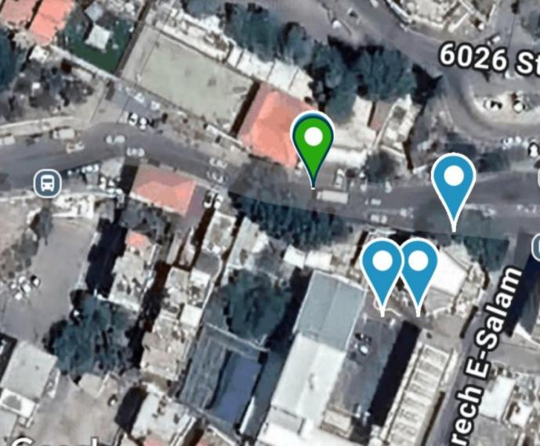

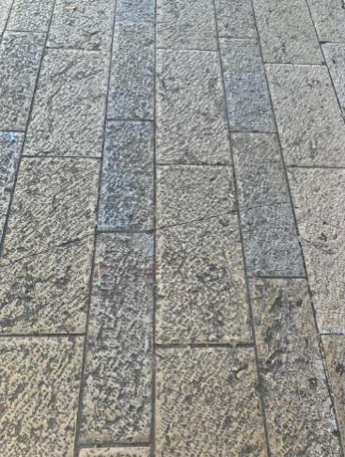

Description

all flooring and measurements were done in Israel, Nazareth Baptist School and all measurements were done on dry conditions.

Asphalt surface colored bright gray really old and has a lot of dirt and dust on it

marble surface colored gray and beige old and has a lot of dust on it

concrete surface recently painted dark red has a lot of dust on it

granulite surface colored beige old and has a lot of dust on it

data collection:

Using Globe atmosphere, we entered our nine measurements of the surface we checked and submitted them, and it gave us an average of the temperatures measured, we did 15 of the said method, then we collected all of the data and put them in a table. After we were finished with all of the 15 measurements we did an average for each surface and put them in a graph.

Data analysis:

To analyze the data, we used the averages that globe gave us of the 15*9 we put in globe atmosphere, then we took all the 15 averages of each surface added them together and divided them by the number of measurements made (15). All this data analysis was made to get a final average of the surface’s temperature throughout the month.

(6) results:

Links of the measurements made (to enter them ctrl+ click)

rock (marble)

granulite

asphalt

concrete

the average temperature of the surface types

|  |  |
| --- | --- |
| The average temperature | Surface type |
| 12.7 | Rock (marble) |
| 18.7 | Granulite |
| 21.3 | Asphalt |
| 20.3 | Concrete |

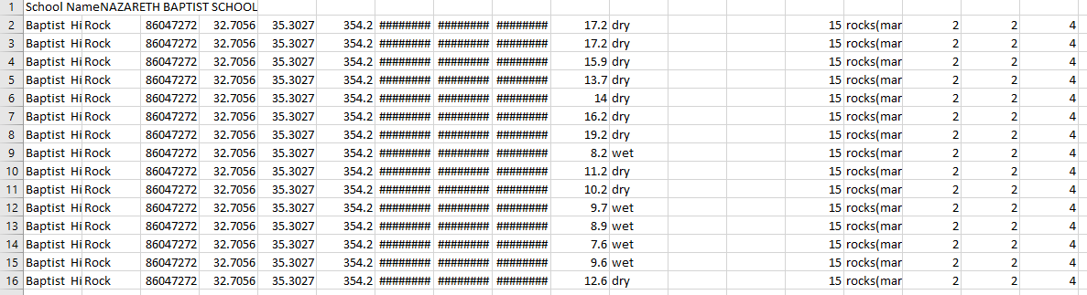

Rock(marble)

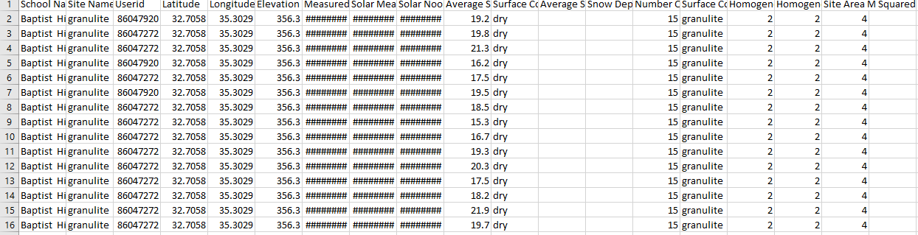

granulite

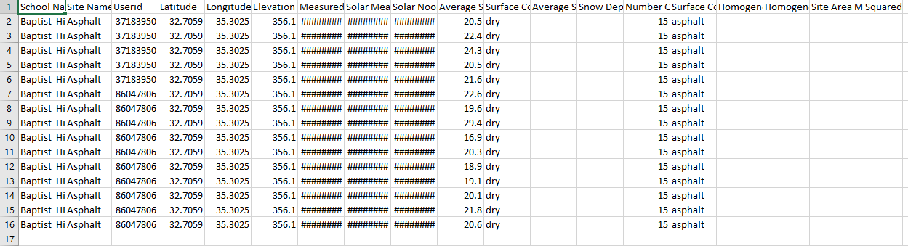

Asphalt

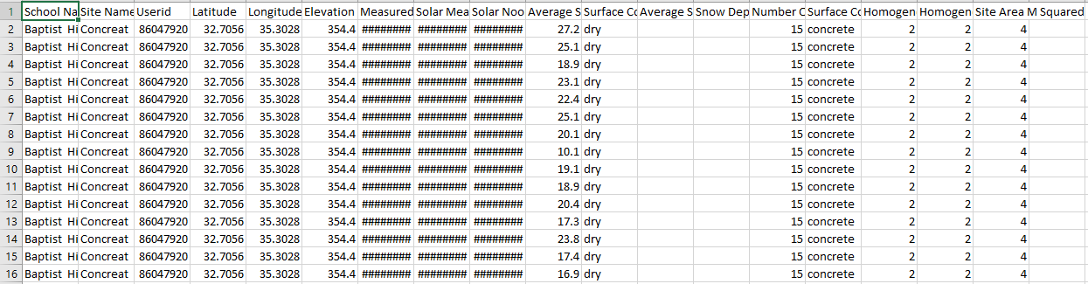Concrete

graph:

(7) discussion:

Interpretation of results:

Based on the results it seems that marble’s surface temperature is cooler than the other surfaces (12.7) which means that it absorbs the least amount of light and heat and reflects most of it. Then we have granulite, it’s surface temperature was higher than marble’s but cooler than asphalt and concrete (18.7), which means that it absorbs a not too much amount of light but not that little, and reflects a little less than marble but more than asphalt and concrete. On the other hand, concrete’s surface temperature was way higher than marble’s and granulite’s but a bit less than asphalt (20.3), which means that it absorbs a big amount of heat and light (more than marble and granulite but less than asphalt) and it reflects a small amount of light and heat. Lastly, we have asphalt which its surface temperature was the highest (21.3), which means that it absorbs the most light and heat and reflects a small amount of it.

Possible sources of error:

In the places that the measurements were made, the streets are old and dusty which can change the surface temperature and cause an error.

Discuss whether results support the hypothesis or not, and why:

Yes we did, we predicted that asphalt will absorb the most light and reflects the least amount. In addition to that we predicted that marble will absorb the least amount and will reflect a big amount of light.

(8) conclusion:

Using Globe atmosphere, we entered our nine measurements of the surface we checked and submitted them, and it gave us an average of the temperatures measured, we did 15 of the said method, then we collected all of the data and put them in a table. After we were finished with all of the 15 measurements we did an average for each surface and put them in a graph in which it turned out that marble had absorbed the least amount of light with the lowest average followed by granulite then concrete and lastly asphalt which had the highest average.

In conclusion, our research demonstrated that the type of surface material plays a significant role in determining the temperature of urban areas. Surfaces such as marble, which have a higher reflectivity (albedo), absorb less heat and therefore maintain lower temperatures. In contrast, surfaces like asphalt and concrete absorb more heat, contributing to higher surface temperatures and the phenomenon of urban heat islands.

Our findings show that marble had the lowest surface temperature at 12.7°C, followed by granulite (18.7°C), concrete (20.3°C), and asphalt (21.3°C). These results support our hypothesis that lighter-coloured surfaces would reflect more sunlight and absorb less heat, while darker surfaces would do the opposite.

Understanding this relationship is crucial for urban planning and the reduction of urban heat islands, as cities with higher temperatures suffer from increased energy use, health risks, and environmental degradation. Therefore, choosing appropriate surface materials is an effective strategy for combating urban heat and contributing to global efforts in mitigating climate change.

Importance to science:

### ****Findings in Context****

Our research findings demonstrate a clear relationship between the type of surface material and the temperature of urban environments. Lighter materials, like marble, have lower surface temperatures because they reflect more sunlight, while darker materials, such as asphalt and concrete, absorb more heat and result in higher surface temperatures. The data we collected supports this, with marble showing the lowest surface temperature (12.7°C), followed by granulite, concrete, and asphalt with progressively higher temperatures.

This research is crucial in understanding the broader environmental and scientific issues associated with urban heat. The temperatures measured reflect the physical properties of materials, such as their **reflectivity (albedo)** and **thermal conductivity**. These properties determine how much solar radiation a surface absorbs versus how much it reflects. This phenomenon is closely tied to the **urban heat island effect**—where urban areas are significantly warmer than surrounding rural areas due to human-made surfaces absorbing and retaining more heat.

**Relevance:**

Urban heat and surface temperatures studies are crucial in understanding how human activities influence local and global climate patterns. Cities tend to significantly warmer than their rural counterparts due to the urban heat islands effect, which results from factors such as increased impervious surfaces, reduced vegetation, and anthropogenic heat sources.

**Scientific impact and applications:**

**Remote sensing and modeling:**

studies using satellite imagery and ground based measurements help quantify temperature variations and predict future climate scenarios

**urban planning:**

findings guide the development of sustainable urban designs such as green roofs, reflective surfaces, and increased vegetations cover to reduce heat absorption.

**Improvements in methods:**

Doing research and measurements on better surfaces, doing multiple researches and doing research in a longer period for months.

**Impact with working with a project mentor**:

Learning and being led right, working with a project mentor taught us to be disciplined and on time and to never forget to take measurement, it also taught us on how to approach a big project like the globe project and it made things a bit easier so we learned a lot working with a project mentor.

**(extra)Solutions and Recommendations**

Based on the findings of our research, we recommend the following solutions to help mitigate urban heat in our community and contribute to a broader effort against global warming:

1. **Use of Reflective and Light-Coloured Materials:**

**Recommendation**: Replace heat-absorbing materials like asphalt and dark-coloured concrete with lighter-coloured surfaces such as marble, light-coloured concrete, or granulite.

**Impact**: These materials reflect more sunlight, absorb less heat, and help keep the surrounding environment cooler, reducing the overall urban heat island effect.

1. **Increase Green Spaces**:

**Recommendation**: Plant more trees and green vegetation in urban areas, particularly around schools, roads, and buildings.

**Impact**: Trees provide shade, cool the surrounding area through evapotranspiration, and improve air quality. Green spaces help mitigate the heat retained by hard surfaces like asphalt and concrete.

1. **Installation of Solar-Powered Roofing**:

**Recommendation**: Install solar cells on building roofs and other available surfaces.

**Impact**: Solar cells absorb sunlight and convert it into electricity, helping to reduce heat absorption and transform that energy into a useful resource for the community. This can also reduce the reliance on air conditioning and lower energy consumption, contributing to lower carbon emissions.

1. **Urban Planning and Policy Changes**:

**Recommendation**: Advocate for urban planning policies that mandate the use of reflective materials and green spaces in city construction projects.

**Impact**: This approach would not only help reduce temperatures in the local environment but also set a precedent for other cities to follow in tackling urban heat islands and climate change.

By implementing these strategies, we can reduce the negative effects of urban heat and create more sustainable and liveable cities. Reducing the urban heat island effect will also lead to lower energy costs, improved public health, and a more comfortable environment for future generations.

.

(9) Bibliography /citations

Materials cited: materials on urban heat were taken from (to enter the links press ctrl and clock on the link)

<https://sites.google.com/view/uhieforstudents>, (from globe)

<https://www.globe.gov/web/surface-temperature-field-campaign>,

(sources beyond those powered by globe)

<https://www.epa.gov/heatislands>,

<https://www.who.int/news-room/fact-sheets/detail/climate-change-and-health>,

<https://www.globes.co.il/news/article.aspx?did=1001252152>