**Impact of Rainfall Events on Select Water Quality Parameters: A Comparative Study in a Southeastern Michigan River**

**Student Researchers:**

Jana Ibrahim, Yasmin Rammal, Aya Soubra, and Layal Zbib

**School:**

Crestwood High School,

Dearborn Heights, MI 48127

**Teacher:**

Mrs. Diana Johns

March 5, 2025

**Table of Contents**

Abstract……………………………………………………………………………………3

Research Questions & Null Hypothesis………………………………………………4

Introduction and Review of Literature……………………………………………….4-6

Materials and Method…………………………………………………………………6-9

Data Summary……………………………………………………………………..9-11

Data Analysis and Results…………………………………………………………………11-12

GLOBE Data Analysis……………………………………………………………………..13-14

Conclusion…………………………………………………………………………………14

Discussion………………………………………………………………………………….15-16

Acknowledgments…………………………………………………………………17

Bibliography ……………………………………………………………………….17-18

Appendix………………………………………………………………………................18

Badges…………………………………………………………………………………19-20

**Abstract**

This research focused on two sites selected for water quality monitoring along **Ecorse Creek** in the southern portion of Dearborn Heights, Michigan just outside of the Metropolitan Detroit area. These sites are located within nearby residential areas and located upstream of an urbanized region. The first site is located near a city recreational center and the second site is located in a light industrial and residential area. **Water quality** parameters tested in this research included nitrates, dissolved oxygen, **phosphates**, E-coli, and temperature. All data was collected following GLOBE protocols when applicable. Data collection began during August 2024 and continued until early-December. Data was then interpreted and compared to previous data collection from July 2023 to August 2023. Researchers found that as **precipitation** levels increased, so did the amounts of dissolved oxygen. Additionally, there was a correlation between precipitation and phosphates, with both parameters significantly increasing after the storm, affecting the quality of the Ecorse Creek. The variables tested resulted in notable correlations, demonstrating how environmental factors interact to influence water quality. The researchers extended their research to include additional water quality parameters beyond the GLOBE protocols used. Looking ahead, they hope to further expand their study by collaborating with the Dearborn Heights Steward Watershed Commission to discuss their data and gather input on environmental protection efforts.

**Key Words**: Ecorse Creek, dissolved oxygen, phosphates, precipitation, and water quality

**Research Questions and Hypotheses:**

**Research questions:**

1. To what extent have significant rainfall events impacted water quality at two sites along the Ecorse Creek over a two-year period?
2. How do water quality parameters tested at each site along Ecorse Creek differ as seasonal changes occur?

**Null Hypotheses:**

1. There is no significant difference in water parameters over a two-year period following major rain events.
2. There is no significant difference in water quality parameters tested at each site along Ecorse Creek as seasonal changes occur.

**Introduction and Review of Literature:**

The North Branch of Ecorse Creek drains over 12,000 acres of land, primarily consisting of residential, commercial, and industrial areas, and is divided into three sub-watersheds. Flowing through both industrial and residential zones, it eventually merges with the South Branch before emptying into the Detroit River (Ecorse Creek Watershed Advisory Group 2014). Spanning approximately 43 square miles across Wayne County, the watershed plays an important role in the local ecosystem. The quality of Ecorse Creek is closely tied to the surrounding biodiversity, as its condition directly impacts the wildlife in the area. As climate change worsens environmental challenges, maintaining the creek’s health is crucial to protecting local communities from increased flooding and water quality degradation.

The North branch of Ecorse Creek has been prone to flooding, which affects both properties and public health. Severe flooding events in the nearby area have impacted up to 9,100 properties, causing significant damage and sewage backups (Ecorse Planning Commission, 2023). The combination of urbanization increased impervious surfaces, and inadequate stormwater infrastructure has worsened flooding by leading to runoff that overwhelms storm drains (Clites & Peterson, 2023). These issues emphasize the need for sustainable flood mitigation strategies. Further research is necessary to protect properties from water damage and enhance the community's ability to withstand severe environmental conditions. Ecorse Creek may also offer opportunities for recreational activities. By preserving the creek's health and aesthetic value, the community can experience social and economic benefits through public activities such as parks, nature walks, and rowing centers (Southgate, 2011). Historical records indicate that the creek supported a rowing club as early as 1873, showcasing its cultural significance (Warnes, 2014). The management and conservation efforts directed towards Ecorse Creek not only benefit the environment and wildlife but also enhance the quality of life for the surrounding communities.

This research was conducted to investigate the effects of yearly variations on the water quality of Ecorse Creek in Southeastern Michigan. Throughout the study, conditions at both the Richard A. Young (located on McKinley Street), and Van Born Rd sites along the creek were observed and documented the surrounding. Researchers from the Department of Agriculture and Biological Engineering have observed that in recent years, climate change has brought about more extreme rainfall, leading to increased flooding in Ecorse Creek. This flooding has caused runoff problems that harm local neighborhoods, showcasing how environmental changes directly affect our communities. These issues are made worse by runoff from hard surfaces that don’t absorb water, as noted by Li, Liu, and Engel (2018). Furthermore, threats to the water quality of Ecorse Creek, including sewage overload, logjams, flooding, and illicit discharges, pose significant concerns that need to be addressed to preserve the health and integrity of the creek's ecosystem.

**Materials and Method:**

The two selected research sites were located within Southeast Michigan’s city of Dearborn Heights, one on McKinley St (Site 1), near a recreational center and housing, and one on Van Born Rd (Site 2), surrounded by a gas station, housing, and businesses. Upon arrival, the air temperature of the site was tested. A sample of 32 oz of water from each site was collected to test for dissolved oxygen, and water temperature immediately, using Vernier probes. The researchers returned to the lab as soon as possible, to begin testing for nitrates, phosphates, and fecal coliform. To test for nitrates, the researchers used GLOBE protocols with the HACH DR 300 Portable Coloremeter device. To test for nitrates, 10 mL of river water was added to clear test vials, with NitraVer 5 Nitrate Reagent Powder Pillow added to all but one control sample. After shaking for one minute and allowing the samples to sit for five minutes, the control vial was used to calibrate the HACH DR 300 Pocket Colorimeter before measuring nitrate levels in the treated samples. The recorded nitrate concentration data was then transferred to a digital spreadsheet for analysis. To test for total phosphates (not a GLOBE Protocol), the researchers used HACH DR/1900 portable Spectrophotometer. The sample was placed in an Erlenmeyer flask which was then boiled and filled into a sample cell to be placed in the device. The data in mg/L PO43- was then recorded and transferred to a spreadsheet. To test for Fecal coliform (not GLOBE Protocol) the researchers used the Coliscan Method. Petri dishes were taped, after the water sample and Coliscan Easygel are placed into the dish. Later, the dishes are flipped to then count the number of colonies. After all spreadsheets were collected, the data was input into excel and graphs were created to be analyzed.

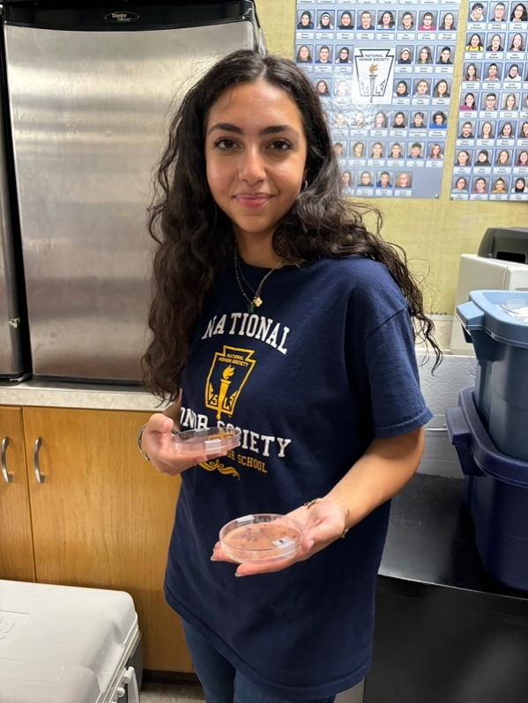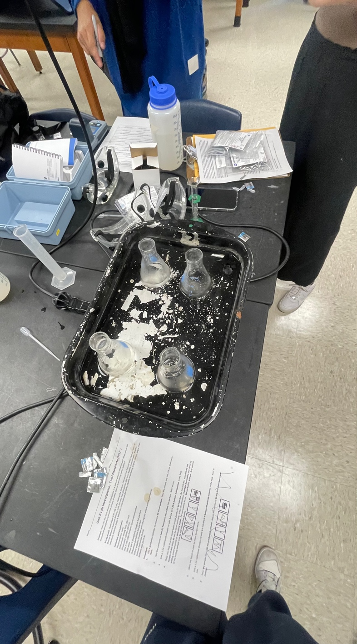

**Figure 1 (Left) and Figure 2 (Right):** Figure 1 showcases a student researcher holding E. Coli samples in a petri dish. Figure 2 demonstrates the process to measure phosphates from the samples collected from both sites.

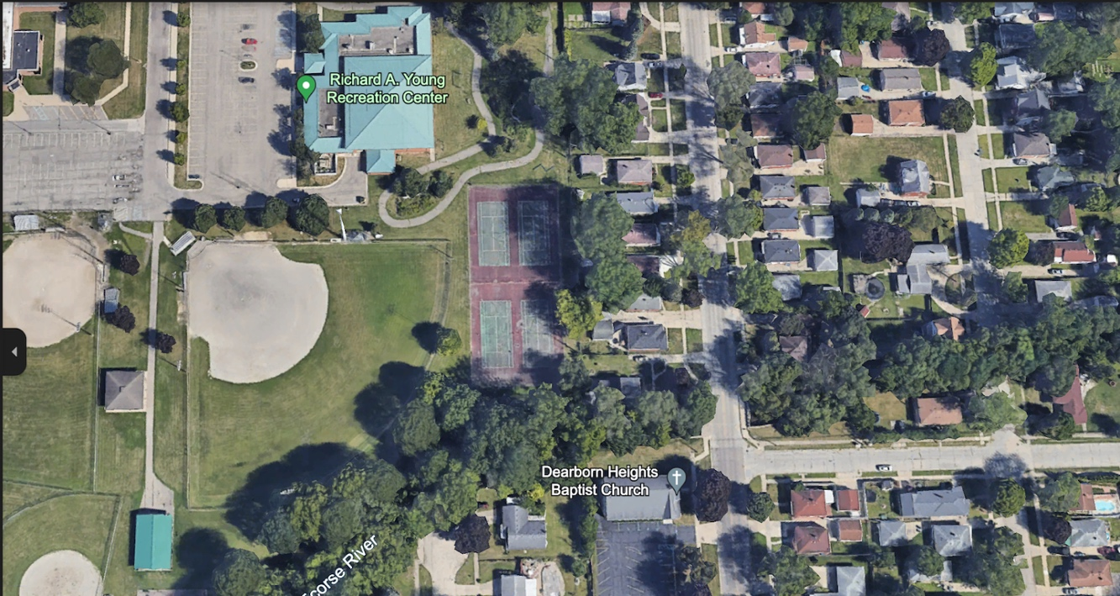

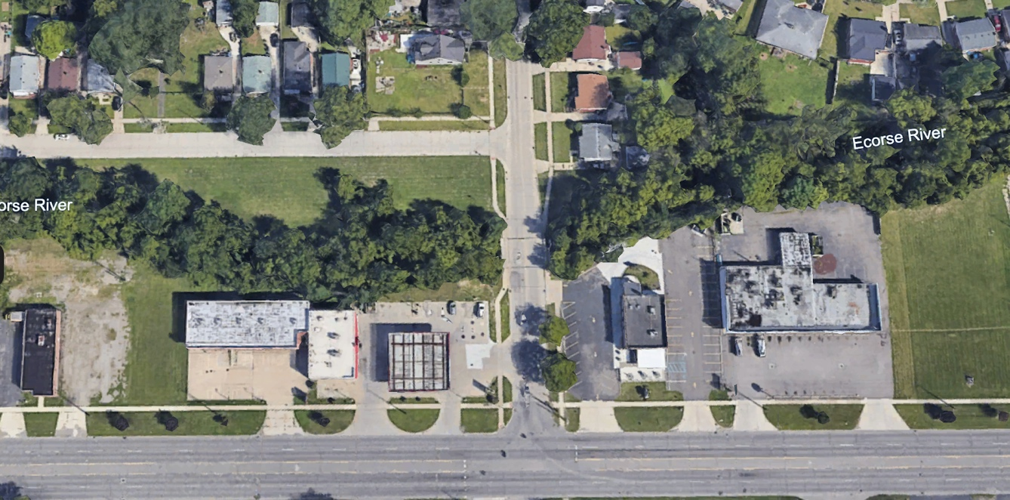

**Figure 3 (Top) and Figure 4 (Bottom):** Visualization of both sites. Figures 3 and 4 show the sites where water parameters were tested. Figure 3 (Top) shows the Richard A. Young site, and Figure 4 (Bottom) shows the Van Born site. The exact location of the Richard A. Young site (Figure 3): 42° 16 '17” N 83°15’03” W 193m. Exact location of the Van Born site (Figure 4): 42°16’10” N 83°17’04” W 183m.

**Data Summary:**

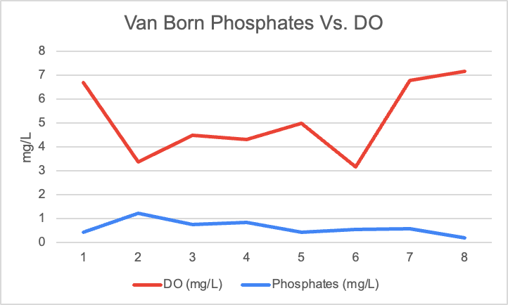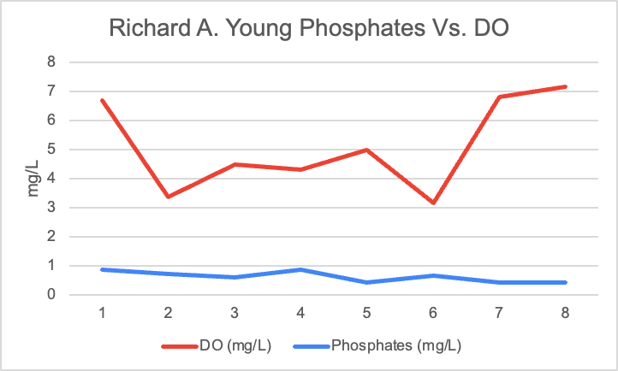

**Figure 5 (Top) and Figure 6 (Bottom) Phosphates and Dissolved Oxygen:** Phosphate levels at Site 1 (Van Born) were at their highest when dissolved oxygen was at its lowest showing an inverse relationship between the two water parameters. Typically, high phosphate levels lead to lower dissolved oxygen levels and data shows this correlation. Phosphate levels measured in (mg/L) were at their highest from weeks 1-4 when dissolved oxygen was at its lowest. Phosphate levels at Site 2 (Richard A. Young) stayed pretty consistent throughout the testing period. At the Van Born site, during weeks 4-5 there was a dip in phosphate levels and an increase in dissolved oxygen which is the typical relationship between phosphates and dissolved oxygen.

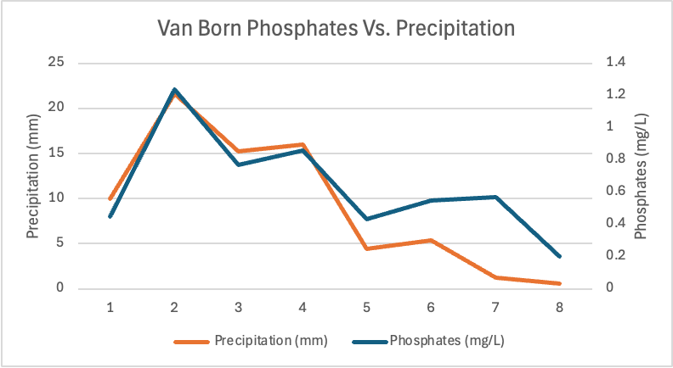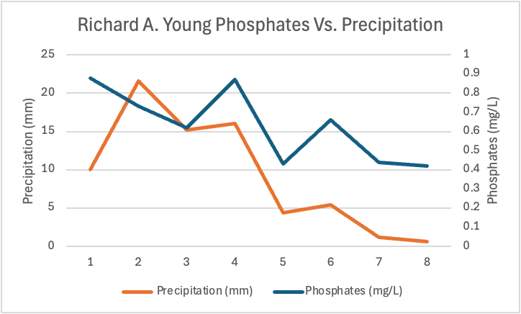

**Figure 7 (Top) and Figure 8 (Bottom) Phosphates and Precipitation:** Phosphates measured in (mg/L) and precipitation levels measured in (mm) showed a positive relationship. In both sites, when precipitation levels were at their highest, so were phosphate levels. Typically, when precipitation levels increase, phosphate levels increase as well.

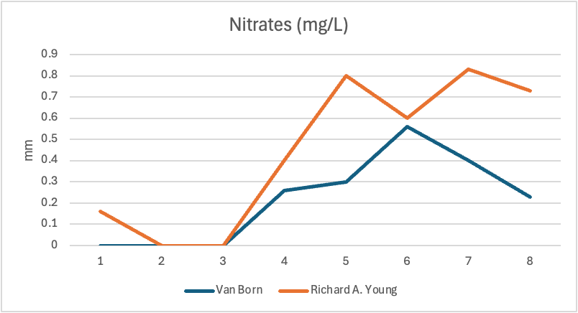

**Figure 9 (Above) Nitrates:** During the testing period, nitrates increased the most during weeks 3-5. For the Van Born site, (Blue line), the levels of nitrates steadily increased from weeks 1-6 then had a significant drop during weeks 6-8. At the Richard A. Young site, (Orange Line), nitrate levels were similar to Van Born’s but had a significant drop during weeks 5-6 then an increase during weeks 6-7.

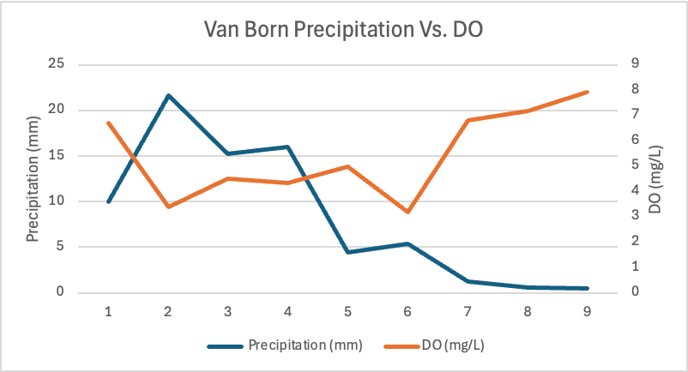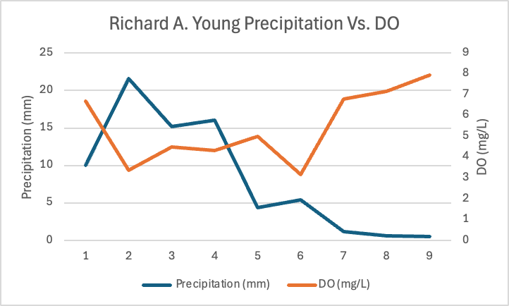

**Figure 10 (Top) and Figure 11 (Bottom) Precipitation vs. DO:** In Figure 10 (Top), the team measured dissolved oxygen at both sites and compared to precipitation levels collected. The data shows that dissolved oxygen levels stayed relatively constant, with different precipitation levels and had a slight spike between weeks 6-7 for both sites.

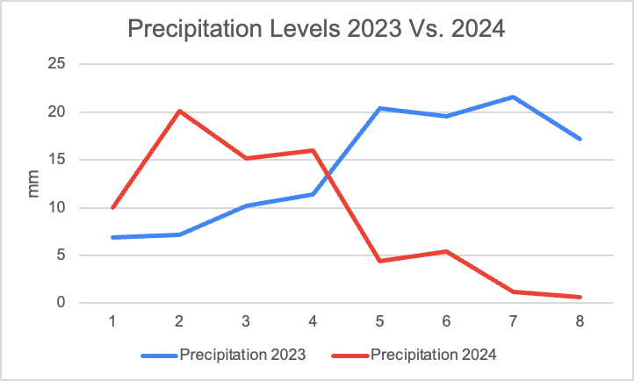

**Figure 12 (Above) Precipitation Levels 2023 Vs. 2024:** In Figure 12 (Above), researchers measured precipitation during 2023 and 2024 and compared levels of rainfall. Rainfall levels were higher in 2023 with an average rainfall of 14.3 mm and lower in 2024 with an average of 9.1 mm.

**Data Analysis and Results:**

The collected data revealed a correlation between precipitation levels and the researcher’s impact on water quality in Ecorse Creek over the past two years. The higher precipitation in 2023 compared to 2024 may have contributed to the elevated dissolved oxygen levels observed in the previous year's data compared to the current year's.

The research rejects the first null hypothesis, as the data has shown a significant difference between nitrates, dissolved oxygen, and phosphates in relation to rainfall events. Dissolved oxygen levels were recorded to be much higher in the study conducted last year compared to the study conducted this year. Following this, precipitation levels were compared over a two-year period, revealing that there were more major rainfall events during the testing period last year than this year. On average, precipitation measured 14.3 mm last year compared to 9.1 mm this year. The study also identified a direct correlation between dissolved oxygen levels and precipitation, with higher dissolved oxygen levels occurring during months with greater rainfall.

Phosphates were also tested this year, and the findings indicated a direct correlation between precipitation and phosphate levels. Phosphate levels increased in response to increased runoff or erosion. As rainfall increased, phosphate levels rose accordingly. During weeks 1–5, when precipitation was at its highest, phosphate levels were also at their highest at both testing sites.

Data collection from the previous year recorded slightly higher nitrate levels compared to the current year, likely due to an increased number of major rainfall events. The average nitrate level last year was 1.01 mg/L, whereas this year it measured 0.375 mg/L, indicating a significant decrease in nitrate levels from the previous year.

Overall, major rain events in the previous year led to an increase in the number of nitrates present in Ecorse Creek along with an increase in dissolved oxygen. Both variables demonstrated a positive correlation with precipitation, as shown in the collected data.

**GLOBE Data Analysis:**

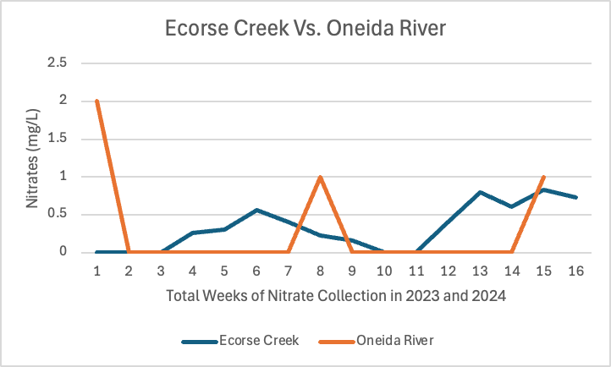

**Figure 13 (Above) Ecorse Creek Vs. Oneida River**

The researchers compared their nitrate data collected from 2023 and 2024 to a river in upstate New York which also tested for nitrates in 2023 and 2024. The researchers this year conducted their data collection from August to December in both 2023 and 2024, while the researchers in New York collected data from December 2023 to September 2024.

As shown in the graph, overall, the nitrate levels measured in mg/L were higher than levels measured in Ecorse Creek during weeks 1-2 and 7-9. There was also a spike in nitrate levels from weeks 14-15. Levels remained 0 mg/L for quite a while in Oneida River which could indicate that there wasn’t much rainfall during these weeks that would cause nitrate levels to increase. The higher levels of nitrates could be due to several factors. Firstly, the Oneida River flows through a region in New York that has significant agricultural activity which could lead to more agricultural runoff from fertilizers, or animal waste. Along with that, the watershed that the Oneida River flows through is a much larger watershed compared to Ecorse Creek, giving it a larger area for stormwater runoff to flow into which also could potentially cause an increase in nitrate levels.

**Conclusion:**

The research conducted during the summer of 2023 complemented the findings from the data collected in the summer of 2024. Researchers observed fluctuations in water parameters corresponding to seasonal changes.

The 9 weeks of research on nitrates, dissolved oxygen, phosphates, and fecal coliform varied from the 2 testing sites as the seasons changed. Comparing the research from the first-year data collected the researchers found that precipitation was lower the following year, leading to decreased nitrates. Dissolved oxygen levels were lower the summer of 2024 due to the difference in weather. As this was the first year the student researchers tested for phosphates there is no data to compare it to, although phosphates were significantly higher during times of higher rainfall due to runoff occurring. In the previous year, data was collected on turbidity, transparency, and total solids. However, the analyses revealed no significant correlations among these parameters, which led the research to move forward focusing on the variables that would give deeper insights into the water’s health. Fecal coliform was also tested in the second year of research, further expanding the research; moreover, providing premises to the issue the creek faces.

**Discussion:**

The objective of the study was to compare water quality data over a longer period displaying the differences in water parameters after a year. The team continued testing at the same sites while adding new water parameters to measure, alongside those previously measured.

Over several months of data collection, the researchers analyzed differences in dissolved oxygen, phosphates, and nitrates. Evidence showed that phosphate levels were significantly higher in the early summer months and gradually decreased over time. In the later months of testing, dissolved oxygen levels began to rise. Similarly, earlier data collection indicated an increase in dissolved oxygen during the late fall months. The researchers also observed that nitrate levels increased during the summer months and began to decline as the seasons changed. These findings demonstrated that precipitation levels influenced water parameters such as nitrates, phosphates, and dissolved oxygen, leading the researchers to reject the initial hypothesis.

The study could be improved in various ways to allow for more accurate results. Increasing sample frequency would help reduce the range of errors that may have occurred. Potential errors could include miscalibration of equipment used, such as the HACH and Vernier testing devices, which may have affected the accuracy of the data collected. Although all GLOBE protocols were followed when conducting the tests, human error could have occurred, particularly if glass tubes were not properly sterilized, as any residue or contamination left behind could have influenced the data and ultimately impacted the reliability of the results. Although measures were taken to clean the test tubes and use an adequate amount of chemicals, errors could still have occurred. At certain testing times, fecal coliform levels were too abundant to count, likely due to increased runoff from an increase of rainfall. As a result, researchers had to reduce the volume of the water sample placed into the Coliscan Easygel to obtain an accurate colony count.

The findings of this research could be applied to improve water quality for both recreational and environmental purposes. By regulating phosphate levels from runoff and flooding, the creek’s habitat could be improved, promoting a healthier environment for aquatic life. Further studying Ecorse Creek would require information on water levels, considering other locations to monitor further levels of flooding, and testing at a downstream location to assess the difference between upstream and downstream water measures.

The research conducted can be used to improve the quality of the water for recreational and habitat use. For example, the increased levels of nitrates could be from the runoff produced from industries affecting both sites and decreasing the quality of water.

**Acknowledgement:**

Thank you to their teachers and mentors, Mrs. Diana Johns, and Ms. Lina Abbas for providing them with the support, knowledge, and materials to conduct this research. Thank you to the Dearborn Heights Watershed Commision for all the support and assistance given.

**Bibliography:**

Author links open overlay panelFazhi Li a, a, b, c, swale, H., district, A. an urban fringe, Ahiablame, L. M., Braswell, A. B., Cao, Q., Carlson, T. N., Chen, J., Chui, T. F. M., Macedo, M. B. de, Fan, M., Hu, M., Jiang, Y., Johnson, R. D., Joksimovic, D., Jones, M. P., … Zhang, K. (2018, December 29). Green infrastructure practices simulation of the impacts of land use on surface runoff: Case study in Ecorse River watershed, Michigan. Journal of Environmental Management. <https://www.sciencedirect.com/science/article/abs/pii/S0301479718315007>

City of Southgate Planning Commission. (2011, June 13). Master plan. <https://www.southgatemi.org/Master> Plan Southgate 2-14-14.pdf

Ecorse Creek Watershed Advisory Group. (2012, June). Ecorse Creek Watershed Management Plan. Ecorse Creek Watershed Management Plan. <https://www.allianceofdownriverwatersheds.com/wp-content/uploads/2014/09/ecorse_creek_wmp.pdf>

Ecorse Planning Commission. (2023, April 26). Master plan. MASTER PLAN CITY OF ECORSE, MICHIGAN. <https://ecorsemi.gov/getattachment/Departments/Community-Development/Planning-and-Zoning/Master-Plan/Ecorse-MasterPlan-2023-FINAL.pdf.aspx?lang=en-US>

Erica Clites, M. S. G. (2023, February 6). Project seeks to find solutions to reduce flooding in Ecorse Creek watershed. <https://www.canr.msu.edu/news/project-seeks-to-find-solutions-to-reduce-flooding-in-ecorse-creek-watershed-msg23-clites23>

Warnes, K. C. (n.d.). Ecorse: Along the Detroit River. Google Books. <https://books.google.com/books?hl=en&lr=&id=NtuRBAAAQBAJ&oi=fnd&pg=PA6&dq=Ecorse&ots=2vMA3qWUhK&sig=6BV66_HEVkN8ymqkYGJ4DGX0bD0#v=onepage&q=Ecorse&f=true>

**Appendix:**

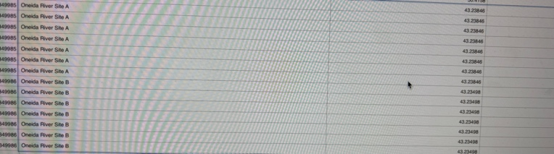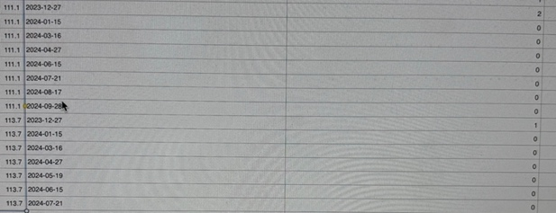

**Figure 13(Above) Data: F**igure 13 (Above) displays the researcher’s raw data collected over the August of 2023 ending in December of 2024. Averages were taken over the 3 tests of nitrates, phosphates and dissolved oxygen and the values were then imported into Excel Spreadsheets and graphed.

**Badges:**

I AM A DATA SCIENTIST

Over the course of 18 weeks, two different sites of Ecorse creek were tested. The team analyzed the data by using Excel spreadsheets and making graphs to determine the differences and correlations between different water parameters. Numerous correlations and relationships were found while testing nitrates, dissolved oxygen, phosphates, E-coli, and temperature.

I AM A STUDENT RESEARCHER

The team created a research report on yearly changes in water parameters. Their research was compiled and analyzed for all correlations between variables while comparing data from 2023 to 2024. Collecting data on water quality can enhance their understanding of the environmental factors affecting the Creek's quality and identify methods for its improvement.

I AM A STEM STORYTELLER

Aya Soubra, a member of her team’s GLOBE research, documented the steps of her research on Ecorse Creek through social media. Their Instagram page ventures into the heart of environmental science - water quality - as they analyze and collect data on this waterway. From images of their work at the Van Born and Richard A. Young sites, images and descriptions of their research at the lab, and vlogs of their days spent analyzing the data, this page offers a look into the discoveries of their journey. All their efforts to understand and preserve Ecorse Creek are displayed on their Instagram account @Nitrate_traveler04!

I AM A PROBLEM SOLVER

As their research determines the yearly changes in water parameters, analyzing the data can help discuss the harmful impacts of runoff that contribute to flooding in residential neighborhoods. By addressing this problem, they can identify solutions to reduce flooding and enhance the water quality of Ecorse Creek!