Protecting Wetlands for Our Common Future_Water quality and sample analysis，taking the Taipei Daan Forest Park Ecological Pond and NTU Drunken Moon Lake as examples

​

Student：LU,YUN-HAN

Teacher：CHIU,YI-CHEN

Taipei Municipal Wanfang Senior High School, Taiwan Taipei

Teach25 March01

**ABSTRACT**

This report is about water quality and sample analysis. Taking Taipei Daan Forest Park Ecological Pond and NTU Drunken Moon Lake as examples. We test and record dissolved oxygen (DO), pH value, turbidity, temperature. We also examine the microplastic in these two areas. We found the dissolved oxygen and temperature of the Daan Forest Park Ecological Pool are lower than those of Drunken Moon Lake, the turbidity is higher than that of Drunken Moon Lake, but the pH values are very similar. We can find microplastics in both area.

# Research Question and Hypothesis

We use extracurricular time or after school hours to conduct this activity. This report is about water quality and sample analysis. Taking Taipei Daan Forest Park Ecological Pond and NTU Drunken Moon Lake(Figure 1) as examples.We use three sample at different times and 3 sample sites at each location. There are 18 data sets in total for comparison.

Dissolved oxygen in the water continues to decrease, and water temperature stratification is likely to occur when the seasons change. Anaerobic fermentation on the surface of the sediment causes the release of toxic gases, algae growth, and algal blooms, which seriously affects the water quality and causes the death of organisms in the lake due to lack of oxygen (Chen Yirong et al. , 2016).

​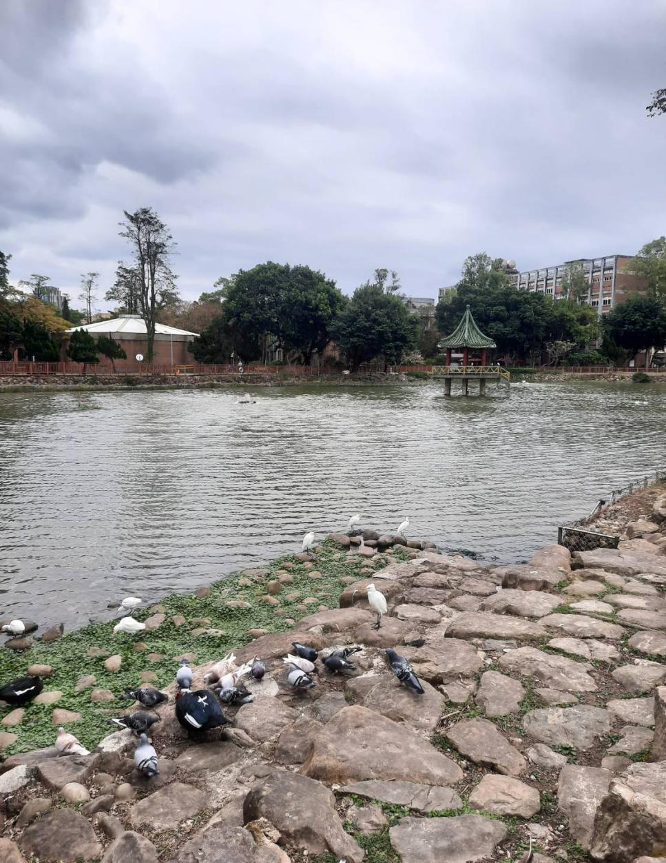

Figure 1. Photo of the National Taiwan University Drunken Moon Lake in Taipei, Taiwan on January 4, 2025

Using tools such as dissolved oxygen (DO), pH test reagents, an electronic thermometer, and a turbidity meter, we aimed to analyze and explain the related data.We think the water quality of the Daan Forest Park Ecological Pond should be better because it is managed by the Taipei City Government.

As for the National Taiwan University Drunken Moon Lake, it is managed by the school, so it may not be as strictly controlled as the government.

The water quality of closed type lakes such as Taipei Drunken Moon Lake​

(醉月湖）can be improved by using both biological and physical methods. These improvement included to increase the dissolved oxygen content, to reduce the water purification time, and to reduce the chance of eutrophication in the water( Chen et al., 2016)

In this article, we will prove whether the water quality of the Daan Forest Park Ecological Pond mentioned earlier is better than that of the National Taiwan University Drunken Moon Lake. We will also provide relevant data on water quality for comparison.

# Materials and Methods

I use my mobile phone to record what I see and hear, and use a memo to record time, location, weather, and water quality information. Meteorological data were obtained from the Central Meteorological Bureau of the Ministry of Transportation, and water quality data were obtained using electronic thermometers, electronic pH meters, DO reagents, and turbidity measurement tools ect.

Figure 2 is the map of our observation. The left one is the Daan Forest Park Ecological Pond, and the right one is the National Taiwan University Drunken MoonLake. We have marked our sampling points in the picture. The left one is 1,2,3 and the right one is 4,5,6.

I conducted observations on December 31, January 4, and January 5. I would like to know what factor is related to the difference of water quality between two ponds. Is it species differences or weather? (Figures 3 and 4) show the experimental process.

In addition to observations, we also conducted microplastic observations to understand when and where samples contained microplastics (Figures 10 and 11), and further added water quality data to analyze the water quality of NTU Drunken MoonLake and Daan Forest Park Ecological Pond (Figures 5 and 7) and compare (Figures 6, 8, and 9).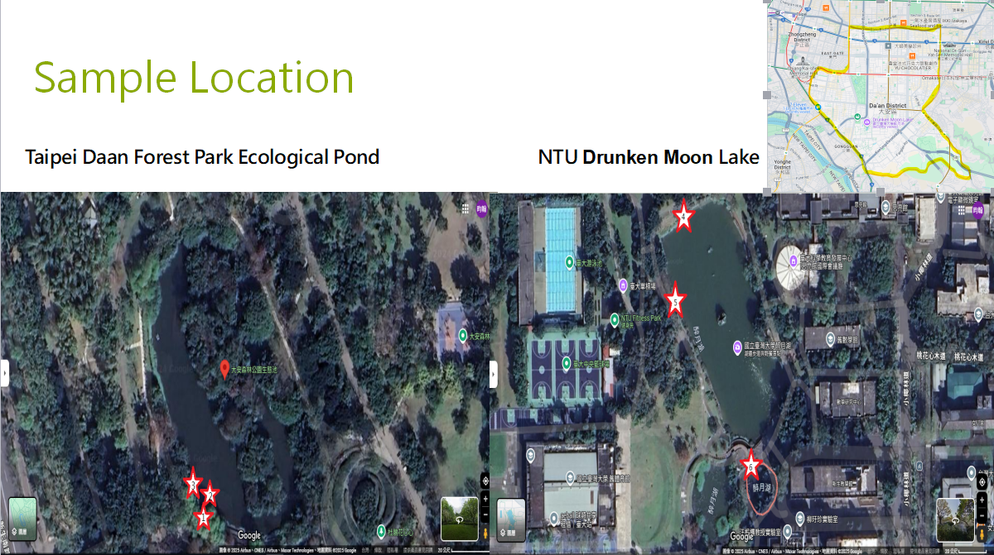

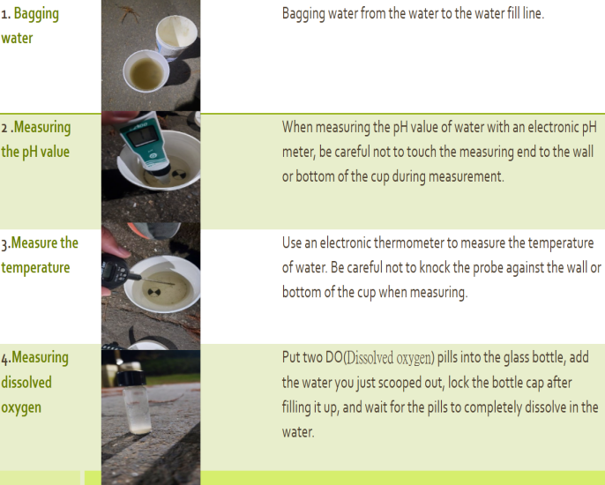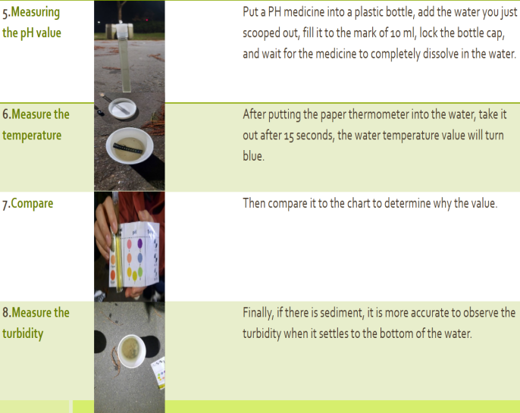

# Figure 3 and 4 This is the flow chart of the experiment I did.

# 3.Data Summary and Analysis

* 1. *Daan Forest Park Water Quality Data*

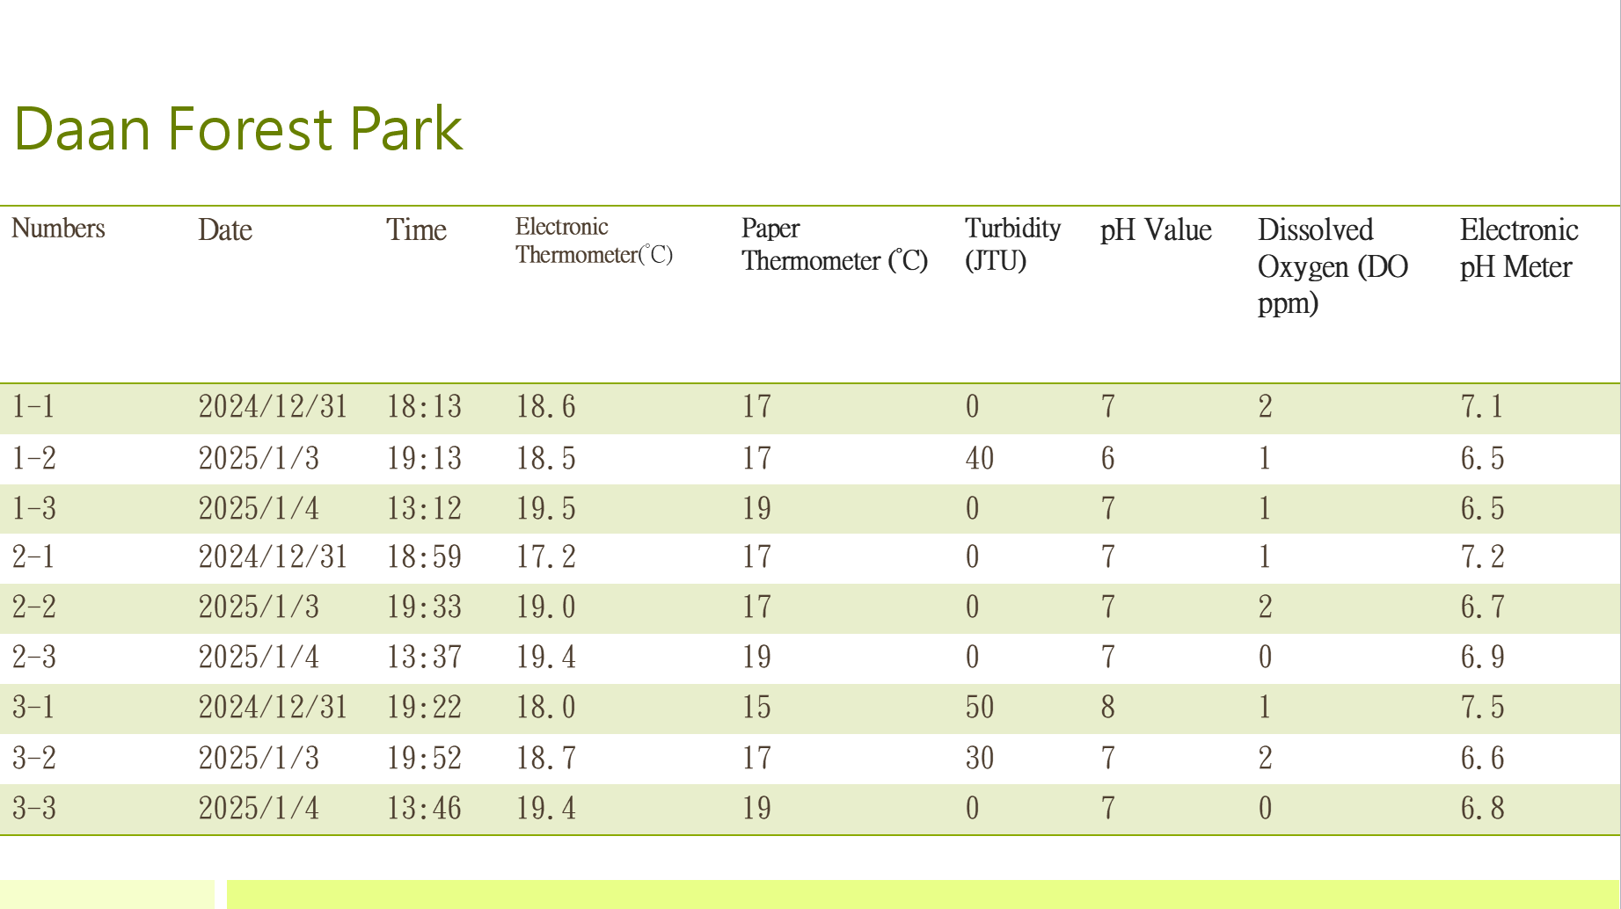

Figure 5. shows the water quality data of the ecological pond in Daan Forest Park. 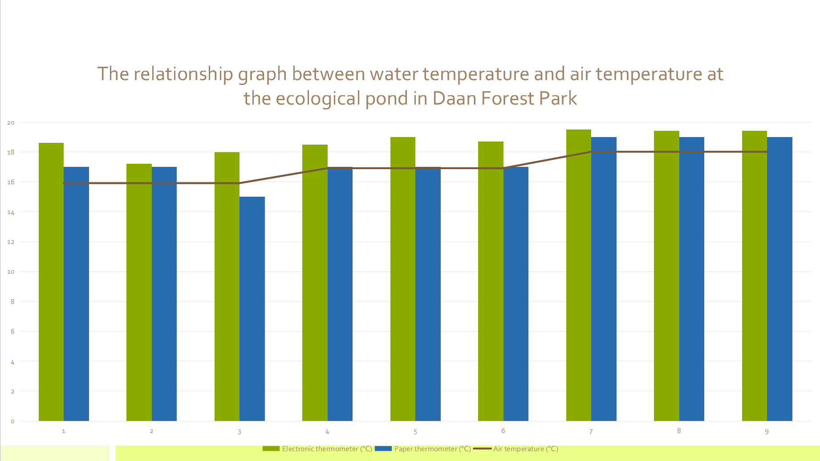

Figure 6. shows the comparison between the air temperature data obtained from the Daan Forest Station of the Central Weather Bureau

*b. Water quality data of* *Drunken Moon**Lake, National Taiwan University*

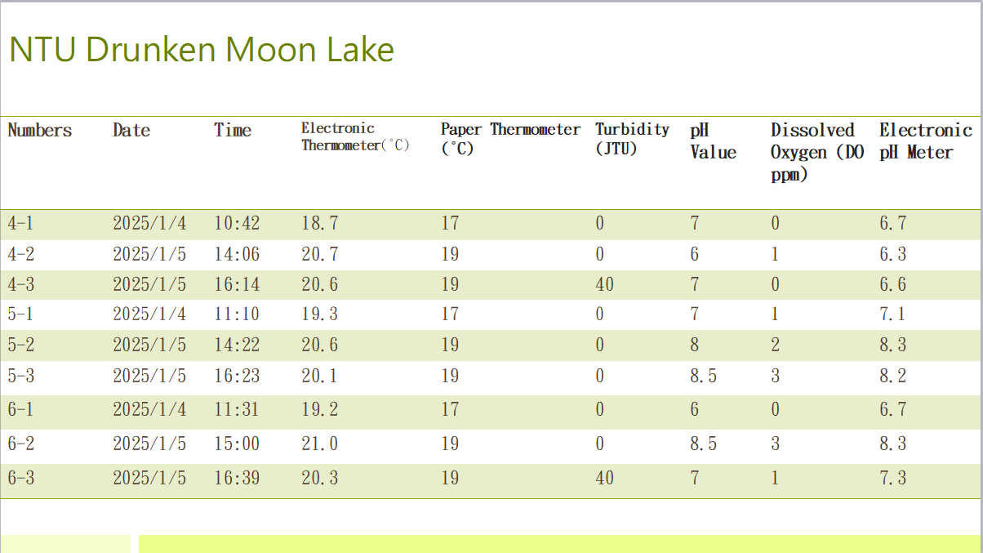

Figure 7. shows the water quality data of Drunken Moon Lake at NTU.

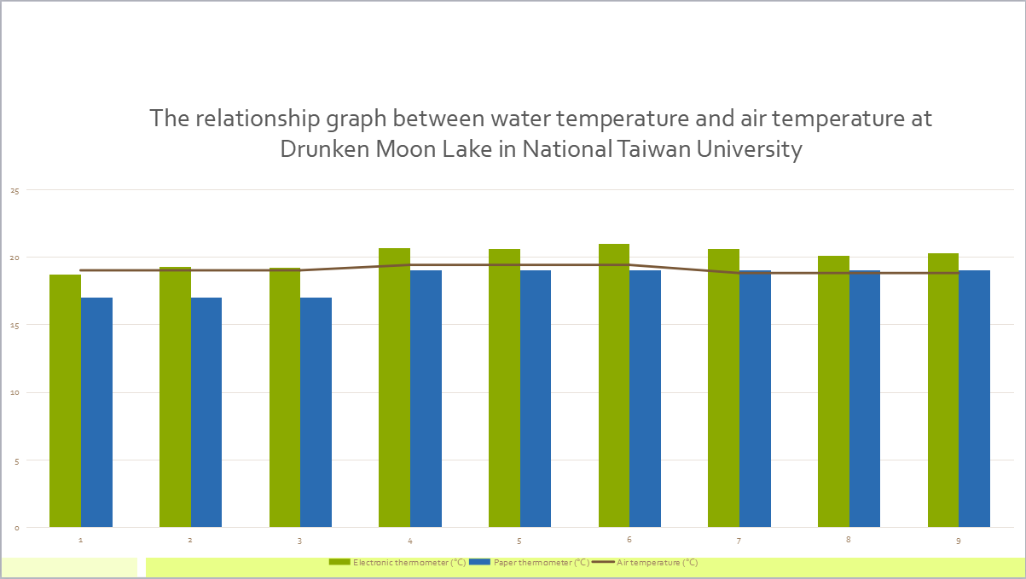

Figure 8. shows the comparison between the air temperature data obtained from the Daan Forest Station of the Central Weather Bureau 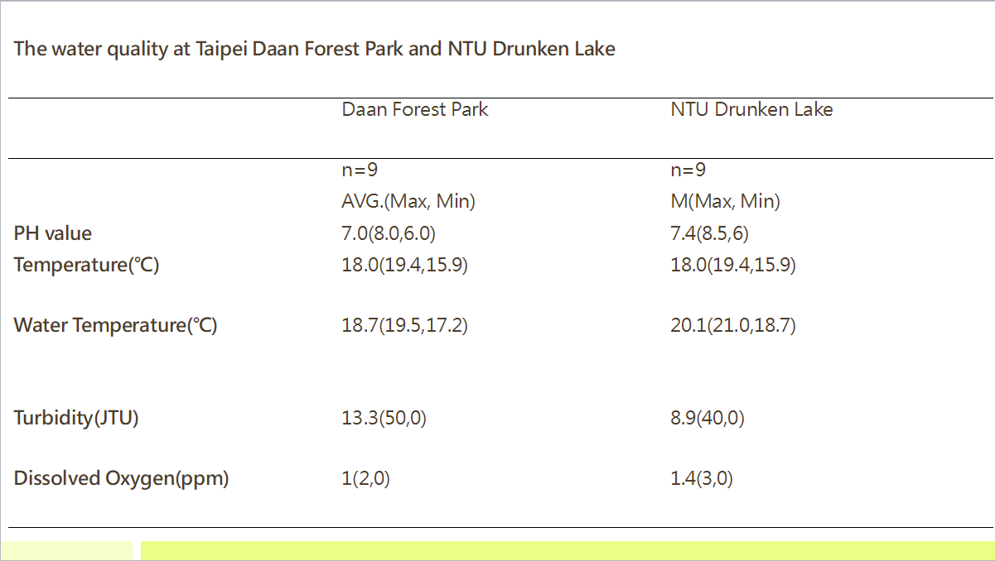

Figure 9. is a table comparing the water quality data of the Daan Forest Park Ecological Pond and the National Taiwan University Drunken Moon Lake

*Figures 10 and 11 show the microplastic data I observed in the Daan Forest Park Ecological Pond and the National Taiwan University Drunken Moon Lake on the same day.*

*c. Data Analysis*

In figure5 it can be seen that the water temperature measured by the electronic instrument is similar to the number measured by paper, but the turbidity at the same point has a maximum difference of 50 JTU. The reason is that the pond is very shallow and the drainage happened to cause the sediment to be raised during the measurement. The rest of the data such as pH value and dissolved oxygen content are not much different.

In figure 5 it can be seen the maximum temperature difference between the electronic thermometer and the paper thermometer is about 3 degrees. The turbidity is mostly 0JTU. There are only two records of 40JTU, one at sampling point 4 and the other at sampling point 6. The strange thing is that the pH value is as low as 6.3 and as high as 8.5. The dissolved oxygen content changes with the rise and fall of the pH value.

In figure 6 it can be seen over three days and nine times and the water temperature data measured in the ecological pond of Daan Forest Park.

In figure 8 it can be seen.over three days and nine times and the water temperature data measured at *Drunken Moon* Lake at National Taiwan University.

*d. Data on the number of microplastics and water quality in the ecological pond of Daan Forest Park*

|  |  |  |  |  |  |  |  |
| --- | --- | --- | --- | --- | --- | --- | --- |
| Geometry | Coordinates | Color | Surface appearance | Longest dimension  (μm) | Shortest dimension  (μm) | Area(μm²) | Photo(Y/N) |
| hook | (1,1) | green | Smooth surface | 1044 | 1044 | 1090 |  |
| Curved | (2,-4) | red | Matte | 1567 | 1566 | 2454 |  |
| Long strip | (-1,-1) | green | Smooth surface | 2350 | 1392 | 3272 |  |
| Short strip | (-4,-4) | red | Matte | 626 | 326 | 392 |  |

Figure 10 shows the microplastic data from the ecological pond at Daan Forest Park. These data were recorded from sampling point 3.

*e. Data on the number of microplastics and water quality in NTU Drunken Moon Lake*

|  |  |  |  |  |  |  |  |
| --- | --- | --- | --- | --- | --- | --- | --- |
| Geometry | Coordinates | Color | Surface appearance | Longest dimension  (μm) | Shortest dimension  (μm) | Area(μm²) | Photo(Y/N) |
| Translucent | (-1,-3) | red | Glass luster | 1174 | 522 | 613 |  |
| none | none | none | none | none | none | none |  |

Figure 11 shows the microplastic data in Drunken MoonLake at National Taiwan University These data were recorded from sampling point 6.

*f. Estimating the content of microplastics in water bodies using Daan Forest Park as an example*

Number of microplastics per cubic meter = 1000L×Number of microplastics found

_____________________________________

Amount of water filtered(liter)

= 1000×4

_____________________________________

0.15(liter)

= 26666

*g. Estimating the content of microplastics in**Drunken Moon water bodies using as an example*

= 1000×1

_____________________________________

0.15(liter)

= 6666

The amount of water filtered at both locations is the same. Drunken Moon Lake has less microplastics and better water quality.

# Results, Conclusions, and Discussion.

After comparison, the conclusion is that the dissolved oxygen content and water temperature of the Daan Forest Park Ecological Pool are lower than those of Drunken Moon Lake, and the turbidity is higher than that of Drunken Moon Lake, but the pH values of the two are very similar.

We have four points to discuss. The first point is the difference between the ecological pond in Daan Forest Park and the Drunken Moon Lake in NTU. The second point is the difference in water quality in the same area of Drunken Moon Lake in NTU.The third point is that we want to know what is the surface of the water body found in the water area of No. 6 Drunken Moon Lake of National Taiwan University Final， Will the animals in the water area affect the water quality such as pH value?

First, we need to discuss the differences between the Daan Forest Park Ecological Pond and the National Taiwan University Drunken Moon Lake. The Daan Forest Park Ecological Pond has a large pond and a small pond. However, since there is a sign near the main ecological pond of Daan Forest Park, we could not observe it and could only go to a small path nearby. Ecological pond sampling. Although its ecology is not as rich as the main pond, it still has the necessary elements of an ecological pond. However, there are few animals due to extremely low levels of dissolved oxygen. In comparison, NTU Drunken Moon Lake has a rich ecosystem. Bird species include Muscovy ducks, black swans, red-crowned moorhens, western cattle egrets, etc. The fish species are mainly koi, and there are also reptiles such as red-eared sliders.

The second point is why the pH value of the same area of the Drunken Moon Lake at National Taiwan University varies greatly. The pH values of points 4 and 5 are alkaline and fall between 7.5 and 8.4, while the pH value of point 6 is only 6.2

At 11:31 am on January 4, we found a layer of floating film on the water surface of No. 6 of Drunken Moon Lake, NTU. The results of our observations showed that the water quality was acidic and the dissolved oxygen content was low. According to the literature, the floating film was mainly composed of biological The layer of oil or pollutants produced after death usually affects the physical and chemical properties of the water. Further discussion of the impact on aquatic life includes the problem of hypoxia. The floating film covers a large area of water, causing low dissolved oxygen levels and harming aquatic life. The respiratory conditions of aquatic organisms are affected by the lack of oxygen, which limits the reproduction and growth of aquatic organisms and has an adverse impact on the ecosystem.

Finally, we need to mention whether the organisms in the water will affect the pH value of the water. We found that at 25.01 degrees north latitude and 121.32degrees east longitude and 25.02 degrees north latitude and 121.53 degrees east longitude, which is 4 and 5 in the picture, The water quality at these two points is slightly alkaline, with an average pH value of 7.87 and a maximum value of 8.4 (measured by an electronic pH meter). Using the pH test reagent, the average value was 7.83 and the maximum value was 8.50. In contrast, at 25.01 degrees north latitude, 121.53 degrees east longitude, the average pH value of the water was only 6.70 and the minimum pH value was 6.30 (measured by an electronic pH meter). ); using the test reagent, the average pH was 6.67 and the minimum pH was 6. Compared to the other two sites, the location closer to the edge presumably allowed waterfowl to feed and defecate there, where chemicals could have caused the pH to drop and reduced dissolved oxygen levels.

We know from our own observations and relevant literature that the results we proposed have been confirmed. For example, the film on the water surface was determined to be an oil film, and we observed that there was a difference in the effect of the oil film on the pH value and dissolved oxygen content of the water. The impact will be far greater than the same water area without oil film, which will in turn affect the ecology of the water body and cause damage to the water quality, so we need to protect this area of water even more.

# REFERENCES

Chen Y., Hou W., Xiang Z., Chu Y., & Lin Y.(2016).Integrated Biomanipulation and Micro-Bubble Aerator Treatment Landscape Ponds Water for National Taiwan University Drunken Moon Lake. Journal of Taiwan Agricultural Engineering,62(3), 13-22.

交通部中央氣象署 Central Weather Administration, MOTC <https://www.cwa.gov.tw/V8/C/>

### Research on the Application of Biomanipulation in Artificial Water Body: A Case Study on Drunken Moon Lake in National Taiwan University[陳以容(YI-RON CHEN)](https://www.airitilibrary.com/Article/Detail/javascript:;)；[侯文祥(WEN-SHANG HOU)](https://www.airitilibrary.com/Article/Detail/javascript:;)；[周楚洋(CHU-YANG CHOU)《台灣水利》 71卷1期 (2023/03) Pp. 1-11](https://www.airitilibrary.com/Article/Detail/javascript:;)