

**Hashemite Kingdom of Jordan**

**Zarqa First Directorate**

**King Abdullah the Second School for Excellence**

**Title of the research:**

**Rainfall in Zarqa Jordan**

**Preparations of the student: Toleen Aladin Shetaya/eighth grade**

**Teacher: Ruba Hapapkh**

|  |  |
| --- | --- |
| abstract | Page 3 |
| Research questions | Page 3-4 |
| introduction | Page 4-5 |
| methodology | Page 5-6 |
| Why Zarqa? | Page 6-7 |
| Factors Influencing Rainfall in Zarqa | Page 7-9 |
| The Data | Page 9-11 |
| Impact of Decrease or Increase in Rainfall on Water Availability in Zarqa | Page 11-12 |
| Role of Climate Change in Shaping Rainfall Patterns in Zarqa | Page 12 |
| Quantifying the impacts | Page 12-13 |
| Solutions to address the rainfall variability in Zarqa | Page 13-14 |
| Places like Zarqa | Page 14-16 |
| Thanks and appreciation | Page 17-18 |
| Sources | Page 18-20 |
| Deserved Badges | Page 21-23 |

**Index**

**Abstract**

This study examines the trends, patterns, and variations in rainfall over the last 30 years in Zarqa, Jordan, focusing on understanding how these changes impact local water resources and agricultural activities. The primary goal is to assess the annual and seasonal distribution of rainfall, identify long-term trends, and analyze fluctuations in rainfall intensity and frequency. The research also aims to explore the implications of these trends for water management strategies, as well as the adaptation measures needed to address water scarcity issues in the region. By synthesizing historical meteorological data, the study will provide insights into how climate variability has shaped the hydrological cycles in Zarqa, offering recommendations for sustainable practices to cope with the challenges of reduced rainfall and its socioeconomic consequences. Ultimately, the study seeks to contribute to regional climate studies and inform policy decisions aimed at securing water resources for the future.

**Keywords**: Rainfall patterns, Zarqa, Jordan, climate change, water scarcity, meteorological data, statistical analysis, trend analysis, seasonal variations, precipitation variability, drought, water availability, agricultural impact, water resource management, urbanization, environmental challenges, hydrological modeling, water stress, sustainable water practices, climate variability, environmental impact.

**Research Questions**

This research seeks to address key questions: What are the long-term trends in annual rainfall in Zarqa, Jordan, over the past 30 years? How do seasonal rainfall patterns vary in Zarqa, and what factors contribute to these variations? What are the key fluctuations in rainfall intensity and frequency in Zarqa over the study period? How has the decrease or increase in rainfall impacted water availability in Zarqa for agricultural and domestic use? What role does climate change play in shaping the rainfall patterns in Zarqa, and how can these impacts be quantified? And what are the solutions for the lack of water in Zarqa.

**Introduction**

Rainfall is a critical factor in shaping the environmental, agricultural, and economic landscape of a region, especially in arid and semi-arid climates like Zarqa, Jordan. Over the last several decades, climate variability and global climate change have begun to exert more influence on local weather patterns, making it essential to understand how rainfall trends in specific regions evolve. In Zarqa, one of the largest and most industrialized cities in Jordan, the availability and distribution of rainfall have a direct impact on water resources, agricultural productivity, and the overall well-being of its residents.

This study aims to investigate the rainfall patterns in Zarqa over the past 30 years, focusing on both annual and seasonal variations. By analyzing historical meteorological data, this research will assess the long-term trends in rainfall intensity, frequency, and distribution across different seasons. Understanding these patterns is crucial for evaluating the region's vulnerability to water scarcity, a problem that has been exacerbated by increasing urbanization and the challenges posed by climate change.

The primary goals of this study are to identify significant trends and fluctuations in rainfall, understand their impacts on water availability, and provide recommendations for water resource management and sustainable agricultural practices in the region. Furthermore, the research will contribute to a broader understanding of regional climate dynamics and offer insights into how policy decisions can help mitigate the challenges posed by changing rainfall patterns.

By exploring these dimensions, this study hopes to provide valuable information for policymakers, local authorities, and communities in Zarqa, helping them navigate the complexities of water scarcity and ensure a more sustainable future for the region.

**Methodology**

This study analyzes rainfall patterns in Zarqa, Jordan using the atmosphere protocol, it helped me by providing the data over the last 30 years in tables and charts that helped me by making studying the data easier. I used Utilizing data from the Department of Statistics in Jordan and other reliable sources. The data collected covers the period from 1994-2022 and includes annual and seasonal rainfall measurements across various months.

***Data Collection*:** The primary source of data for this study is the Department of Statistics in Jordan (mainly), which provides comprehensive records on meteorological conditions, including rainfall data, for cities and regions across the country. The data includes monthly and annual rainfall totals for Zarqa, and it is publicly available through government reports and the department’s online databases. And the rain mlm measuring tool in the site.

***Data Selection*:** The selected dataset includes only recorded rainfall data from meteorological stations located within or near Zarqa. The study uses data from Zarqa station to ensure consistency and accuracy. Data for missing years or months were excluded from the analysis, and any inconsistencies in the dataset were addressed by cross-referencing with other available sources, where necessary.

***Data Analysis***: To analyze the trends in rainfall over the last 30 years, several statistical techniques were employed:

***Trend Analysis***: This method was used to examine the long-term rainfall trends and to identify any significant increases or decreases over the years.

***Graphical Representation***: Various graphs, including line charts, bar charts, and box plots, were created to visually represent the rainfall trends and seasonal variations in Zarqa.

***Software Tools***: The data was processed and analyzed using statistical software such as Excel, which facilitated the computation of averages, trends, and the creation of graphical representations. Sometimes I had missing data and I used AI to fill these gaps.

***Limitations***: While the Department of Statistics provides reliable and detailed data, some limitations were noted in terms of occasional gaps in monthly rainfall data for certain years, which were addressed by interpolation or the use of neighboring station data when necessary.

**Why Zarqa?**

Zarqa, the second-largest city in Jordan, was chosen as the focus of this research due to its significant environmental and climatic challenges. Located in a semi-arid region, Zarqa frequently experiences drought conditions, which exacerbate water scarcity and strain the city's limited natural resources. These recurring droughts highlight the importance of studying rainfall patterns to better understand the shifts in climate and their implications for water availability.

Additionally, Zarqa faces environmental issues related to pollution, driven by several factors. As an industrial hub, the city hosts numerous factories, including heavy industries, which contribute to air and water pollution. The rapid population growth and urban expansion have also led to increased waste generation and inadequate infrastructure to manage pollution effectively. The contamination of the Zarqa River, one of Jordan's most critical waterways, is a stark example of the environmental challenges faced by the city.

By focusing on Zarqa, this research aims to shed light on the interplay between climate variability, such as rainfall and drought, and the city's environmental issues. The findings will provide valuable insights for addressing water management challenges and improving the sustainability of natural resources in this vital region.

**Factors Influencing Rainfall in Zarqa**

Zarqa Governorate is located in the northeastern part of Jordan, experiences a semi-arid climate with limited rainfall throughout the year. Understanding the factors that influence rainfall in this region is crucial for water resource management, agriculture, and urban planning. Several geographical and climatic factors contribute to the patterns of precipitation observed in Zarqa.

**1. *Geographical Location*:** Zarqa's inland position and distance from major water bodies contribute to its relatively low rainfall. Being located in the rain shadow of the western highlands of Jordan, moist air masses from the Mediterranean lose much of their moisture before reaching Zarqa, resulting in decreased precipitation.

**2. *Topography*:** The terrain of Zarqa is predominantly flat to slightly hilly, which does not encourage significant orographic rainfall. Unlike the western highlands of Jordan that experience greater rainfall due to elevation-induced cooling, Zarqa's lower elevation limits the formation of clouds and precipitation.

**3. *Proximity to Water Bodies*:** Zarqa is not located near large bodies of water, which limits the availability of atmospheric moisture. The absence of significant lakes or rivers nearby means that there is minimal local evaporation contributing to precipitation.

**4. *Atmospheric Pressure Systems*:** Zarqa is influenced by high-pressure systems that dominate the region during most of the year, leading to dry conditions. Occasionally, low-pressure systems from the Mediterranean bring rain, particularly in the winter months.

**5. *Wind Patterns*:** Prevailing winds in Zarqa are typically dry and originate from the desert regions to the east. These winds carry little moisture and contribute to the region's arid climate. During the winter, westerly winds may bring limited rainfall when Mediterranean depressions affect the area.

**6. *Seasonal Variations*:** Rainfall in Zarqa is highly seasonal, with the majority occurring between November and March. The summer months are generally dry due to the dominance of high-pressure systems and increased temperatures that lead to higher evaporation rates.

**7*. Climate Change*:** Recent studies indicate that climate change may be affecting rainfall patterns in Zarqa. Rising temperatures and shifting weather patterns could lead to increased variability in precipitation, with potential for more frequent droughts and occasional heavy rainfall events.

**The Data**

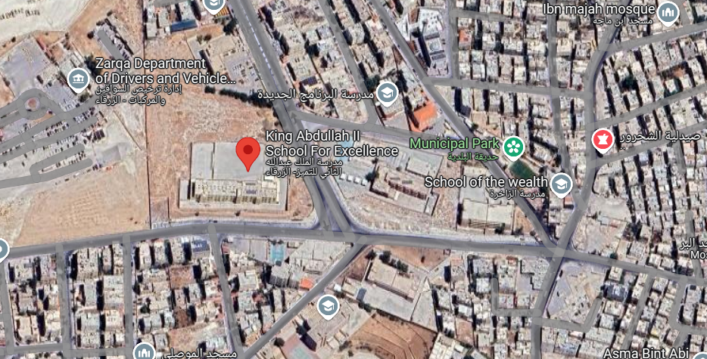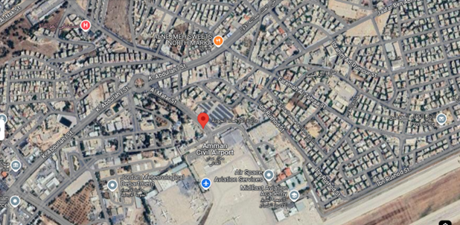

Site 2

Site 1

The provided data illustrates the annual rainfall measurements in millimeters for various years between 1994 and 2022. Several key observations can be made from the data:

**1.*Fluctuations in Rainfall* :**The data indicates significant fluctuations in rainfall over the years. For instance, the rainfall in 2002-2003 reached a peak of 177.7 mm, the highest recorded in the dataset, while in 2017 it dropped to a low of 5.2 mm, indicating considerable variability in precipitation patterns.

**2.*Periods of High Rainfall* :**The years 2001, 2002-2003, 2005-2006, 2006-2007, 2009-2010, and 2010-2011 show relatively high rainfall amounts, with values exceeding 100 mm, suggesting favorable weather conditions during these years.

**3. *Declining Trend in Recent Years:*** Starting from 2014, there has been a noticeable decline in rainfall levels, with most years recording values below 15 mm, except for minor fluctuations in 2019 and 2020.

**4.** ***Comparative Analysis*:** Comparing earlier periods (1994-2011) with recent years (2014-2022), the data reveals a substantial decrease in rainfall. This decline could be attributed to climatic changes, urbanization, and other environmental factors impacting precipitation patterns.

**5.** ***Irregular Rainfall Patterns*:** The data does not show a consistent trend but rather a pattern of irregular peaks and drops, highlighting the unpredictability of rainfall in Zarqa and emphasizing the need for better water resource management.

**Conclusion:** The analysis suggests that Zarqa Governorate experiences highly variable rainfall, with occasional peaks followed by long periods of decline. This variability underscores the importance of adopting sustainable water management strategies to address potential water scarcity issues.

**Impact of Decrease or Increase in Rainfall on Water Availability in Zarqa:**

The region of Zarqa, being semi-arid, is highly sensitive to changes in rainfall patterns. Rainfall directly influences water availability for both agricultural and domestic uses.

**Decrease in Rainfall**:

Agricultural Impact: A reduction in rainfall can lead to a shortage of surface water for irrigation. This forces farmers to rely more heavily on groundwater, which is often unsustainable. Crops that require large amounts of water, such as wheat and vegetables, are hit the hardest, leading to lower yields and economic losses.

Domestic Impact: Reduced rainfall also leads to less water in the dams and reservoirs, which supply water for domestic use. This could result in water shortages for households, particularly in urban areas like Zarqa, where demand for water is high.

**Increase in rainfall:**

While an increase in rainfall may seem beneficial, it can also have drawbacks. Heavy rainfall could overwhelm existing water infrastructure, causing flooding and leading to the contamination of water supplies, especially in areas with poor drainage systems. Additionally, an increase in rainfall is not necessarily spread evenly throughout the year, which can still result in periods of drought.

**Role of Climate Change in Shaping Rainfall Patterns in Zarqa**

Climate change plays a critical role in altering rainfall patterns across the Middle East, including Zarqa. The region has seen both an overall decrease in rainfall and more erratic weather patterns.

1.***Changing Rainfall Patterns***: Research indicates that climate change is leading to more frequent droughts and extreme weather events, such as heavy rains followed by long dry periods. This results in highly unpredictable rainfall, making it difficult for farmers and city planners to manage water resources effectively.

2.***Rising Temperatures***: The increase in average temperatures contributes to higher evaporation rates, reducing the effectiveness of rainfall. Higher temperatures can also cause droughts to last longer, further diminishing water resources.

3.***Shift in Rainfall Seasons***: Rainfall is becoming more concentrated in short periods, leading to flash floods instead of the consistent, seasonal rains needed for sustainable water use.

**Quantifying the Impacts:**

Quantifying the impacts of changes in rainfall patterns requires a multi-faceted approach:

**1.*Data Collection*:** Regular monitoring of rainfall data (using local weather stations and satellite data) is essential. Long-term historical rainfall records can be analyzed to identify trends, such as shifts in the start and end of rainy seasons or changes in annual totals.

**2.*Hydrological Models*:** Hydrological models, which simulate the movement of water within a specific area, can help predict how changes in rainfall will affect groundwater levels, surface water availability, and agricultural productivity.

**3.*Water Stress Index*:** A Water Stress Index can be used to measure the degree to which water resources are strained due to changes in rainfall. It combines data on water demand (for both agriculture and domestic use) with water availability, providing a clear picture of the water situation over time.

**4.*Crop Yield Models*:** These models can assess how changes in rainfall patterns affect agricultural yields by correlating precipitation data with crop production outputs.

**Solutions to address the rainfall variability in Zarqa**

The city of Zarqa in Jordan faces challenges related to rainfall, including both scarcity and sudden heavy downpours. To address these issues, several solutions can be implemented:

***Rainwater Harvesting*:** Collecting and storing rainwater during periods of heavy rainfall can help mitigate water scarcity during dry spells. This practice involves capturing runoff from roofs and other surfaces and storing it for later use.

***Improved Drainage Systems:*** Enhancing urban drainage infrastructure can prevent flooding during heavy rains. This includes constructing and maintaining efficient stormwater drainage systems to manage sudden downpours effectively.

***Public Awareness Campaigns*:** Educating residents about water conservation and the importance of maintaining drainage systems can lead to more sustainable water usage and better management of rainfall. Initiatives like the "With Water We Live" campaign aim to encourage responsible water use.

***Sustainable Agricultural Practices*:** Implementing water-efficient irrigation techniques and selecting drought-resistant crop varieties can reduce the agricultural sector's reliance on unpredictable rainfall. This approach helps in managing water resources more effectively.

***Climate Change Mitigation*:** Addressing the root causes of climate change can help stabilize rainfall patterns. This involves reducing greenhouse gas emissions and adopting renewable energy sources to combat global warming.

**Places like Zarqa**

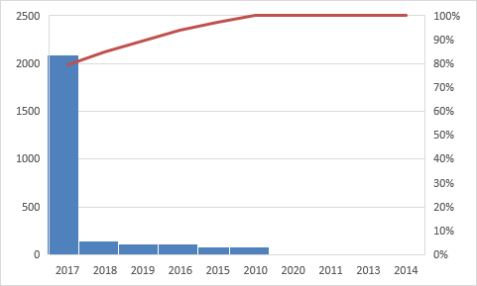

This is data of the capital of Saudi Arabia Riyadh. Riyadh is known for it’s lack of rainfall and it has lack of rainfall more than Zarqa.

Riyadh experiences a hot desert climate with low and sporadic rainfall, averaging about 93 mm (3.66 inches) per year, mostly concentrated in the cooler months. The wettest period typically occurs in March and April, with April receiving around 24 mm (0.94 inches), while the summer months, especially June, July, and September, usually see no rainfall. Rain in Riyadh is unpredictable, often coming in short but intense bursts, sometimes accompanied by thunderstorms, strong winds, and dust storms. Due to the city's arid landscape and limited water absorption, flash floods can occur after heavy downpours. Despite these occasional rains, Riyadh remains one of the driest major cities in the world.

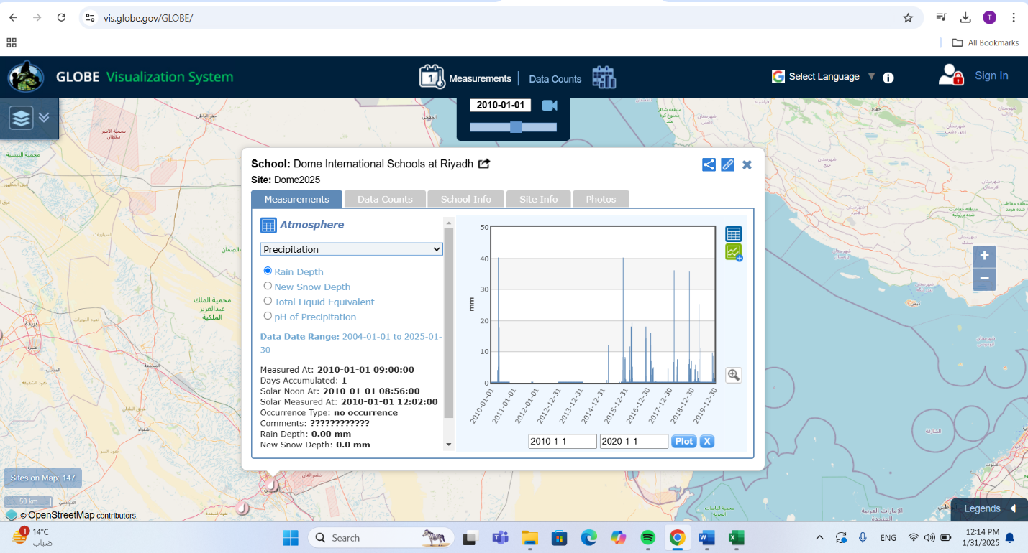

As seen in this photo, the data for Riyadh was token from Dome International Schools at Riyadh (the site) between 2010-2017. Most of the data occurrence type was rain mixed with snow or rain only.

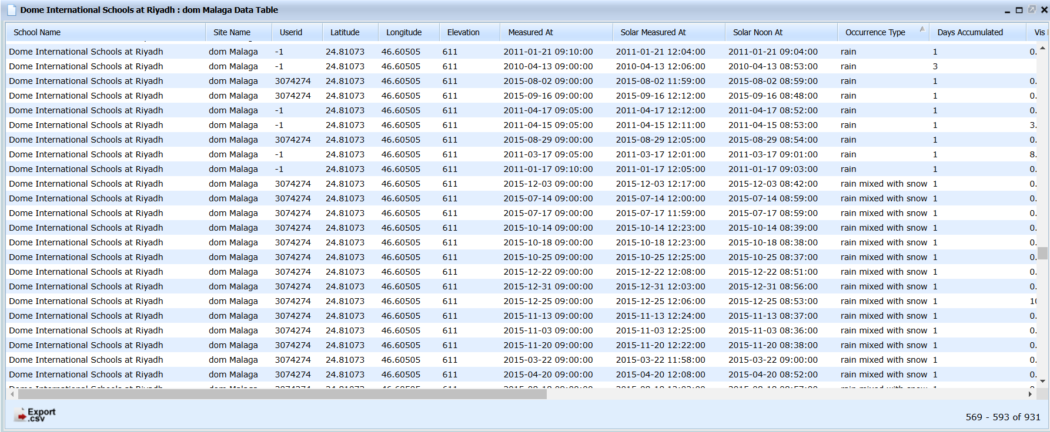

**Thanks and appreciations**

I would like to express my deepest gratitude to Dr. Rania Mehydate, the Principal of King Abdullah II School for Excellence, for her continuous support, encouragement, and leadership. Her vision and commitment to excellence have created an environment where students are empowered to pursue their goals, and I am truly grateful to be part of this inspiring institution.

A special thank you goes to Ms. Ruba Hapapkh, the GLOBE team trainer, for her invaluable guidance and support throughout this journey. Her expertise, patience, and dedication have played a key role in shaping the direction of my research and helping me stay focused and motivated.

I would also like to thank Ms. Amal Qtairi for her encouragement and contributions to the overall GLOBE experience. Her support has been a source of inspiration, and I appreciate the positive impact she has had throughout this process.

Finally, I would like to extend my heartfelt thanks to the entire GLOBE team at King Abdullah II School for Excellence: Raghad Wael, Rand Yousef, Malak Abu Hammam, Jana Awad, Toqa Al-Rousan, Yousef Sami, Yousef Ibrahim, Sallam Soufan and Yahia Zakaria. Although each of us worked on our own individual projects, we always came together to offer support, share advice, and help each other when needed. This spirit of collaboration and mutual assistance has been crucial in ensuring the success of our individual efforts, and I am grateful for the sense of community and encouragement we all shared.

As I move forward, I am excited to continue working with such an inspiring and dedicated group of individuals. Thank you all for your commitment and belief in this project and in the value of education.

**Sources**

<https://jorinfo.dos.gov.jo/Databank/pxweb/ar/Environment/Environment__State_Quality__Physical_Properties__Atmosphere/clim2.px/table/tableViewLayout2/>

<https://jorinfo.dos.gov.jo/Databank/pxweb/ar/Environment/>

<http://www.dos.gov.jo/dos_home_a/main/env/env_a/nashrat/2001/nasrat_ahsaiea/ahwal/nat_1.1_a.htm>

<https://forum.arabiaweather.com/showthread.php?p=1091395>

<http://jmd.gov.jo/%D8%A7%D9%84%D9%85%D9%88%D8%B3%D9%85-%D8%A7%D9%84%D9%85%D8%B7%D8%B1%D9%8A>

<https://forum.arabiaweather.com/showthread.php?p=473830>

<https://www.arabiaweather.com/ar/content/%D9%83%D9%85%D9%8A%D9%91%D8%A7%D8%AA-%D8%A7%D9%84%D8%A3%D9%85%D8%B7%D8%A7%D8%B1-%D8%A7%D9%84%D9%87%D8%A7%D8%B7%D9%84%D8%A9-%D8%AE%D9%84%D8%A7%D9%84-%D8%A7%D9%84%D9%85%D9%88%D8%B3%D9%85-%D8%A7%D9%84%D9%85%D8%B7%D8%B1%D9%8A-20142015>

<http://www.dos.gov.jo/dos_home_a/main/env/env_a/nashrat/2000/nasrat_ahsaiea/ahwal/nat_1.1_a.htm>

<https://www.weather.gov/jetstream/precipitation>

<https://www.nationalgeographic.org/encyclopedia/precipitation/>

<https://www.ametsoc.org/ams/index.cfm/education-careers/education-program/k-12-teachers/ams-weather-studies/textbook/chapter-7/>

<https://earthobservatory.nasa.gov/features/OceanCurrents>

<https://www.ipcc.ch/report/ar5/wg1/precipitation/>

<https://www.ammonnews.net/article/443878?utm_>

<https://vis.globe.gov/GLOBE/>

<https://www.facebook.com/watch/?v=1811453389680243>

<https://water.fanack.com/ar/jordan/water-challenges-in-jordan/?utm_>

<https://zm.gov.jo/ar/node/633?utm_>

<https://www.undp.org/sites/g/files/zskgke326/files/migration/jo/eace74912be69a8a99b655123dac10d92b1f5b0fb5cb6460eaf4d8fdf42e58b4.pdf?utm_>

<https://www.iwra.org/proceedings/congress/resource/2985903.pdf?utm_>

<https://www.researchgate.net/publication/271965528_Detecting_Variability_and_Trends_in_Daily_Rainfall_Characteristics_in_Amman-Zarqa_Basin_Jordan>

<https://www.academia.edu/11658143/Climate_Change_effects_on_Water_Resources_in_Amman_Zarqa_Basin_Jordan?utm_>

<https://archive.iwmi.org/wle/climate-change-impacts-surface-water-availability-management-jordans-zarqa-river-basin-using-soil/index.html?utm_>

<https://www.researchgate.net/publication/374569722_Impact_of_climate_change_on_groundwater_resources_in_Jordan_a_case_study_of_Amman_Zarqa_basin>

**Deserved Badges**

This research deserves this badge because the research applies scientific methods to analyze rainfall patterns in Zarqa, Jordan, using meteorological data and statistical analysis. It has investigated real-world environmental issues like water scarcity and climate change, applying evidence-based solutions.



This research deserves this badge because it identifies critical issues like water scarcity and climate change in Zarqa, Jordan, and proposes data-driven solutions to address them. By analyzing rainfall trends, you offer practical approaches to improve water management and mitigate environmental challenges. This aims to create sustainable solutions for real-world problems.



This research deserves this badge because the research on rainfall patterns in Zarqa, Jordan, relies heavily on data and methodologies developed by experts in meteorology, climate science, and data analysis. While I did not directly communicate with a STEM professional, my study uses meteorological data from the Department of Statistics in Jordan, which was collected and analyzed by professionals in these fields.



This research deserves this badge because there was a lot of collaboration between all the GLOBE team in King Abdullah the Second School for Excellence.