**An Analysis of Fifteen Years of GLOBE Hydrologic and Atmospheric Data Collected in Southeastern Michigan**

**Student Researchers:**

Mohammed Ali Al-Sabeh, Noor El Fadl, Maryan Farhat, Hala Komaiha

**School:**

Crestwood High School

Dearborn Heights, MI 48127

**Science Teacher:**

Mrs. Diana R. Johns

March 5, 2025

**Table of Contents**

Abstract...........................................................................................................................................3

Research Questions and Null Hypotheses......................................................................................4

Introduction and Review of Literature........................................................................................5-6

Materials and Methods................................................................................................................6-8

Data Summary...........................................................................................................................9-12

Data Analysis and Results.......................................................................................................12-15

GLOBE Data Analysis..................................................................................................................16

Conclusion.....................................................................................................................................17

Discussion................................................................................................................................17-18

Acknowledgements.......................................................................................................................19

Bibliography.................................................................................................................................20

Appendix.......................................................................................................................................21

Badges.....................................................................................................................................22-23

**Abstract:**

In this project, student researchers analyzed the relationship between air temperature and key **water quality** parameters over a fifteen-year period in Southeastern Michigan. This study focused on how fluctuations in **air temperature** correlate with water temperature, **dissolved oxygen levels, nitrate levels,** and **pH levels**, providing insight into potential environmental trends. Data collection took place annually in early May from 2009 to 2024, ensuring consistency in seasonal conditions. By examining long-term patterns, the researchers aimed to determine whether rising air temperatures influence **aquatic ecosystems** and water quality parameters. The research involved field data collection using standardized measurement techniques to minimize human error and ensure data reliability. Temperature and water quality readings were taken at the middle branch of the **Rouge River**. Dissolved oxygen levels were measured to assess aquatic health, while nitrate levels provided insight into nutrient pollution. pH levels were recorded to track changes in water acidity or alkalinity, which can impact aquatic life. The findings of this study contribute to understanding the broader implications of **climate change** on freshwater systems. By identifying trends in air and water temperature relationships, as well as shifts in water chemistry, this research provides valuable data for **environmental monitoring** and conservation efforts. Future studies can expand on this work by incorporating additional variables, such as precipitation patterns and land use changes, to further explore the interactions between climate and **freshwater ecosystems.**

**Key Words:** water quality, air temperature, dissolved oxygen levels, nitrate levels, pH levels, aquatic ecosystems, Rouge River, climate change, environmental monitoring, and freshwater ecosystems.

**Research Questions:**

The following research questions guided the researchers’ investigation of the trend and relationship between select atmospheric and hydrologic variables at the middle branch of the Rouge River which flows through northern Dearborn Heights, Michigan.

1. Is there a chronological relationship between atmospheric variables, such as air temperature, and hydrologic variables, such as water temperature, dissolved oxygen, pH, and nitrates?
2. Is there a chronological relationship between water temperature and dissolved oxygen, pH, and/or nitrates?
3. Has there been a significant change in the levels of atmospheric and hydrologic variables between 2009 and 2024?

**Null Hypotheses:**

1. There is no chronological relationship between atmospheric variables, such as air temperature, and hydrologic variables, such as water temperature, dissolved oxygen, pH, and nitrates.
2. There is no chronological relationship between water temperature and dissolved oxygen, pH, and/or nitrates.
3. There has been no significant change in the levels of atmospheric and hydrologic variables between 2009 and 2024.

**Introduction and Review of Literature:**

From the years 2009 to 2024, Crestwood High School student researchers have been collecting hydrologic data at the Middle Branch of the Rouge River. Historically, “Combined sewer overflows (CSOs) prevent surges in sewer networks by releasing untreated wastewater into nearby water bodies during intense storm events. CSOs can have acute and detrimental impacts on the environment and thus need to be managed” (Reyes-Silva et al., 2020). Every time the river got too high, CSOs would discharge raw sewage into the Rouge River, making it necessary to track fluctuations in dissolved oxygen (DO), pH, and nitrates.

Crestwood High School (CHS) first started monitoring the Rouge River in 1987 and was one of only two schools conducting research at the time. In 1995, with the introduction of the GLOBE program, CHS began using GLOBE protocols for monitoring. As Lovett (2007) states, “Long-term monitoring data also provide context for short-term experiments and observations.” This ongoing research has generated valuable data for conservation efforts and environmental monitoring.

In 2012, the method of wastewater management shifted from CSOs to retention basins. Instead of raw sewage directly entering the river, retention basins stored and gradually released wastewater. This change impacted water quality, affecting key variables such as DO, pH, and nitrate levels. According to Wetzel (1983), Hogan and Graham (1994), Matthews (1998), ANZECC/ARMCANZ (2000), and Pearson et al. (2003), “Because of its effect on aquatic fauna, especially fishes, one of the most important components of coastal wetland water quality is dissolved oxygen (DO).”

Seasonal variation also plays a role in water quality trends. As Ozaki et al. (2003) found, “It was found in almost all rivers that an increase in air temperature resulted in rises in BOD and SS and a drop in DO. From the analyses of the four seasons, the gradients differed significantly over the seasons for water temperature, BOD, DO, DO saturation ratio, SS, and pH, and enhanced dependencies were observed in summer” (p. 2852). Furthermore, wastewater effluent continues to be a concern, as Lehman (2016) states, “STW-effluent poses risks to the environment, to essential ecosystem services performed by rivers and eventually to humans.”

Through consistent monitoring, CHS students have provided critical data on how wastewater management and environmental factors influence the Rouge River.

**Materials and Methods:**

The data presented in this study was collected annually in May over a 15-year period, from 2009 to 2024. The research site was located in the middle branch of the Rouge River, which flows through northern Dearborn Heights, Michigan.

Each year, student researchers measured five parameters: dissolved oxygen, air temperature, water temperature, total nitrates, and pH. The student researchers followed GLOBE protocols to measure all the parameters.

From 2009 to 2013, the student researchers measured air temperature and water temperature with a LaMotte Liquid-filled Armored Thermometer. To measure dissolved oxygen, they used a HACH OX-2P. To measure total nitrates, the student researchers used the HACH Nitrates Test Kit (Low Range) to measure total nitrates. From 2013 to 2024, the researchers transitioned to using a Vernier Temperature Probe to measure air temperature and water temperature. To measure dissolved oxygen, they used a Vernier Optical Dissolved Oxygen Probe. To measure total nitrates, the researchers used the HACH DR 300 Pocket Spectrophotometer. Throughout the entire study period (2009–2024), pH was consistently measured using the HACH Phenol Red pH Test Kit 17-11, which has a range of 6.5 to 8.5.

Over the past 15 years, student researchers recorded their data in a Microsoft Word chart. This year, the data was extracted, transferred into a Microsoft Excel spreadsheet, and analyzed through graphical representation. This data was compiled and uploaded directly to the GLOBE website database.

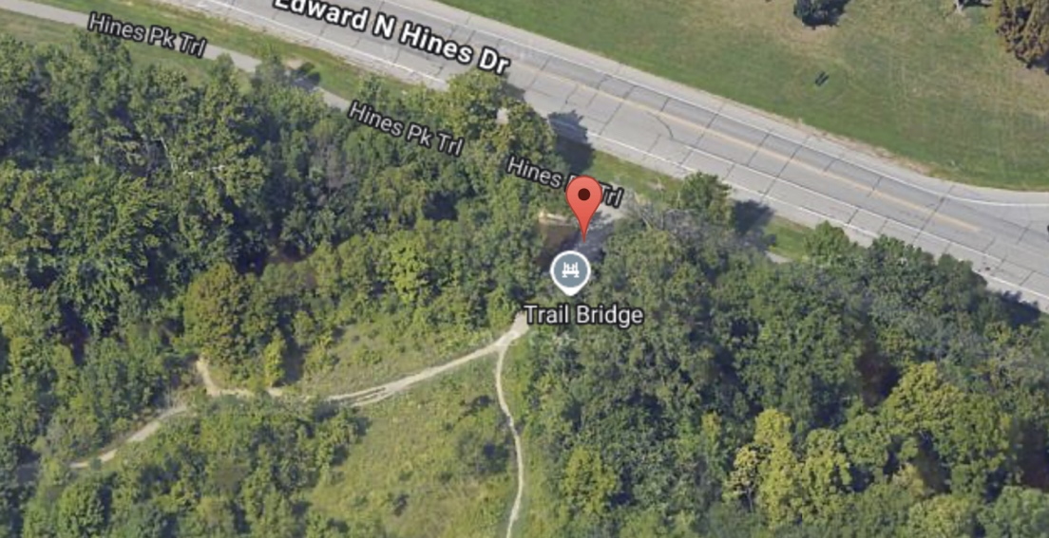

**Figure 1. Research Site.** Over the past 15 years, the data was collected in the same location, pictured above. The exact coordinates for this location are 42.347202° N and -83.276715° W.



**Figure 2 and Figure 3. GLOBE Data Entry.** The data collected over the past 15 years was obtained using GLOBE protocols. Figure 3 (right) shows student researcher Mohammed Ali Al-Sabeh inputting the collected data on air temperature, water temperature, dissolved oxygen, total nitrates, and pH into the GLOBE Website.

**Data Summary:**

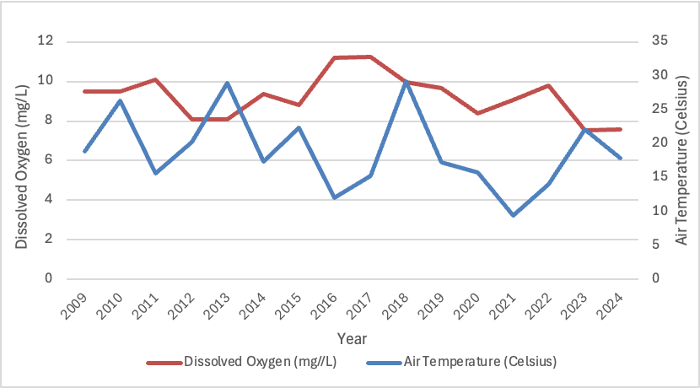

**Figure 4. Dissolved Oxygen vs. Air Temperature.** The line graph above shows the comparison of dissolved oxygen levels and air temperature from 2009 to 2024. While dissolved oxygen does not fluctuate significantly throughout the 15-year period, air temperature displays major variations. There appears to be a strong, inverse relationship between dissolved oxygen and air temperature.

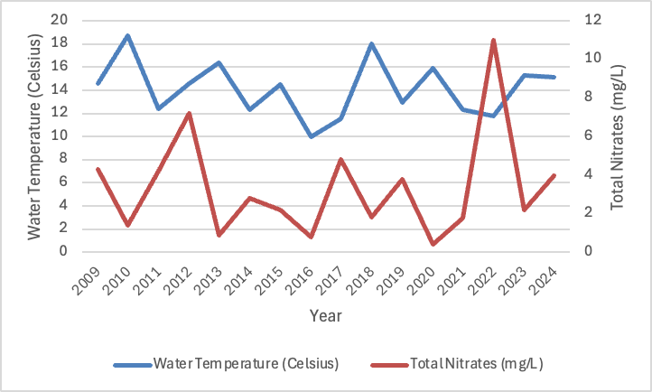

**Figure 5. Water Temperature vs. Total Nitrates.** The line graph above shows the comparison of water temperature and total nitrates from 2009 to 2024. Both the water temperature and total nitrates vary significantly throughout the 15-year period, fluctuating heavily. The graph shows an inverse relationship between water temperature and total nitrates.

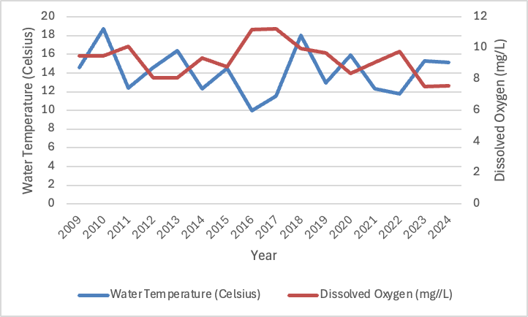

**Figure 6. Water Temperature vs. Dissolved Oxygen.** The line graph above shows the comparison of dissolved oxygen levels and water temperature from 2009 to 2024. Both the dissolved oxygen and water temperature remain relatively stable throughout the 15-year period, not fluctuating significantly. The graph shows a moderately strong, inverse relationship between dissolved oxygen and water temperature.

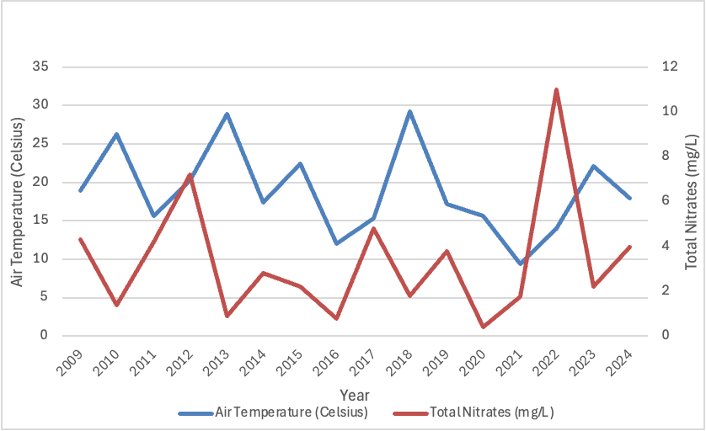

**Figure 7. Air Temperature vs. Total Nitrates.** The line graph above shows the comparison of air temperature and total nitrates from 2009 to 2024. Both the air temperature and total nitrates vary significantly throughout the 15-year period, fluctuating heavily. Moreover, there appears to be no net change in the two variables from 2009 to 2024. The graph shows an inverse relationship between water temperature and total nitrates.

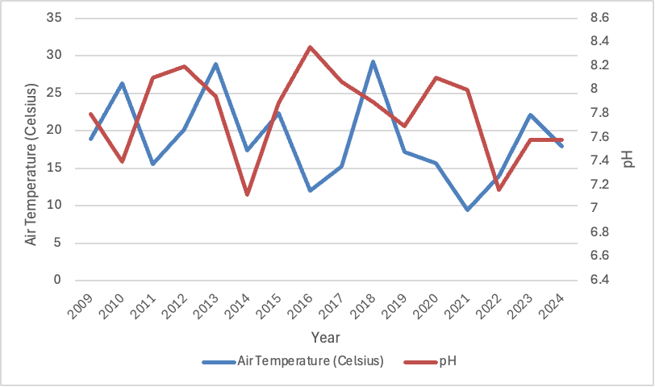

**Figure 8. Air Temperature vs pH.** The line graph above shows the comparison of air temperature and pH from 2009 to 2024. Both the air temperature and pH fluctuate significantly throughout the entire data collection period but appear to have no net change from 2009 to 2024. The graph shows little to no relationship between air temperature and pH.

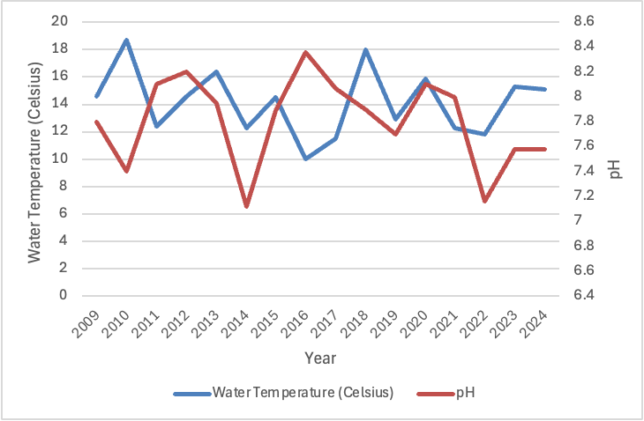

**Figure 9. Water Temperature vs pH.** The line graph above shows the comparison of water temperature and pH from 2009 to 2024. While the water temperature does not fluctuate significantly, pH displays major fluctuations throughout the entire data collection period. However, both the water temperature and pH display no net change from 2009 to 2024. The graph shows little to no relationship between water temperature and pH.

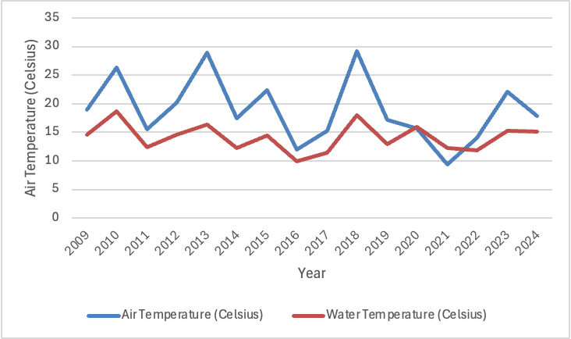

**Figure 10. Air Temperature vs Water Temperature.** The line graph above shows the comparison of air temperature and water temperature from 2009 to 2024. While air temperature fluctuates significantly throughout the 15-year period, water temperature remains relatively stable. There is little to no net change in both the variables from the beginning to end of the study. Air temperature and water temperature appear to have a strong, directly proportional relationship.

**Data Analysis and Results:**

The researchers both confirm and reject certain conditions within the first null hypothesis, which states that there is no relationship between atmospheric variables and hydrological variables. Specifically, the data displays a directly proportional relationship between air temperature and water temperature. As shown by the data in Figure 10, the amount of air temperature (measured in degrees Celsius) changes with respect to water temperature consistently from 2009 to 2024. Moreover, throughout the entire 15-year period, water temperature is less than air temperature during every collection period. This trend is due to the fact that water has a higher specific heat capacity relative to air, meaning it takes significantly longer for water to heat up or cool down compared to air. Furthermore, air temperature is shown to have a significant, inverse relationship with the amount of total nitrates (measured in milligrams per liter of water) at any given point, illustrated in Figure 7. Throughout the entire collection period, each peak in air temperature is coupled with a divot in total nitrates. This inverse relationship between air temperature and total nitrates in the river water can be explained due to microbial activity. In many aquatic systems such as rivers, certain microbes, like nitrifying bacteria, convert ammonia into nitrates. However, if temperatures become too high, these microbes can become stressed and reduce their nitrification activity, resulting in lower concentrations in the river water. Another reason for this inverse relationship between air temperature and total nitrates could be the change in plant growth, specifically algae. As air temperature increases, the growth of aquatic plants and algae tends to also increase. These organisms utilize nutrients like nitrates for growth and survival. Therefore, as air temperature increases, these plants may consume more nitrates, resulting in lower concentrations in the river water. Another inverse relationship that the researchers discovered was between air temperature and dissolved oxygen. As seen in Figure 4, as air temperature increases, the amount of dissolved oxygen in the river water decreases. This inverse relationship remained prominent over the entire 15-year period and is due to the change in the movement of water molecules in response to fluctuations in air temperature. As air temperature increases, water molecules begin to move at a faster rate which prevents oxygen molecules from dissolving into the river water. In terms of pH, the researchers found no relationship between pH and air temperature. As seen in Figure 8, from 2009 to 2024, there was no observed inverse or direct relationship between the two variables throughout the entire period.

Furthermore, the researchers reject the second null hypothesis that states there is no relationship between water temperature and dissolved oxygen, pH, and/or nitrates. As seen in Figure 5, there is a clear, inverse relationship between water temperature and the amount of nitrates. From 2009 to 2024, as water temperature increases, the amount of nitrates observed in the river water decreases. This is due to the change in the activity of nitrifying bacteria and growth of aquatic plants as a result of water temperature detailed earlier. Moreover, water temperature is shown to have a significant, inverse relationship with the amount of dissolved oxygen present at any given point, as illustrated in Figure 6. This finding aligns with previous scientific research, which shows that as water temperature rises, less oxygen can dissolve in the water due to the increased movement of water molecules. Additionally, there appears to be no relationship between water temperature and pH throughout the entire 15-year period according to Figure 9. With pH being determined by the concentration of hydrogen ions in water, water temperature has no significant impact on these factors as hydrogen ion concentration is controlled by the presence of dissolved substances and chemical reactions, rather than temperature alone.

Additionally, the researchers both reject the last null hypothesis that there has been no significant change in the levels of atmospheric and hydrologic variables between 2009 and 2024. Throughout the entire 15-year period, multiple atmospheric and hydrologic variables fluctuated heavily, including air temperature, pH, and total nitrates. However, water temperature did not fluctuate significantly from 2009 to 2024, most likely due to water’s high specific heat. With every atmospheric and hydrologic variable, there was no significant net change between 2009 and 2024. This conclusion is contrary to common findings regarding the change in water temperature over the past 15 years, likely because most readings are conducted in larger bodies of water, not small branches of a river. Therefore, with measurements being conducted in a smaller body of water, the changes in water temperature observed by previous scientists may not apply.

However, a crucial factor the researchers did not consider is the recent switch to the Vernier temperature probe device, which measures air temperature and water temperature, from the liquid-filled armored thermometer. With this switch, recent measurements of temperature have been rounded to the nearest hundredth, in contrast to past measurements, in which measurements were rounded to the tenth. Moreover, another limitation of the study is the change in researchers from year to year. With the study being conducted over a 15-year period, the researchers collecting the data varied, which may account for some fluctuations in accuracy as a different part of the river may have been used. Additionally, another reason for uncertainty is the amount of data collected per year. Since the researchers utilized one sample per year when creating graphs, the relationships between atmospheric and hydrologic variables may not be as accurate as only a moment in time is collected.

**GLOBE Data Analysis:**

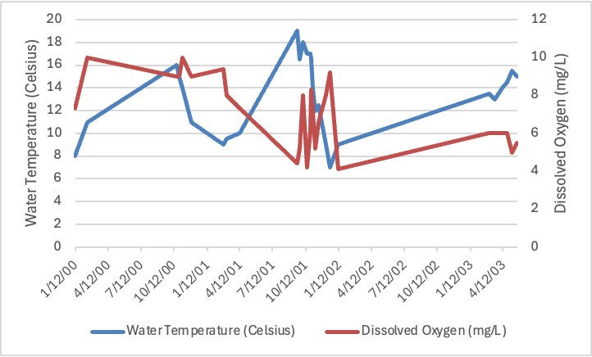

**Figure 11. Sheldon High School: Water Temperature vs. Dissolved Oxygen.** The line graph above shows the comparison of dissolved oxygen levels and water temperature from 2000 to 2003 collected by Sheldon High School in Oregon. The graph shows a moderate inverse relationship between dissolved oxygen and water temperature.

This data was collected in Eugene, Oregon (44° N, 123° W), a region with a Mediterranean climate characterized by mild, wet winters and warm, dry summers. Comparatively, Dearborn Heights, Michigan, where this study's data originates, experiences a continental climate with cold winters and warm-to-hot summers. Both pieces of data suggest that dissolved oxygen and water temperature have an inverse relationship. This is supported by the fact that increased temperature reduces the solubility of gases in liquids and therefore, warmer water carries less dissolved oxygen.

**Conclusion:**

At the end of the fifteen-year study period, the researchers concluded that air temperature and water temperature can significantly impact select water quality parameters, such as dissolved oxygen, total nitrates, and pH. A strong, indirect relationship was observed between almost all these parameters in correlation to air and water temperature - apart from pH vs. water temperature and air temperature vs. water temperature. The difference between air temperature in comparison to dissolved oxygen levels, total nitrate concentration, and pH levels were notable, with a yearly increase in air temperature corresponding to a decrease in these water quality parameters and vice versa. Moreover, similar inverse trends were seen with water temperature to dissolved oxygen levels and total nitrate concentration, with each yearly increase in water temperature corresponding to a decrease in DO levels and total nitrate concentration. In contrast, air temperature and water temperature demonstrated a directly proportional relationship. On the other hand, little to no correlation was found between water temperature and pH levels, suggesting that while these conditions can influence aquatic systems, their impact is not significant.

The information from this research has significant implications for climate change. Spanning a period of fifteen years, this study presents the opportunity for further analysis and expansion to include other branches of the Rouge River Watershed, thereby fostering a broader understanding of the impact of climate change across various geographic locations.

**Discussion:**

To reduce uncertainty, the study could be expanded to account for factors such as geographical variation, inconsistent sampling methods, and potential seasonal or temporal changes. For example, limiting the study to a single season may overlook fluctuations in water quality caused by human activity, storms, or biological factors like species composition changes throughout the year. Variations in sampling frequency, time of day, or equipment calibration can also introduce errors. Additionally, unmeasured pollutants, such as heavy metals or pharmaceuticals, could influence water chemistry, leading to potential inaccuracies. Nutrient loading from sources like agricultural runoff or wastewater discharge could vary seasonally, and the impacts of climate change might alter temperature patterns, precipitation, and other environmental factors, further increasing the level of uncertainty. By expanding the study over multiple seasons and ensuring consistent methodologies, these variables could be better accounted for, leading to a clearer and more reliable understanding of the relationships between environmental factors.

In the future, researchers could measure water quality parameters during various times of the day, allowing for a more comprehensive understanding of the impact hydrological factors have on aquatic systems. Moreover, this research could be expanded to locations both upstream and downstream from this study’s data collection location. Also, by working with the local Dearborn Heights Stewards Commission and its student commissioners, researchers could highlight issues regarding water quality to expand environmental protection efforts.

**Acknowledgements:**

Thank you to Friends of the Rouge for the constant support over the years. Thank you also to Mr. Bydlowski of the GLOBE AREN for providing many of the equipment necessary to properly perform this research, as well as Dr. Czajkowski at NASA GLOBE Mission Earth at the University of Toledo. Finally, thank you to Mrs. Diana Johns, the GLOBE and Science Club advisor, as without her guidance, it would not have been possible to complete this research.

**Bibliography:**

Improved dissolved oxygen status following removal of exotic weed mats in important fish habitat lagoons of the tropical Burdekin River floodplain, Australia. (2005). *Marine Pollution Bulletin*, *51*(1–4), 138–148. https://www.sciencedirect.com/science/article/abs/pii/S0025326X0400400X

Is monitoring science? (2007). In *Front Ecol Environ* (Vol. 5, Issue 5, pp. 253–260). The Ecological Society of America. https://www.fs.usda.gov/nrs/pubs/jrnl/2007/nrs_2007_lovett_001.pdf

Lehmann, K., Bell, T., Bowes, M., Amos, G., Gaze, W., Wellington, E., & Singer, A. (2016). *Trace levels of sewage effluent are sufficient to increase class 1 integron prevalence in freshwater biofilms without changing the core community.* https://www.semanticscholar.org/paper/Trace-levels-of-sewage-effluent-are-sufficient-to-1-Lehmann-Bell/96bd53ea81c04b82795451d178572d67fecd37d1

Ozaki, N., Fukushima, T., Harasawa, H., Kojiri, T., Kawashima, K., & Ono, M. (2003). Statistical analyses on the effects of air temperature fluctuations on river water qualities. *Hydrological Processes*, *17*(14), 2837–2853. https://doi.org/10.1002/hyp.1437

Reyes-Silva, J., Bangura, E., Helm, B., Benisch, J., & Krebs, P. (2020). The role of sewer network structure on the occurrence and magnitude of combined sewer overflows (CSOs). *Water*, *12*(10), 2675. <https://doi.org/10.3390/w12102675>

**Appendix:**

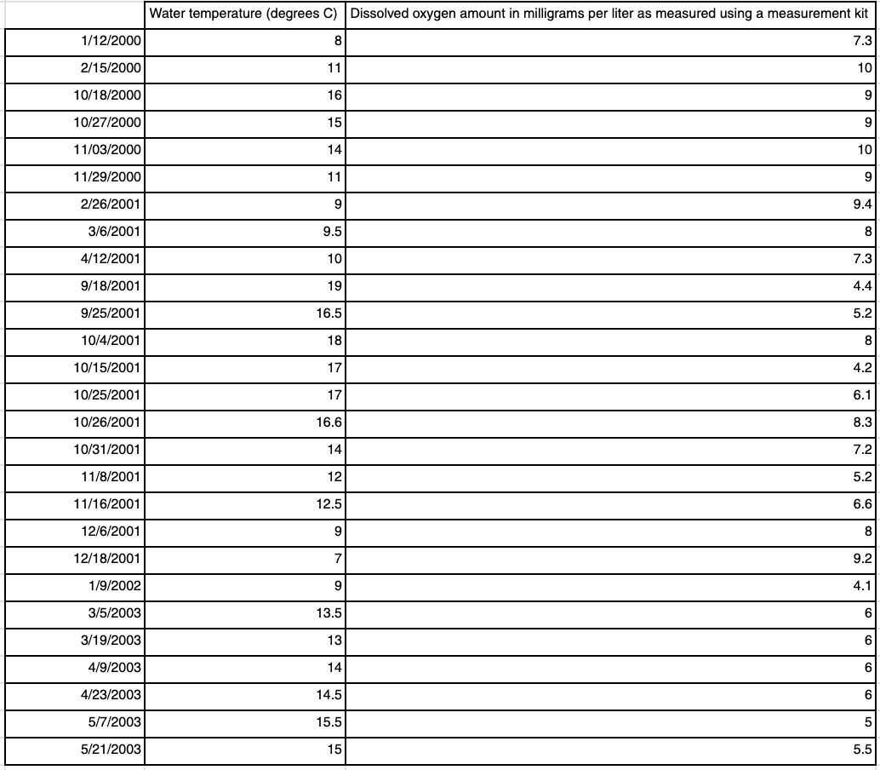**Figure 12. Data from GLOBE Website.** This data was collected by researchers at Sheldon High School in Eugene, Oregon (44° N, 123° W). The researchers in this study then created graphs and compared these trends with their own data.

**Badges:**

***I am a Data Scientist:***

The researchers hope to achieve the “I am a Data Scientist” badge for their collection, organization, and analysis of air and water temperature in relation to total nitrate concentrations, dissolved oxygen levels, and pH. For a fifteen-year period, the researchers gathered and compared data from the Rouge River location in Northern Dearborn Heights. This data was then compiled into Microsoft Excel and converted into graphs. The information provided by these graphs allowed the researchers to determine the correlation between parameters to air and water temperature, allowing them to draw conclusions between temperature and specific water quality parameters. The researchers hope that by using their findings, they can draw inferences that can be applied to broader hydrologic protocols in the future.

***I Make an Impact:***

The researchers worked to achieve the “I Make an Impact” badge as the results of the students’ research can make a local and global difference. This research can bring light to future environmental trends, providing insight into possible environmental effects on aquatic life. Directing the research findings to the Dearborn Heights Steward Watershed Commission, further mitigation of the raw sewage in the ecosystem will contribute to the management and restoration of waterways.

***I am a STEM Storyteller:***

The researchers hope to achieve the “I am a STEM Storyteller” badge for their creation of a public Instagram account that provides information regarding air temperature and water temperature and its impact on specific water quality parameters. The account (@environomentaltimetravelers) dives into the atmospheric and hydrosphere interconnection in the Rouge River Watershed through posts and stories. The researchers plan to use their account to bring further awareness and light to possible environmental protection efforts.