**My place yesterday and today RUGVICA**

Students: Bartol Kušeković, Laura Kovačić, Gabrijela Petek

Mentors: Petra Sekulić, Monika Puhalović

Link to ArcGis StoryMap: <https://arcg.is/0qCGW1>

**SUMMARY**

We are students of the GLOBE group from the Rugvica Elementary School in Croatia and last year we made an analysis of the land cover in our area using satellite images to see the changes in our area and how they affect us. As part of the World GLOBE Climate and Carbon Campaign, we were involved by implementing activities called "My Place Yesterday and Today".

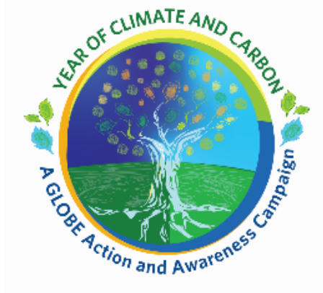

**INTRODUCTION**

Rugvica Elementary School has been actively participating in the GLOBE program since 2017. Since then, we have been actively conducting measurements and observations, participating in various events at the local level and transferring the knowledge we learn by participating in the program. Also, every year we participate with projects at the National Competition. By participating in the campaign, we wanted to find out what changes are happening in our immediate environment and how these changes affect us. We observed all the changes through satellite images and compared them together in extracurricular activity classes.

**METHODS AND MATERIALS**

For our work, we used satellite images from various sources, which we then analyzed. We took different years and used the legend to analyze and change the space. We also photographed the spaces we chose. We also used different literature to learn more about the area we live in. All images and maps are part of the StoryMap digital story, so we did not put them in this short written summary.

**RESULTS AND DATA**

We presented the results through a digital tool <https://storymaps.arcgis.com/> in which we made maps of our area. We have described all our results in a digital story.

**DISCUSSION AND CONSLUSION**

In the classes, we made certain conclusions and saw the changes in the space that we also wrote in our digital story.

The Municipality of Rugvica has recently been transformed and has become one of the most promising municipalities in the Republic of Croatia. In accordance with this, there is a transformation of the space, which is regularly accompanied by a change in the spatial plan. At the same time, our municipality is among the transparent municipalities in Croatia and regularly publishes changes in the spatial plan on its website ([Općina Rugvica - Prostorni plan](https://www.rugvica.hr/prostorni-plan)). It should certainly be noted that we have noticed changes from agricultural use to commercial/construction land and this change is shown on the interactive map above (KFK under construction). Furthermore, by inspecting the documents of the spatial plan, we read that the mentioned changes in the spatial plan, especially regarding the construction of the industrial zone, will not have a negative impact on the environment([Ocjena-i-strateška-procjena-utjecaja-na-okoliš.pdf (rugvica.hr)](https://www.rugvica.hr/wp-content/uploads/2015/07/Ocjena-i-strate%C5%A1ka-procjena-utjecaja-na-okoli%C5%A1.pdf)). There are no significant areas under forest in the municipality, especially within populated areas, so the construction will certainly not have an impact on the reduction of areas under forest.

With the help of satellite images that we used and with the help of literature and observation of the environment, we saw the changes in our area that we have shown and explained through this story. Attention should certainly be drawn to changes in the environment and the environment, and in addition to the accompanying changes, environmental protection and the prevention of excessive construction to the detriment of the environment should also be taken into account.

**LITERATURE:**

1. <https://www.rugvica.hr/prostorni-plan>
2. <https://www.rugvica.hr/wp-content/uploads/2015/07/Ocjena-i-strate%C5%A1ka-procjena-utjecaja-na-okoli%C5%A1.pdf>
3. <https://www.rugvica.hr/opcenit-o-opcini>
4. <https://earthmap.org/compare.html>
5. <https://srddugoselo.wordpress.com/ribolovna-podrucja/jezero-trstenik-iii/>
6. <https://mingo.gov.hr/UserDocsImages/UPRAVA%20ZA%20ZA%C5%A0TITU%20PRIRODE/NATURA%202000/PU%207013%20Sava%20kod%20Hruscice%20i%20Rakitje.pdf>

**BADGE DESCRIPTIONS:**

**I AM A DATA SCIENTIST**

Through different images of different satellites, the students approached the analysis of them. Based on the analysis of the recordings, we understood what changes have occurred in our area and whether these changes are positive or negative, and also how we can bring this problem closer to the local community.

**I AM AN EARTH SYSTEM SCIENTIST**

We used the following Bundle: Agriculture Protocol Bundle, Soil Bundle in a way that we looked at how environmental changes affect our space and how important soil is and how important agricultural land is.

**I AM A STEM STORYTELLER**

We told the story of our environment in a creative way, through a series of interactive maps and photographs that can be used to reveal the problems in our environment more closely.