Evaluating Hydrosphere Protocols in Correlation with Microplastic Levels in the Rouge River

Student Researchers:
Dunya Aidibi, Reham Alkased, Fatme Khalil

School:
Crestwood High School,
Dearborn Heights, MI 48127

Science Teacher:
Mrs. Diana R. Johns

March 5, 2025
Table Of Contents

- Abstract..........................................................................................................................3
- Research Questions and Null Hypotheses......................................................................4
- Introduction and Review of Literature........................................................................4-6
- Methods and Materials..................................................................... ........................6-11
- Data Summary..................................................................... ........... .......................12-14
- Data Analysis and Results..................................................................... .................14-17
- GLOBE Data Analysis..................................................................... ......................17-18
- Conclusions..................................................................... ........... ...........................18-19
- Discussion..................................................................... ........... .............................19-21
- Acknowledgements..................................................................... ........... ...............21-22
- Bibliography..................................................................... ........... ...............................23
- Appendix..................................................................... ........... ....................................24
- Badges..................................................................... ........... ...................................24-26

Abstract:
Microplastic pollution poses a growing threat to freshwater ecosystems, yet its relationship with key water quality parameters remains poorly understood. This study investigates the correlation between microplastic concentrations and hydrosphere protocols, including pH, turbidity, total solids, conductivity, and temperature in the Rouge River. The researchers collected and analyzed water samples from two sites: Parr Wayside, an urban recreational area, and Rouge River Wallaceville, a downstream location with residential and agricultural influence. The study aimed to determine whether seasonal variations and precipitation patterns affect microplastic levels and how microplastics interact with water quality factors. The researchers hypothesized that increased rainfall would not significantly impact microplastic concentrations and that higher levels of microplastics would correspond with increased turbidity and total solids while showing no significant relationship with pH or temperature. Samples were collected over several months and analyzed using standard hydrosphere testing protocols, microplastic filtration, and microscopy. Results revealed a positive correlation between microplastic concentrations and both turbidity and total solids, suggesting that higher suspended particle content is associated with increased microplastic pollution. Conversely, electrical conductivity and air and water temperatures showed an inverse relationship with microplastics, while pH exhibited no clear correlation. These findings indicate that microplastic contamination may be influenced more by particulate matter in or temperature changes. This research contributes valuable data to local environmental initiatives, informing conservation efforts and emphasizing the need for continued monitoring. The study underscores the importance of mitigating plastic pollution to protect freshwater ecosystems.

Key Words: Microplastic Pollution, Water Quality, Turbidity, Total Solids, Conductivity,
Research Questions:
- How do seasonal variations and related precipitation patterns influence microplastic concentrations?
- In what ways do microplastic concentrations affect pH, turbidity, total solids, conductivity, and water and air temperatures?
- How do different types of microplastics (man-made, biological, etc) vary in concentration across two different sites?
Null Hypothesis:
- Increased rainfall during wet periods has no relationship with microplastic concentrations found in river water.
- Higher microplastic concentrations would increase turbidity, total solids, and conductivity and may lower pH. Microplastics do not influence local air and water temperatures by absorbing solar radiation.
- The concentration of different microplastics (man-made, biological, etc.) will not vary between two sites. Parr Park, a more urban area, may have higher levels of man-made plastics, while Riverside, a more agricultural area, may show more biological microplastics.
Introduction and Review of Literature:
Microplastics are everywhere - in trash, dust, fabrics, cosmetics, cleaning products, rain, seafood, produce, and even table salt. As plastic production and consumption continue to rise, so does plastic pollution. Over time, larger plastic waste breaks down into tiny fragments due to environmental factors like sunlight, wind, and water erosion. These microplastics, defined as plastic particles less than 5 mm in diameter, can persist in the environment for decades. In addition to being byproducts of plastic degradation, some microplastics are intentionally manufactured and added to personal care products like facial cleansers and cosmetics for exfoliation or texture enhancement (Li, 2023).
Microplastics pose a potentially serious threat to aquatic ecosystems. They can reduce nutrient availability for microalgae - the foundation of many aquatic food webs - by blocking access to nutrients in the water column, ultimately disrupting entire ecosystems (Prata, 2019). Additionally, microplastics are easily ingested by marine organisms, from tiny plankton to larger fish, leading to biomagnification - a process where contaminants become more concentrated as they move up the food chain (Prata, 2019). This not only affects wildlife consumers but also raises concerns about human exposure through seafood consumption.
Microplastics come from both human-made and natural sources. Primary microplastics are deliberately produced in small sizes, such as microbeads in personal care products or synthetic fibers released from clothing. In contrast, secondary microplastics form when larger plastic materials break down over time due to exposure to sunlight, water movement, and physical wear (Ali, 2023).
Previous studies conducted by fellow student researchers Nour Abu Alaywa, Sally Nassereddine, and Huda Yaseen from Crestwood High School found that pH did not affect microplastic concentrations. Turbidity showed an inverse relationship but may have trapped microplastics in sediment, and colder temperatures unexpectedly correlated with higher microplastic levels. Some environmental factors influenced microplastic concentrations, while others did not, supporting their null hypothesis in several cases. Our research aimed to further their work by exploring additional factors such as total solids and water temperature.
Although preventing the breakdown of microplastics is an optimistic solution, it is not yet feasible with current technology. Instead, reducing the introduction of microplastics into waterways is a more effective approach. Creating strategies to reduce or eliminate the flow of microplastics into waterways is essential to global waterway protection initiatives. Because of the risks that microplastics pose-ingestion by a variety of species can compromise energy reserves and can bioaccumulate and biomagnify through the food chain-monitoring microplastics is crucial for the safety of the ecosystem.
Materials and Methods:
Between August and December 2024, researchers collected water quality and air temperature data in Dearborn Heights, MI, focusing on the Parr Wayside area and Rouge River Wallaceville site along the Middle Branch of the Rouge River. The Parr Wayside location was selected for its proximity to Hillcrest Elementary School and its role as a recreational space where families participate in outdoor activities such as biking, hiking, and barbecuing. The Rouge River Wallaceville area was chosen due to its position upstream from Parr Wayside, allowing for a comparative analysis of water quality between two points along the river. This site also provided an opportunity to examine potential variations in microplastic concentration and other water quality parameters in an area influenced by residential, recreational, and school-related activities due to its proximity to Riverside Middle School and the Warren Valley Golf Course. Given the urbanized nature of the surrounding environment, assessing the presence of microplastics in the river is essential to understanding their potential impact on the watershed.
At both sites, Water sampling and pH, conductivity, and air and water temperature testing were conducted using a Nasco Swing Sampler (12ft), a Vernier pH probe, a Vernier Conductivity Probe, and a Vernier Temperature Probe. At both sampling sites, before collecting any water samples, researchers measured air temperature in degrees Celsius three times using the Vernier Temperature Probe. Then, water samples were collected using the Nasco Swing Sampler. The water temperature was immediately measured in degrees Celsius three times using the Vernier Temperature probe, while conductivity was assessed using the Vernier Conductivity Probe. The pH level was determined using the Vernier pH Probe. The samples were then transported to Crestwood High School in Dearborn Heights, MI, for further filtration and analysis of total solids and turbidity.
The further analyses that were made at Crestwood High School were total solids, turbidity, and microplastic filtration, for which measurements were made using a Hach Utility Oven, an OHAUS Pioneer Analytical Balance, which measures to the nearest milligram, and MilliporeSigma MF-Milipore membrane filters with a Nalgene filtration vacuum.
Turbidity was measured using (XX) mL of Rouge River water from each site three times, inverting the vials each time before setting them into the Hach 2100N Turbidimeter. The water was then filtered using a Nalgene filtration vacuum in 250 mL intervals with a MilliporeSigma MF-Millipore Membrane Filter marked off with 4 quarters and analyzed within 24 hours in a moist environment with a Parco LTM-400 series compound microscope. To minimize contamination and ensure the accuracy of results, all sampling and testing materials were composed of 100 percent cotton-based materials. Since sedimentation may have occurred during transport, each sample was shaken for 30 seconds before additional testing to ensure consistency in results.
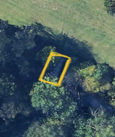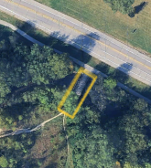
Figure 1a. and Figure 1b. Site Visualization. The left photo shows Parr Wayside, and the right shows Rouge River Wallaceville along the Middle Branch of the Rouge River. Parr Wayside was selected for its recreational use and proximity to Hillcrest Elementary, while Rouge River Wallaceville, located upstream, offers a comparison of water quality between the two sites, influenced by nearby residential and school activities.

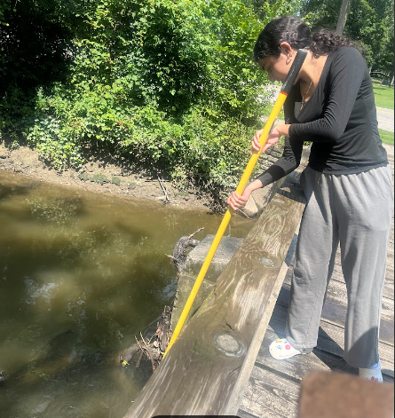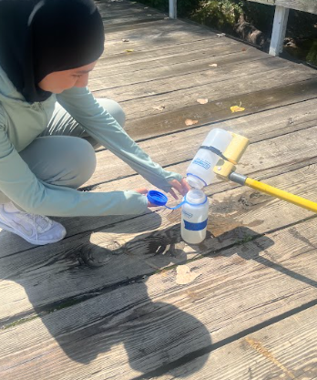
Figure 2a and Figure 2b. Collecting Samples. The image on the far left shows a student researcher collecting a 500-mL (about 16.91 oz) sample of Rouge River water at the Rouge River Wallaceville site. In the picture on the right, another student researcher is transferring 100ml (approx. 3.38 oz) from the 500-mL (approx. 16.91 oz) sampling bottle.

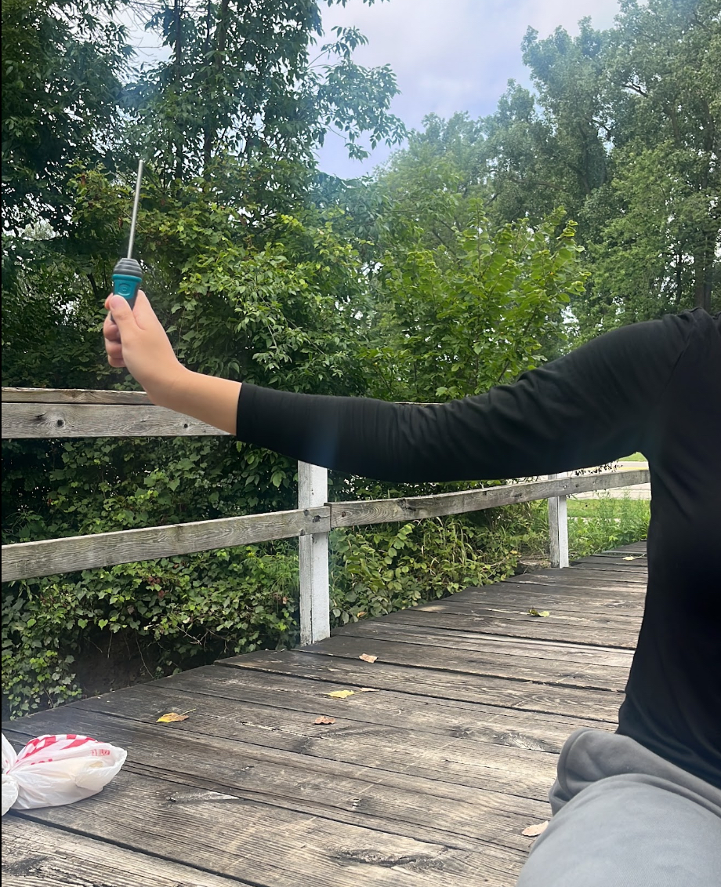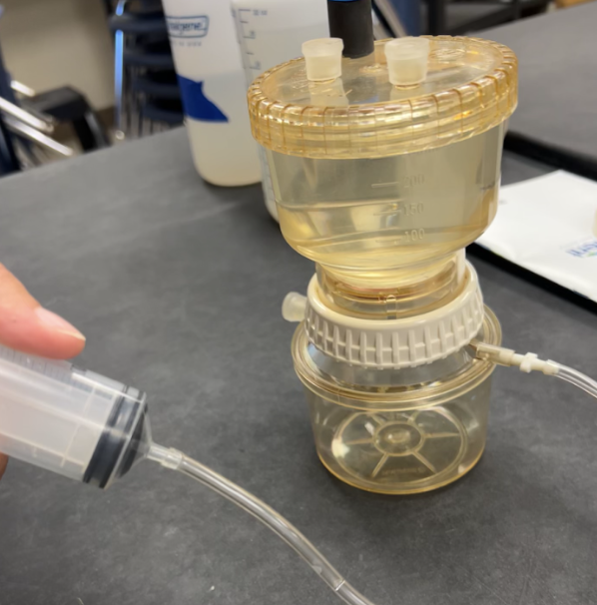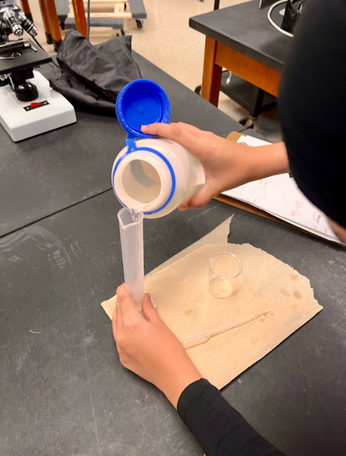
Figure 3. Collecting Temperature. Filtering Microplastics. Measuring water. The photo on the left shows the use of a Vernier Temperature Probe to measure air temperature in degrees Celsius before sampling. The photo in the middle shows a Nalgene filtration vacuum being used to filter microplastics from Rouge River Samples. The photo on the right features a student researcher measuring 50 mL of Rouge River water to be prepared for total solid measurements.

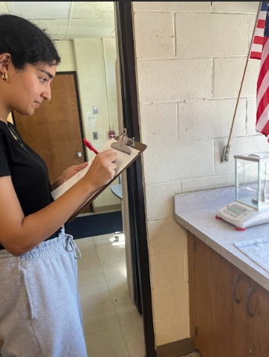
Figure 4a. Measuring Total Solids (left). Figure 4b. Analyzing Petri dishes (right). The photo on the left shows a team member recording data while measuring total solids from a Rouge River water sample, with the scale visible for weighing the collected solids. The photo on the right features two team members analyzing petri dishes of separated dissolved solids for microplastic counting.
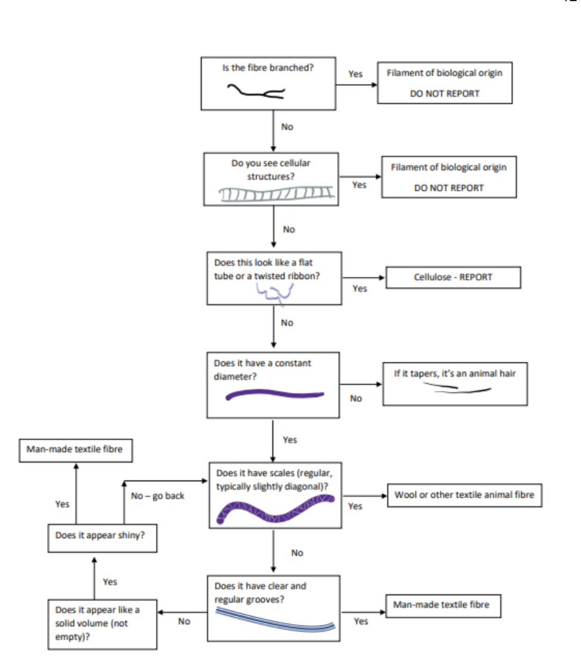
Figure 5a. Figure 5b. Microplastic Identification Guide
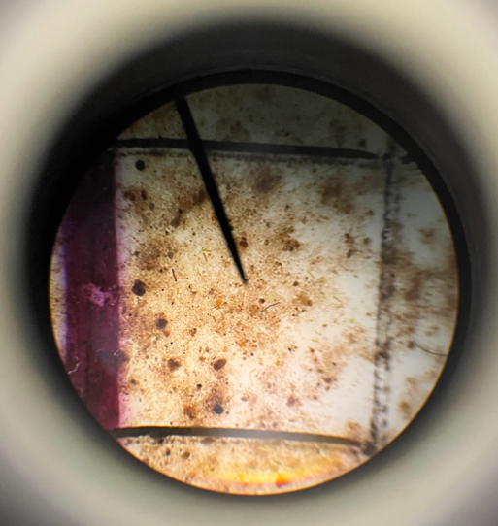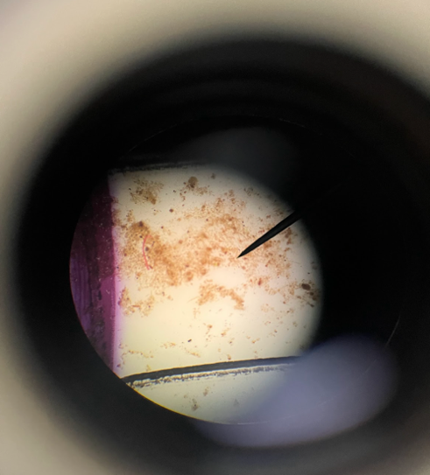
Figure 6 Microplastic Identification. Sample 1 of the Rouge River Wayside Parr sample is depicted on the left, where cellulose and synthetic fiber concentrations are clearly visible. Sample 2 is shown in the picture on the right. Wallaceville water from the Rouge River following flooding. Deep observation was necessary to discover microplastics because of the increasing silt that may have imbedded them. Cellulose fibers are still apparent, though.

Figure 14. Data Entry. Student researcher submits data to a GLOBE database for GLOBE verification
Data Summary:
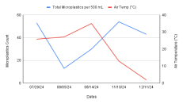 |  | 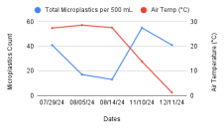
Figure 7. Air Temperature (°C) vs. Total Microplastics per 500 mL. This line graph compares the relationship between air temperature and total microplastics identified in each 500-mL sample. The data on the left represents the Rouge River Wallaceville site, while the data on the right corresponds to the Parr Wayside area.
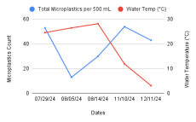 |  | 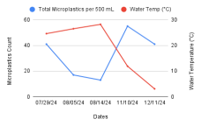
Figure 8. Water Temperature (°C) vs. Total Microplastics per 500 mL. The line graph above compares water temperature to the total quantity of microplastics identified in each 500-mL sample. The data on the left represents the Rouge River Wallaceville site, while the data on the right corresponds to the Parr Wayside area.

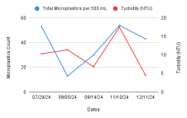 |  | 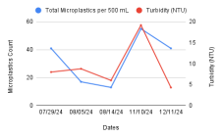
Figure 9. Turbidity (NTU) vs. Total Microplastics per 500 mL. The line graph above shows the correlation between turbidity (measured in NTU) and the total abundance of microplastics in each 500-mL sample. The data on the left represents the Rouge River Wallaceville site, while the data on the right corresponds to the Parr Wayside area.
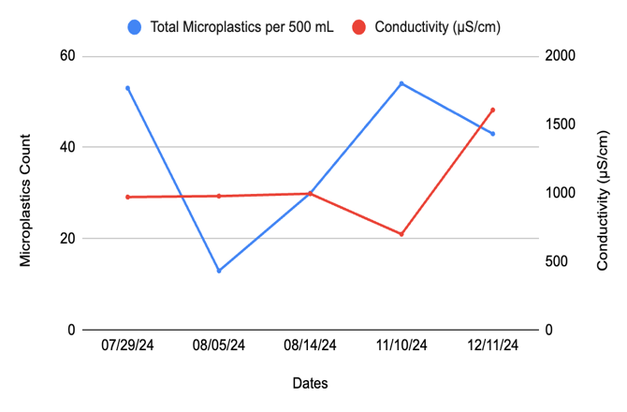 |  | 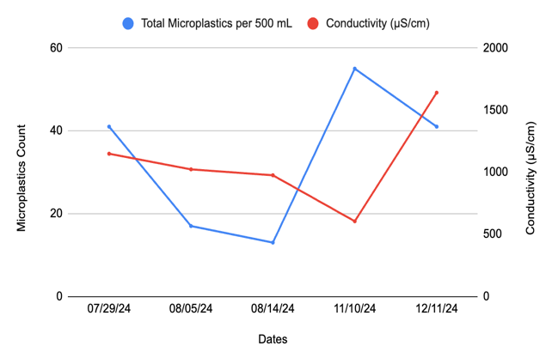
Figure 10. Electrical Conductivity (μs/cm) vs. Total Microplastics per 500 mL. The line graph above compares electrical conductivity to the total amount of microplastics identified in each 500-mL sample. The data shows that electrical conductivity is inversely related to the amount of microplastics identified, with the data on the left representing the Rouge River Wallaceville site and the data on the right corresponding to the Parr Wayside area.
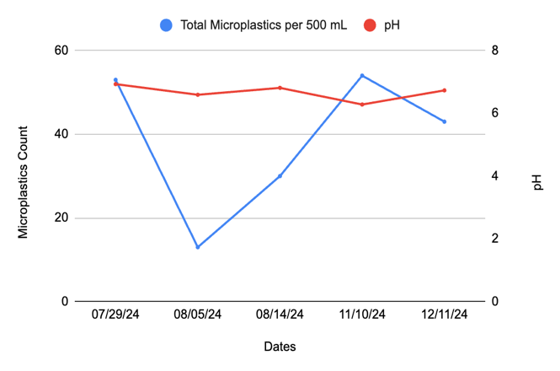 |  | 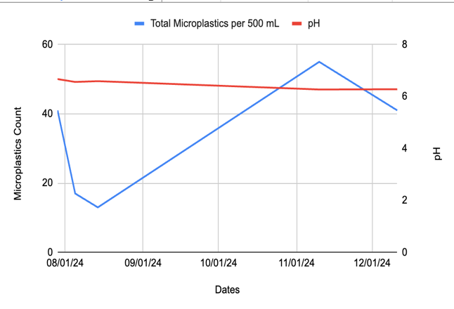
Figure 11. pH vs. Total Microplastics per 500 mL. The line graph above compares pH levels to the total quantity of microplastics identified in each of the five 500-mL samples. The data on the left represents the Rouge River Wallaceville site, while the data on the right corresponds to the Parr Wayside area.

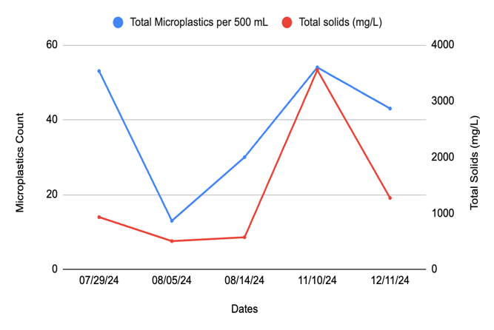 |  | 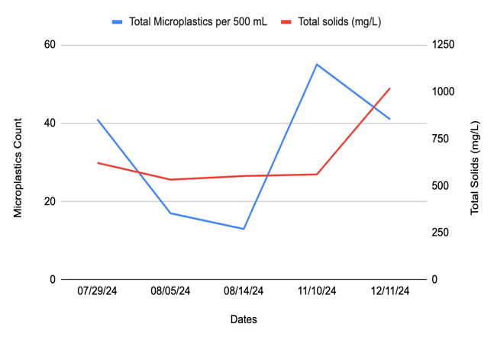
Figure 12. Total Solids (mg/L) vs. Total Microplastics per 500 mL. The line graph compares total solids (mg/L) to the total microplastics identified in each 500-mL sample. The data on the left represents the Rouge River Wallaceville site, while the data on the right corresponds to the Parr Wayside area.
Data Summary:
In this study, the relationship between microplastic concentrations in water samples and various environmental and water quality parameters was analyzed using the Pearson correlation coefficient through an online calculator. The data were collected from two locations: Parr Wayside area and Rouge River Wallaceville. The parameters examined included air and water temperature, turbidity, electrical conductivity, pH, and total solids. The results suggest that some of these factors have more influence on microplastic levels than others.
The analysis of the data revealed a negative correlation between air temperature and microplastic concentrations in the samples. As air temperature increased, microplastic counts tended to decrease, and vice versa. This suggests that air temperature may influence microplastic levels, potentially affecting factors such as atmospheric deposition or water turbulence.
Similarly, water temperature also demonstrated an inverse relationship with microplastic concentrations. Higher water temperatures corresponded to lower microplastic counts, while cooler temperatures were associated with increased concentrations. This trend indicates that water temperature may play a role in microplastic distribution, possibly due to changes in water density, flow dynamics, or biological interactions.
Turbidity, a measure of water clarity due to suspended particles through light, demonstrated a moderate direct correlation with microplastic concentrations. Higher turbidity values were often associated with higher microplastic counts, indicating that areas with more suspended particles in the water tend also to have higher microplastic contamination. This finding suggests that turbidity could be used to indicate microplastic pollution in aquatic environments.
The relationship between electrical conductivity and microplastics was inversely correlated. In locations where the water had higher electrical conductivity, typically indicating higher levels of dissolved solids or ions, the microplastic concentrations were lower. This suggests that areas with higher ionic content in the water may have fewer detectable microplastics, possibly due to interference from the dissolved solids or a reduced ability to detect microplastics.
pH, however, did not show any clear relationship with microplastic concentrations. Changes in pH levels did not correlate with variations in microplastic levels, suggesting that pH does not have a significant impact on the presence or concentration of microplastics in the water samples.
Finally, total solids, which represent the suspended particles in the water by weight, showed a moderate direct correlation with microplastics. In areas with higher levels of total solids, microplastic concentrations were generally higher as well. This suggests that regions with greater suspended particle content may also experience higher levels of microplastic contamination.
Several potential sources of error may have influenced the results of this study. One key source of error is sampling variability. Even when samples are taken from the same location, the microplastic concentrations can vary, leading to inconsistencies in the data. Measurement errors from the instruments used to measure parameters like turbidity, conductivity, pH, and total solids could also introduce inaccuracies into the results. The calibration and precision of these instruments may vary, affecting the reliability of the data. Additionally, environmental factors such as local pollution sources or seasonal variations in water quality could influence the results. For instance, runoff from nearby roads or industrial areas may contribute to changes in turbidity and conductivity, impacting the measurements of these parameters. Human errors during data recording or sample processing may have also introduced discrepancies into the results.
The uncertainties in the data stem from the challenges of accurately measuring water quality parameters in the field, the inherent variability of natural water systems, and the potential limitations of detection methods for microplastics. These uncertainties should be considered when interpreting the results and when designing future studies to better understand the relationship between environmental factors and microplastic contamination.
GLOBE Data Analysis:
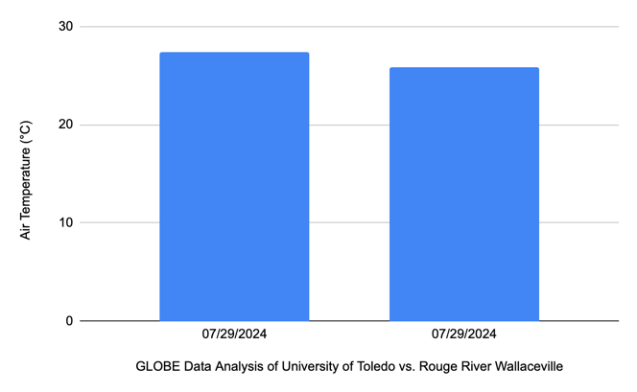 |  | 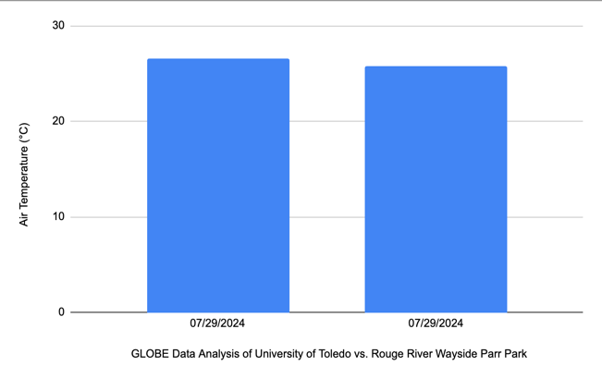
Figure 12. Air temperature readings from Rouge River Wayside Parr and Wallaceville vs. University of Toledo. The first bar graph compares the air temperature at the Rouge River Wayside Parr with the University of Toledo data of average air temperature. The bar graph on the left shows a comparison between Rouge River Wallaceville and the University of Toledo.

The University of Toledo's air temperature is lower than that of Rouge River Wayside Parr and Rouge River Wallaceville, according to these two bar graph comparisons taken on 7/29/2024. This research team decided to compare their data with that of the University of Toledo since it is trustworthy, was collected on the same day, and is nearby. Geographical location, altitude, and local climate conditions are some of the reasons for the temperature differential between Rouge River Wayside Parr and Wallaceville and the University of Toledo. The University of Toledo may have slightly different weather patterns than Rouge River Wayside Parr and Wallaceville because of its location, which is slightly to the south. The longitude and latitude for Rouge River Wayside Parr is Latitude 42.347119, Longitude -83.276754, and then for Rouge River Wallaceville is Latitude 42.345421, Longitude -83.291632, for the University of Toledo is Latitude: 41.6577 Longitude: -83.6137 Temperature differences can also be influenced by local landscape factors including vegetation, urban heat islands, and bodies of water. In summary, the main causes of temperature variations between Rouge River Wayside Parr and Wallaceville and the University of Toledo are geographic position, urbanization, and local climate.
Conclusions:
This study aimed to evaluate the correlation between microplastic concentrations and various environmental and water quality parameters in the Rouge River, with data collected from Parr Wayside and Rouge River Wallaceville. The results indicate that microplastic concentrations are more closely associated with turbidity, total solids, and electrical conductivity than with factors like temperature and pH.
The positive correlations between turbidity and total solids with microplastic concentrations suggest that areas with higher levels of suspended particles in the water tend to have more microplastics. This finding supports the idea that turbidity could serve as an indicator of microplastic contamination. The inverse relationship between electrical conductivity and microplastic concentrations suggests that higher ionic content in the water could affect the detectability of microplastics. The lack of correlation between temperature, pH, and microplastics suggests that these factors do not have a direct impact on microplastic concentrations in the Rouge River.
The findings also support the hypothesis that microplastic contamination is more strongly influenced by suspended particles and dissolved solids in the water rather than environmental factors like seasonal variations or temperature. The study’s limitations, including sampling variability and instrument sensitivity, highlight areas for improvement in future research. Expanding the study to include more sites and increasing the frequency of sampling would provide more robust data and better insights into the dynamics of microplastic pollution in urban and rural environments.
Overall, this research provides valuable information about the factors that contribute to microplastic contamination in the Rouge River. By sharing the results with local organizations such as the Friends of the Rouge and the Dearborn Heights Watershed Commission, the team hopes to contribute to ongoing efforts to reduce microplastic pollution and protect local water ecosystems. Future research should explore the impacts of microplastics on aquatic life and their potential risks to human health, which will be crucial for developing effective solutions to the growing problem of plastic pollution in local waterways.
Discussion:
This study explored the correlation between microplastic concentrations and various environmental and water quality parameters in the Rouge River, specifically at the Parr Wayside and Rouge River Wallaceville sites. The analysis revealed that turbidity, total solids, and electrical conductivity was strongly associated with microplastic concentrations, while temperature and pH showed weaker or no significant relationships.
The first research question asked how seasonal variations and related precipitation patterns influence microplastic concentrations. Although the study spanned several months, there was no clear pattern showing that increased rainfall or seasonal variations directly impacted microplastic concentrations in the river. This lack of correlation suggests that other factors, such as local pollution sources, runoff, and water flow, may have a more immediate influence on microplastic levels than seasonal variations alone.
Regarding the second research question, which examined how microplastic concentrations affect pH, turbidity, total solids, conductivity, and water and air temperatures, the study found significant relationships between microplastic levels and turbidity as well as total solids. Higher turbidity and total solids were associated with higher microplastic concentrations, indicating that as the number of suspended particles in the water increases, so do microplastic levels. This finding suggests that turbidity could serve as an indicator of microplastic contamination. Electrical conductivity showed an inverse relationship with microplastic concentrations, with higher conductivity linked to lower microplastic levels. This inverse correlation may be due to the presence of dissolved solids, which could reduce the detection of microplastics or affect their behavior in the water. However, no significant correlation was found between pH, temperature, or air temperature and microplastic concentrations.
For the third research question, which addressed how different types of microplastics vary in concentration across two sites, the study did not differentiate between man-made and biological microplastics. However, based on the urban and rural differences between the sites, it is reasonable to hypothesize that the Parr Wayside site, closer to urban areas, may have higher levels of man-made microplastics, while Rouge River Wallaceville, which is more agricultural, could have more biological microplastics. Future studies focusing on categorizing microplastics by type would provide more detailed insights into this aspect of microplastic contamination.
In terms of the null hypothesis, the study did not find a significant relationship between increased rainfall and microplastic concentrations in the river water. This suggests that rainfall alone does not directly influence microplastic levels, although runoff and other factors could still be contributing to variations in microplastic contamination. The hypothesis that higher microplastic concentrations would increase turbidity, total solids, and conductivity was supported, particularly in terms of turbidity and total solids. However, the null hypothesis stating that microplastics do not influence local temperatures was not addressed directly, as the study did not find any significant relationship between microplastics and air or water temperatures.
Potential errors in this study could stem from sampling variability, as microplastic concentrations can fluctuate even within the same location. Measurement inaccuracies from the instruments used to assess parameters like turbidity, conductivity, and total solids could also introduce errors, especially if calibration or precision was not consistent. Additionally, environmental factors such as local pollution sources, runoff, and seasonal changes might have influenced the data, causing variability that was not fully accounted for. Human error in data recording or sample processing could further contribute to discrepancies in the results.
Acknowledgements:
First and foremost, the research team would like to express their gratitude to Mrs. Diana Johns and Ms. Abbas for her time, support, and direction during their entire research project. Furthermore, the team would also like to thank the Friends of the Rouge for assisting the team in purchasing much-needed filtration equipment and expendables needed to process water samples collected during this research. Lastly, the researchers would like to express their gratitude to the GLOBE Program for hosting a worldwide program that encourages young people to investigate the natural world around them and share their data with others interested in similar research.

Bibliography:
Ali, N., Khan, M. H., Ali, M., Sidra, Ahmad, S., Khan, A., Nabi, G., Ali, F., Bououdina, M., & Kyzas, G. Z. (2024). Insight into microplastics in the aquatic ecosystem: Properties, sources, threats, and mitigation strategies. Science of The Total Environment, 913, 169489. https://doi.org/10.1016/j.scitotenv.2023.169489
Li, Y., et al. (2023). Potential health impact of microplastics: A review of environmental distribution, human exposure, and toxic effects. Environment & Health, 1(4), 249–257. https://doi.org/10.1021/envhealth.3c00052
“Pearson Correlation Coefficient Calculator.” Social Science Statistics,
https://www.socscistatistics.com/tests/pearson/default2.aspx
Prata, J. C., Costa, J. P., Lopes, I., Duarte, A. C., & Rocha-Santos, T. (2019). Effects of microplastics on microalgae populations: A critical review. Science of The Total Environment, 665, 400–405. https://doi.org/10.1016/j.scitotenv.2019.02.126
Vethaak, A. D., & Legler, J. (2021). Microplastics and human health. Science, 371(6530), 672–674. https://doi.org/10.1126/science.abe5041

Appendix:
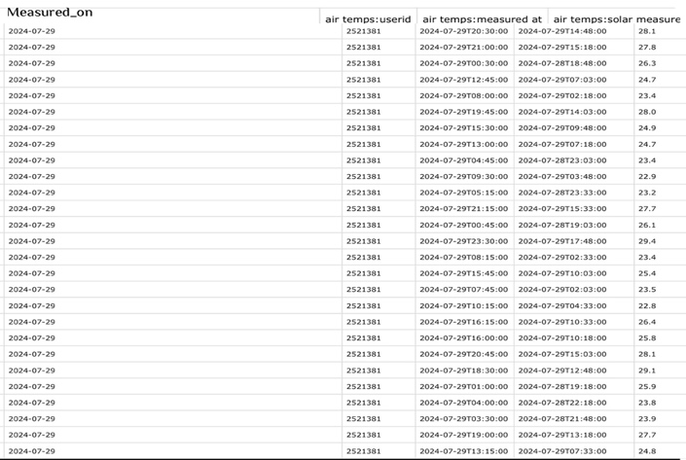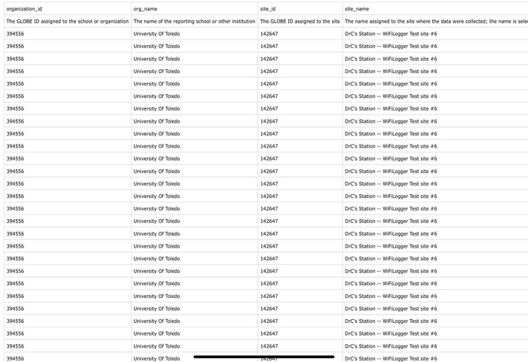
The University of Toledo air temperature protocol chart. The University of Toledo’s data, which the research team compared to their own, is displayed in these charts. Air temperature was the protocol compared in this data, which was collected on July 29, 2024.

Badges:
I Am A STEM STORYTELLER: Since the researchers recorded their journey on an Instagram profile under the username “the_microplastic_doctors,” they are hoping to be awarded the “ I Am A STEM STORYTELLER” badge. This social media platform has been used by the team to inform community members about the effects of microplastics in waterways and to introduce them to their research. Every time they sample and collect data, the team publishes updates on their research. In an effort to encourage people to create their own stories using the GLOBE program, the team has been able to create an engaging narrative that highlights their progress on the project while emphasizing the scientific methodology they applied.


I Make an Impact: Since the application of this study can have a local and worldwide impact, the researchers aspire to be awarded the “I Make an Impact” badge. Once we have finished we will share with the “Friends of the Rouge” at our local watershed organization and Present at a meeting of the Dearborn Heights watershed commission, who will be there to announce accepted practices for measuring microplastic concentrations so that potential solutions can be implemented to address the problem in our nearby waterways. By sharing these results with the city, the team may come up with creative ways to educate the locals on ways to lessen the amount of microplastics in the Rouge River and in their daily life.

I Am a Data Scientist: Throughout their investigation into the impacts of microplastics, the research team demonstrated excellent data gathering and analytical abilities. They have demonstrated an amazing capacity to understand and deliver significant results by collecting and evaluating important data on temperature (water and air), conductivity, Ph, water transparency, and turbidity. They have shown the relationship between microplastics and temperature (water and air), conductivity, Ph, water transparency, and turbidity using graphs. They are confident in their ability to analyze data and aspire to receive the “ I Am a Data Scientist” badge for their innovative use of scientific data to reduce microplastics in waterways.

