**1.Who do mosquitoes like?**

**Students: Margareta Kljun,**  **Patricia Pešić**

**Mentors: Marina Pavlić, Petra Pincan**

**School: Prirodoslovna i grafička škola Rijeka**

**2.Abstract**

In the last few years we noticed that some new mosquitos have arrived in our County. Up until now they would sting us during summer nights, an itch would appear and it would pass quickly without much consequence. Now we all are a target for mosquitoes day and night.

We noticed that the inhabitants in west part of Rijeka do not follow the instructions of the Educational institute, they keep standing water infinitely, do not empty flower pots after the rain, leave old tires out all potential places for mosquitoes nests.

GLOBE group students decided to help the inhabitants of the west part of Rijeka to realize the dangers of such attitude.

They gave lectures to inhabitants of our chosen sites, primary students and our school's students.

By using GLOBE protocols and other methods we determined that the prevailing species of mosquito in west part of Rijeka is *Aedes aegypti* (tiger mosquito), that their appearance depends mostly on temperature.

Our County mosquitoes prefer to bite blood type 0 people, with pale and delicate skin, wearing dark clothes and who like to cool themselves with beer.

**3.Research questions**

-Do not-indigenous species of mosquitos prevail in west Rijeka?

-Does the amount of rainfall, temperature and air humidity have any effect on the number of mosquito larvae in the observed period?

-Do mosquitos only sting certain kinds of people?

-Is the County of Promorsko goranska endangered by diseases carried by non-indigenous mosquitos?

-Can we stop them with natural preparations?

**4.Introduction**

In the last few years we noticed that some new mosquitoes have arrived in our County. Up until now they would sting us during summer nights, an itch would appear and it would pass quickly without much consequence. However, now a lot of our students and acquantances have complained that they are a target for mosquitos day and night, that after the stings they suffer from blisters that would last up to a few days. Escpecially endangered are our students that attend classes near our GLOBE site. We decided to find out what is happening around our school and in the west side of our town where we noticed the same problem.

We refered to the Educational institute for public health of Primorsko-goranska County-NZZJZ PGŽ so we could find out what kind of danger do these mosquitos pose. NZZJZ PGŽ introduced us to their findings in the last couple of years and informed us that tiger mosquitoes have inhabited our County in 2008. We found out that in the world around million people die per year from diseases transmitted by mosquitoes. Head of Section for disinfection pest and rodent control NZZJZ PGŽ in Rijeka helped us with literature, advice and determining the mosquito species. She informed us that from last year the Institute distribute flyers with instructions how to prevent mosquitoes developing but that only small number of inhabitants read them. We consulted NZZJZ literature to learn about mosquitoes in our County and the capital Rijeka. The Institute specialists instructed us that male mosquitoes do not sting, they feed on plant nectar and help with pollination. At the same time, they are food for birds, fishes and amphibians.

We noticed that the inhabitants around our school, on Turnić, Marelica and Grbci sites do not follow the instructions of NZZJZ either, they keep standing water infinitely, do not empty flower pots after the rain, leave old tires out. These are all potential places for mosquito nests.

GLOBE group students decided to make them realize the dangers of such attitude.

**5. Research methods:**

**GLOBE** **protocols:**

* Mosquito Larvae Protocol
* Current Maximum and Minimum Temperature Protocol
* Relative Humidity Protocol
* Rainfall Protocol
* pH

**Other:**

* mosquito poll (who do they like to bite?)
* count of the bites on chosen students during the entire observed period (which we considered exposed)
* talk with the doctor-dermatologist specialist about health and skin problems after the bites
* prepare natural products in our school lab with which we will try to stop the growth of mosquitos and track their effectiveness (in the months of 2018. when we detect mosquitoes on our sites)

From July 2017 to January 2018 we determined the species of mosquitos in the area of Turnić, Srdoči, Grbci and Škola with the help of specialists of NZZJZ PGŽ Rijeka.

We will continue doing so till August 2018. Acquired data will be compared to the data of prevailing species of mosquitos in PGŽ in collaboration with NZZJZ PGŽ.

pH data were collected when the larvae developed.

**6. Results**

**Table1: Measuring sites**

|  |  |  |
| --- | --- | --- |
| Measuring site | Coordinates | Elevation |
| Turnić | N45.33966o E14.4123o | 48 m |
| Marelica(Srdoči) | N45.2116o E14.2117o | 142 m |
| Grbci | N45.3533o E14.3781o | 139 m |
| Škola | N45.338013 o E 14.424786 o | 50 m |

Table 1 shows measuring sites in the west part of Rijeka

The selection of measuring sites in west part of Rijeka was based on ease of access to the measuring sites and undisturbed possibility of water accumulation in buckets during summer and autumn months. The measuring sites themselves are close to places of residence of GLOBE students involved. Data acquired in the west part will be compared to the data of entire PGŽ.

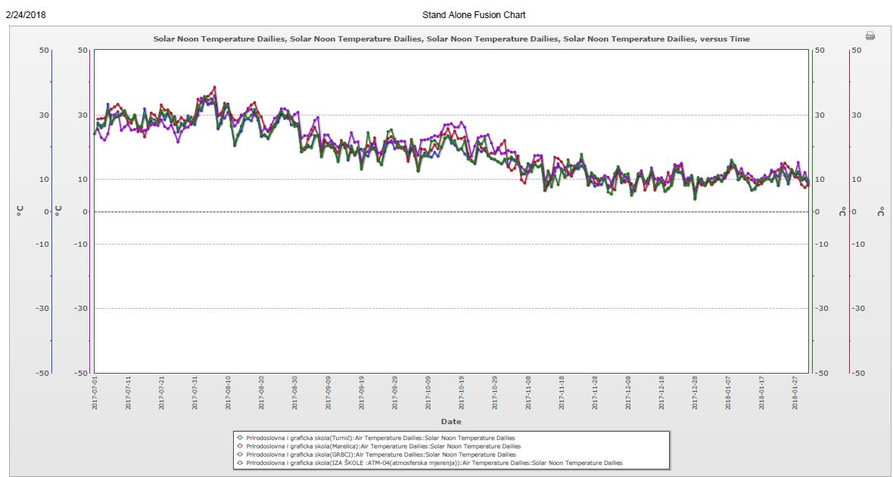

Picture 1: Current air temperature comparison on sites: Škola, Turnić, Marelica and Grbci from July 1st 2017 to January 31st 2018

We can observe that the current solar noon temperatures are the highest on Škola and Turnić sites.

We measure continuously on four sites but begun working on the report the 1st of February.

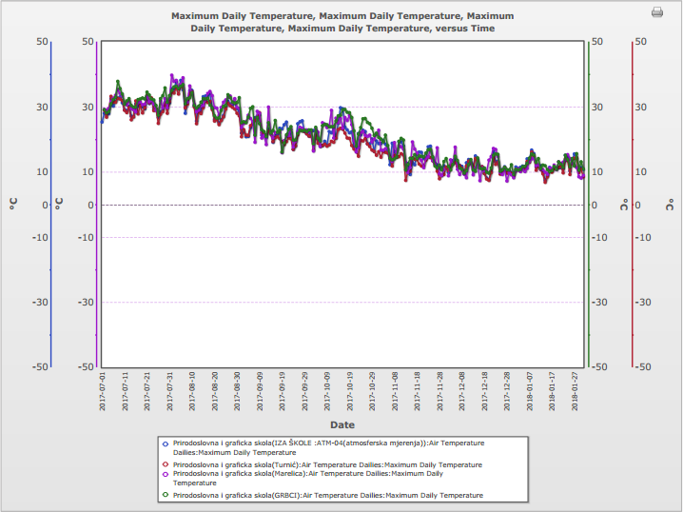

Picture 2: Maximum air temperature comparison on sites: Škola, Turnić, Marelica and Grbci from July 1st 2017 to January 31st 2018

The picture shows that the max temperatures are observed at all the sites on some days. We think that it is because of the insolation of site Instrument shelters. We observed that on some days some shelters were covered with shade (clouds) while others were not.

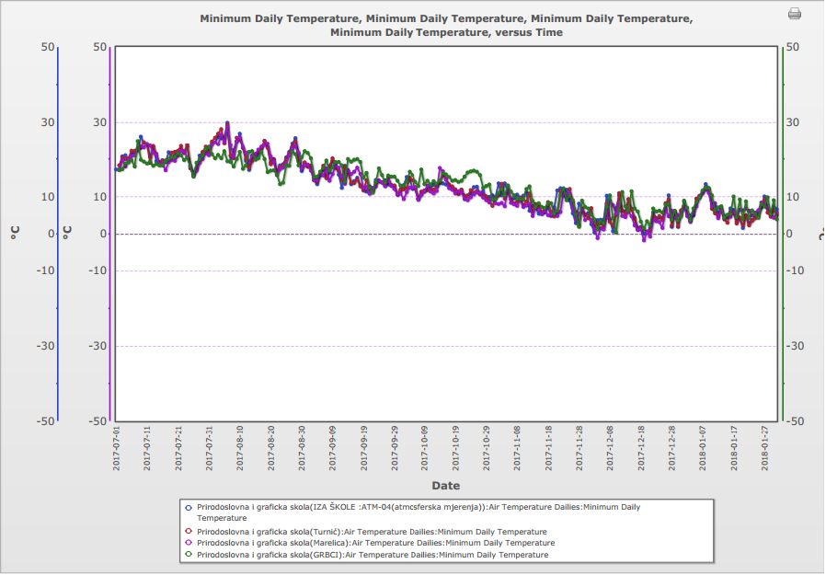

Picture 3: Minimum air temperature comparison on sites: Škola, Turnić, Marelica and Grbci from July 1st 2017 to January 31st 2018

The picture shows that after 18th of November the temperature dropped on all our sites and that concurs with our four student’s reports: they reported being bitten till about 15th of November.

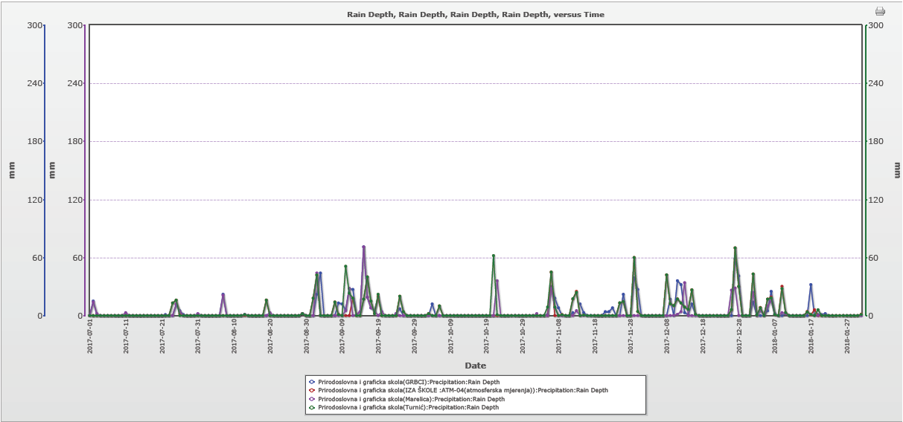

Picture 4: Rain depth comparison on sites: Škola, Turnić, Marelica and Grbci from July 1st 2017 to January 31st 2018

The picture shows that the rain depth is similar on all sites.

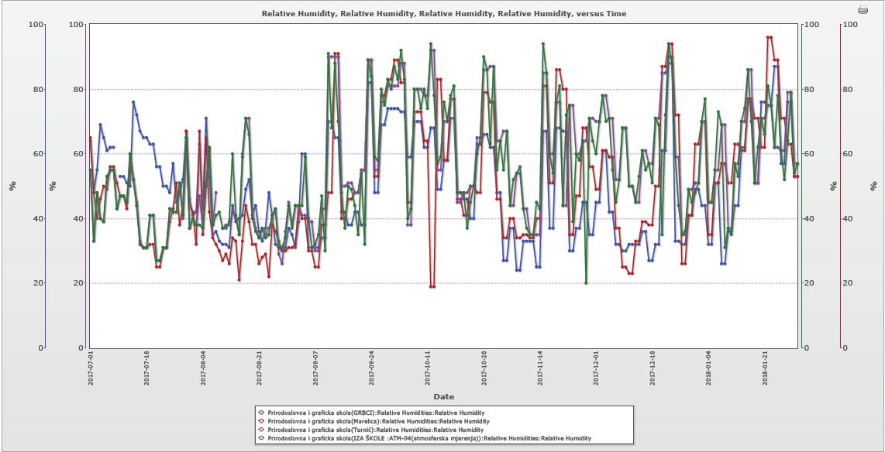

Picture 5: relative humidity comparison on sites: Škola, Turnić, Marelica and Grbci from July 1st 2017 to January 31st 2018

The picture shows that the humidity varies but it does not affect the appearance of mosquitoes.

**Table 2: Measuring site Turnić - mosquito larvae**

|  |  |  |  |  |  |
| --- | --- | --- | --- | --- | --- |
| Month  July | mosquito species | larvae number | Material and color of the container | Container depth | Extent of the body of water |
| 7th | *Aedes aegypti* | 122 | black plastic bucket | < 0,5 m | < 1 m |
| 9th | *Aedes aegypti* | 36 | black plastic bucket | < 0,5 m | < 1 m |
| 10th | *Aedes aegypti* | 94 | black plastic bucket | < 0,5 m | < 1 m |

Table 2 shows species and number of mosquitos which prevail in July on measuring site Turnić. We can see the depth, color and material of the water filled container in which larvae are developing. There is no data for August because of the water spill caused by neighbors.

**Table 3: measuring site Grbci- mosquito larvae**

|  |  |  |  |  |  |
| --- | --- | --- | --- | --- | --- |
| Month  July | mosquito species | larvae number | Material and color of the container | Container depth | Extent of the body of water |
| 8th | *Culex pipiens* | 18 | colorless jar | <0,5 m | <1 m |
| 8th | *Aedes aegypti* | 9 | white plastic flower pot | <0,5 m | <1 m |

Table 3 shows the species and number of prevailing mosquitos in the month of July in measuring site Grbci, as is the depth, color and material of the water filled container in which the larvae are developing. The data was collected in one of the Grbci gardens.

We saw the mosquito larvae in large water containers that inhabitants of Grbci are keeping for watering their gardens but they would not let us in the garden to count the larvae.

**Table 4: Water pH**

|  |  |  |  |  |  |
| --- | --- | --- | --- | --- | --- |
| SITE | ŠKOLA | TURNIĆ | TURNIĆ-PLASTIC BUCKET | MARELICA | GRBCI |
| pH | 7.12 | 8.18 | 8.34 | 7.99 | 7.16 |

Table 4 shows pH on our measuring sites on the date of July 25th /26th Students collected rain samples after two rainy days. They also measured pH in the black plastic bucket where they found larvae.

We were puzzled with the results because usually the rain pH is acidic (below 7). We collected the specimens and analyzed them with the help of NZZJZ PGŽ Rijeka.

The analysis showed unusual results and we will try to explain them in our next research paper.

To determine what kind of person mosquitos attack the most 11th grade GLOBE students conducted a survey on about 250 people. They tested their parents, neighbors, professors, habitants of Turnić, Srdoči and Grbci, our school students and primary school students in Srdoči. First we asked if they are usually bitten by the mosquitoes. We found out that 204/250 people were bitten during the summer.

We tested only the 204 bitten persons to find the connection between the amount of stings and blood type, type of skin, style of clothing, sport activity and dietary habits.

After collecting all data two 12th grade students elaborated the survey.

These are the results:

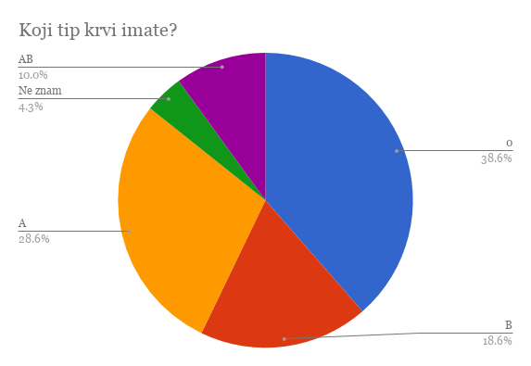

Picture 6: What blood type do you have?

In the picture we can see that prevailing blood group in bitten persons is 0 (around 40%), followed by type A (28%), type B (18%), Type AB (10%) and 4% of people that don’t know their blood type (mostly primary students).

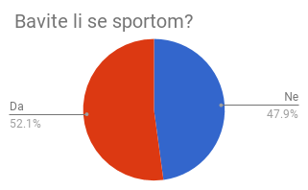

Picture 7: Do you play any sports?

52% of people with blood type 0 play some kind of sport.

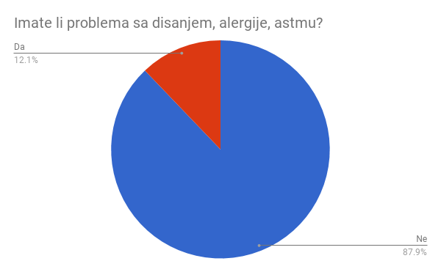

Picture 8: Do you have any problems with breathing, allergies or asthma?

Small percentage has problems with breathing and allergies.

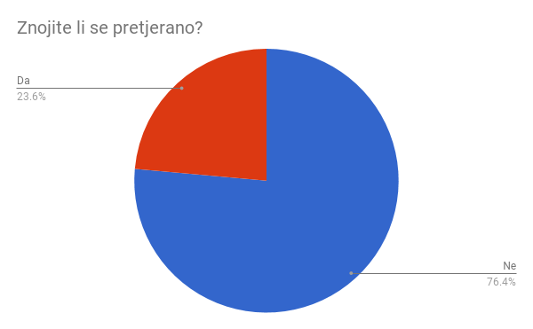

Picture 9: Do you sweat excessively?

23% sweats excessively.

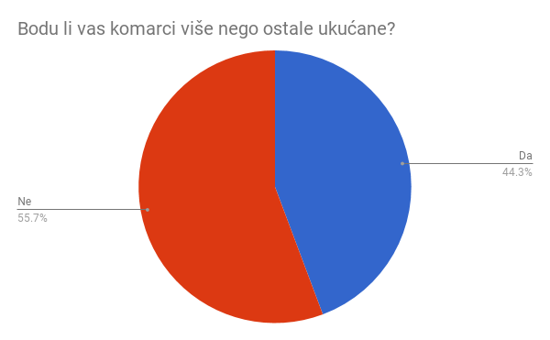

Picture 10: Do the mosquitoes bite you more than the rest of your family?

44% says that the mosquitoes bite them more than their family.

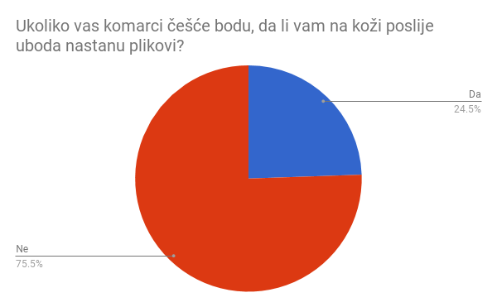

Picture 11: If the mosquitoes bite you more, do the blisters appear after the bite?

Around 24% get blisters after the mosquito bite.

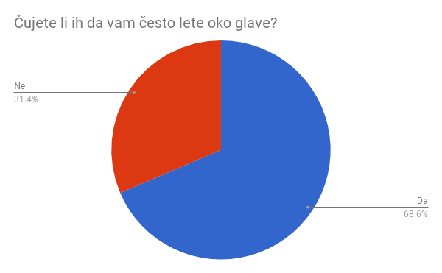

Picture 12: Do you hear them fly around your head often?

68% people hears the mosquitoes when they fly around their heads. It appears that mosquitoes are attracted by exhaling of the carbon dioxide.

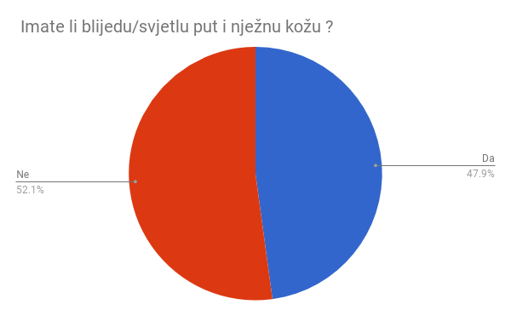

Picture 13: Do you have pale and delicate skin?

48% people says that they have pale and delicate skin.

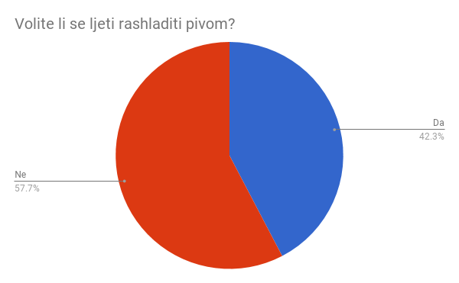

Picture 14: Do you like to cool yourself down with beer during summer?

42% likes to drink beer during summer.

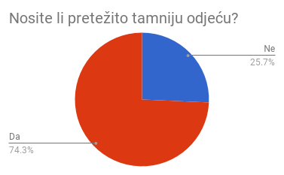

Picture 15: Do you mostly wear dark clothes?

74% wears darker clothes.

According to results we chose four students to count the stings:

Blood type 0

Pale complexion

Dark clothes

**Table 5: Student’s report of mosquitoes bites number**

|  |  |  |  |  |
| --- | --- | --- | --- | --- |
| **SITE/**  **MONTH** | **ŠKOLA**  **(STUDENT 1)** | **TURNIĆ**  **(STUDENT 2)** | **MARELICA**  **(STUDENT 3)** | **GRBCI**  **(STUDENT 4)** |
| **SEPTEMBER** | 16 | 14 | 14 | 12 |
| **OCTOBER** | 12 | 14 | 6 | 7 |
| **NOVEMBER** | 5 | 4 | 2 | 0 |
| **TOTAL BITES** | 33 | 32 | 22 | 19 |

The table shows that the most bitten students were in the area of Škola and Turnić sites.

**7. Discussion**

From the data collected from different measuring sites we can notice that the highest current temperatures during the summer and autumn were on stations Škola and Turnić. On the site of Turnić the highest number of mosquitos has been documented as well.

Talking with our school’s students we documented the high rate of stings. All of them told us they hear the mosquitoes around their heads. Mostly all the students and their teachers were bitten continuously till the end of November. We tried to find the larvae nests but we could not. Our school’s site adjoins a high wall and on the other side there is a garden. We suspect that there is some standing water used to water the garden plants.

Humidity and rainfall are close in value on all stations but current temperatures were highest on Škola and Turnić sites. By tracking mosquito bites we noticed that the attacks continued until around the middle of November on all sites. Comparing mosquito stings and temperature, we noticed that during the second half of November 2017 minimum temperature on all sites has fallen under 100 C so we consider that as the main cause for the lack of mosquitos.

Being that the determination of number and species of mosquitos was done from July to November 2017 we need to track the appearances of mosquitos during the spring time and the beginning of the summer 2018

By implementing GLOBE Mosquito Larvae Protocol we noticed that the fault in the protocol itself is that the exact volume of water is not taken into consideration nor is the time period for larvae development precisely given. Our data is collected in various ways: on Grbci, after rain, we looked in the flower pots in one of the gardens and found larvae. On Turnić the larvae appeared in a barrel that was used for watering the garden.

On stations Škola and Marelica we were exposed to mosquito stings but were unable to locate their nest.

During the talk with the dermatologist we found out that during this summer more than ten cases of swollen lymph nodes and high fever were noticed and were prescribed to mosquito stings. We intend to once again speak with the dermatologist and confirm the findings when the mosquito season start again. In collaboration with NZZJZ PGŽ we presume it will be in April.

We will also continue to monitor our four students for bites.

We are trying to alert the inhabitants of local boards Turnić, Marelica and Grbci to empty the containers and prevent mosquitoes forming. Our students held lectures to the inhabitants of all local places and distributed them pamphlets from NZZJZ PGŽ Rijeka.

They concluded that the best course of action is to lecture younger students. Two of GLOBE students gave a lecture to students from 5th to 8th class in Primary school Srdoči frequented by both Srdoči and Grbci children.

**8. Conclusions**

According to data collected so far we can conclude that the prevailing species of mosquito in west part of Rijeka is *Aedes aegypti* (tiger mosquito). It is the non-indigenous species that adapted to the climate and environment of our County.

We concluded that our County is threatened by serious illnesses which are transmitted exclusively by blood-sucking female mosquitos. One of the most dangerous ones is West Nile virus, a disease transmitted by *Aedes aegypti.* Headache, fever, muscle pain, swollen lymph nodes, nettle rash on stomach area and nausea and vomiting are symptoms of this disease. Ailment passes in a few days, but the problem occurs with people suffering from chronic diseases and/or older people with weaker immune systems. In these people there is a possible occurrence of brain inflammation or meninges’ inflammation, two rather serious diseases.

Humidity and rainfall are close in value on all stations so for now we can conclude that in west part of Rijeka the temperature has the greatest impact on the development of mosquitoes

The other factors, according to our measurements, had no influence on the appearance of mosquitoes in our County.

After processing the survey of 250 people we came to conclusion that the mosquitoes like to bite people with blood type 0 who wear dark clothes and have pale skin. And who like to cool themselves with the beer during the summer. We think that they also like the smell of carbon dioxide (flying around our heads)

Things to do:

If the temperature is favorable during March, April, May and June of 2018 for larvae development, we will search all the places around the school station to locate the nest and attempt to destroy it using natural products. Our goal is also to have some effect on the inhabitants of local boards where we conducted the research so we can determine if our lectures were heard. For all of them we will organize another lecture to teach them how to protect themselves by using natural products.

We hope that the student’s lectures will be heard and that the next summer there will be less bites.

**9. Bibliography/Citations**

1. Krunoslav Capak, Pavle Jeličić, Ira Gjenero Margan, Iva Pem Novosel, Vedran Poljak – Javnozdravstveni značaj suzbijanja komaraca u Hrvatskoj. *Korunić d.o.o Zagreb, DDD i ZUPP 2013 – novi izazovi. Zagreb: 2013.*
2. Enrih Merdić, Goran Vignjević, Ivana Vrućina. Komarci prijenosnici virusa zapadnog Nila u Hrvatskoj. *Korunić d.o.o Zagreb, DDD i ZUPP 2013 – novi izazovi. Zagreb: 2013.*
3. Đana Pahor, Vesna Šušnić, Mirna Čoklo, Jelena Vuletić Lenić. Aktivnosti Nastavnog zavoda za javno zdravstvo Primorsko – goranske županije na području monitoringa i suzbijanja komaraca. *Korunić d.o.o Zagreb, DDD i ZUPP 2013 – novi izazovi. Zagreb: 2013.*
4. Krunoslav Capak, Pavle Jeličić, Nataša Janev Holcer, Ivan Trumbetić, Ana Klobučar, Nediljko Landeka, Toni Žitko, Magdalena Sikora, Itana Bokan, Enrih Merdić, Kata Krešić, Ante Cvitković, Ivan Lipovac, Alen Medić, Vanja Slavić – Vrzić, Marko Klemenčić, Slavica Slavica, Andreja Sanković, Sanja Mitrović Hamzić, Ivana Fičko, Zoran Vrsaljko, Biserka Hranilović, Ivana Grgić, Ivan Stanić, Božidar Putarek. Provedba nacionalnog sustava praćenja invazivnih vrsta komaraca na području Republike Hrvatske. *Korunić d.o.o Zagreb, DDD i ZUPP 2017 – 800. obljetnica od odlaska hrvatskih hospitalaca u Križarski rat i 70. obljetnica od ustroja DDD djelatnosti u Republici Hrvatskoj. Zagreb: 2017.*
5. Enrih Merdić. Komarac vrste *Aedes aegypti* (Dyar, 1920), nova (stara) prijetnja Europi. *Korunić d.o.o Zagreb, DDD i ZUPP 2017 – 800. obljetnica od odlaska hrvatskih hospitalaca u Križarski rat i 70. obljetnica od ustroja DDD djelatnosti u Republici Hrvatskoj. Zagreb: 2017.*
6. Nataša Janev Holcer, Pavle Jeličić, Krunoslav Capak. Značaj prepoznavanja potencijalnih žarišta komaraca i provedbe asanacijskih mjera. *Korunić d.o.o Zagreb, DDD i ZUPP 2017 – 800. obljetnica od odlaska hrvatskih hospitalaca u Križarski rat i 70. obljetnica od ustroja DDD djelatnosti u Republici Hrvatskoj. Zagreb: 2017.*
7. Ranko Dujmović, Josip Rukavina, Tihomir Grgat, Anamaria Trbović. Dronovi i kontrola populacije komaraca. *Korunić d.o.o Zagreb, DDD i ZUPP 2017 – 800. obljetnica od odlaska hrvatskih hospitalaca u Križarski rat i 70. obljetnica od ustroja DDD djelatnosti u Republici Hrvatskoj. Zagreb: 2017.*
8. <https://mosquito.site-ym.com/page/mosquitoinfo>
9. <https://mosquito.site-ym.com/page/mosquitocontrol>

**10. Badges selected**

**Collaboration:** Students from our school have collected data and distributed the survey: Margareta Kljun, Patricia Pešić, Amela Halilović, Silvija Bartolović, Denis Subašić, Karmen Gabrić, Ena Knežević, Fran Kalčić, Mia Kolanović, Deni Balen, Rene Turković, Rene Radović, Izabela Kosović, Antonio Jelovica, Sara Buneta, Sara Denona, Sara Barić, Lea Njegovan, Mariela Šiša, Darijan Sergo, Klaudija Tomišić, David Rumora, Lara Zatezalo, Lara Pleše, Antonella Negrić, Bruno Kovačević, Andrej Rumora.Sebastian Šodolović,Lucian Smojver, Barbara Milosavljević, Nika Dujmović, Elizabeta Rajnović, Borna Baretić,Matija Loparac,

Margareta Kljun and Izabela Kosović have prefigured the data.

**Community impact:** We are trying to alert the inhabitants of local boards Turnić, Marelica and Grbci to prevent the forming of mosquitoes by destroying their nests emptying containers in their gardens. Our students held lectures to the inhabitants of local boards Turnić, Srdoči and Grbci and distributed them pamphlets from NZZJZ PGŽ Rijeka.

They concluded that the best course of action is to lecture younger students. Two of GLOBE students gave a lecture to students from 5th to 8th class in Primary school Srdoči frequented by both Srdoči and Grbci children.

Students that helped us with this project Izabela Kosović, Nika Dujmović, Lucian Smojver, Dea Čanak , Monika Kokorović, Eni Šimetić, Tihana Čop, Ema Franković, Maja Andrešić

**Connection to STEM professionals**:

We collaborated with NZZJZ PGŽ Rijeka::

Professor Željko Linšak, B.Sc., Assistant Director

mr.sc. Vanda Piškur, B.Sc., Deputy Director, Department for Drinking Water Control and Water in the Nature

Assistant mr.sc. Paula Žurga, B.Sc., Director, Department of Common Analytical Techniques .Sc.,

Mr.sc. Vesna Šušnić, B.Sc. Director, Department for Disinfection, Disinsection and Deratization

**GLE theme:** Environmental problems and solutions. Margareta Kljun and Patricia Pešić will be attending the GLE meeting in Killarney, Ireland 2018.