Biocidal Activity of Euphorbia
Milii Dye on Cotton
Textiles

Biocidal Activity of Euphorbia
Milii Dye on Cotton
Textiles

by

Theresa Mae Abong
Eunice Cortes

Submitted to the Faculty of the
Raja Soliman Science and Technology High School
in partial fulfillment of the requirements for
Research 9

September 2015

Eco-friendly Deco tile Made of Styrofoam (Polystrene)
With Powdered Eggshells

Abstract
The deco tile is made by mixing crushed styrofoam and powdered eggshells and dissolved with paint thinner. The research aims to determine the feasibility of making deco tiles using styrofoam with reinforce eggshells and paint thinner. The research used styrofoam to help the environment decrease non- biodegradable waste. The deco tile was cast on a 5cm x 5cm wooden mold until it was dry and hard. Physical test were done and compared with a commercial tile. Results show that the deco tile is not deformed or broke in 1 kg. force applied while the commercial deco tile is broke at 0.2 kg. force applied. The research has proven that the styrofoam with eggshells deco tile is stronger, more flexible and more resilient.

Introduction
Styrofoam (Polystyrene) is commonly used for insulation properties, packaging materials such as appliances and serving as containers like styrocups and plates. Styrofoam is a petroleum based plastic made from styrene monomer was actually a very dangerous material because of the substance ‘styrene’. The research used styrofoam to help the environment decrease non- biodegradable waste.
The research aims to make a strong, flexible and resilient deco tile to avoid accident that caused by breakable ceramic tiles using styrofoam and eggshells.

The scope of this study is for customation and decoration of residential houses only. It cannot be used in big projects such as buildings and other infrastructures. The product’s limitation is to be stored in cold places only. It should not be stored in warm places exceeding 30 degree Celsius because of highly flammable substance in paint thinner.

Methodology
- Production of Eco-friendly Deco tiles
In making the Deco tile from Styrofoam and paint thinner, 5 grams of Styrofoam and 2 grams of egg shells were gathered. The styrofoam was torn into pieces manually while the egg shells was powdered by mortar and pestle. Then, 100 ml of paint thinner was put in the glass bowl together with the styrofoam and the egg shells. The glass bowl was left for 3 minutes for dissolving. After the dissolving the deco tile was put into the wooden molder and let it sun- dried for 1 week.

- Strength and Flexibility Test
The strength and flexibility of deco tile is compared with commercial tile. The strength is tests by using weights with different mass and specific height. The flexibility is tests by using hook with different force applied. The results tallied in table and the observations are to be recorded.

Results and Discussions
The deco tiles made is hard and dry. It has 1cm thick and 3cm x 3cm size. The product has a gasoline-like odor. The texture is rough.
The experimental product, Styrofoam and eggshells as deco tiles and Styrofoam as deco tiles, was compared with the commercial product Mariwasa deco tiles by testing their strength and infrangibility in giving different force in every trials. In every trial there are different tiles being test. The results were recorded in Table 1 below.
Table 1: Strength and the Infrangibility Test Results
Trials | Force Applied  (kg) | Commercial Deco tiles | Experimental Deco tiles
 |  | Mariwasa Deco tiles | Styrofoam and eggshells as deco tiles | Styrofoam as deco tiles
1 | 0.02
 | 0.2
 | 0.5
 | 1
2 | 0.02
 | 0.2
 | 0.5
 | 1
3 | 0.02
 | 0.2
 | 0.5
 | 1
Legend:
- Nothing Happened
- Slight crack / Slight Deformed
- Break/Deformed

The products undergo in strength and infrangibility test to determine the ability to resist being moved or broken. The tests will prove the capability of the product to not separate easily. The strength and infrangibility test is conducted by using weights and iron stand. Different weights for different trials will free fall in the height of 12 inches.
The result showed that the commercial tile was broken or deformed at 0.5 kg on the first and second trial but in the last trial it broke and deformed at just 0.2 kilograms. The experimental tiles (Styrofoam without eggshells) were deformed at 1kg. on the first and second trial but at the last trial it broke and deformed at 0.2 kg. while the other experimental tiles (Styofoam with eggshells) at the three trials nothing happened.
The Styrofoam with eggshells deco tile is the strongest and most infrangibly among the deco tiles and it is because the solid molecules gets more attracted to the solvent molecules so that the product disintegrates. When the paint thinner evaporated the remaining molecules combine with the solid molecules. In the case of Styrofoam and paint thinner, the solvent evaporates and leave lumps in the ambient air that makes the Styrofoam a solid polysterene.
The mean of the samples, the commercial deco tiles’ mean was 2 (Acceptable), the Styofoam without eggshells’ mean was 2 (acceptable) while the styrofoam with eggshells’ mean was 3 (very effective). From the results given above, the Deco tile out of styrofoam with egg shells was the most efficient product among the 2 samples.

Table 2: Before and After the Strength and Infrangibility Test
Products | Before | After
Commercial Deco tile | 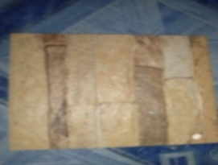  Original State | 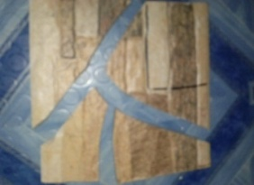  Broken
Styrofoam with Eggshells Deco tile | 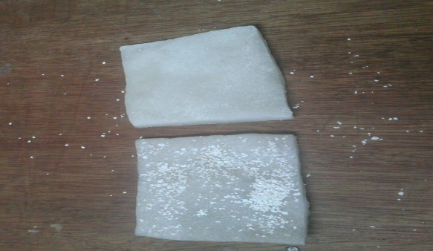  Original State | 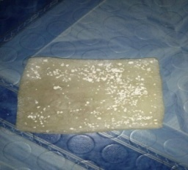  Nothing happened
Styrofoam Deco tile | 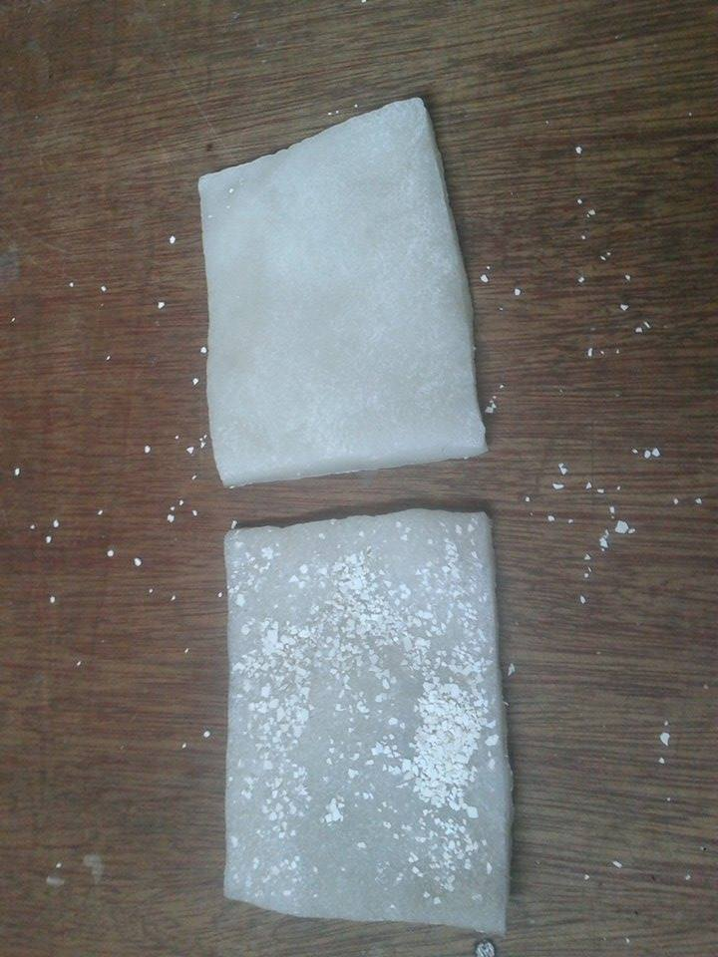  Original State | 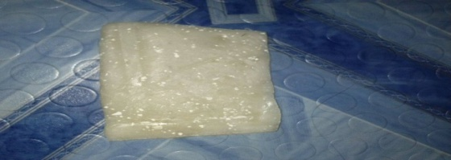  Slightly Deformed
Before the strength and infrangibility test, the commercial product was strong, hard and thick. The Styrofoam with eggshells deco tile was compact, strong, dry and hard. Also the Styrofoam deco tile was compact, strong, dry and hard.
After the strength and infrangibility test, the commercial product was broken and torn into pieces. The Styrofoam with eggshells deco tile was not broken and it still on its original state. While the styrofoam deco tile was slightly deformed.
The results showed that before and even after the strength and infrangibility test the Styrofoam with eggshells was still compact, strong, dry and hard.
Table 2 : Flexibility Test of the Products
Trials | Force Applied | Experimental Product
 | (kilograms) | Styrofam with Eggshells Deco tiles | Styrofoam as Deco tiles
1 | 0.02
 | 0.2
 | 0.5
 | 1
2 | 0.02
 | 0.2
 | 0.5
 | 1
3 | 0.02
 | 0.2
 | 0.5
 | 1
Legend:
- - Nothing Happened
- - The product can be bend
- -The product is very flexible
The Styrofoam with eggshells deco tile undergo in the flexibility test to determine the capability of the product to be bent or being bent. The test conducted to prove the transition of product unlike the Styrofoam deco tile.
The flexibility test of the experimental products is done by using hook with different weights and clanged with the products. The results showed that the styrofoam with eggshells deco tile is more flexible than styrofoam deco tile. Styrofoam was made of a polymer that is also used in production of plastics. In the molecules the chains are tangled up and so it slides to each other that make the product flexible.
Conclusion
The deco tile made from the styrofoam with egg shells and paint thinner is strong and very resillient but still need to go under further examinations and tests. The Styrofoam deco tile with egg shells received an average of 3 as very effective in both tests.
The styrofoam with eggshells deco tile made by the researchers has positive results and proved to be stronger, flexible and eco-friendly than the other product. There is a high potential of using this materials in making deco tiles.

Recommendation
The research still has problems need to be solved like the highly flammable substance in paint thinner. The researchers also observed that the longer the tile was stored the harder it will be. The deco tile can be improved by using other substance to harden the tile.
The deco tile should be developed onto further experimentation to be used in bigger projects and infrastructure. The gasoline-like odor should be lessen.

Reference
Espinosa, A. (2006) Ceramic Tiles from Crassostrea iredalei (Oyster shells)
Obrero, F. (2007) Potential Use of Oyster Shells in Ceramic Production
Allan, R. (2012) Feasibility of Foam Polystyrene and Powdered Cockle Shells as Tiles
Abayon, M..et al (2012) Styrofoam + Contact Cement Roof Sealant
Camara, P. (1996) Feasibility of foam polystyrene and powdered Talaba shells as Tiles
Fernandez, R. (2005) Recycled shells good for tile making. The Philstar

