The effect of eco-friendly embankments

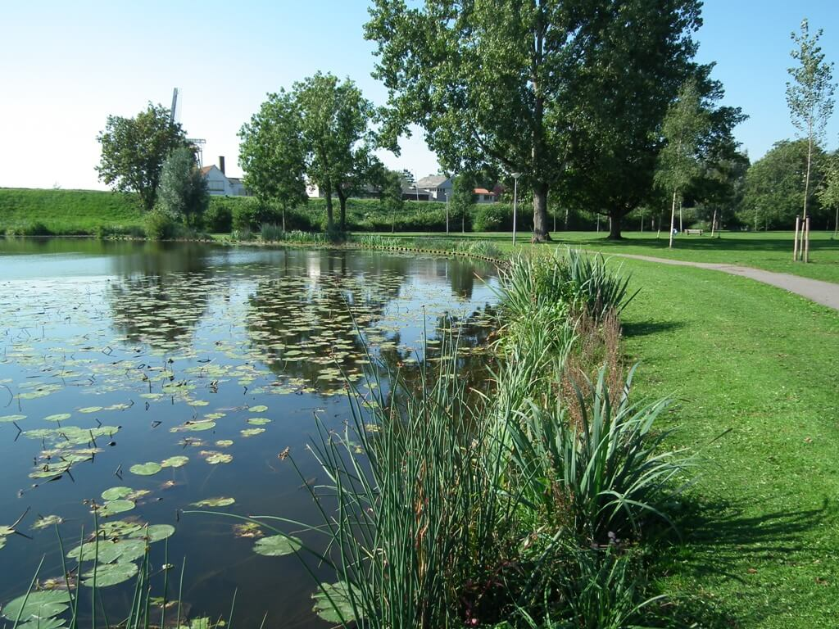End Report

*Client:* Wouter Quist

*Company:* Waterschap Scheldestromen

*Group:*

V4A: Yzon Dorreman, Thijs Hagenaars, Arco Hollestelle

V4C: Eline van Toer

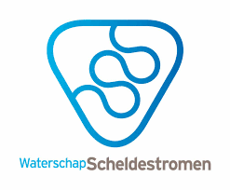*Submission date:* 17-05-18

# Summary

The cause for this research is the fact that Waterschap Scheldestromen has spent quite some money on constructing eco-friendly embankments in recent years. They asked us to find out if the eco-friendly embankments indeed have a positive effect on the water quality and the flora and fauna there.

We came up with the main question “What is the effect of making a ditch eco-friendly on the levels of ammonium and nitrate in the water in comparison to a ditch with non-eco-friendly embankments?” To gather enough information to get to a conclusion we took monsters from 2 ditches, one with eco-friendly embankments and one without.

We analysed the water and measured the content of Ammonia and Nitrate. The results we found were not at all what we expected. But due to all the other factors involved, we can’t conclusively say if it works or not.

# Preface

For this project, we have done research on eco-friendly embankments. Our client was Mr Quist on behalf of Waterschap Scheldestromen. Waterschap Scheldestromen wanted to know if these embankments truly are eco-friendlier than the ‘normal’ embankments. In order to get to a conclusion, we first have made a research proposal and we have done some pre-research to broaden our knowledge needed for this project. After we have finished these assignments, we have made a measurement proposal as a preparation for our measurements. Our next step was analysing the results we got from the HZ and ‘s-Gravenpolder (purification Willem Annapolder) and putting them to use in a table. The results are presented in this report, in our presentation and on our poster, which we will also present at the TTO Globe Science Fair in Wageningen. This report is mainly written in a biological way because most of our research needed biological reasoning.

We would like to thank Waterschap Scheldestromen and Mr Quist for giving us the opportunity to do this project and helping us to get results. We also want to thank the HZ and ‘s-Gravenpolder (purification Willem Annapolder) for having us and giving us the opportunity to measure with their equipment. Of course, we also want to thank our teachers, Mr Groot and Ms Robyn for guiding us through our project.

# Index

Summary 2

Preface 3

Index 4

1. Introduction 5

2. Pre-research 6

*Nitrogen cycle* 6

3. Research questions & hypothesis 9

*3.1* *Research questions* 9

*Main question* 9

*Sub-questions* 9

*3.2* *Hypothesis* 9

4. Methods & materials 10

*List of materials* 10

*Method* 11

5. Results 12

6. Conclusion, discussion & recommendations 14

*6.1* *Conclusion* 14

*6.2* *Discussion* 14

*6.3* *Recommendations* 14

Epilogue 15

Recourses 16

Supplements 17

# Introduction

Our client Mr W. Quist from Waterschap Scheldestromen has assigned us this project about the difference in nitrate and ammonia between eco-friendly and non-eco-friendly embankments. Because Waterschap Scheldestromen spends a lot of money on making eco-friendly embankments they would logically like to know the effects of the eco-friendly embankments compared to ‘normal’ embankments.

Our main question is; “What is the effect of making a ditch eco-friendly on the levels of ammonium and nitrate in the water in comparison to a ditch with non-eco-friendly embankments?”

We will put the results in tables and graphs given in this report so that we can easily compare the results and give a proper conclusion of our research. In the end, we will make a poster presentation with this information and we will present this at the TTO Globe Science Fair in Wageningen.

# Pre-research

We did research to find the difference between eco-friendly embankments and non-ecofriendly embankments. To conduct further research on the difference in nitrate and ammonia content between the two types of ditches, we first wanted to know what their physical differences were, and we discovered that there are a few major differences.

The biggest difference is that the eco-friendly embankment is wider and less steep than the normal variant, the ditch. The eco-friendly can because of this store more water and thus protect us against floodings better.

The eco-friendly embankment also has more differences in depth, which means that there should be a bigger variety of animal and plant species there. The bigger variety also means that the water could be cleaner, plant species like reed, which clean the water of algae; and the water is also supposed to be cleaner because of the distance between the water and the fields mean that it’s more difficult for the eutrophication to happen.

### *Nitrogen cycle*

The nitrogen cycle is the cycle in which nitrogen or nitrogen bonds move around in nature. Imagine ammonium in a pond, bacteria in this pond will use the ammonium to get energy by making it into nitrite and other bacteria (which are called chemo auto troves) will make this nitrite into nitrate which is used by plants to make glucose into amino acids. When the plants are eaten by animals they also get these amino acids in them and use this in their own body. When these animals have too much of these acids they will get rid of them in the urine or faeces, the faeces are used for fertilizer and used close to ditches and it will get back into them. But when the animals die bacteria and fungi will use the body for energy and some of the nitrogen is set back to nitrite and flushes away but some of the nitrogen is released into the air. Little bacteria on the buds of trees set this back into nitrate and give it to the trees and in exchange, they get glucose and so the circle goes round day by day.

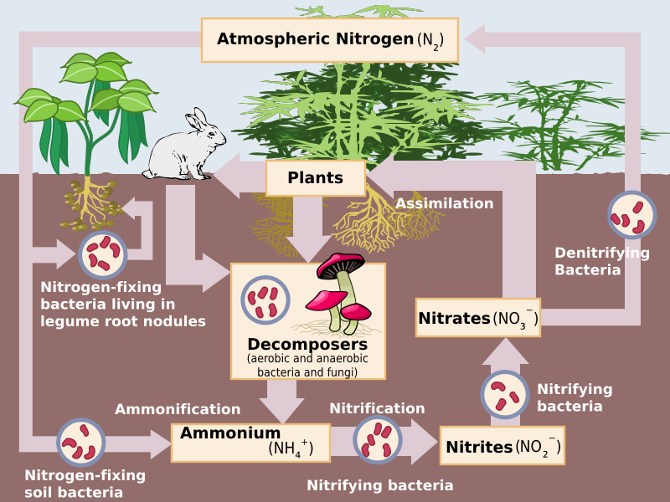

# Research questions & hypothesis

## *Research questions*

### *Main question*

What is the effect of making a ditch eco-friendly on the levels of ammonium and nitrate in the water in comparison to a ditch with non-eco-friendly embankments?

### *Sub-questions*

* Is there a difference in nitrate and ammonia content within a ditch at different temperatures?
* Is there a difference in nitrate and ammonia content within a ditch with different weather conditions (precipitation)?

## *Hypothesis*

As the effect of the eco-friendly embankments, we expect these ditches to have less nitrate and ammonia content in the water. This is because the plants at the embankments ensure this. We also think that the nitrate and ammonia content within the ditch with eco-friendly embankments will lower when the temperature rises and when the weather conditions get better (mostly sunny and sometimes rain), this is because at higher temperatures and with better weather conditions, the plants will be more active and will ensure this process.

# Methods & materials

## 4.1 List of materials

* Four closable cups with a volume of 75-100 mL
* The extendable stick with the cup attached to it (see drawing below)
* The location of the two embankments (see map below)
* Measurement tape
* Four labels
* Camera

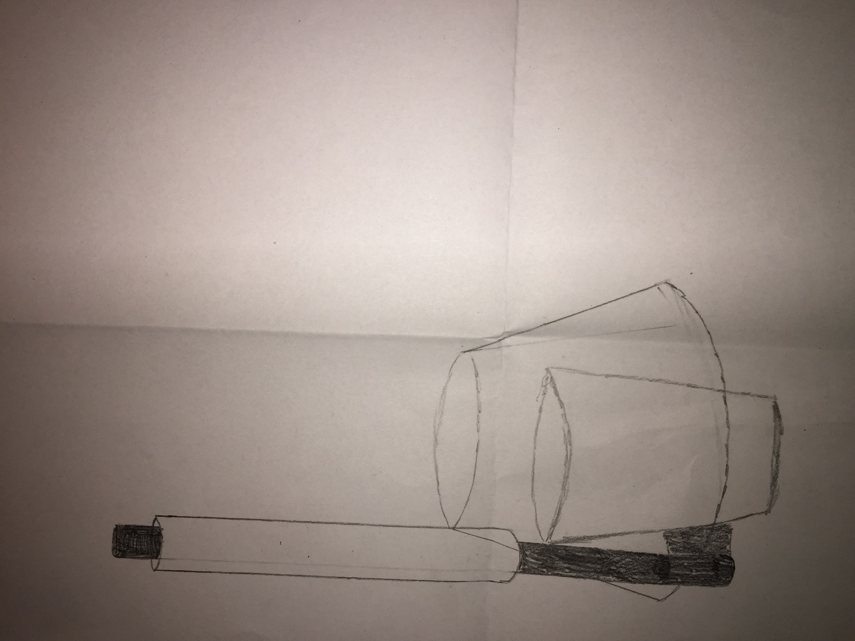

A drawing of the stick used by the measurements

## 4.2 Method

1. Get a screenshot of the weather forecast from the day you’re measuring.
2. Go to the ditch with the non-eco-friendly embankments with four of the cups;
3. take a picture of the embankment and make sure that the weather conditions are visible;
4. take the first cup and take water 10 cm from the side and 20 cm depth of the embankment;
5. fill the cup with the water;
6. close the cup and label it with 1A;
7. take the second cup and open it;
8. lower the pole until it’s about 1 meter deep and take water in the middle of the embankment at 20 cm depth;
9. fill the second cup with the water;
10. close the cup and label it with 1B;
11. go to the eco-friendly embankment and repeat step 2 to 10 (instead of 1 A&B you label them with 2 A&B);
12. go to the research lab and measure the concentration with the steps given on the boxes;
13. after a few weeks repeat the steps 1 to 12;

Afbeelding met elektronica, circuit

Beschrijving is gegenereerd met zeer hoge betrouwbaarheid

The location of the embankments.

# Results

These are the circumstances the monsters should be taken in (information is given on the boxes of the test tubes from the Dr De Lange Hach kit).

* Ammonium - +2℃ ... +8
* Nitrate - +15℃ … +25℃
* Nitrite - +15℃ … +25℃

From all samples, we did the measurements in duplo, because if we were to do just 1 measurement per sample, the results will undoubtedly be less accurate as they are now. (You can see in the table the differences between the 1st and 2nd measurement of the same sample and do all steps in the exact same way.)

In the supplements, you can see some pictures of the ditch at the days we measured. There are also screenshots of the weather forecast at the days of the third and fourth measurement and pictures of our group getting to know the method of the measuring.

### *Measurement 1; March 2nd, 2018:*

At the HZ Vlissingen.

When the samples were taken from the ditch:

* The ditch was frozen.

* The Temperature was -2℃

* There was no precipitate.

|  |  |  |  |  |  |  |
| --- | --- | --- | --- | --- | --- | --- |
| **measurement 1** | **Ammonium 1** | **Ammonium 2** | **Average** | **Nitrate 1** | **Nitrate 2** | **Average** |
| non ecofriendly side (1A) | 0,04 | 0,04 | 0,04 | 0,09 | 0,13 | 0,11 |
| non ecofriendly middle (1B) | 0,04 | 0,05 | 0,045 | 0,32 | 0,1 | 0,21 |
| ecofriendly side (2A) | - | - | - | - | - | - |
| ecofriendly side (2B) | 0,14 | 0,17 | 0,155 | 0,26 | 0,6 | 0,43 |

(We could not take the fourth sample at the side of the non-eco-friendly embankment, because the ditch was at that point of the ditch frozen until the bottom)

### *Measurement 2; March 23rd, 2018*

At purification Willem Annapolder ‘s Gravenpolder.

For the 2nd measurement we did exactly the same as the 1st one, but this time there was no block of ice while taking the monsters at the ditches and went therefore much smoother.

When the samples were taken from the ditch:

* There was no precipitation

* The temperature was 5℃

* The water of the eco-friendly ditch was filled with many ducks.

|  |  |  |  |  |  |  |
| --- | --- | --- | --- | --- | --- | --- |
| **measurement 2** | **Ammonium 1** | **Ammonium 2** | **Average** | **Nitrate 1** | **Nitrate 2** | **Average** |
| non ecofriendly side (1A) | 0,038 | 0,052 | 0,045 | 0,395 | 0,028 | 0,2115 |
| non ecofriendly middle (1B) | 0,036 | 0,04 | 0,038 | 0,039 | 0,012 | 0,0255 |
| ecofriendly side (2A) | 0,037 | 0,033 | 0,035 | 0,388 | 0,454 | 0,421 |
| ecofriendly side (2B) | 0,037 | 0,037 | 0,037 | 0,424 | 0,4 | 0,412 |

### *Measurement 3; April 10th, 2018*

At purification Willem Annapolder ‘s Gravenpolder.

The third and fourth measurement went the exact same way as the second.

When the samples were taken from the ditch:

* There was no precipitation

* The temperature was 16℃

* The water of the eco-friendly ditch was filled with many ducks.

|  |  |  |  |  |  |  |
| --- | --- | --- | --- | --- | --- | --- |
| **measurement 3** | **Ammonium 1** | **Ammonium 2** | **Average** | **Nitrate 1** | **Nitrate 2** | **Average** |
| non ecofriendly side (1A) | 0,038 | 0,032 | 0,035 | 1,9167 | 1,703 | 1,80985 |
| non ecofriendly middle (1B) | 0,029 | 0,031 | 0,03 | 1,57 | 1,5067 | 1,53835 |
| ecofriendly side (2A) | 0,067 | 0,063 | 0,065 | 0,58 | 0,4855 | 0,53275 |
| ecofriendly side (2B) | 0,051 | 0,049 | 0,05 | 0,3228 | 0,2364 | 0,2796 |

### *Measurement 4; May 8th, 2018*

At purification Willem Annapolder ‘s Gravenpolder.

When the samples were taken from the ditch:

* There was no precipitation

* The temperature was 23℃

* The water of the eco-friendly ditch was filled with many ducks.

|  |  |  |  |  |  |  |
| --- | --- | --- | --- | --- | --- | --- |
| **measurement 4** | **Amonium 1** | **Amonium 2** | **Average** | **Nitrate 1** | **Nitrate 2** | **Average** |
| non ecofriendly side (1A) | 0,053 | 0,051 | 0,052 | 0,1755 | 0,2625 | 0,219 |
| non ecofriendly middle (1B) | 0,057 | 0,054 | 0,0555 | 0,02595 | 0,286 | 0,155975 |
| ecofriendly side (2A) | 0,046 | 0,047 | 0,0465 | 0,191 | 0,2465 | 0,21875 |
| ecofriendly side (2B) | 0,065 | 0,061 | 0,063 | 0,275 | 0,2455 | 0,26025 |

### *Graphs*

Graph concentration nitrate

Figure 2 Graph concentration ammonium

# Conclusion, discussion & recommendations

## *Conclusion*

The effect of a ditch with eco-friendly embankments is that, on average, this ditch has a higher nitrate and ammonia content. This doesn’t suit with our hypothesis, this is probably because there are many ducks in the ditch with eco-friendly embankments and their faeces provide more nitrate and ammonia in the ditch. There’s also a difference in nitrate and ammonia content at different temperatures. At higher temperatures, there’s a higher nitrate and ammonia content than at lower temperatures. This also doesn’t suit our hypothesis, this is probably because at the higher temperatures, there are more animals in and at the side of the ditch and their faeces get in the water which will provide more nitrate and ammonia. We can’t determine if there’s a difference in nitrogen content at different weather conditions because we didn’t have much difference in weather conditions except for the temperature, it was always dry and mostly sunny.

## *Discussion*

One of the good sides of our method is that it’s reliable because we can assume that the data we have obtained is correct because this has been measured with professional equipment. Another good side is that we have obtained a lot of data to compare so that if one measurement isn’t correct, we can let this one out and still get a good comparison. On the other hand, we couldn’t choose what weather conditions we were going to measure because we had set the dates in advance, so this is a downside of the method. Our hypothesis was that there would be a lower nitrate and ammonia content in a ditch with eco-friendly embankments and that the content would also lower at higher temperatures and better weather conditions, this wasn’t correct, this is probably because of all the ducks and other animals in the ditch, whose faeces provide more nitrate and ammonia. The most important factor that has influenced our research is the weather. Because of the extreme temperatures, we couldn’t get all the samples which led to some missing data. But it also had a good side, because it ensured that we had a lot of different conditions that we could compare.

## *Recommendations*

* To confirm our research, measurements should be done in other seasons (summer/autumn), because of the weather circumstances.
* There could be done some extra measurements in different ditches with fewer ducks to see if the differences are in the same ratio.

# Epilogue

In our project, we have done research on eco-friendly embankments. The subject of our project was given to us by our client Mr Quist in a very good and clear way from the start. This was only an example of something done and organised by one of our guides, who helped us out well. This made the project for us better to understand and to execute in times when we had some difficulties. The project was also a lot of fun for us, especially the measurements were enjoyable and stressful at times as well. Long story short, the project was for us a success in many ways although there might have been some problems we had to overcome.

# Resourses

Orehek, J., Massari, J. P., Gayrard, P., Grimaud, C., & Charpin, J. (1976, February). Retrieved May 16, 2018, from <https://www.ncbi.nlm.nih.gov/pmc/articles/PMC436654/>

Orehek, J., Massari, J. P., Gayrard, P., Grimaud, C., & Charpin, J. (1976, February). Retrieved May 16, 2018, from <https://www.ncbi.nlm.nih.gov/pmc/articles/PMC436654/>

Fields, S. (2004, July). Retrieved May 16, 2018, from <https://www.ncbi.nlm.nih.gov/pmc/articles/PMC1247398/>

Nitrogen in the Environment: Nitrogen Cycle. (n.d.). Retrieved May 16, 2018, from <http://extension.missouri.edu/p/WQ252>

Fields, S. (2004, July). Retrieved May 16, 2018, from <https://www.ncbi.nlm.nih.gov/pmc/articles/PMC1247398/>

Nitrogen Dioxide Toxicity: Practice Essentials, Background, Pathophysiology. (2017, January 10). Retrieved May 16, 2018, from <http://emedicine.medscape.com/article/302133-overview>

Nitrogen Cycle. (n.d.). Retrieved May 16, 2018, from <https://enviroliteracy.org/air-climate-weather/biogeochemical-cycles/nitrogen-cycle/>

# Supplements

### *Pictures of the ditches at the days of the measurements*

Afbeelding met water, boom, meer, rivier

Beschrijving is gegenereerd met zeer hoge betrouwbaarheid Afbeelding met boom, buiten, hek, gras

Beschrijving is gegenereerd met zeer hoge betrouwbaarheid

Afbeelding met boom, water, buiten, hek

Beschrijving is gegenereerd met zeer hoge betrouwbaarheid

Pictures of the ditch with the non-eco-friendly embankments at May 8th, 2018.

Afbeelding met gras, buiten, water, huis

Beschrijving is gegenereerd met zeer hoge betrouwbaarheid Afbeelding met water, buiten, boom, lucht

Beschrijving is gegenereerd met zeer hoge betrouwbaarheid

Afbeelding met gras, water, buiten, lucht

Beschrijving is gegenereerd met zeer hoge betrouwbaarheid Afbeelding met buiten, water, boom, gras

Beschrijving is gegenereerd met zeer hoge betrouwbaarheid

Pictures of the ditch with the eco-friendly embankments at May 8th, 2018

### *Screenshots of the weather forecasts at the days of the measurements*

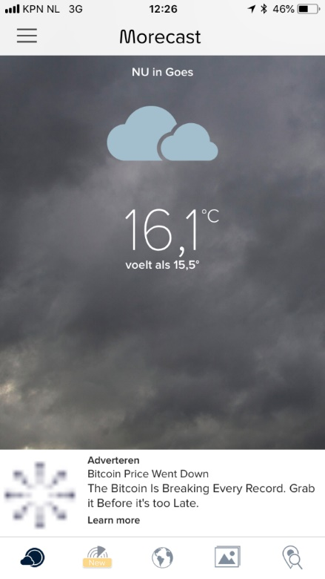 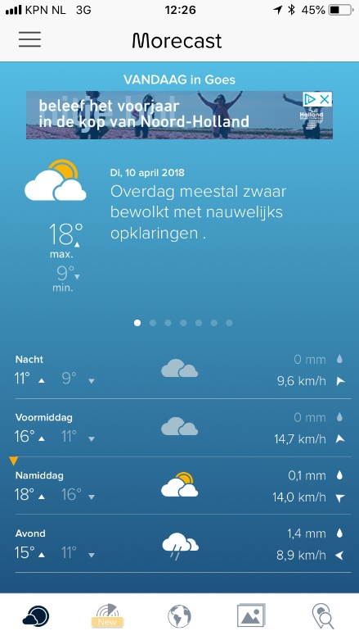 Afbeelding met schermafbeelding

Beschrijving is gegenereerd met zeer hoge betrouwbaarheid Afbeelding met schermafbeelding

Beschrijving is gegenereerd met zeer hoge betrouwbaarheid Afbeelding met schermafbeelding

Beschrijving is gegenereerd met zeer hoge betrouwbaarheid

The weather forecast at April 10th, 2018.

Afbeelding met schermafbeelding

Beschrijving is gegenereerd met zeer hoge betrouwbaarheid Afbeelding met schermafbeelding

Beschrijving is gegenereerd met hoge betrouwbaarheid Afbeelding met schermafbeelding

Beschrijving is gegenereerd met zeer hoge betrouwbaarheid Afbeelding met schermafbeelding

Beschrijving is gegenereerd met zeer hoge betrouwbaarheid Afbeelding met schermafbeelding

Beschrijving is gegenereerd met zeer hoge betrouwbaarheid Afbeelding met schermafbeelding

Beschrijving is gegenereerd met zeer hoge betrouwbaarheid Afbeelding met schermafbeelding

Beschrijving is gegenereerd met hoge betrouwbaarheidAfbeelding met schermafbeelding

Beschrijving is gegenereerd met zeer hoge betrouwbaarheid

The weather forecast at May 8th, 2018.

*Pictures of the measurements*

The pictures below are from our first measurement at the HZ Vlissingen.

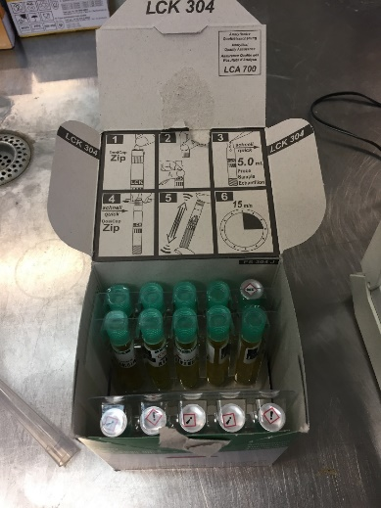 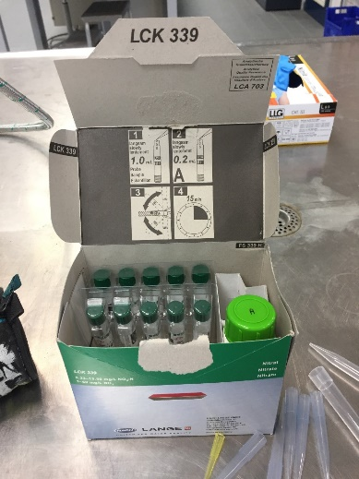 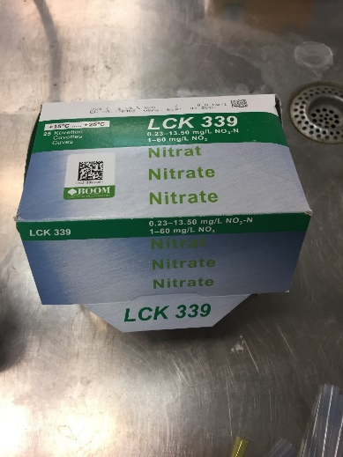

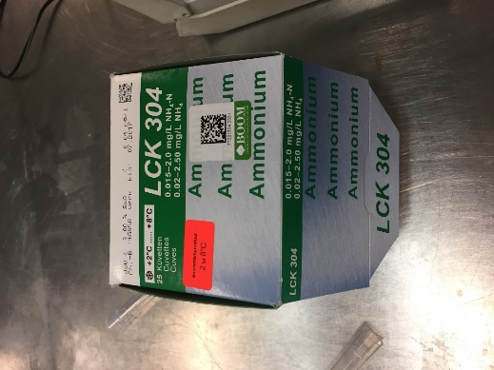 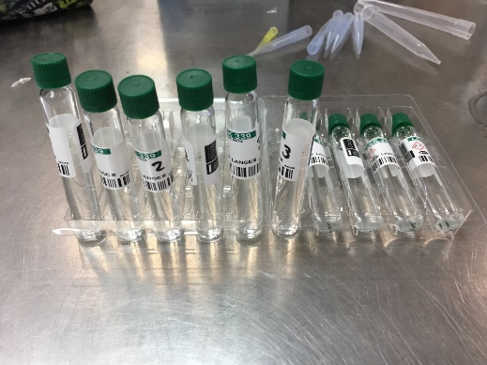 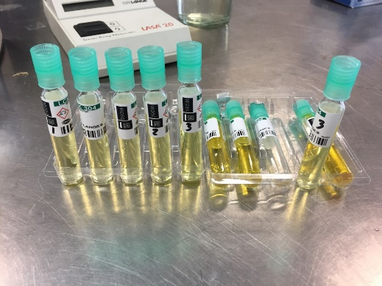 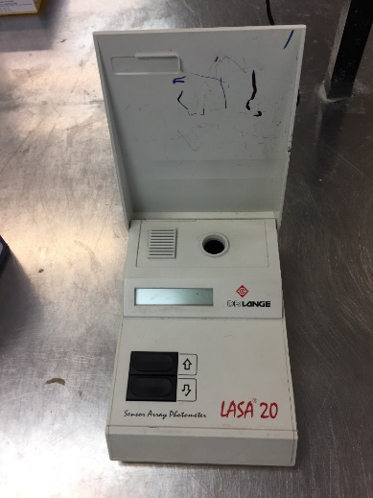

The first 4 pictures are from the kits we measured with and the 5th picture is the way we measured.

Afbeelding met binnen, persoon, keuken, voorbereiden

Beschrijving is gegenereerd met zeer hoge betrouwbaarheidAfbeelding met persoon, binnen, tafel, voedsel

Beschrijving is gegenereerd met zeer hoge betrouwbaarheid Afbeelding met persoon, binnen, gebouw, man

Beschrijving is gegenereerd met zeer hoge betrouwbaarheid

The pictures above are from us getting to know how to measure the concentrations.