**GLOBE International Virtual Science Symposium**

**2018**

WATER QUALITY IN NEARBY AREAS TO CANELONES CITY THROUGH THE USE OF MACROINVERTEBRATES AS BIOINDICATORS.

**Participating students:**

Josefina Sicco (5th grade)

Bryan Leal (5th grade)

Lautaro Andruskievicz (5th grade)

Bruno Battaglino (5th grade)

Tiago Stone cave (5th grade)

**Teacher Coach:**

Dario Olivieri Greni

**Rural School No. 88, "Alfred Nobel"**

Las Violetas, Canelones

**Scientific Advisor:**

María José Manivesa (Chemical Engineer)

https://www.linkedin.com/in/mar%C3 % ADa-manivesa-29749631 /

Montevideo, February 5, 2018

Table of Content

1. Abstract 1

2. Research question, hypothesis and objectives 2

3. Introduction 3

4. Research methodology and materials 4

4.1 Study area 4

5. Results 7

5.1 Data analysis 7

5.2 Description of the sampling areas 8

5.3 Physicochemical quality of water 10

5.4 Analysis of results 10

6. Discussion 13

7. Conclusions 14

Bibliography 15

Acknowledgments…………………………………………………………………….16

Anexes 17

Schedule of activities 17

Data entry screenshots to the GLOBE database 20

Badges to which the group nominates 23

Photographs …………………………….………………………………………..24

**TITLE**

WATER QUALITY IN NEARBY AREAS TO CANELONES CITY THROUGH THE USE OF MACROINVERTEBRATES AS BIOINDICATORS.

**1.ABSTRACT**

The situation of Canelón Chico creek was evaluated in three different study sites: before (Cascadita de los Monjes), next (Parque Artigas) and after Canelones city (Pacífico creek), with the aim of verifying whether the activities of the inhabitants of this city affect the quality of freshwater of the mentioned stream in the same way.

This unique monthly assessment was done using MACROINVERTEBRATES as these beings are BIOINDICATORS of water quality according to their level of sensitivity. This level is on a scale of 1 to 10, corresponding 1 to the strongest beings and 10 to the most sensitive. The findings were supplemented with water physicochemical measurements (pH, transparency and temperature) using GLOBE protocols.

In the three different sampling sites three repetitions were performed. At the end of the monitoring and after establishing correlations among the variables evaluated, it is concluded that water quality in PACIFICO creek could be better for life of macroinvertebrates as it presents a greater number of individuals and species.

The results of this research will serve to raise awareness among residents of the area of influence of the creek, communicating the research results through different means.

Keywords: Macroinvertebrates, water quality, sensitivity of bioindicators, Canelón Chico creek

**2. RESEARCH QUESTION, HYPOTHESIS AND OBJECTIVES**

**Researchable question**

Due to human activities of the inhabitants of the city of Canelones, is the freshwater quality of the stream studied affected differently along a spatial gradient according their proximity to the population?

**Hypothesis**

Hypothesis raised. In places with less human activity, far from Canelones City, the amount of macroinvertebrates is greater than in the area next to the creek.

Null hypothesis: Are there no differences in the intensity of human activities on the population of macroinvertebrates along the Pacífico Creek?

**Objectives**

* Analyze the state of water quality in Canelón Chico creek in three different sites, through the study of macroinvertebrates as bioindicators during the winter season in June.
* Inform the population and the authorities concerned so that they intervene on the results achieved while maintaining or improving water quality.

**3. INTRODUCTION**

"Santa Lucía River Basin has a strategic importance for Uruguayan society as is the main source of water supply, providing drinking water to 60% of the population across the country. In the sub basin Santa Lucía Chico, Paso Severino reservoir is located, with a dam of 20 km2 with 70 million m3 of volume, and 3.5 m deep, which receives a water drainage area of 2500 km2 (Florida Department). The reservoir allows flow control of the water downstream, to supply the OSE (State Sanitary Works) water treatment plant, located in Aguas Corrientes (Canelones). The main purpose of purified water is domestic use.

Having an appropriate management system in the basin is essential to have enough water in quantity and quality to cover all necessary uses and avoid environmental conflicts. Therefore, use systems and users commitment should converge in all sub basins, from north to south, to avoid water deterioration or contamination, which is a strategic social good. The basin area extends along six departments; therefore, environmental policies should be agreed to coordinate actions to advance on the path of sustainability. "(Achkar, 2012, p. 1)

According to the Measure 8 applied by DINAMA (National Environmental Directorate), Ministerial Resolution No. 229 / 015 states that those owners bordering such important river basin must comply with an action plan for its protection.

"Because of the input of organic matter, riparian vegetation plays an important role in the structure and complexity of rivers (Boothroyd et al., 2004). The riparian vegetation is more connected to life happening in the river than outside it, playing a main role in the trophic chain of these environments and in determining the composition of the communities that inhabit them such as macroinvertebrates are (Vannote et al, 1980; Corbacho et al, 2003). Changes in land use are reflected in water resources, suffering degradation in quality through contamination. At the same time, there are lots of aquatic and terrestrial ecosystems that depend directly on the quality of water” (Morelli, 2014, p. 1160).

In these waterways there are large quantities of species living together, such as tadpoles, larvae, small and medium-sized fish like catfish, mojarrita (*Pyrrhulina australe*) and tararira (*Hoplias malabaricus*), diversity of snails, mosquitoes, flies and birds like the aguatero (*Nycticryphes semicollaris*), the pavita de monte (*Penelope obscura*) and horneros (*Furnarius rufus*)

"The presence, condition and quantity of certain group of organisms such as fish, insects, algae, plants or other aquatic life can provide accurate information about the health of a water body (rivers, streams, lakes, wetlands, estuaries). That is, the biological characteristics are used to understand the factors in their environment” (Pugaca, 2012).

"Focusing on the beings that allow this research, it can be established that the benthic macroinvertebrates are organisms that live at the bottom of rivers or river beds, which can be seen with naked eye. Their great diversity, type of food and different life cycles make them good indicators of the ecological quality of rivers, offering a wide spectrum of responses to different environmental disturbances.

These individuals are used as biological indicators for the following characteristics:

* They are widely distributed, abundant and easily collected because of their size that makes them visible to naked eye.
* Being in all aquatic systems, encourage comparative studies. The taxonomy of various groups is known, and its identification is relatively less complex compared to inferior groups such as algae, bacteria or fungi.
* The sedentary nature of many of the species, facilitates spatial assessment of long term adverse effects in the community.
* The sampling technique is relatively simple and with inexpensive equipment.
* After a disturbance, they require minimum time to recover.

The most sensitive groups to ecosystem alterations are aquatic insect larvae of Trichoptera, Ephemeroptera, Plecoptera and the larvae and adults orders of Coleoptera. These individuals are highly sensitive to degradation of aquatic ecosystems.

On the other hand, Hyalellidae and Amphipoda species are resistant to changes in the ecosystem in which they live.

Macroinvertebrates help to know the water quality of the Canelón Chico creek. They are a tool to reflect and establish what could be the state of the stream. "(MMAYA, 2012, p. 17)

In order to verify the effect of human activities on the river, and to raise a long term participatory monitoring proposal in the area, it was proposed to develop this research that seeks identify the most sensitive species to certain water conditions.

In June the samples were taken in the study areas. During that period it could do all that was proposed: the macroinvertebrates, water temperature, pH and water transparency GLOBE protocols.

**4. RESEARCH METHODOLOGY AND MATERIALS**

**4.1 Study area**

Canelones is an Uruguayan city, capital and administrative center of the department of Canelones and its municipality homonym. It has a population of 19,865 inhabitants. It is one of the most important cities of the department, in the southern part of Uruguay, which is located along the Canelón Chico creek. According to the above mentioned, this creek is more than important for the inhabitants of this urban center since it provides them the water used daily for different activities.

The surrounding inhabitants have pastures and livestock breeding, small orchards and in recent years has flourished the number of soybean fields.

It is located at -34.516666 ° and -56.283333°geographic coordinates, with a maximum height of 29 m. above sea level.

The three sampling sites are all within the Canelón Chico water stream, an important stream for the inhabitants of the south of the country as it is tributary of the main river which water is extracted to be made drinkable and consumed by the inhabitants. Therefore, it was decided to estimate the quality of that water and observe the characteristics of the three sites from north to south. They are in a radius of about 4 km. from Canelones city. One of them, (Cascadita de los Monjes), is located in Villa Guadalupe, before the city. The second (Pacífico creek), is in the area of Margat and the third (Artigas Park) is on the eastern edge of the departmental capital, just 500 meters from it.

The first thing to do in each one of the chosen sites was to delimit the area and select a 50 meters transect line with the guidelines of GLOBE protocols to perform the corresponding studies y samplings there.

A characterization of the study areas was made based on the following criteria which may influence the quality of the water.

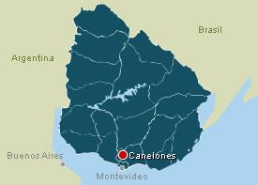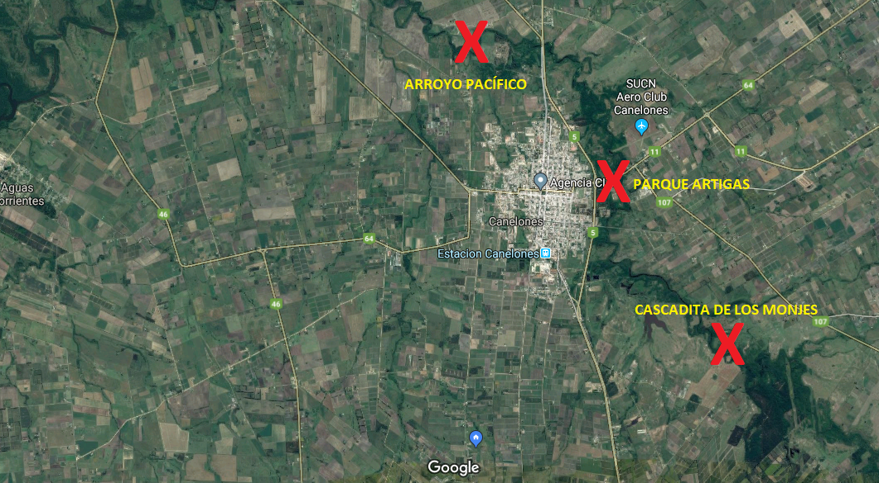

* Location of the 3 sites according to proximity to the city of Canelones

***Table 1***

Elements used for habitat characterization of the sampling areas were plotted to facilitate sites comparison.

|  |  |
| --- | --- |
| **ELEMENTS TO OBSERVE** | **UNIT OF MEASUREMENT** |
| **Cattle** | **Presence / absence** |
| **Birds** | **Presence / absence** |
| **Water with smell** | **Presence / absence** |
| **Neighboring crops** | **Presence / absence** |
| **Algae** | **Presence / absence** |
| **Turbulence** | **Presence / absence** |
| **Riparian forest** | **Presence / absence** |
| **Stream bed** | **Type** |
| **Stream width** | **In meters** |

**Source: Own Processing**

The criterion used to prepare this table was direct observation, recording presence or absence of said elements.

For the only monitoring of water quality undertaken in 2017, the GLOBE protocols used were:

1. pH
2. Temperature
3. Transparency
4. pH indicates the acidic content of water. The pH scale (measured from 0.0 to 14.0) is a logarithmic scale of concentration of (H+) ion hydrogen. Solutions with a pH higher than 7.0 are classified as basic and those with pH less than 7.0 are acidic. pH 7.0 is neutral. Per each pH unit, concentration of hydrogen ions is ten times larger than the next. Therefore a small change in pH might have significant effects on water quality. Most lakes and streams have pH values between 6.5 and 8.5. (GLOBE, 2005, p. 2)

pH measurements were taken with a digital pH meter brand Cole Parmer, which was calibrated before performing field work, with the calibration solutions for pH 4 and 7. Such measurement was repeated three times in each of the sampling sites.

1. Temperature is a simple measure to do. However, it is very important because allows scientists better understand other hydrology measurements such as pH, which is the case that concerns us. The temperature influences the amount and diversity of aquatic life. (GLOBE, 2005, p. 2)

This measurement was performed with alcohol thermometer calibrated days before the field work. This measurement was repeated 3 times in each of the sampling sites.

1. The third measurement performed was water transparency. Suspended particles in water are similar to dust in the atmosphere, since they reduce the depth to which light can penetrate. Sunlight provides the energy for photosynthesis. The depth to which sunlight penetrates in the water body determines the depth to which aquatic plants can grow.

Transparency decreases with the presence of molecules and particles that can absorb or scatter light. Black or dark materials absorb more wavelength light while white or clear materials reflect it. The particle size is also important.

The way the light disperses as enters a water body depends on the amount, composition and size of the dissolved and suspended materials. (GLOBE, 2005, p. 2)

This measurement was performed using a transparency tube of 120 cm, creating shadow there in, and repeated three times in each of the sample sites. The water was extracted from the stream using a jar that is reserved for that purpose.

These protocols were performed by students in conjunction with the macroinvertebrates protocol as they enrich the discussion about the possible causes of the existence of these beings in the current study. The data is then recorded on the data entry sheet provided by GLOBE to be uploaded to the web.

Beyond performing protocols to know the pH, temperature and water transparency, the investigation focused on the collection, sorting and counting macroinvertebrates that were obtained in the three samplings. The sampling technique used was the one for muddy bottoms. (GLOBE, p. 15) This work was carried out at solar noon local time.

Three replicates were performed at each site by placing individuals found in jars with water from the stream of study. These jars were labeled and taken to classroom where the specimens were observed with magnifying glass, were classified and counted.

The Identification Key: Miniguía zooplankton y macroinvertebrados de agua dulce de Uruguay (s.d.) was used for species identification. Biologist Emanuel Machin, who accompanied all the research, provided this key and guided in using it for identification.

We chose macroinvertebrates, as these living beings are BIOINDICATORS of water quality according to their sensitivity level. This level is on a scale of 1 to 10, corresponding 1 to the strongest individuals and 10 to the most sensitive. The findings were verified with physicochemical water measurements (pH, transparency and temperature) using GLOBE protocols.

To determine the sensitivity levels of each group of macroinvertebrates the MMAYA guide (2012) was used.

**5. RESULTS**

**5.1 Data Analysis**

Each of these data was uploaded to the database of GLOBE website, enriching the registration of similar activities undertaken the previous year. In addition, it is planned to carry out the same sampling next year and thus compare whether there were improvements in water quality or not.

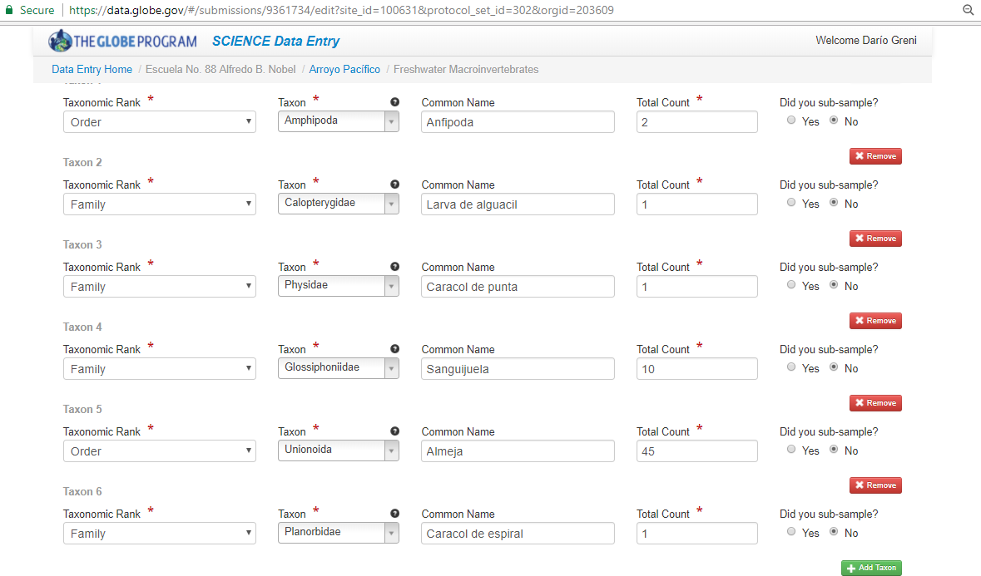

***Figure 1:*** Data on the GLOBE web page

Once the specimens were sorted and counted, proceeded to record data in tables and graphs were developed to capture results in a more illustratively way.

**5.2 Description of the sampling areas**

Observations of the physical environment were very different:

* ARTIGAS PARK:
  + A site with lots of vegetation: in the creek shores there were grasses.
  + Large accumulation of household waste: plastic bags, plastic and glass bottles, paper, fabrics.
  + On the water surface observed an oily layer.
  + It is an area that is not affected by agricultural activities.
* PACIFICO CREEK:
  + The site had lots of mud, was slippery and there was much vegetation on both shores.
  + That mud was greasy, thick and black with smell of sewage.
  + There was waste, but less than in the previous site.
  + On the water surface observed an oily layer.
  + It is an area used for cattle ranching.
* CASCADITA DE LOS MONJES:
  + Of the three sites is the one with more vegetation and less human intervention.
  + Large presence of grass on both shores was observed.
  + It is a field used only for cattle ranching.
  + Water had no odor.
  + There were birds in the area.
  + We saw no waste in our sampling area.

***Table 1***

Elements used for habitat characterization of the sampling areas.

|  |  |  |  |
| --- | --- | --- | --- |
| **ELEMENTS TO OBSERVE** | **ARTIGAS** | **PACIFICO** | **CASCADITA DE LOS MONJES** |
| **Presence of cattle** | NO | XXX | XXX |
| **Presence of birds** | XX | XXX | XXX |
| **Water with smell** | X | XXX | NO |
| **Neighboring crops** | NO | XX | NO |
| **Algae** | NO | NO | NO |
| **Turbulence** | NO | NO | NO |
| **Riparian forest** | NO | XXX | XXX |
| **Stream bed** | muddy | muddy | muddy |
| **Stream width** | 4 meters | 8 meters | 4 meters |

**Source: Own Processing**

* Note: the X letters represent the degree of occurrence of the observed, where X corresponds to "poor" and three X stands for "overmuch"

**5.3 Physicochemical water quality**

***Table 2***

|  |  |  |
| --- | --- | --- |
| **ARTIGAS PARK** | **PACIFICO CREEK** | **CASCADITA DE LOS MONJES** |
| **Transparency** | | |
| Measurement 1: 62.1 cm | Measurement 1: 15 cm | Measurement 1: 67.1 cm |
| Measurement 2: 60.5 cm | Measurement 2: 15.2 cm | Measurement 2: 65 cm |
| Measurement 3: 63.2 cm | Measurement 3: 15.3 cm | Measurement 3: 65.3 cm |
| **pH** | | |
| Measurement 1: 7.4 | Measurement 1: 7.5 | Measurement 1: 7.5 |
| Measurement 2: 7.3 | Measurement 2: 7.8 | Measurement 2: 7.3 |
| Measurement 3: 7.3 | Measurement 3: 7.7 | Measurement 3: 7.3 |
| **Temperature** | | |
| Measurement 1: 18.7 ° C | Measurement 1: 12.1 ° C | Measurement 1: 18.7 ° C |
| Measurement 2: 18.2 ° C | Measurement 2: 12.1 ° C | Measurement 2: 18.2 ° C |
| Measurement 3: 18.3 ° C | Measurement 3: 12.1 ° C | Measurement 3: 18.3 ° C |

**5.4 Analysis of results**

***Table 3***

Number of individuals per species of macroinvertebrates found in the sampling areas.

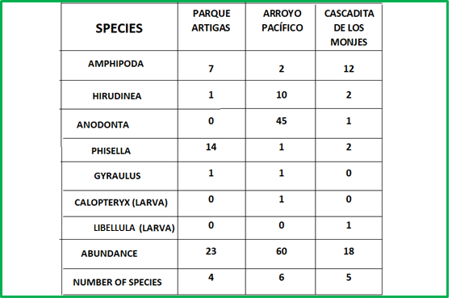

***Figure 1***

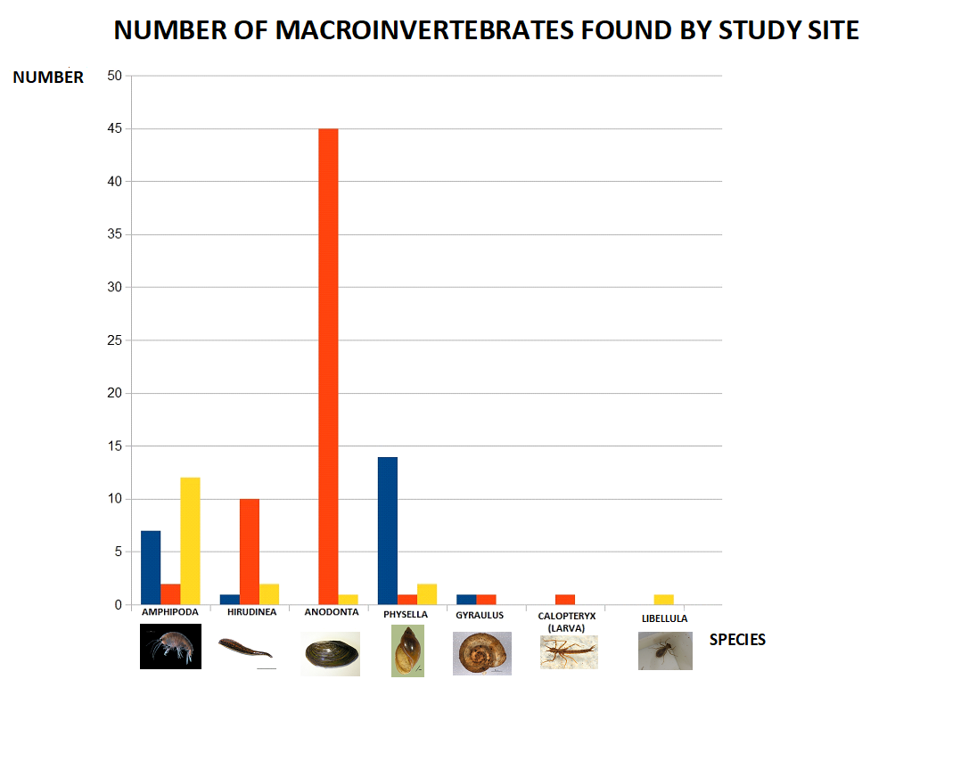

Relations were established between the physicochemical values of the areas studied with macroinvertebrates according sensitivity indices.

|  |  |  |  |  |
| --- | --- | --- | --- | --- |
| **SPECIES** | **PARK ARTIGAS** | **ARROYO PACIFICO** | **CASCADITA DE LOS MONJES** | **SENSITIVITY LEVEL** |
| **AMPHIPODA** | **7** | **2** | **12** | **4** |
| **HIRUDINEA** | **1** | **10** | **2** | **3** |
| **ANODONTA** | **0** | **45** | **1** | **6** |
| **PHISELLA** | **14** | **1** | **2** | **4** |
| **GYRAULUS** | **1** | **1** | **0** | **4** |
| **CALOPTERYX** | **0** | **1** | **0** | **7** |
| **LIBELLULA** | **0** | **0** | **1** | **6** |
| **ABUNDANCE** | **23** | **60** | **18** |  |
| **NUMBER OF SPECIES** | **4** | **6** | **5** |  |

Based on these data, we can affirm:

* A total of 7 different species of macroinvertebrates was found in the three distinct sampling sites at Canelón Chico creek, being a total of 101 individuals.
* The number of species found in Artigas Park is 4, Pacífico creek is 6 and Cascadita de los Monjes is 5.
* The species of greatest appearance in two of the three sites is the ANODONTA, since 45 individuals were found, that means 46% of the total in three sites.
* There are only 3 species appearing in the 3 sampling sites: AMPHIPODA, PHISELLA and HIRUDINEA.
* The higher sensitivity level corresponds to 7, being a single individual (CALOPTERYX) of its kind in Pacífico creek.
* Regarding the level of sensitivity 6, 45 individuals were found in Pacífico creek, all belonging to the same species and 2 individuals from different species with that level in Cascadita de los Monjes.
* The sensitivity level of the most abundant species in the Pacífico creek is 6. In contrast, in the other two sites, the predominant species are level 4.

**6. DISCUSSION**

The three sampling sites differ from each other as the Cascadita de los Monjes is the one with less human intervention because it is only surrounded by fields of cattle breeding, however the Artigas Park site is the most modified for being in the outskirts of Canelones city. Finally, the Pacífico creek site presents modifications due to crops since one of its banks has plantations of genetically modified soybeans, with all that this entails: use of pesticides, herbicides and fertilizers. (Difilippo, s.d.)

But, the latter is the one with the highest level of water quality according to the types and amounts of macroinvertebrates found. In addition, many individuals and variety of species were observed.

After attending the University of Sciences (UDELAR), it was understood that for a stream having living beings in it, the pH should be between 4.5 and 9.5. A good quality water must have a pH between 6 and 9. It should be noted that this varies if there is vegetation in the sampling sites. Thus, it was established that the samples were drawn from similar sites (muddy bottom type), still water, muddy banks, sampling the banks, banks with vegetation).

After this first study, it could established that the water quality in the Canelón Chico stream has an intermediate degree in the level of macroinvertebrates sensitivity, since that the higher number of individuals obtained belong to groups having an intermediate degree of sensitivity (4, 5 and 6).

According this first survey we can conclude that the quality of this water body, so important for the inhabitants of the area, could present a slightly different level of impairment in the three study sites.

Throughout this process, students were whom performed all the sampling work, analysis and data upload. The relationship between them was improved thanks to the team work carried out. The importance of having a stream of water as much suitable as possible for consumption and use was understood, as well as the fact of raising public awareness about this issue.

**7. CONCLUSIONS**

* PACIFICO CREEK, despite receiving the influence of urban and productive activities in the area after the city, is the site with more variety and level of sensitivity of macroinvertebrates, thanks to its natural characteristics in this point.
* Because it was observed a type of hydrocarbon on the surface of the water in PACIFICO CREEK (which nature could not be determined), as the oily layer did not reach the bottom, it might have little influence or promote the growth of some species.
* PACÍFICO CREEK has natural conditions and a factor of human origin, unlike the other two sampling sites that make possible the existence of a high number of clams.
* In some of the sites exist productive activities that favor the development of particular species, rather than diversity.
* It should be noted that the macroinvertebrates pursue and seek the best environmental conditions for living, which can be imperceptible for us.
* Since clam species is the largest contributor to this total abundance, this species may be feeding and favoring with some feature of the environment.
* The most sensitive macroinvertebrates were found on those sites that have less human intervention.
* The hypothesis was not fulfilled as the area that is in the third section of study and which receives water from the other two, is the one with greater variety and number of macroinvertebrates.

Therefore, it may be necessary further research studying macroinvertebrates in one study site at different depths and distances from the banks and research on the relationship of the clams with the medium, nutrients, competitors and conditions that promote or affect their growth. To improve research, it could be proposed in a future stage to collect samples at all sites at the same time, in a period of less than a week and similar conditions.

Based on the study and after analyzing the results, we cannot risk saying that there is contamination in the watercourse studied since it would be necessary to investigate other parameters in Canelón Chico water course to complement this research.

**BIBLIOGRAPHY**

Achkar, M. (2012). Cuenca del Río Santa Lucía - Uruguay Aportes para la discusión ciudadana. Recuperado de <https://www.redes.org.uy/wp-content/uploads/2012/12/Publicacion-Santa-Lucia-WEB.pdf>

Arango, N. et al.  (2009). Principios y prácticas de la enseñanza de la ecología en el patio de la escuela. Instituto de Ecología y Biodiversidad – Fundación Senda Darwin. Santiago, Chile.

Di Filippo, Aldo. Impactos del Cultivo de Soja en Uruguay. (s.d)

MACHIN, Emanuel. Miniguía zooplancton y macroinvertebrados de agua dulce de Uruguay (s.d.)

Resolución Ministerial N° 229. Diario Oficial de la República oriental del Uruguay, Montevideo, Uruguay. 23 de noviembre de 2015.

Reichert Lang, Juan Jorge. Atlas ilustrado de los peces de agua dulce del Uruguay. Rocha: PROBIDES, UNDP. 2002.

**Web sites**

Enseñanza de la ecología en el patio de la escuela. 2014. [ONLINE] (CITADO MARZO 2016]. Disponible en Internet en: <http://eepechile.blogspot.com.uy/p/ciclo-de-indagacion.html>

Guía del docente GLOBE: <https://www.globe.gov/es/do-globe/globe-teachers-guide>

Morelli, Enrique, Verdi, Ana, Diversidad de macroinvertebrados acuáticos en cursos de agua dulce con vegetación ribereña nativa de Uruguay. Revista Mexicana de Biodiversidad [en linea] 2014, 85 [Fecha de consulta: 5 de febrero de 2018] Disponible en:<http://www.redalyc.org/articulo.oa?id=42532670017> ISSN 1870-3453

Observando nuestro entorno local: exploraciones escolares. Pág. 191-204 (PDF download available). Available from: https://www.researchgate.net/publication/317045991_Observando_Nuestro_Entorno_Local_Exploraciones_Escolares_Pag_191-204 [accessed Feb 05 2018]. Unidad de Gestión Ambiental y Calidad del Agua – VRHR y del ULRA de la UMSS. 2012. Guía para evaluar la calidad acuática mediante el índice BMWP/Bol. La Paz.

PACHECO, Juan Pablo et al. Evaluación del estado trófico de arroyos de la cuenca de Paso Severino (Florida, Uruguay) mediante la utilización del índice biótico TSI-BI. AUGMDOMUS, [S.l.], v. 4, p. 80-91, jan. 2013. ISSN 1852-2181. Disponible en: <https://revistas.unlp.edu.ar/domus/article/view/502>. Fecha de acceso: 06 feb. 2018

Programa GLOBE Argentina. 2013. [ONLINE] [Citado abril 2016]. Disponible en Internet en: [www.globeargentina.org/](http://www.globeargentina.org/)

**ACKNOWLEDGMENTS**

To begin with, we thank María José Manivesa who has joined this project in 2017, a Chemistry Engineer who guided our work and enabled its registration in a more methodical way.

To Andrea Ventoso (National Coordinator of the GLOBE Program in Uruguay) with who we have worked since 2012 conducting workshops and field trips with students. Her contribution has enriched this research significantly.

To Emanuel Machin, Biologist, who has developed a series of workshops on environmental studies and the use of Macroinvertebrates as bioindicators of water quality in the school.

To the Limnologist Rafael Arocena, from the University of Sciences (UDELAR) with who everything related to pH and bioindicators was worked.

To the teacher, Headmistress and Hydrosphere Master Trainer, Patricia Píriz, who was invited to the school to give a talk before the start of the investigation, to learn a little more about the topic macroinvertebrates.

To the Biologist Claudia Caro Vera, from Perú, for bearings in the preparation of the report and review of literature providing interesting results.

To Professor Verónica Rodríguez who translated this document.

***Annex 1:***

**Schedule of Activities**

|  |  |
| --- | --- |
| DATE | ACTIVITY |
| 12/03/2017 | Working with the concept of macroinvertebrates.  Recognition.  Using a Video lesson about Google Drive work. |
| 25/04/17 | Field trip: collecting macroinvertebrates in Cañada Las Violetas.  -Site map  -measurement PH, TRANSPARENCY, TEMPERATURE  elements employed  +brand digital pH meter Cole Parmer  +transparency tube 120cm  +alcohol thermometer water Gerber- Funke brand  +boiler  +bucket  +measuring tape  +pennants  +rope |
| 26/4 /2017 | SAMPLING LOCATIONS  Canelón Chico creek, before and after CANELONES city  -Current located in Parque Artigas |
| 26/04/17 | COUNTING AND CLASSIFYING  ELEMENTS: specimens, key, sensitivity level book, alcohol, trays, bowl, colander  Index Biological Monitoring Working Party (BMWP) was instituted in England in 1970, as a simple method that assigns a score to all groups identified macroinvertebrate to the family level, having qualitative data of presence as a requirement or absence. Assigned score goes from 1 to 10 according to the tolerance to pollution. The most sensitive families have a score of 10 and the least sensitive of 1. Alba-Tercedor & Sánchez Ortega 198821 performed the adaptation of this index and called it BMWP'. (MMAYA, 2012, p. 20) |
| 11/5/17 | We coordinate a visit to the University of Sciences to work as follows:  Bio-indicators, PH.  THIS ACTIVITY WAS CONDUCTED BY PROFESSOR AROCENA  We attended the 5th of June at 11:00  Students who attended:  - Josefina - Lisa  -Romina - Melani  -Sofia - Francisco  -Mariano - Bryan  -Santiago - Ayrton  -Ingrid - Constanza |
| 16/5/17 | We selected our research title:  “ANALYSIS OF THE QUALITY OF WATER IN AREAS CLOSE TO THE CITY OF CANELONES”  It was decided, with the children, to attend the departmental science fair to present the research. |
| 1/6/17 | Sampling at ARTIGAS PARK |
| 1/6/17 | Correction of graphics. We solved that all must have an order, pattern colors, size and measurement of equal axis.  Establish a uniform picture of references.  Choice of hypothesis:  A- the quality of the freshwater that is found in a stream in the western part of the Department of Canelones will not be equal because of human activities of the inhabitants of the capital city.  B- due to the human activities of the inhabitants of Canelones city, the quality of the freshwater of the current study will not be the same at all sampling sites.  C- **in places with less human activity the number of Macroinvertebrates is higher.** |
| 5/6/17 | Visit to the University of Sciences with Limnologist Rafael Arocena. |
| 5/6/17 | Sampling at PACÍFICO creek, site map. |
| 14/6/17 | First talk in charge of the chemistry María José Manivesa. We exchanged ideas and information. |
| 16/6/17 | Sampling at CASCADITA DE LOS MONJES, site map. |
| 20/6/17 | Classification and counting of specimens found.  Recording videos to communicate the above-mentioned work. |
| 27/6/17 | Day of activity with María José Manivesa: comparison of data plotted. |
| 24-28/7/17 | Drafting of the report to be presented in science clubs meeting.  Reflection based on the data obtained. |

***Annex 2***

**Data entry screenshots to the GLOBE database**

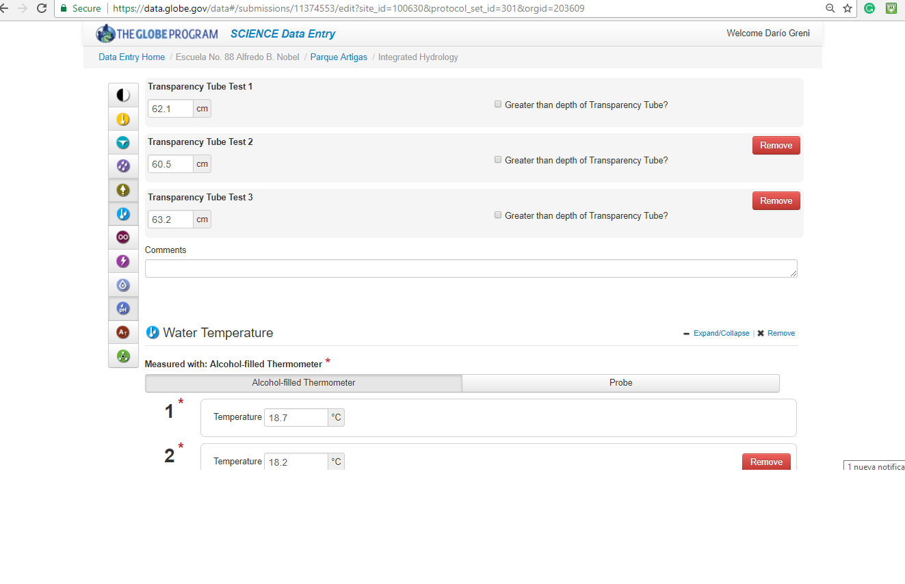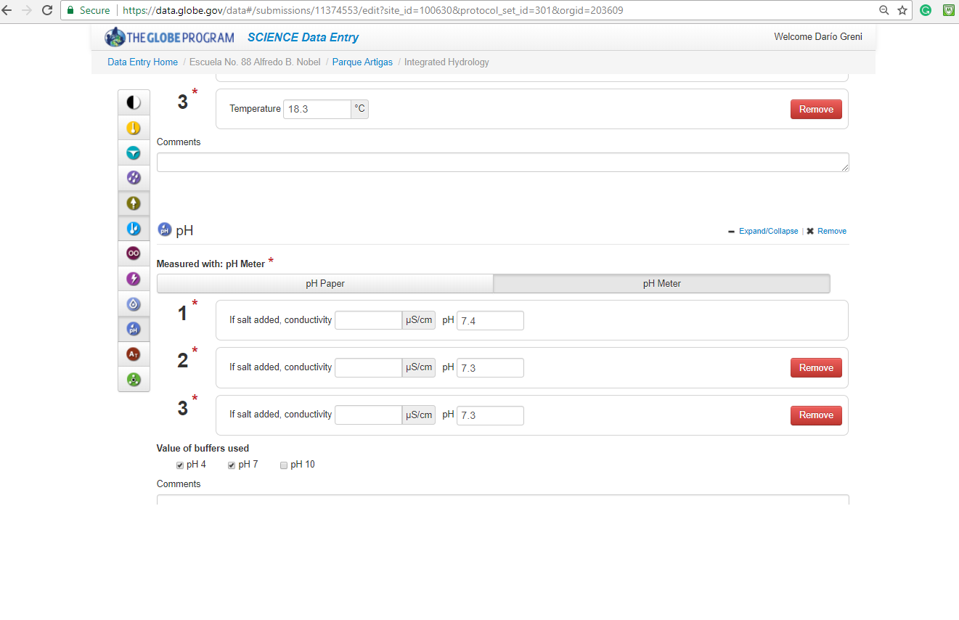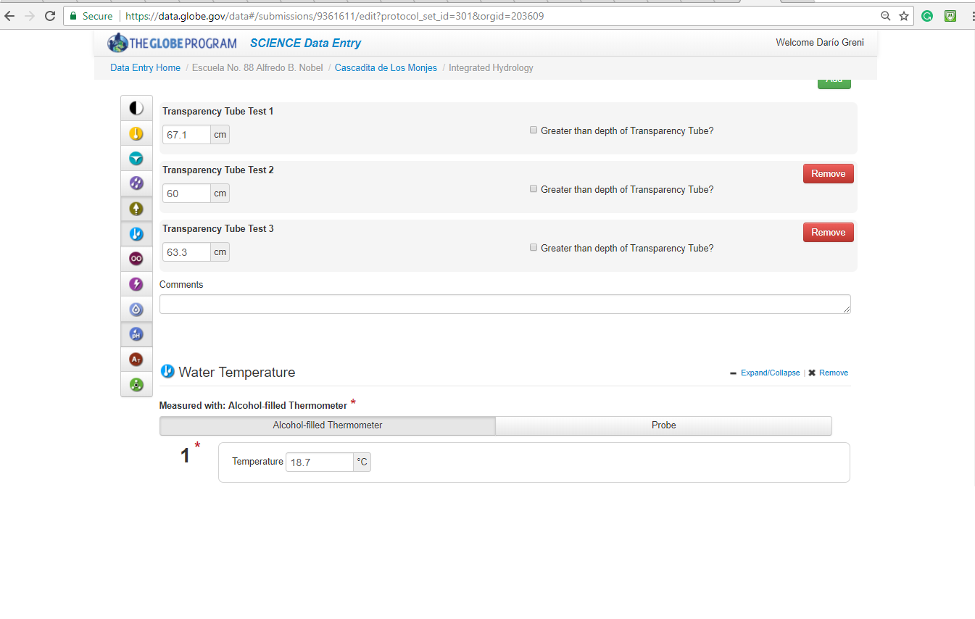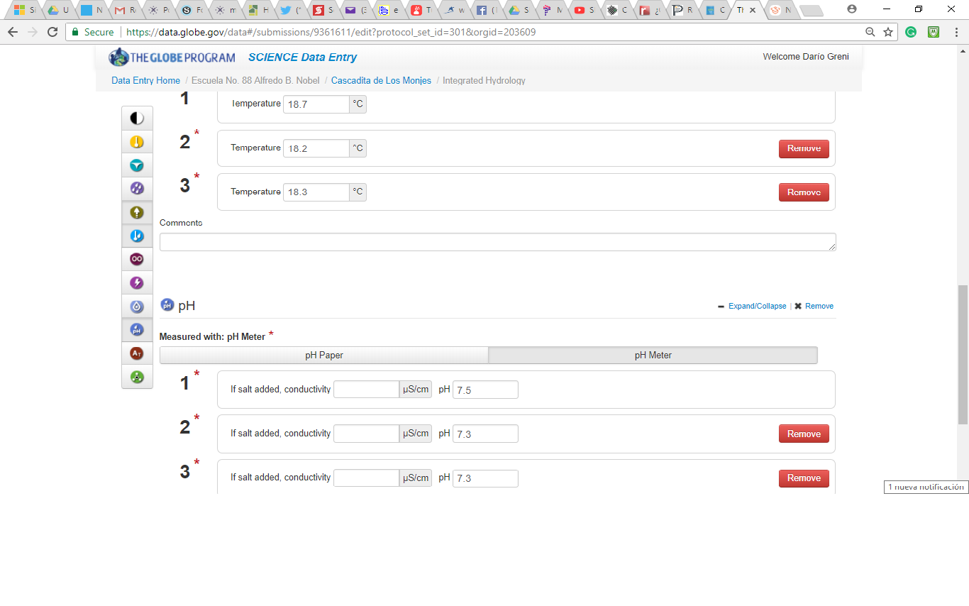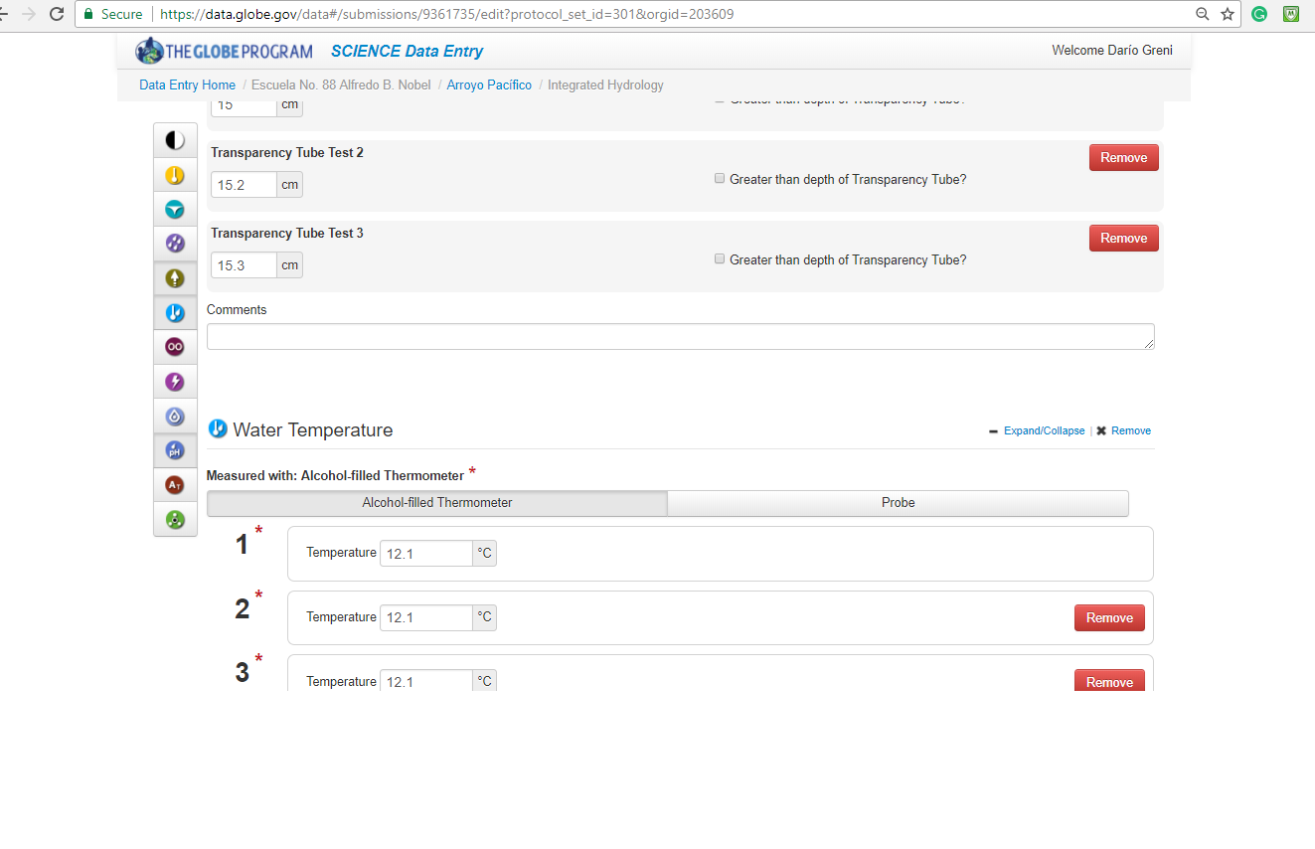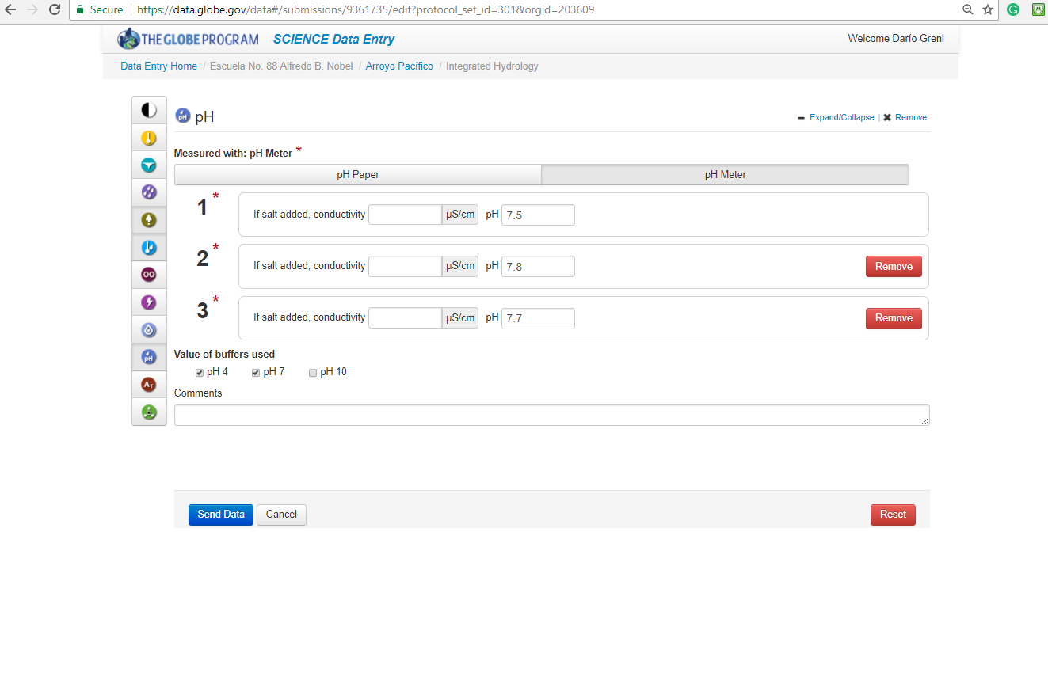

***Annex 3***

**Badges to which the group nominates**

**COLLABORATION**

To carry out this research has been a great collaborative work between different social actors with a level of expertise that made it possible to reach the expected results. In addition to collaboration on various teams inside and outside of the classroom, this work is also supported with a biologist, a chemical engineer and with members of the departmental community with which it will seek to further improve the quality of the water of this stream of study and enjoy the same as it was previously the case. In this 2018 will be added the historical Institute of Canelones, providing a look from the importance of this stream at historic level.

**COMMUNITY IMPACT**

After starting work on this project in class, there has been a profound change in the student body regarding the care of the environment already awareness on the importance of this current water. This process of awareness has been communicated to their families not only in a fair that was held in our school in the month of August of 2017, but also through the local press. It is projected to make a citizen intervention in order to inform citizens of Canelones in a more direct way and add to the work carried out by the Canelones’ municipality.

**CONNECTION TO A STEM PROFESSIONAL**

Due to the complexity of knowledge which should be handled in this investigation, it was necessary to work with a biologist (Emanuel Machin) since the beginning of the same. It was he who supported work on computer, the field trips and the handling of information obtained after the performed survey. This biologist is promoting the creation of a protected Area in part of the area in which you pass this stream. They also worked with a chemical engineer (María José Manivesa) everything relevant to the characteristics of the stream of water itself as well as writing a scientific report. It boosted the analysis of information and obtaining conclusions, encouraging critical reflection of the data.

***Annex 4***

**Photographs**



