BENIN

Name: LAWANI Ylliass Destin
Function: Assistant CC, Acting CC
Organisation: GLOBE Benin
E-mail: ylliass@outlook.fr
Tel: +229 97397176 / 95235037
Skype: ylliassesf
Website:

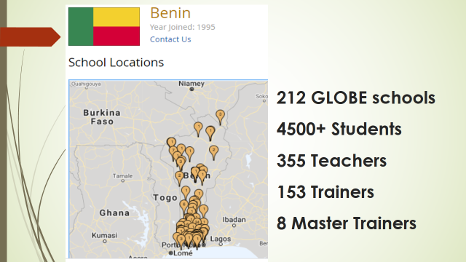

In 2021 Benin concluded its participation in the GLOBE ZIKA Prevention and Education Project by being part of the GLOBE Zika project closeout event organized by GIO on Thursday, March 25 2021, with the Department of State.
This project had very good impacts on Benin Republic community
- Benin is the second data contributors to the project in Africa region. We are proud of that!
- Schools could benefit from equipment. Eg. Lenses distributed to participants could help practice biology topics like water microinvertabrates observation, cells, etc.
- Engagement of Local Communities, community leaders, local administrative Units (municipalities)
- Involve 75 new GLOBE schools
- Excitement of GLOBE students and academics about the project
- Recruit new GLOBE observers
- awareness on health impacts of mosquitoes larvae,
- prevention efforts
- Setting up a public health officers and health care workers Zika project network
- And somehow overall relaunched GLOBE activities in the country by raising interest of general people, academics and officials.

Benin also participated in the GLOBE Africa virtual annual meeting, the GLOBE 2021 virtual annual meeting, and 2021 IVSS.
In addition the coordination could contact officials and resources persons who can help GLOBE activities to be relaunched and funded by the Government.

Organization and Number of Staff: GLOBE BENIN / GLOBE Alumni Africa, 1

Funding by: No funding available

Cooperating Organizations/Individuals: None

GLOBE Schools:
IIFMEC UNIVERSITY, CEG DAVIE P/N,UNIVERSITY OF ABOMEY CALAVI, CEG1 AKPRO-MISSERETE, CEG TAKON (SAKÉTÉ), ECOLE NORMALE SUPÉRIEURE DE NATITINGOU, YOUNG WOMEN’S CHRISTIAN ASSOCIATION (YWCA), CROIX ROUGE-RED CROSS OUEDO,
ONG HAPPY SCIENCE, CEREID, AFRICA HOPE NGO, CEG FIYEGNON, CEG DJEGAN KPEVI, CEG HOUMBO, CEG AKPRO- MISSÉRÉTÉ, CEG TAKON, COMPLEXE SCOLAIRE SAINT FRANÇOIS XAVIER, UNIVERSITE DE PARAKOU, LYCEE MATHIEU BOUKE, AMERICAN CORNER PARAKOU, AMERICAN CORNER PORTO NOVO, EPP DOGOUDO, COMPLEXE CATHOLIQUE SAINT MICHEL DE DASSA, CEG SOHEDJI, CEG YAGBO, CEG1 GLAZOUE, CEG2 DASSA-ZOUME, CEG 3 SAVALOU, CEG1 SAVALOU, CENTRE DE SANTE D'ARRONDISSEMENT DE GBAFFO, SOS CIVISME, CEG SOWE, CEG 4 COME, COME HOSPITAL, CEG COME, COME MUNICIPALITY, CEG KPOVIDJI, EPP OUEDEME PEDAH, EPP GADOME, EDUCARE BENIN NGO,
COMPLEXE SCOLAIRE SEKO, LABORATOIRE D’ENTOMOLOGIE APPLIQUEE (LEA/UAC), FACULTE DES SCIENCES AGRONOMIQUES (FSA/UAC), MAIRIE DE GRAND-POPO (GRAND POPO MUNICIPALITY), CEG GRAND-POPO, CEG GBEHOUE, CENTRE SOCIO-EDUCATIF AS-SADAKA ; LYCEE TECHNIQUE COMMERCIAL ET INDUSTRIEL DE KANDI, CENTRE DE SANTE AS-SADAKA, ECOLE PRIMAIRE PRIVE AS-SADAKA, HOPITAL DE ZONE DE KANDI, COLLEGE D'ENSEIGNEMENT GENERAL PRIVE AS-SADAKA, CENTRE DE PROMOTION SOCIAL (CPS) DE MALANVILLE, CEG MALANVILLE, HOPITAL DE ZONE DE MALANVILLE.

GLOBE Protocol Areas: Hydrosphere - Biosphere

Number of Schools Reporting Data over Past Year: 2 schools

Program Implementation, International Cooperation in GLOBE Network, and Activities over Past Year (categorized by GLOBE Strategic Plan 2018-2023 Goals):

- Education : Mosquito awareness for kindergarten and primary school students through the Zika Zine
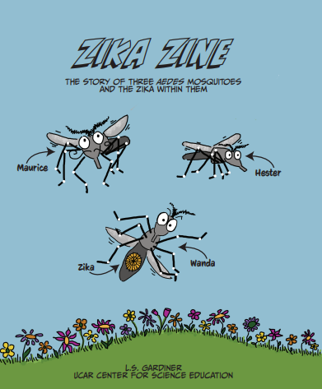
We could organize many educational sessions for kindergarten and primary school students through the Zika Zine. This comic book was developed by Dr Lisa Gardiner (We collaborated in its translation in French ) part of the Zika projet. We organized a total of 03 storytelling actions with students from kindergates and primary schools of Benin, and 1 zikazine distribution to participants to a Words spelling competition called "la guerre des mots" on 22nd february 2020. Due to the Covid 19 situation we could not continue. Later we could publish the french version of the zika zine on flipsnack for people to view and read it at https://www.flipsnack.com/8AEB8BBBDC9/zika-zine_fr.html. This link was shared on whatsapp and social media to reach a wider audience. Participants really loved this humorous and educational graphic novel.

- Science: Mosquitoes and cloud data collection. Participation to water bodies IOP, and the Cloud Challenge
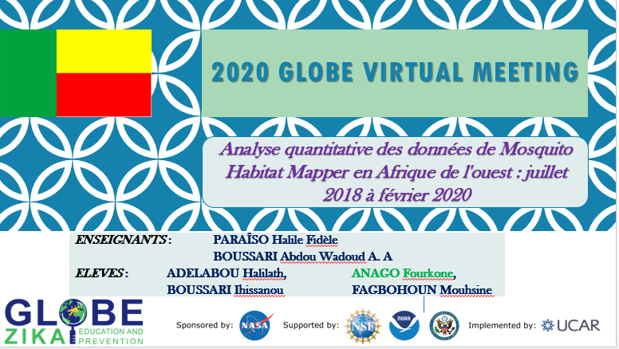
4 GLOBE students from 3 schools ADELABOU Halilath, ANAGO Fourkone, BOUSSARI Ihissanou and FAGBOHOUN Mouhsine, under the supervision of their GLOBE teachers Mr. PARAÏSO Halile Fidèle and Mr. BOUSSARI Abdou Wadoud submitted their research at the 2020 GLOBE IVSS
They won the DoS Zika prize for Africa Region and could present their research at the 2020 GLOBE Virtual Meeting.
Students also received a certificate for attending /presenting at the 2020 GLOBE Virtual Meeting

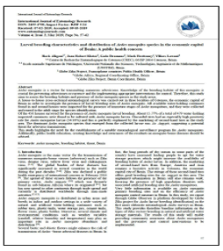
A research paper “Assessment of population dynamics and biting trends of Aedes aegypti in northern Benin: Public health implications.” Was published in the International Journal of Mosquito Research in October 2018. Research lead author was the Francophone Regional PHO, Dr. Rock Aikpon, Co-authors: Mark Brettenny (Regional Coordinating Officer) & Ylliass Lawani
This research presents important findings about the biting behavior of Aedes mosquitoes in Benin, and the probability of exposure to Aedes aegypti mosquitoes (based on the indoor and outdoor collection of 485 adult Aedes aegypti mosquitoes). Download this at www.entomologyjournals.com/archives/2019/vol4/issue3/4-3-26
This paper was presented at the Pan African Mosquito Control Association (PAMCA), Cameroon, 2019 by Dr. AIKPON who published other papers on Zika larvae, but not specifically part of the project.

We are working to create through Dr Rock and other GLOBE alumni who became researchers and lecturers, a local GLOBE Science Network to promote STEAMs and research initiatives.

- Community: part of the GLOBE Zika project, we are working with many GLOBE communities in Benin (scientists, lecturers, teachers, Public Health officers, doctors, school clinics, and Municipalities). We are also collaborating with local NGOs ( Saved People, Save our Planet NGO)

- Technology : use of zoom plateform and phones to explore GLOBE resources

- Communications: Creation of GLOBE whatsapp group to communicate with the community for each training organized participation in the zoom and skype calls.

Plans and Ideas for Next Year:

Make plan to conduct GLOBE Training as many as possible (try to find funds for that)
Enrole municipalities, NGOs and more peoples in GLOBE
Ensure to have community leaders involved
Develop collaborations with neighbor countries like Togo and Nigeria
Encourage trainers to use GLOBE online resources
Strongly work with municipalities and community leaders
Continue contacts with officials and resources persons who can help for GLOBE implementation
Regain interest of Benin Government in order to get funding from them.

