MADAGASCAR
Name: RANDRIANARISOA Paul  Function: country coordinator  Organization: Ministry of National Education  E-mail: randripaul@yahoo.fr randripaul@gmail.com  Tel: +261 33 11 063 21  Skype: paul.randrianarisoa1  Website | 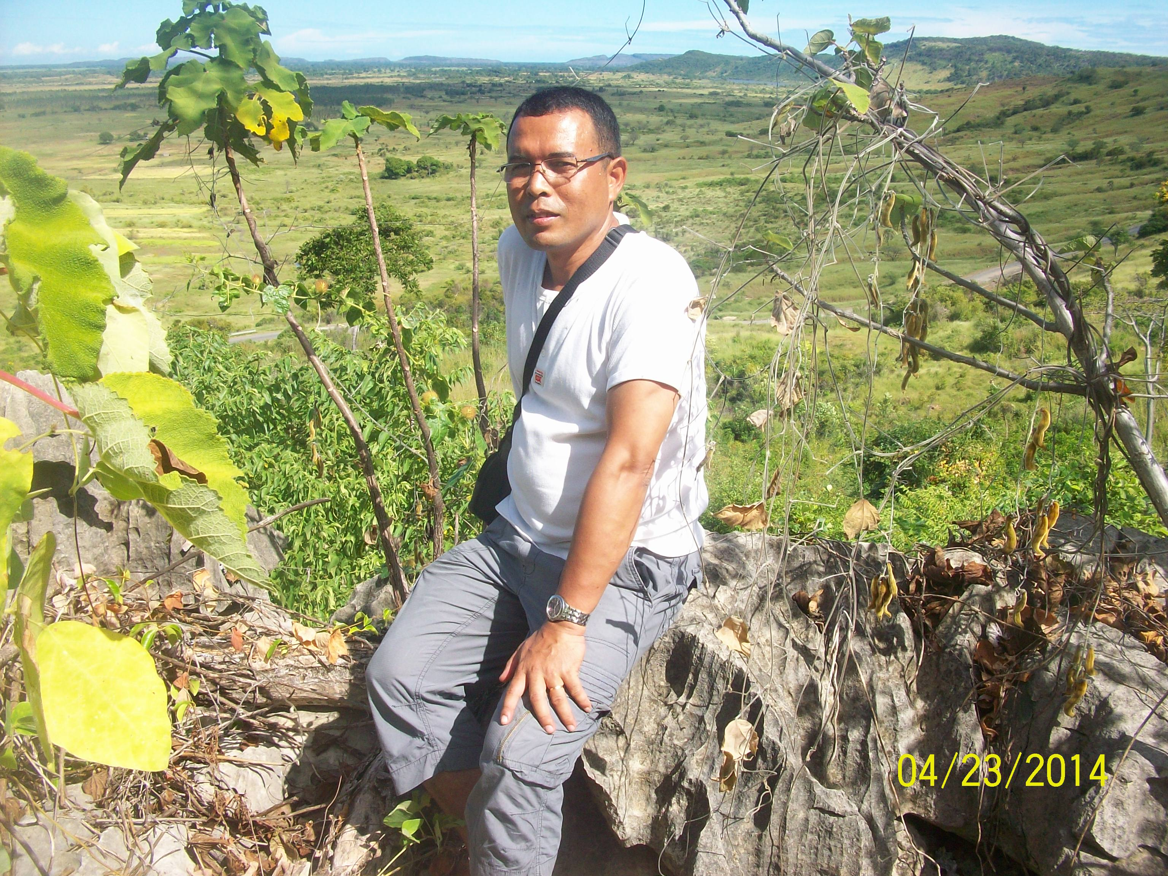

Name: RAVOAVY Denis  Function: assistant CC  Organization: Ministry of National Education  E-mail: ravoavydenis1@gmail.com  Tel: +261 34 09 368 53  Skype:  Website: | 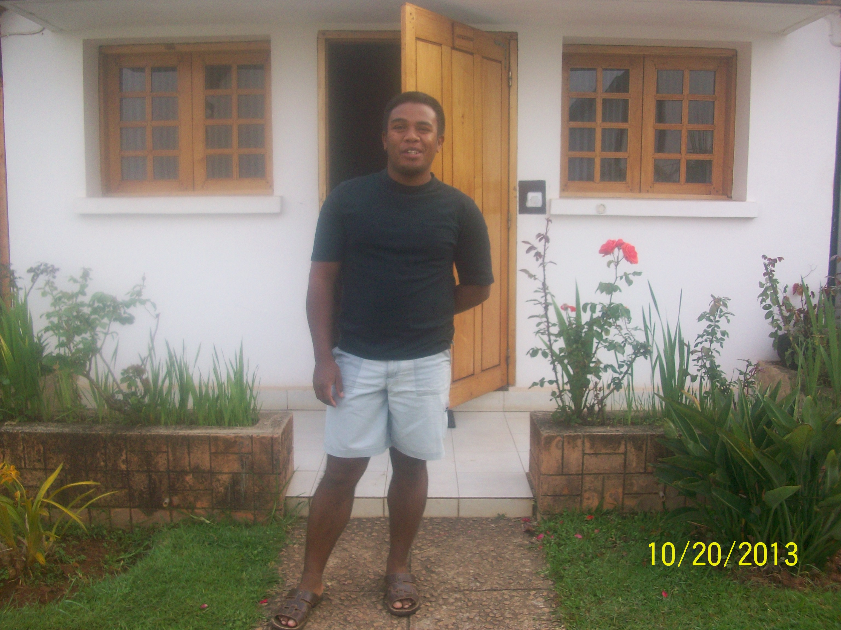

Cooperating organizations: Government, WWF, UNICEF

Participating schools: 37

Funding by: Government and partnership

GLOBE protocols used in country: atmosphere and climate study, hydrology, soil study, land cover and biology, Mosquito study.

Number of schools currently reporting data (2014): 6

Description of the program in your country and recent activities in 2014:

- From May to December 2014: Visit of 20 GLOBE schools for mentoring GLOBE teachers and students and for identifying some problems in implementing GLOBE in each school.
As a result we have identified that we should establish a close collaboration between the decentralized structure of the Ministry and GLOBE schools for solving some problems.
We have also installed some GLOBE Meteorological Station respecting the norm.
We have been conscious that:
- At some GLOBE schools the materials are not exploited correctly;
- GLOBE activities are integrated into pedagogical process;
- There is effectively transmission and exchange of knowledge and competency between GLOBE students and local community;
- The students give hands each other and have auto organization in realizing GLOBE activities;
- Some GLOBE schools don’t spend enough time for the learning activities before observing and collecting data;

- September 2014: Visit of GLOBE schools in two regions of Madagascar for mentoring teachers and students to participate for the local sustainable development. In this case we have reinforced the capability of the GLOBE teachers in:
- Education for sustainable development ;
- GLOBE protocols;
- Pedagogy process;
- Strategy for integrating GLOBE activities into the pedagogical process;
- Ecology;
- Initiation of GLOBE students in research and publication of the result to sensitize local community in environmental awareness.

- From February to July 2014: Mentoring of two students preparing their thesis about GLOBE protocols. That is to say that GLOBE is an important way and mean for the scientific research and an educational support.

- From March 2014 to December 2014: Development of partnership.
As a result:
- Signature of an accord of partnership with UNICEF to provide GLOBE materials for 3 new GLOBE schools and to train 30 teachers in GLOBE protocols in January or February 2015;
- Signature of an accord of partnership with WWF to provide GLOBE materials for 1 school and to train 8 teachers in GLOBE protocols in April 2015;
- Negotiation with Madagascar National Park in order to:
  - Provide technical support in environmental data collect;
  - Exchange competency with the agents of the park in collecting data;
  - Sensitizing community in environmental awareness.

- Participation in national events:

  - June 2014: Participation in celebration of the World Meteorological Day 2014:
- Information of community about GLOBE Program;
- GLOBE schools Exhibition realized by GLOBE students from two GLOBE schools;
- Participation of GLOBE students in discussion and animation about climate change.

  - June 2014: Participation in celebration of the Environmental World Day 2014.

