Cameroon
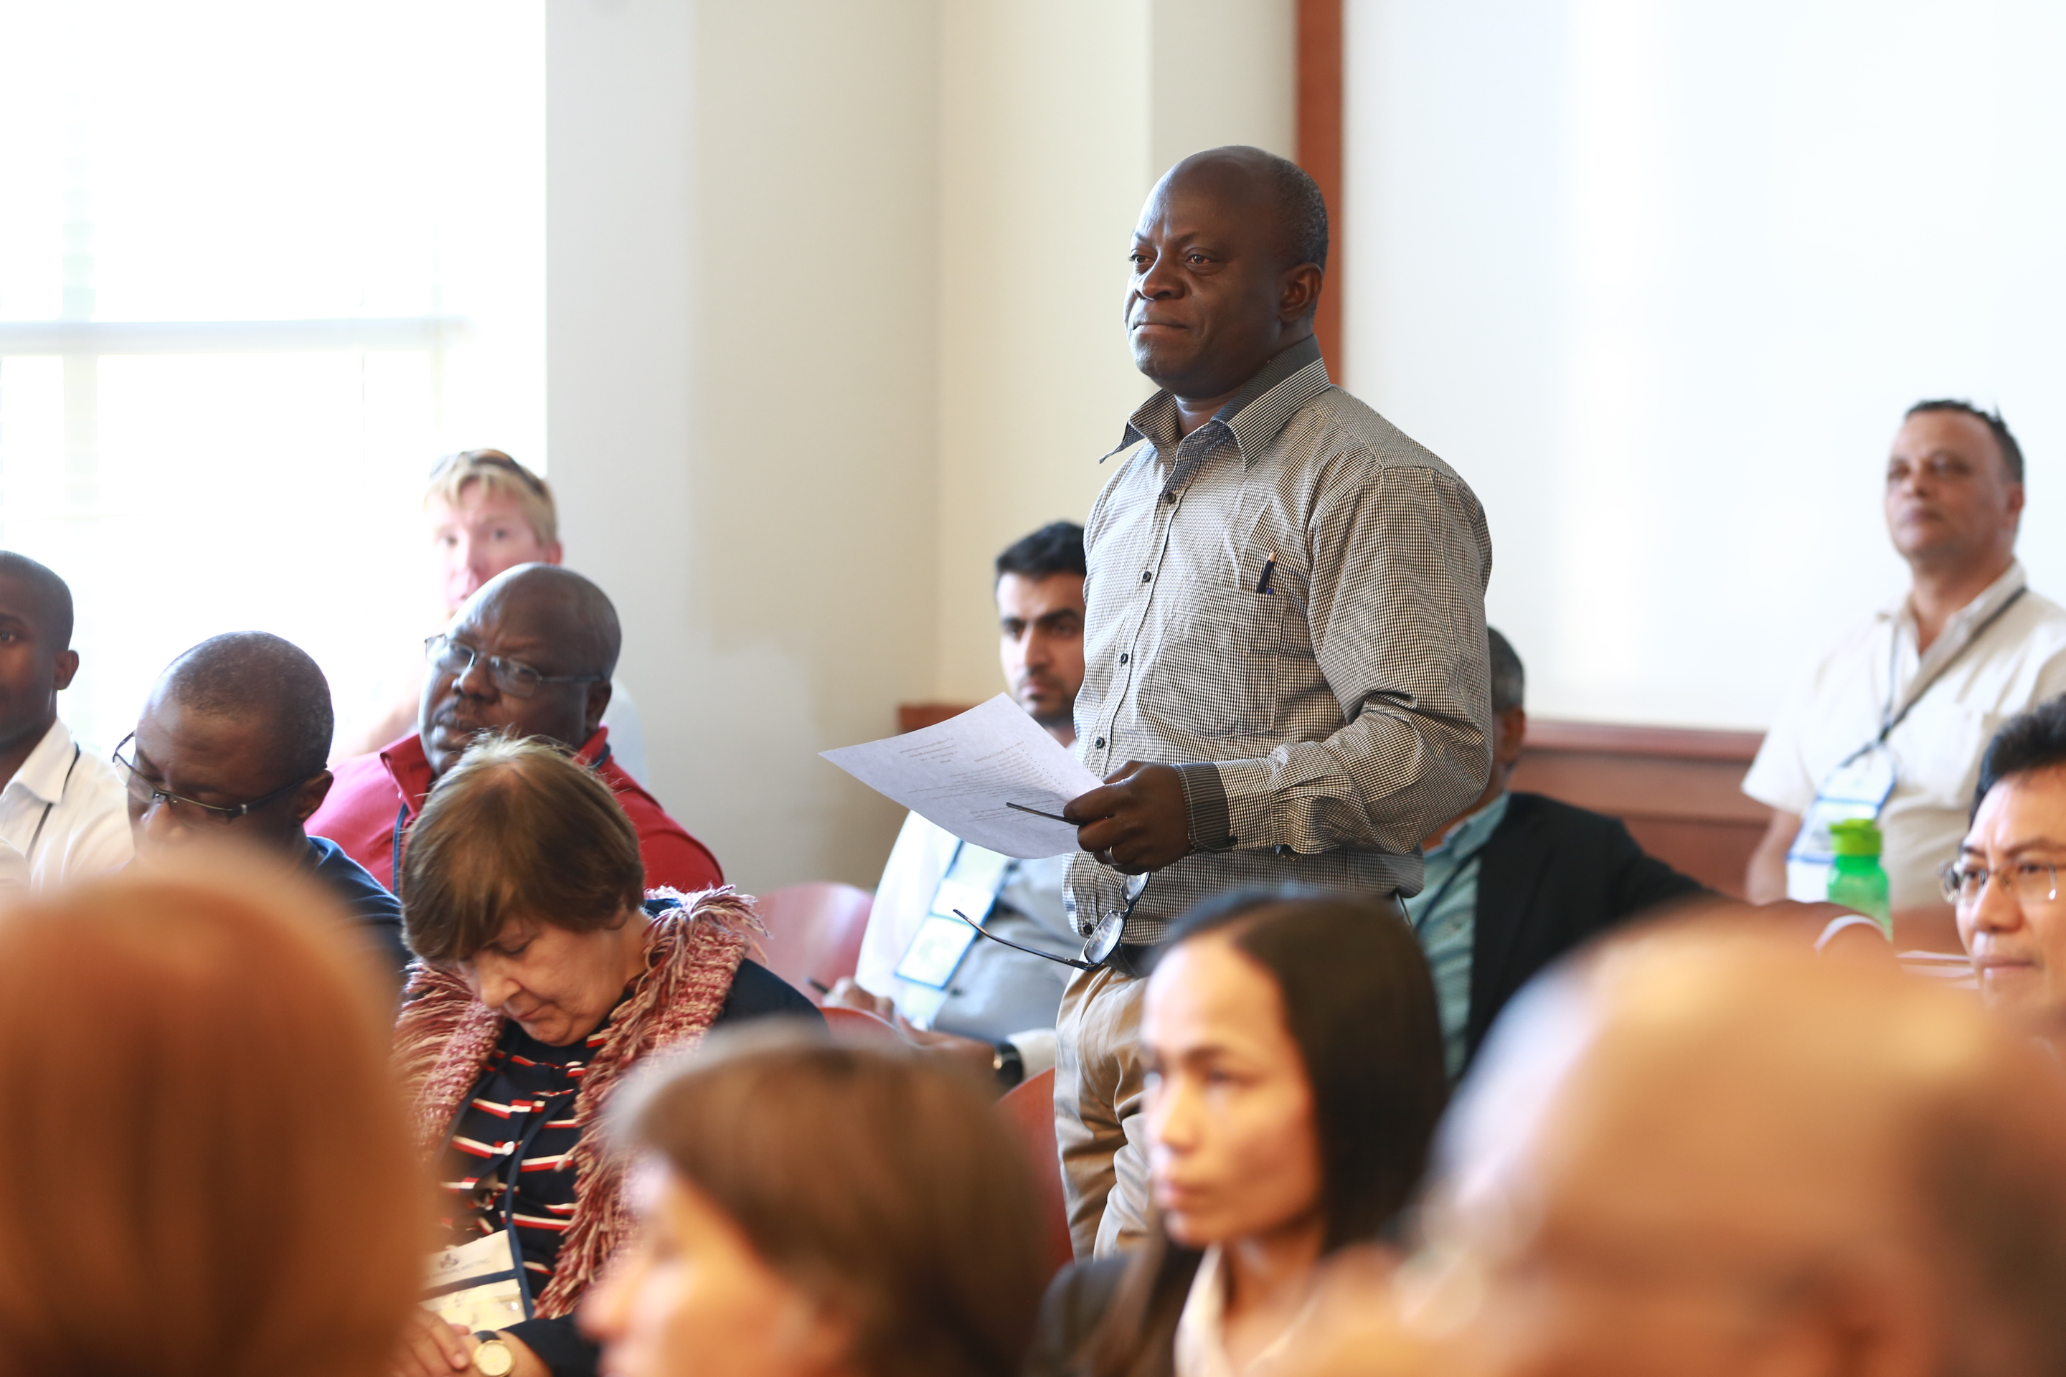
Insert photo of CC
Name: Lawrence Kambiwoa
Function: National Coordinator (CC)
Organisation: Ministry of Secondary Education
E-mail: LawrenceKambiwoa@hotmail.com
Tel: +237677819751
Skype: Lawrence.Nunatcho
Website:

Name:
Function: Assistant CC
Organisation:
E-mail:
Tel:
Skype:
Website:

Cooperating organizations: Peace Corps and the US Embassy.

Participating schools: Over 30 schools and more than 60 teachers received training in 2017

Funding by: Subvention from the Ministry of Secondary Education

GLOBE protocols used in country: Atmosphere, Hydrosphere, Biosphere, Pedosphere

Number of schools currently reporting data (2018):

Description of the program in your country and recent activities in 2017: The main actors in the GLOBE Program Cameroon are Pedagogic Inspectors (Advisers, Curriculum specialists, course experts) who take roles in mentoring teachers on the major investigation areas. As such, receive support from the Inspectorate General of Education as well as enjoy subvention from the Ministry of Secondary Education to equip GLOBE schools with GLOBE science materials, train and mentor teachers.
In 2017, a training workshop was held in Yaounde with the participation of about sixty teachers representing thirty secondary schools. The Country Coordinator took part in the GLOBE Annual Conference in New Haven, USA. The combined result of these workshops and involvement in the annual conference enhanced the quest to revamp the GLOBE Program in Cameroon. In fact, early 2018 saw the triumphant endorsement of the regulatory instrument on the modalities for steering the GLOBE Program in Cameroon by the Minister of Secondary Education and the Minister of Basic Education. Of course, the Office of the Prime Minister is currently reviewing this important text for publication in the course of the year.

