BENIN
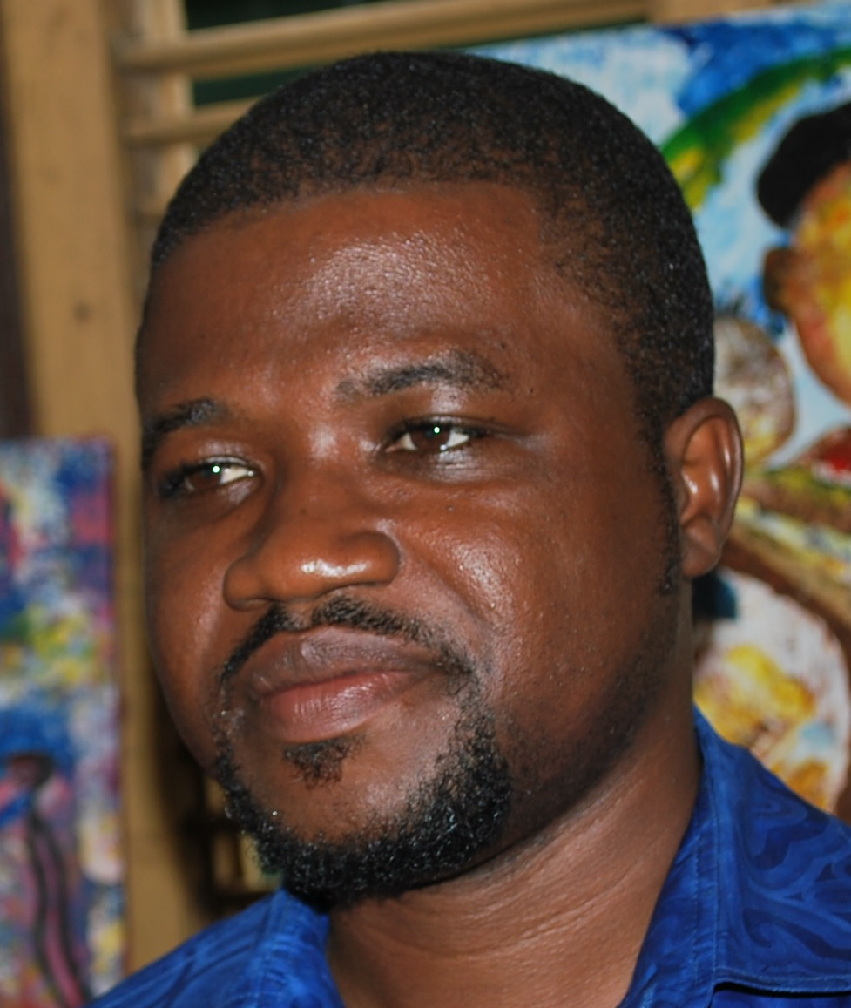

Name: LAWANI Ylliass Destin
Function: Assistant CC - GLOBE Alumni Benin/Africa coordinator, GLOBE Evaluation Working Group
Organisation: GLOBE Benin
E-mail: ylliass@outlook.fr , copy at ylliassdestin@gmail.com
Tel: +229 97397176 / 95235037
Skype: ylliassesf
Website: https://www.globe.gov/web/ylliass

In 2019 Benin continued its participation in the GLOBE ZIKA Prevention and Education Project. All Local Mosquito Workshops (LMW) that were conducted are part of this project.
In addition We organized 3 workshops in Guinea and conducted one workshop in Ghana on GLOBE water quality protocols.

Organization and Number of Staff: GLOBE BENIN / GLOBE Alumni Africa

Funding by: GIO, Zika Fund, SERVIR West Africa, IIFMEC University, and Personal funds

Cooperating Organizations/Individuals:

CREC-American Corner Porto-novo, American Corner Parakou, IIFMEC University,
GLOBE Schools:
IIFMEC UNIVERSITY, CEG DAVIE P/N,UNIVERSITY OF ABOMEY CALAVI, CEG1 AKPRO-MISSERETE, CEG TAKON (SAKÉTÉ), ECOLE NORMALE SUPÉRIEURE DE NATITINGOU, YOUNG WOMEN’S CHRISTIAN ASSOCIATION (YWCA), CROIX ROUGE-RED CROSS OUEDO,
ONG HAPPY SCIENCE, CEREID, AFRICA HOPE NGO, CEG FIYEGNON, CEG DJEGAN KPEVI, CEG HOUMBO, CEG AKPRO- MISSÉRÉTÉ, CEG TAKON, COMPLEXE SCOLAIRE SAINT FRANÇOIS XAVIER, UNIVERSITE DE PARAKOU, LYCEE MATHIEU BOUKE, AMERICAN CORNER PARAKOU, AMERICAN CORNER PORTO NOVO, EPP DOGOUDO, COMPLEXE CATHOLIQUE SAINT MICHEL DE DASSA, CEG SOHEDJI, CEG YAGBO, CEG1 GLAZOUE, CEG2 DASSA-ZOUME, CEG 3 SAVALOU, CEG1 SAVALOU, CENTRE DE SANTE D'ARRONDISSEMENT DE GBAFFO, SOS CIVISME, CEG SOWE, CEG 4 COME, COME HOSPITAL, CEG COME, COME MUNICIPALITY, CEG KPOVIDJI, EPP OUEDEME PEDAH, EPP GADOME, EDUCARE BENIN NGO,
COMPLEXE SCOLAIRE SEKO, LABORATOIRE D’ENTOMOLOGIE APPLIQUEE (LEA/UAC), FACULTE DES SCIENCES AGRONOMIQUES (FSA/UAC), MAIRIE DE GRAND-POPO (GRAND POPO MUNICIPALITY), CEG GRAND-POPO, CEG GBEHOUE, CENTRE SOCIO-EDUCATIF AS-SADAKA ; LYCEE TECHNIQUE COMMERCIAL ET INDUSTRIEL DE KANDI, CENTRE DE SANTE AS-SADAKA, ECOLE PRIMAIRE PRIVE AS-SADAKA, HOPITAL DE ZONE DE KANDI, COLLEGE D'ENSEIGNEMENT GENERAL PRIVE AS-SADAKA, CENTRE DE PROMOTION SOCIAL (CPS) DE MALANVILLE, CEG MALANVILLE, HOPITAL DE ZONE DE MALANVILLE.

GLOBE Protocol Areas: Hydrosphere- Atmosphere- Biosphere

Number of Schools Reporting Data over Past Year: 31

Program Implementation, International Cooperation in GLOBE Network, and Activities over Past Year (categorized by GLOBE Strategic Plan 2018-2023 Goals):

- Education : Based on the Zika project guidelines we have conducted 14 Local Mosquito Workshops (LMWs) across the country, and 3 community sensitization.

We have fully funded 1 additional LMW and 1 introduction to GLOBE and MHM workshop.

We had also personally organized and funded 3 trainings in Guinea, and we hope that all these efforts will be continued by the GLOBE management team in this country in 2020. Guinean trained GLOBE people are very eager to continue with GLOBE

We have also been recruited by SERVIR West Africa (a NASA funded program in West Africa) to conduct a regional training on GLOBE water quality protocols. The deliverable was a GLOBE water quality Guide which will be used as training tools for all GLOBE/SERVIR Clubs which will be involved and promised to participate in the next IVSS 2020. More explanation with the GLOBE Africa Regional Office.

- Science: Mosquitoes and cloud data collection. Participation to water bodies IOP

- Community : part of the GLOBE Zika project, we are working with GLOBE many communities in Benin (scientists, lecturers, teachers, Public Health officers, doctors, school clinics, and Municipalities)

- Technology : use of zoom plateform and phones to explore GLOBE resources

- Communications: Creation of GLOBE whatsapp group to communicate with the community for each LMW organized participation in the zoom and skype calls.

Plans and Ideas for Next Year:

Ensure that all planned additional LMTs are conducted (try to find funds for that)
Enrole municipalities and more NGOs in GLOBE
Ensure to have community leaders involved
Develop collaborations with neighbor countries like Togo and Nigeria
Encourage trainers to use GLOBE online resources
Strongly work with municipalities and community leaders
Regain interest of Benin Government in order to get funding from them.

