

INVITATION

2018 GLOBE Training for Europe and Eurasia
14 – 16th November 2018, Toulouse, France

Dear GLOBE Country Coordinators, Trainers, Teachers, Alumni, Scientists and Partners,

We are pleased to cordially invite you to the GLOBE Training for Europe and Eurasia, which will be held in Toulouse, France. The Meeting will be organized in cooperation with GLOBE Europe and Eurasia Board, GLOBE Program Europe and Eurasia Region Coordination Office, GLOBE France and CNES.

The registration is now open and attendance can be registered through this link.

Please, note that the deadline for registration is September 30th .

Agenda can be downloaded at the GLOBE Program website.

We are looking forward to seeing you in Toulouse!

GLOBE France  Danielle DeStaerke  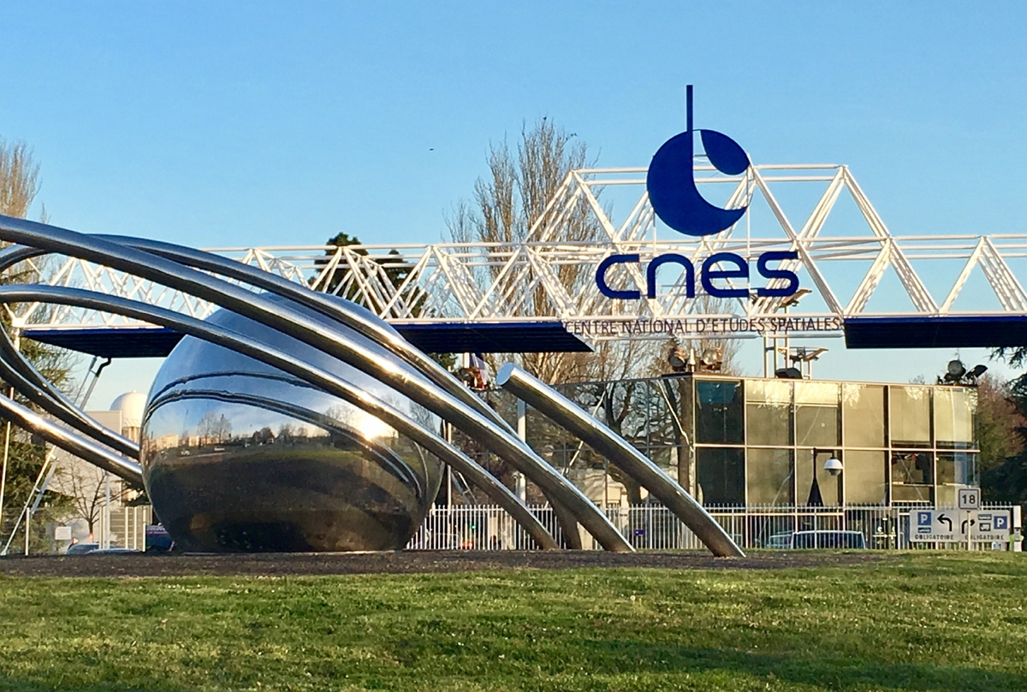 | GLOBE Europe and Eurasia Board  Matthijs Begheyn (Netherlands)  Juliette Vogel (Switzerland)  Magda Machinko-Nagrabecka (Poland)  Laura Altin (Estonia)  Karl Schneider (Germany)  Farid Hamdan (Israel) | GLOBE Europe and Eurasia Region Coordination Office  Bara Semerakova (Czech Republic)  Dana Votapkova (Czech Republic)  GLOBE Implementation Office, USA  Anthony Murphy  The GLOBE Program Director
