
Programa Globe Argentina

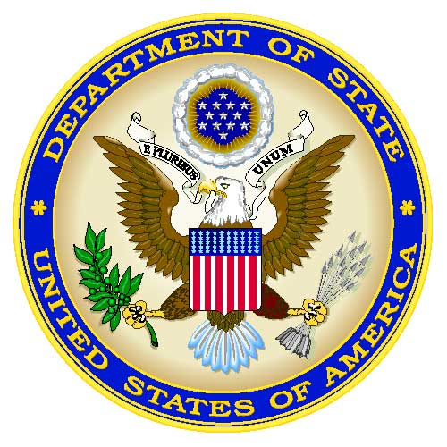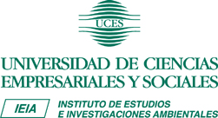

GLOBE PROGRAM ARGENTINA – ANNUAL REPORT

Annual Report: July 2007– June 2008
Presentation of Activities
National Coordinator Prof. Maria del Carmen Galloni
Director of Environmental Studies and Research Institute
IEIA – UCES

Regular Monthly Meetings
Every second Tuesday of each month, since the inception of the GLOBE Program in Argentina in 1995, we hold scholastic coordinator meetings.

- 2007 -

July - December

- Presentation of the GLOBE Program

During a one day Workshop, the GLOBE Program was presented, to managers and supervisors of metropolitan schools. with the cooperation of the Rotary Club of Victoria,

The Master Trainers explained the way to apply the protocols and guidelines to make reliable measurements and how to incorporate the GLOBE Program in the different levels of the educational system

- Participation at the workshop in Faibanks, Alaska, about “Seasons and Biomes”

Prof. María del Carmen Galloni, GLOBE representative for Latin America and the Caribbean, participated at the second workshop about Seasons and Biomes.
Also Guillermo Grimaux participated at the workshop. He is the GLOBE Alumni of the Region.

- Translation of GLOBE Protocols

The Protocol Caverns were translated into Spanish, in order to send them to the countries coordinators of Latin America and The Caribbean.

- Annual Workshop - “Training of Trainers GLOBE”

It was attended by teachers from the different provinces of Argentina. Some of them had participated on workshops years ago and for others, was the first step to integrate de Program GLOBE

Also was attended by representatives of GLOBE Program of Paraguay.
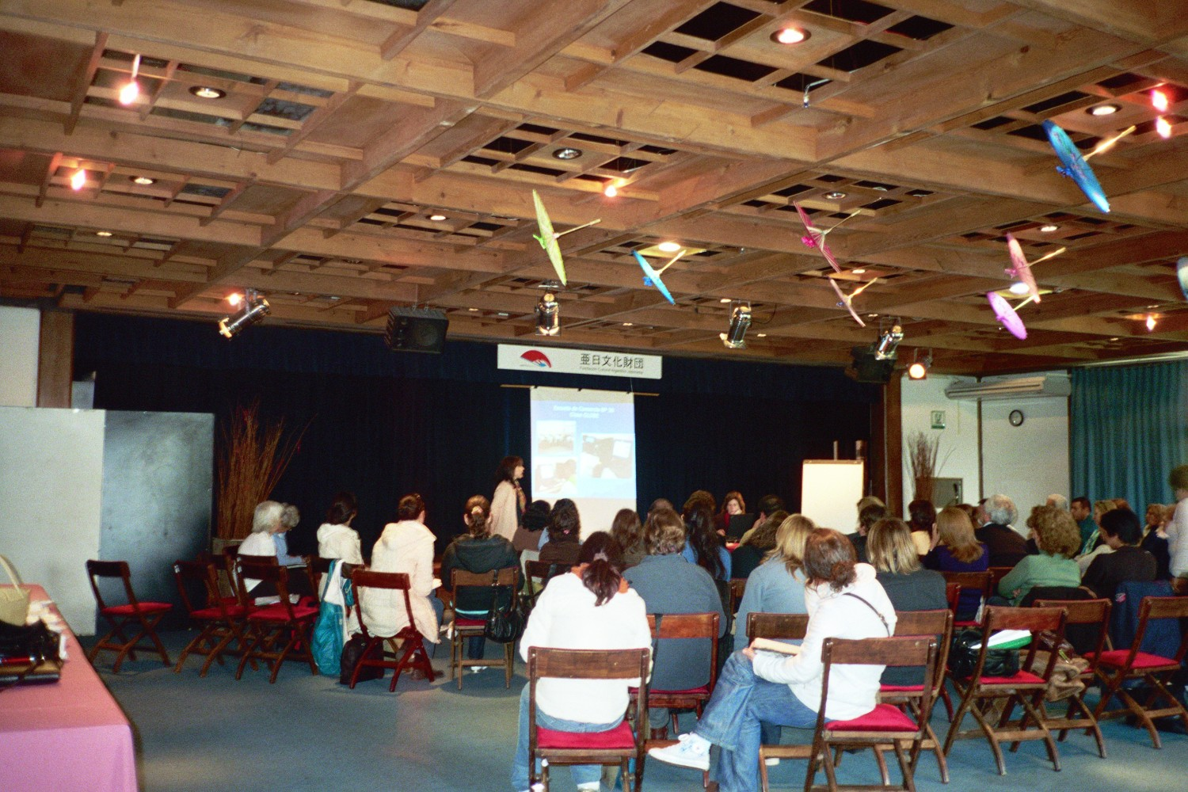
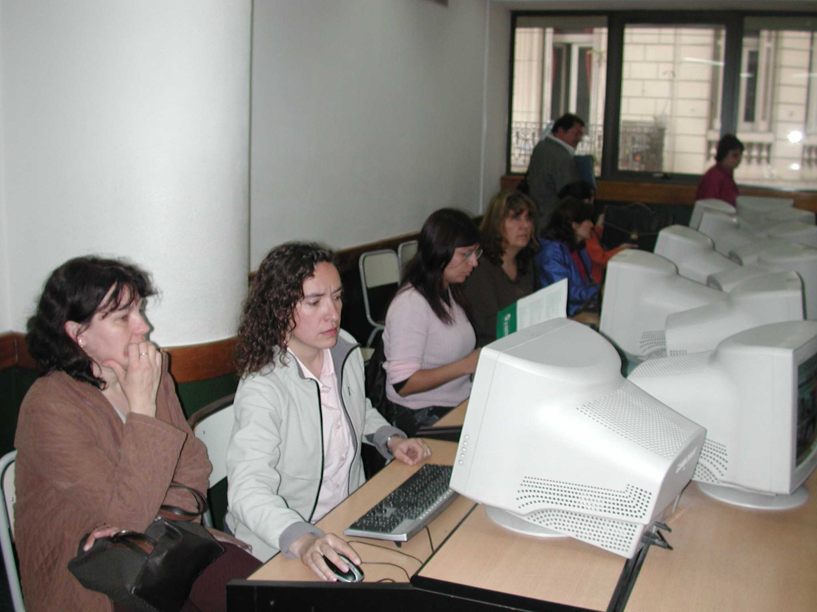

2008

January - June

- Videoconference Pole to Pole - “Seasons and Biomes”

Students from GLOBE schools of Fairbanks in Alaska and Ushuaia in Argenitna, exchanged their own experience about Seasons and Biomes of each Región. They were being supported by scientists from both latitudes., who, with scientific rigor, clarified their doubts.

It became a very interesting meeting.
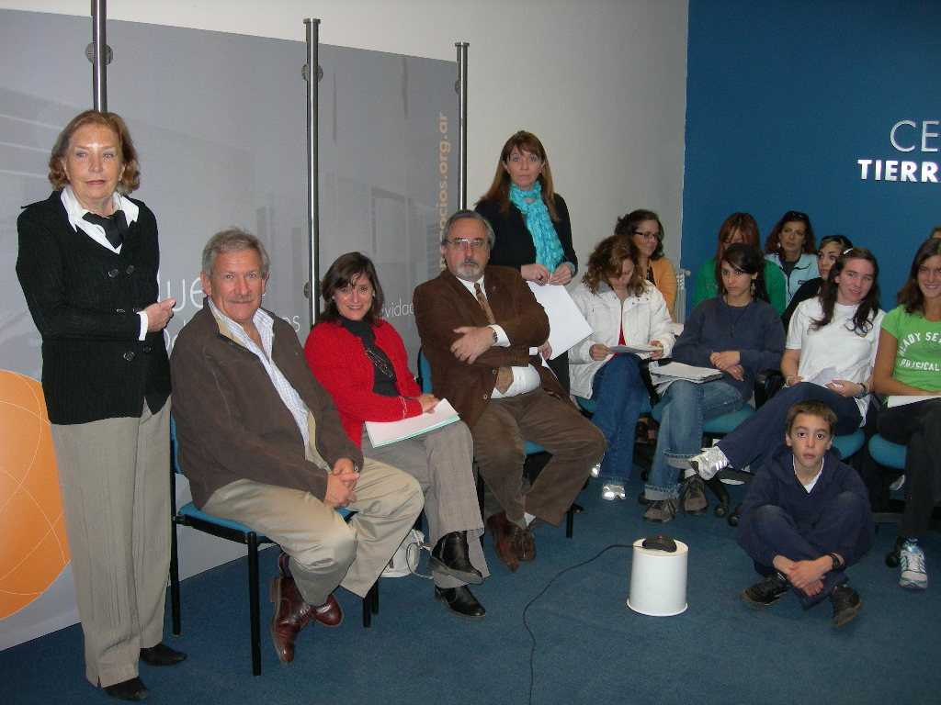

A Brief Summary of the Videoconference

Dr. Peggy LeMone opened the second GLOBE Seasons and Biomes International Polar Year Pole-to-Pole Videoconference from Boulder, Colorado. Participating schools included: Escuela Provincial No. 38 Julio Argentina Roca, a GLOBE school in Esperanza, Antarctica hosted by Argentina, participating from Ushuaia, Argentina; and Randy Smith Middle School (Fairbanks), Moosewood Farm (Fairbanks), Innoko River School (Shageluk), and Wasilla High School (Wasilla), from Alaska. Students and scientists were meeting again after a year of studying changes in their environment, learning about climate change, and wondering how they, students, can become involved in climate change research. The goal of this videoconference conversation with scientists and students near both poles was thinking of ways students can be involved in climate change research in their local environments and in collaborative partnerships with scientists and other students worldwide.

Dr. LeMone introduced Dr. Jorge Rabassa, who opened the videoconference from Ushuaia, Argentina. The word was then passed to Dr. Elena Sparrow, who opened the videoconference from Fairbanks, Alaska.

Students were asked to think about: the most important seasonal indicators, if these are being impacted by climate change, and how they could study these indicators to see if they are impacted by climate change. Amongst the discussion topics proposed by the students were:
- Why are leaves falling later each year? (Wasilla)
- Seasons in Ushuaia (Ushuaia)
- Rivers freeze later and melt earlier; it is not possible to fish as in the past (Shageluk)
Dr. LeMone thanked the students for helping focus the discussion and introduced herself and the scientists from the Boulder site: Dr. Marika Holland, Mr. Todd Ellis, Dr. Walt Meier.

Dr. Sparrow introduced herself and the scientists from Alaska: Dr. Dave Valentine, Dr. Greg McFarquhar, Dr. Jenny Baeseman, and Dr. Yongwon Kim.

Dr. Maria Del Carmen Galloni introduced herself and the scientists from Ushuaia: Dr. Jorge Oscar Rabassa, Dr. Andrea Coronato, Colonel Ugarte, and Engineer Sergio Luppo.

After the above introductions, a question and answer session on the topic of climate change began. Students asked questions to other students and shared their observations, scientists joined them.

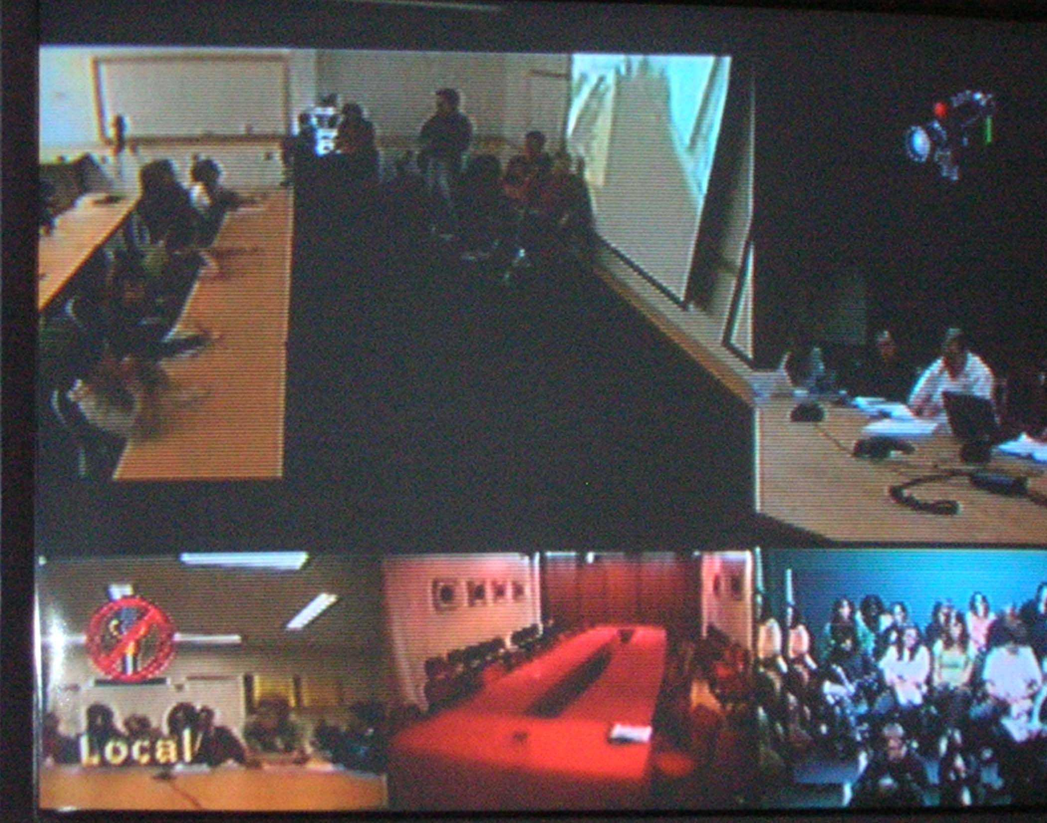

- Presentation of the GLOBE in 34th International Book Fair in Buenos Aires


As every year, once again, the GLOBE Program was presented in this important event.
This presentation was addressed to students, teacher and people interested in the GLOBE Program.

- Globe School Winne

Directors and Students of the CEI –San Ignacio from Junín de los Andes, in Argentine Patagonia, were greeted at the Casa Rosada by the President.

They were awarded for their initiative "Environmental Studies for the Improvement of Quality of Life in the Community".

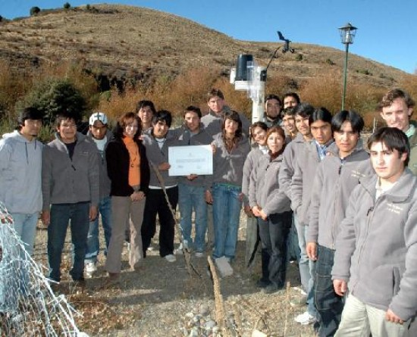

- Meeting monthly of School’s Coordinators

The meeting of May was special.

In this occasion we had the opportunity to welcome Astronaut Frank Caldeiro from NASA, who visited us, as host of the United States of America Embassy.

He wished to meet with directors, teachers and students from GLOBE schools.

It was a very interesting experience for the participants, to get to know about his experiences as an Astronaut.

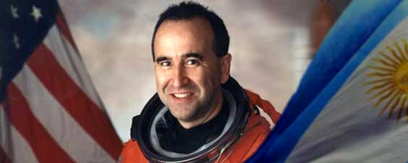

- GLOBE from Latin America and Caribbe during the Environmental Day
June, 5th.

Through Country Coordinators, GLOBE students were invited to choose a picture and give their point of view with regard to environmental issues.

In www.uces.edu.ar / programaglobe, include presentations selected.

This is one of them.
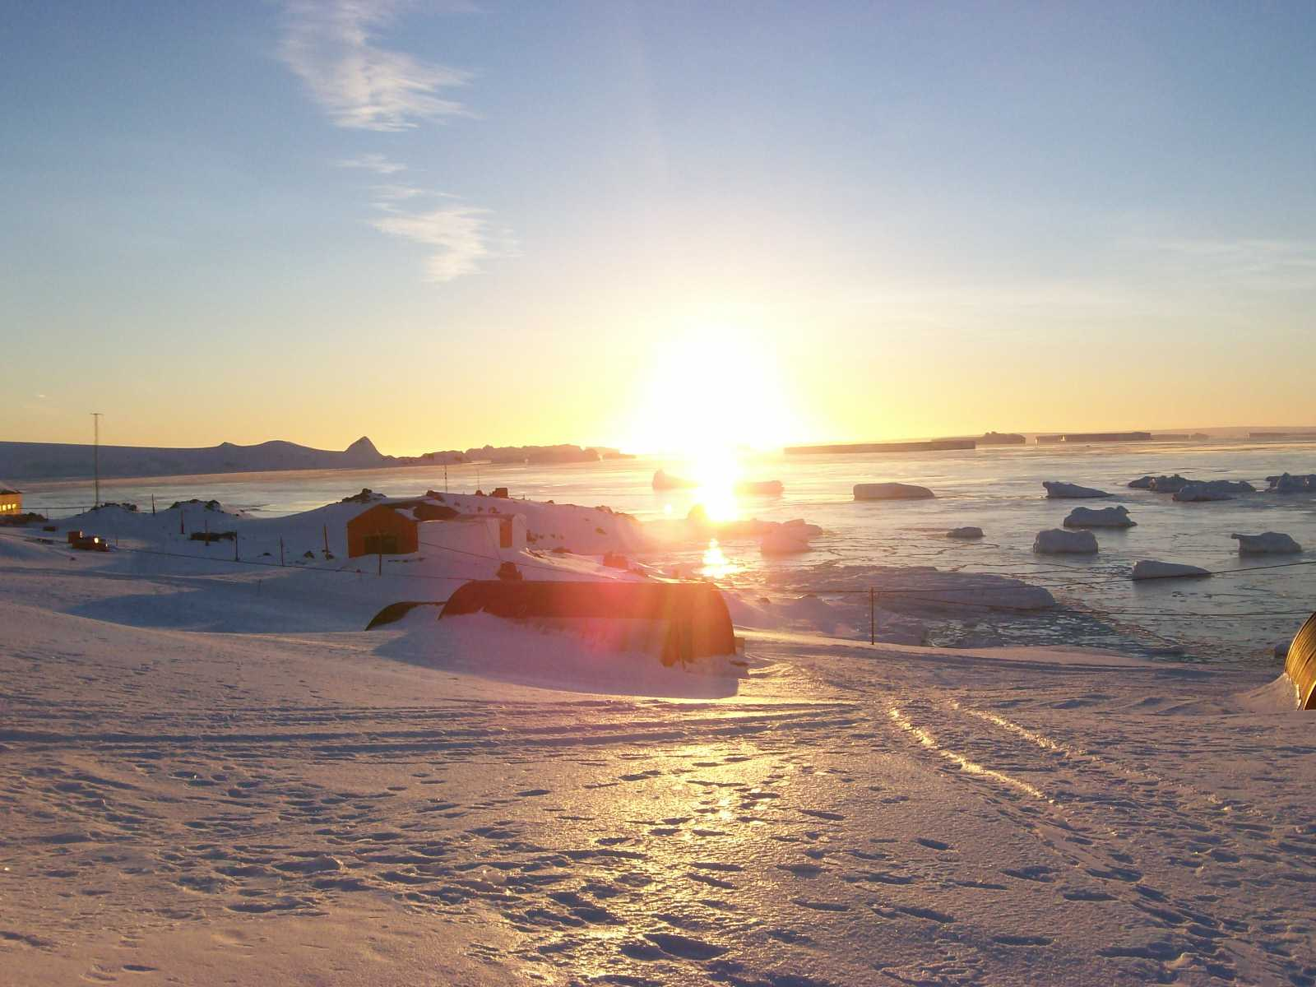

Sunrise in Base Esperanza

Antarctica, ice, snow and mountains

¡ Preserve our environment while avoiding what could alter it !!!
¡ Hopefully future generations will can enjoy the natural wonders of our planet depending on us !!!

- GLE 2008 - Students from three schools in Argentina, participated at this important expedition.

Their research were:

• “Water that you haven’t to drink …”
• ”New green in PUJATO “
• “The effects of climatic change in the flows of
the rivers Chimehuín, Malleo and Quilquihue
and their relationship with the humidity of the
steppe and “mallín” (wetland) land. “
• “Effects of the climatic change in the
frequency and duration of the fires in the North
of the Patagonia.”
• “Effects of climate change on water quality
Chimehuín River. Junín de los Andes,
Patagonia, Argentina.”

Argentine School at the GLE

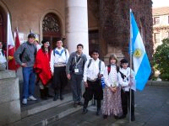
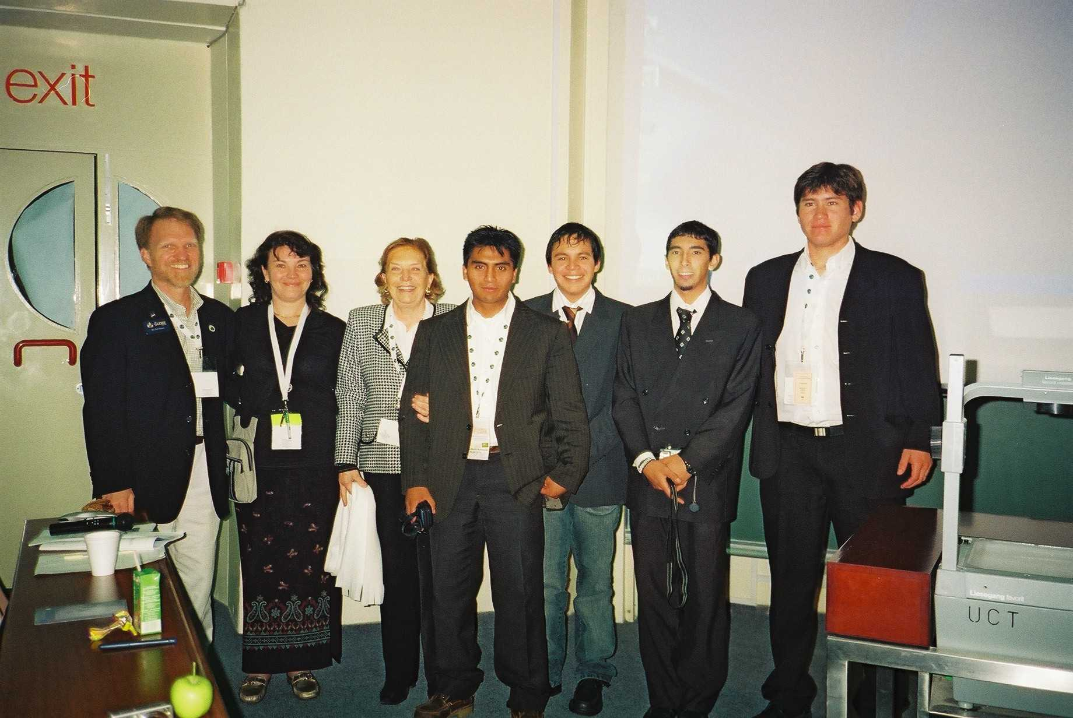

Schools from Pujato of Province Santa Fe and Junín de los Andes,of Province Neuquén

