
2010
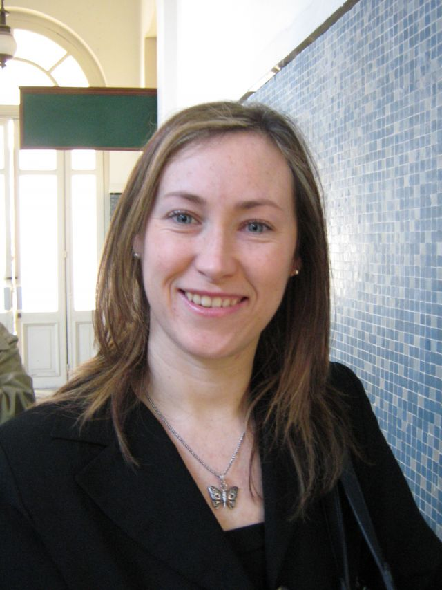
GLOBE Country:
Uruguay

Name: Andrea Ventoso, Librarian
Function: Uruguayan Country Coordinator of the Globe Program and Chief Librarian at the National Directorate of Environment.
Year joined GLOBE: 1995. As Country Coordinator: 2009
Organization: Ministry of Housing, Land Planning and Environment. National Directorate of Environment.
Opinion: The Program is a powerful tool to teach sciences in the school curricula and share data with other students and the scientific community, but in some cases it has not been explored in its whole potential or has not been understood in its baseline philosophy.
Email: andrea.ventoso@dinama.gub.uy, globe.uruguay@dinama.gub.uy
Tel: (0598) 29170710 ext. 4654
Skype: andrusky3
Web site: www.mvotma.gub.uy/Dinama

Cooperating Organizations: National Administration of Primary Education (ANEP), Embassy of The United States of America in Uruguay.

Participating Uruguayan Partners: schools of Primary level of the country
Teachers Trained: 25 Schools: 23 Data reported: 2.518

Description of the program and recent activities:
In 1995 the Ministry of Housing, Land Planning and Environment (MVOTMA) signed the Cooperation Agreement with the NOAA to implement the Globe Program in Uruguay.
The First Workshop of Training of the Program was developed in Nueva Helvecia, Colonia. Teachers of state Primary School and some from the Uruguayan-American School (private) were trained as well as civil servants of ANEP and technical personnel of the National Directorate of Environment (DINAMA). The ratification of the Globe Agreement with ANEP was delayed till 1999 when contacts were taken again to sign it.
The Second Workshop of Training was coordinated and developed in the Vacations Cologne of Piriápolis from May 31 to June 4, 1999 with the teachers and headmasters of the schools.
The Embassy of the United States (momentarily coordinating the program) organized the "Third National Workshop of the Program GLOBE-Uruguay" in the facilities of the Cultural Alliance Uruguay-United States and the Uruguayan-American School, which took place between the 28th and 30th March, 2003.

GLOBE activities developed during the past three years

In 2009 the implementation of the Plan Ceibal (a computer per child) placed to state schools in excellent positioning to restart the program, and this motivated the reinitiation of the Program Globe, among the authorities of the education, our Ministry and the Embassy of the USA.
In the frame of these conversations, I was designated Country Coordinator in March, 2009.
In this function I attented to the Regional Globe Workshop of Country Coordinators' at the Latin-American level, which took place in Iguazú, Argentina, from March 23 to March 24, 2009.
While coordinator of the Program, I relieved in June, 2009 by means of a survey among all the teachers qualified in the different workshops their disposition to take again the program. The results, although showed some difficulties of the teachers for the application of the Program, also showed a new scenery to implement it without major obstacles at least at pilot level with some schools, with the collaboration of Primary Education, or otherwise, with High School.
Since the assumption of the new authorities in March 2010, we are developing activities with the schools by means of personal interviews (since I had not made contact personally with most of the teachers) and relieving the needs and difficulties that each one faces to facilitate the implementation of the program.
Also the Annual Evaluation of the Program was completed and sent in April since that it was my first year of tasks as coordinator.
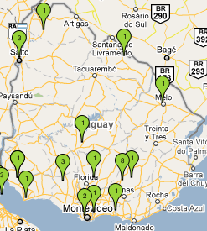
That year I attended the Annual Regional Meeting of GLOBE Coordinators of Latin America and the Caribbean and the 14th GLOBE Annual Meeting and Professional Development Workshop developed in Calgary, Canada, from 28th July to 3rd. August.
In September I received the invitation from the Regional Office in Buenos Aires to attend the “Taller Formador de Formadores GLOBE“ from 19th to 21st. October, for which I chose two candidates, Patricia Piriz and Ma. Leonor Rossi, to assist.

Goals GLOBE to reach in the next 3 years
- To ratify the support and coordinate with the authorities of Primary Education the assignement of new schools and teachers (maximum 20) to be qualified in the frame of the Program Globe as soon as possible.
- To implement a meeting in the next months with the teachers already trained and the new ones in order to announce the Program and impulse them to involve, viewing it as a powerful tool in the school curricula, involving private schools also.
- To obtain resources to invite one or two regional Master Trainers who have the skills to develop a new workshop for the new teachers and to refresh the knowledge of those who already have some level of training.
- To achieve the resources and the means in order that the teacher Patricia Piriz, who only lacks a level for Master Trainer, could accede to this one, becoming this way the first Master trainer in the country.
- To realize the negotiations for the search of partners that finance the Program in our country, since nowadays we do not have any support.
- To take part in all the possible instances of training in order to get involved in the program and take active part of it as a way of encouraging teachers for its insertion in the classrom.

