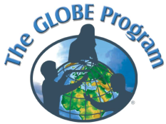
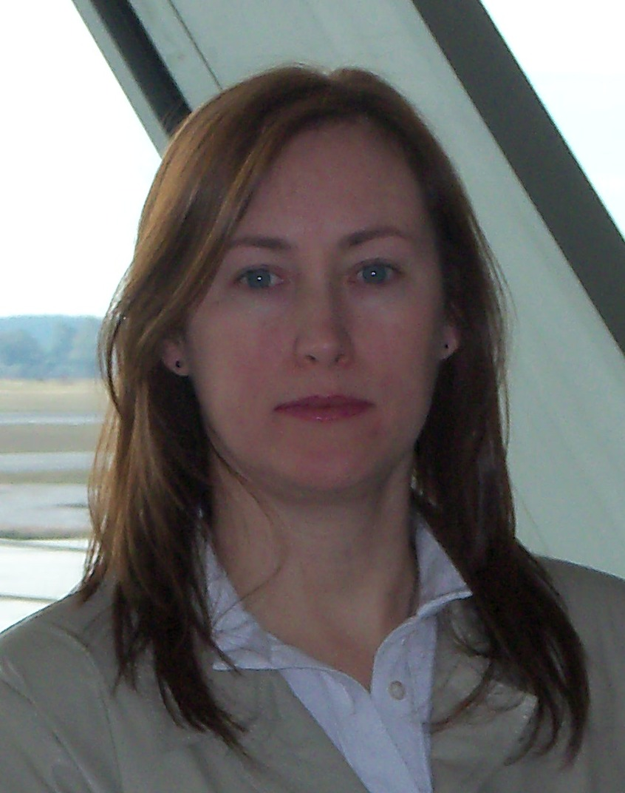
GLOBE Country:
Uruguay

Name: Andrea Ventoso, Lic. Bibliotecología
Position: GLOBE Program Coordinator in Uruguay since 2009
GIAC Representative for LAC Region (2011-2013)
Year joined GLOBE: 1995
Organization: Ministry of Housing, Land Planning and Environment. National Directorate of Environment.
Opinion: The Program is a powerful tool to teach sciences in the school curricula and share data with other students and the
scientific community, with a wide potential for investigation and development of environmental projects.
E-mail: globe.uruguay@dinama.gub.uy, andrea.ventoso@dinama.gub.uy
Telephone: (598)29170710 ext. 4654
Skype: Andrusky3
Web: www.mvotma.gub.uy

Cooperating organizations: National Administration of Primary Education (ANEP), USA Embassy in Uruguay.
Participating Partners: Primary and High Schools
Teachers Trained: 49 Schools: 27 Data reported: 2.784

Description of the Program: In 1995 the Ministry of Housing, Land Planning and Environment (MVOTMA) signed the Cooperation Agreement with the NOAA to implement the Globe Program in Uruguay. Within this frame, the National Administration of Primary Education (ANEP) was invited to participate in the Program in order to choose the schools and teachers to get involved and trained.

GLOBE Activities developed during the last year (May 2011 – May 2012):

16 – 22 July 2011 - I attended the “VIII Annual Regional Meeting of GLOBE Coordinators of Latin America and the Caribbean (LAC) “ and the “16th GLOBE Annual Meeting and Professional Development Workshop” in Bethesda, Maryland, United States of America, where we presented our annual country report and a poster with the school activities for the GLOBE Program, besides a power point presentation on the LAC region during the annual meeting.
Also during those days it was held the GIAC Meeting with the participation of all GIAC representatives from the six regions, the GLOBE Director, the Director of the GLOBE International Division and representatives from the organizations financing GLOBE Program (NASA, NOAA, UCAR). The documents “Vision and Mission” and “Strategic Plan 2012-2017” were presented and discussed at that time.

Sept. 2011 – It was translated the document “Scheme of Development Strategy 2012-2017”presented by the GLOBE Director at the GIAC Meeting in July, and sent to the Country Coordinators to be revised and commented. Once the feedback was received, it was shared with the Director of the International Division who worked with the GLOBE Director to write the final draft.
Sept. 2011 – It started the preparing of an initial list of candidates to Master Trainer in order to plan the training workshop to be held in Dominican Republic, with that purpose the Country Coordinators were asked to send updated data of their Master Trainers in activity and the possible candidates to the training.
Oct. 2011 – Ms. Jan Heiderer, GLOBE Communications Coordinator proposed me a kind of interview for the publication of the “Community Spotlight” in the GLOBE web, in my character of new GIAC Representative for the Region, that was later published in the GLOBE website.
16th January 2012 – Participation in the first GIAC Meeting of the year via electronic conference. All the GIAC Representatives and the Director of the International Division, Dra. Teresa Kennedy attended it. The final drafts of the documents below were discussed and later translated and presented to the Country Coordinators for their knowledge:
- Strategic plan 2012-2017
- The GLOBE Program: Vision and Mission
- GLOBE Regional Office Responsibilities
- GLOBE International Advisory Committee (GIAC)
- GLOBE Trainers and Master Trainers – Draft Certification Processes

Feb. 2012 – The organization process of the next Regional Meeting and the Master Trainers Training in Sto. Domingo, Dominican Republic began jointly with Amalia Aubone (Reg. Office), Teresa Kennedy and Maria Lorraine (hostess of the event). The tasks and responsibilities were distributed and the agenda for the Regional Meeting was address with Amalia Aubone.

Feb. 2012 – We completed the new GLOBE Annual Survey, where we detail the advances and difficulties of the Program in Uruguay.

Dec. 2011 – Feb. 2012 – Planning and preparation of a GLOBE Workshop on the Hydrology and Atmosphere protocols to be held in Montevideo, Uruguay, from 27 to 28 March. It was planned with the International Master Trainers Beatriz Vázquez and Marta Kingsland.

March – Apr. 2012 – In the frame of the national workshop, it raised the preoccupation of the National Director of Environment about the relevance of the Program Protocols for our reality, since it was introduced 17 years ago in Uruguay. We were mandated at this stage to proceed to the validation of the GLOBE protocols for our country. With this purpose, a group of professionals of our organization were selected to study and evaluate the protocols by research Area. For this reason, the workshop planned for March had to be suspended till this process is ended.

March 2012- Meeting with the Inspection of the CEIP (Initial and Primary Education Council) with the Mtra. Insp. Denise Vázquez to evaluate the GLOBE Program with the aim of coordinating actions and designing new Primary schools and teachers.

March 2012- Meeting with Verónica Pérez Urioste (US Embassy) and Gustavo Riestra to start making the contacts with DICYT (Directorate of Innovation, Science and Technology for Development) as a way of introducing GLOBE Program to the Primary and High School Science Clubs and ask for their support to train new teachers.

March – Apr. 2012 – In the frame of the tasks to be developed for the Training of Master Trainers, the Educational Development Committee is convoked to set the criteria for the presentation and evaluation of the candidates. All the candidates’ CVs are collected, studied and evaluated, resulting in a final draft of candidates qualified to MT and Trainer. The results area communicated to the candidates, to the Country Coordinators and the Director of the International Division.

2011 - 2012: Permanent support and monitoring tasks to teachers’ activities. The data base of teachers in activity and non active is being updated twice a year.
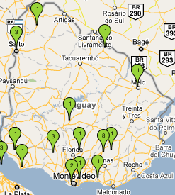
GLOBE goals for the next 3 years:

- To ratify the support and coordinate with the authorities of Primary Education and DICYT, the designation of new teachers to train in the Program.
- Negotiate the search of partners to finance the Program in our country, since we do not have any financial support nowadays.
- To organize workshops in Montevideo later than June, since that moment we will have our own Master Trainer. The goal is to develop at least one workshop a year.
- To make available our own GLOBE website for Uruguay in Spanish (basically) for our teachers, students, alumni and potential GLOBE partners.
- To publish the “Guía de identificación de especies arbóreas de Uruguay” (Guide identification of tree species in Uruguay”) for the teachers in order to contribute to improve the better knowledge and protection of our native flora and the right application of the phenology protocols.

