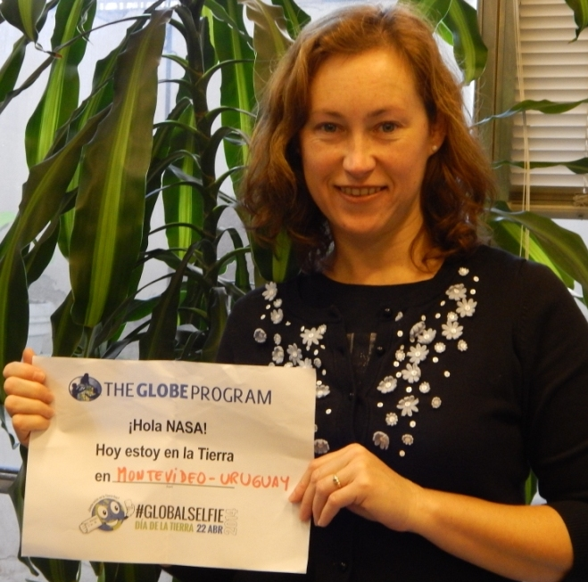
Country: Uruguay

Name:| Andrea Ventoso
Function: Country Coordinator
Organisation: Ministry of Housing, Land Planning and Environment. National Directorate of Environment.
E-mail: andrea.ventoso@mvotma.gub.uy
Tel: (0598)2917.07.10 ext. 4654
Skype: andrusky3
Website: https://www.facebook.com/GlobeUruguay

Name: Patricia Píriz
Function: Assistant CC
Organisation: National Directorate of Innovation, Science and Technology
E-mail: patywuan@gmail.com
Tel: (5982)94104356
Skype: Patricia Piriz
Website: https://www.facebook.com/GlobeUruguay

Cooperating organizations: United States Embassy in Uruguay.

Participating schools: 47 Primary and High Schools. (not all active).

Funding by: ----

GLOBE protocols: Atmosphere: air temperature, precipitation, precipitation ph, clouds type and cover.
Hydrology: water ph, water temperature, water transparency, water conductivity, macroinvertebrates.
Land cover and phenology: site determination, green up, green down, trees height and circumference, dominant species.
Soil: site determination, soil characterization, soil ph, soil temperature.
Campaign: Globe at Night.

Description of the program and recent activities in this sheet:
The program is carried out with teacher of Primary School and teachers of Biology, Chemistry and Geography of High School, and also pre-service teachers who will introduce the methodology in their future schools and classes.

- Attendance to the X LAC Regional Meeting in Lima, Perú, from 25 to 26 May 2013 where the 14 active country coordinators of the region were present and shared the main achievements of the period and discussed new strategies and plans for the countries. I also transferred my position of GIAC member to Godfrey Burnside from Bahamas who will be in this function from 2013 to 2015. I also presented the first collaborative project in the region that is being developed by teachers and students from Argentina, Perú and Uruguay.
- Participation as a judge in the 27th National Fair of Science Clubs from 30th. October to 1º November 2013, where many teachers trained in GLOBE participated with their students with science projects on clouds, water quality, food.
- Development of the III GLOBE Workshop for Initial Teachers the 26 and 27 November in Montevideo, Uruguay, organized by the Country Coordinator and the support of the United States Embassy, the LAC Regional Office that made possible the coming of MT Marta Kingsland who taught the protocols of atmosphere and soil. 20 teachers and pre-service teachers attended and the Alianza Cultural Uruguay-EE.UU. provided the facilities and infrastructure to hold the workshop.
- Second face tracking and planning meeting of the Collaborative ENSO Project among Argentina, Perú and Uruguay with the participation of five teachers, a Portuguese scientist and many students at the Marin College in Buenos Aires, Argentina from 28-30 November, 2013.
- Completion of the Annual Survey of GLOBE partners on line (February 2014).
- Introducing the GLOBE Program and development of protocols and activities in a full-time and half journey (8-9 March) during the Latin American Science Camp in Minas, Lavalleja to 20 students aged 15 to 19 years old coming from Colombia, Chile, Paraguay and the different departments of Uruguay. Activity shared between the CC and the MT Patricia Píriz.
- Introducing the GLOBE Program and development of protocols and activities in a full-time (3 April) during the Second National Science Camp organized by the National Directorate of Innovation, Science and Technology (DICYT) to 47 students of the Teacher Training Institutes. MT Patricia Píriz taught the main protocols of atmosphere, land cover, hydrology and soil and the GLOBE at Night campaign.
- Exposition on scientific methodology of the GLOBE Program in the Workshop “Project-based learning in early childhood centers and early education” organised by DICYT on 12 May for teachers and social educators working with small children (3-year old).
- Recent exposition in the INTEL-ISEF Science Fair in Los Angeles, United States (10-17 May) of the GLOBE alumni Melissa Cristóbal and Claudio Lacuesta with the Science Club “Bénticos” and their teacher Patricia Píriz of the winner project at the National Science Fair in oct.-nov. 2013.
- Publication of 2 stars in the GLOBE website and the GLOBE Facebook of Uruguay:
- Teacher Training Workshop in Montevideo, Uruguay (Feb 11, 2014)
- GLOBE Alumni in Montevideo will represent Uruguay at the 2014 ISE Intel International Science and Engineering Fair (May 03, 2014)

