**ANNUAL REPORT**

**GLOBE PERU**

**2020 - 2021**

TABLE OF CONTENTS

INTRODUCTION 3

EDUCATION 4

SCIENCE 6

COMMUNITY 7

APENDIX 8

# INTRODUCTION

The year 2021 in Peru was marked by the context of virtuality; classes in schools and educational institutions of higher education were held remotely and did not allow physical encounters between teachers and students who are part of the local GLOBE community. This situation caused the activities of GLOBE Peru to be limited to the virtual space and in most cases restricted only to maintaining communication with GLOBE teachers and citizen scientists and to carrying out some specific training actions in coordination with state entities in the education sector and other allies.

This report shows a look at the actions carried out by GLOBE Peru during the year 2021.

Mg. José Martín Cárdenas Silva

GLOBE Perú

# EDUCATION

As we mentioned, the activities of GLOBE Peru were limited to maintaining communication with the GLOBE Local community, for which the main communication channel was our Facebook Fan Page: <https://www.facebook.com/CIENCIAPERUGLOBE>. We hereby share various resources (especially videos) to promote the use of the GLOBE Observer App and other tools. Likewise, it also served to share information on campaigns and webinars organized by the GLOBE NASA central office and GLOBE Regional Office.

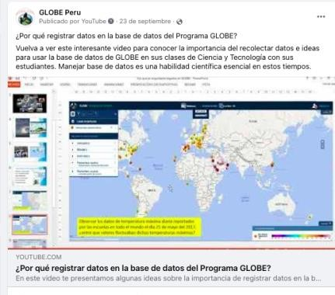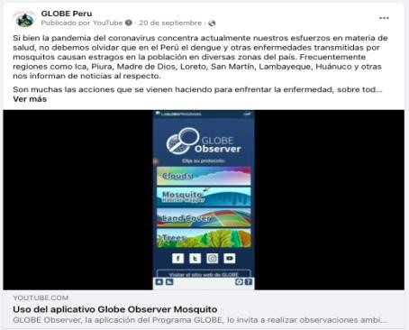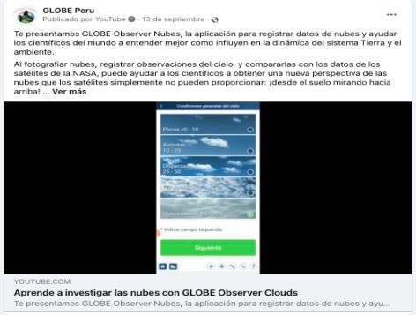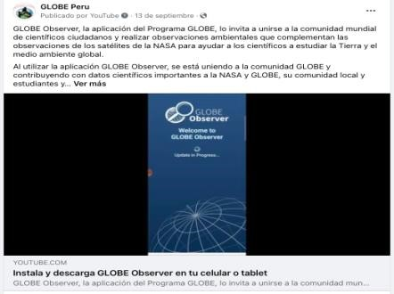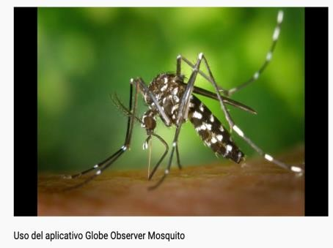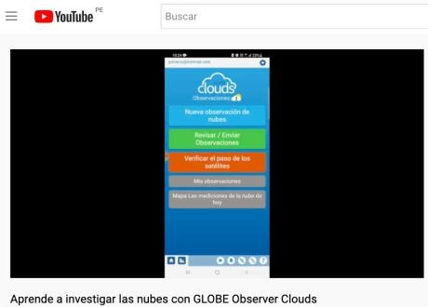

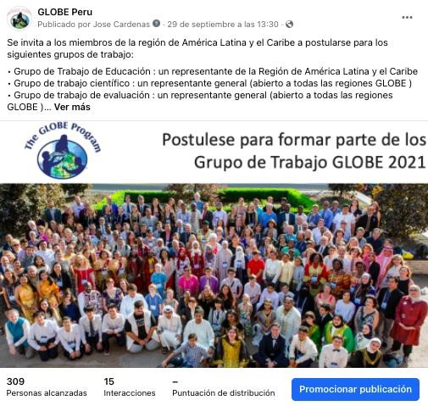

Similarly, we spread GLOBE at events organized by state organizations in the education sector and local associations.

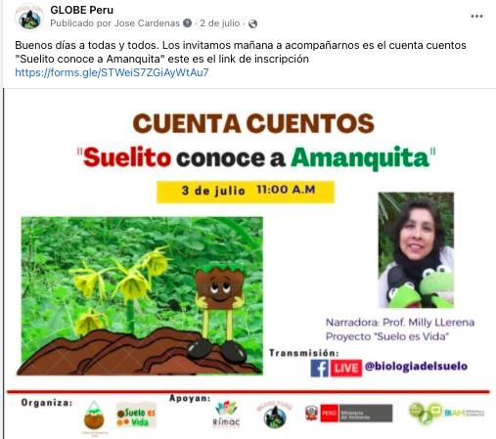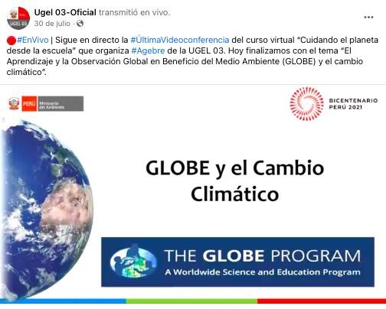

# SCIENCE

As we do every year, we participate and organize activities for the International Day of Women and Girls in Science (February 2021).

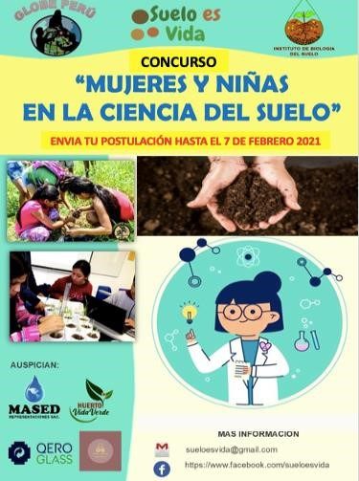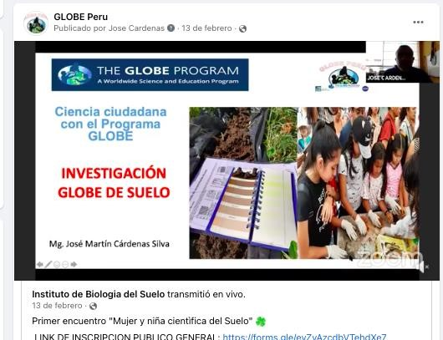

# COMMUNITY

In order for the GLOBE community to continue expanding and for many more teachers and citizens to learn about GLOBE's educational resources, we promoted the inclusion of some of these resources on the "Environmental Classroom" page of the Ministry of the Environment. Environmental Classroom is an initiative of the Ministry of the Environment that aims to bring children, adolescents, youth and adults closer to environmental issues, providing them with educational material in various formats and inviting them to be agents of change. <https://aulaambiental.minam.gob.pe/>

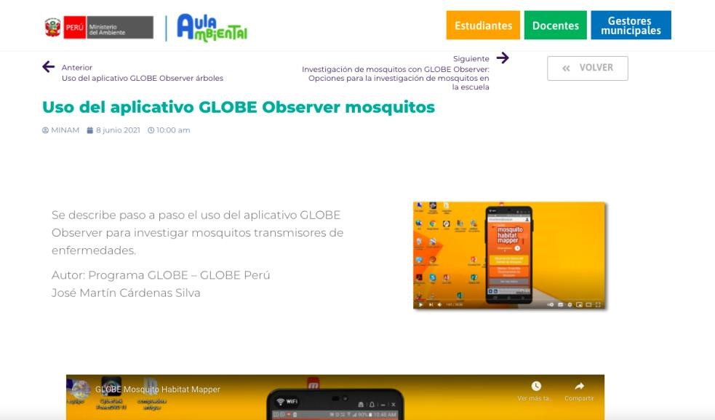

# APENDIX

Dissemination of GLOBE information on the Fan Page of GLOBE Peru.

