ANNUAL REPORT

GLOBE Mexico
2019 - 2020

TABLE OF CONTENTS
INTRODUCTION 3
EDUCATION 4
SCIENCE 5
COMMUNITY 6
COMMUNICATIONS 7
APENDIX 8
STAFF 11

INTRODUCTION
In 1996, Mexico signed an Agreement between the Ministry of Environment, Natural Resources and Fisheries and the National Oceanic and Atmospheric Administration of the United States of America to promote the GLOBE Program, to date 112 schools have been incorporated nationwide from 12 Federal entities.
GLOBE is coordinated by the Center for Education and Training for Sustainable Development (CECADESU) and currently the national coordinator is Teacher Teresita del Niño Jesús Maldonado Salazar, Deputy Director of Basic and Normal Education.
SEMARNAT, through the Center for Education and Training for Sustainable Development, began a training strategy throughout the country. Since 2001, institutional links have been established with the Ministry of Public Education in most of the states of the country. country, with secondary and higher education institutions, as well as with civil society organizations, in order to spread the educational benefits of the program and train to be able to implement it in schools.
In 2020, the aim was to strengthen the program and the link with the educational communities.

EDUCATION
In Mexico, in the evaluations carried out by the educational communities, it has been proven that its benefits are:
- Increased scientific knowledge about the Earth
- Academic training of students and teachers in science and mathematics Formation of an interdisciplinary group of teachers
- Approach of students to scientific subjects,
- Curriculum support,
- Didactic support to promote the construction of competencies established in the study plans and programs of the different educational levels.
- Important contribution with the data generated by each school, for the development of research on environmental issues.
- Development of school projects for environmental improvement of the environment from the data generated both locally and globally.
- Collegiate work with teachers of other subjects
In the month of October 2019, thanks to the support and management of the Embassy of the United States of America in Mexico, we received instruments donated by the Youth Learning as Citizen Environmental Foundation (YLACES). This allowed the delivery of the equipment that were obtained by
- the Museum of Natural History and Environmental Culture, with the Project "Pilot Project of the GLOBE Program: avifauna and flora of the Chapultepec Forest";
- the Secondary School 73 whose project name is "The empowerment of girls in science"
- the Aquilés Serdán Elementary School that participated with the project: Bíin Úuchk (Future in the Mayan language).
Within the framework of the XXV anniversary of the GLOBE Program, on February 27, 2020, an Atmosphere and Climate Workshop was held at the facilities of the Center for Atmospheric Sciences of the National Autonomous University of Mexico, the biologist Pablo Sánchez Álvarez Instructor of the GLOBE program in Mexico.
The group was made up of 11 teachers and environmental educators from the General Directorate of Technical Secondary Education, from the Aquiles Serdán Primary School; of the Museum of Natural History and Environmental Culture and Jacaranda Education in Mexico City.
The workshop was aimed at new entrants and its purpose was the introduction to the investigation of the Atmosphere line, as well as the protocols and specifications that the GLOBE Program establishes to enter data to collaborate in the international database that the program establishes.

SCIENCE
This permanent participation in an international scientific project allows young students to build foundations for understanding theories about global climate, in this context, as well as students, teachers and advisors, who in addition to taking, capturing and sending data, passed, to the processing, analysis and interpretation of the same to be in a position to propose suggestions or alternative solutions for the adaptation and mitigation of factors that influence climate change.
To date, 27 meetings have been held; 64 workshops. There are 2033 trained teachers, a staff of 29 Masters Trainers and 105 regional Instructors from 23 entities in the country. Mexican schools have reported 214,165 data on the internet page.
The Technical Secondary Education System has given a boost to the program and periodically holds GLOBE Schools meetings where teachers and students prepare essays and propose projects derived from the Program's activities. Likewise, they document their teaching practice, for the approach of scientific-educational topics. The measurements they make of the GLOBE protocols support specific projects such as: "Let's do a miracle through the air".
The teachers and students of the Technical Secondary Education System incorporated into the GLOBE Program actively participate in the Quetzalatl Brigades, the Water Forum and in cycles of conferences for students that take place in October and November of each year. In addition, they participate in specific programs promoted by the GLOBE Program such as Globe at Night.

COMMUNITY
In the first three months of 2020, the commemorative activities for the 25th Anniversary of the GLOBE Program will be coordinated and the strategy to strengthen the program will be planned.
Communications have been received from higher secondary education institutions interested in enrolling in the program.
On June 30, we participated in the Webinar "GLOBE applied to the classroom" dictated by Marta Kingsland at 6 p.m. time zone.
On July 7 at 2:00 p.m. time zone Argentina participated in the regional meeting to share the issues raised and discuss new ideas for cooperation, either between countries of our Region or also with other GLOBE regions.
On Tuesday, August 25 at 3:00 p.m. Mexico time, 5:00 p.m. Argentina time, participants participated in the GLOBE WEBINAR with the theme: New certification process for Trainers and Mentor Trainers.
The purpose of the WEBINAR was to present to the Coordinators of the member countries of the GLOBE Program in Latin America, the process of registration and accreditation of Trainers and Mentor Trainers, established by the Education Working Group (EWG), in order to update the directory of active instructors in each country that is part of the GLOBE Program.
The main objective of this process is to maintain the quality of the information and the updating of specialist and active Instructors in the GLOBE Program in each country, in order to update teachers on the news and protocols of the international GLOBE Program.

COMMUNICATIONS
In the first three months of 2020, schools were invited to carry out commemorative activities for the 25th Anniversary of the GLOBE Program and the strategy to strengthen the program was planned.
Communications were received from higher secondary education institutions interested in enrolling in the program
However, due to the health emergency caused by the pandemic caused by the SAR-CoV-2 virus (Coronavirus), educational activities in Mexico were suspended as of March.
In this scenario, the GLOBE Program Coordination had to suspend the invitations and calls to carry out the activities of the GLOBE program in the educational establishments.
The priority on the part of the educational authorities is focused on maintaining the educational service, online and at a distance with the students so that they do not miss the school year, which limited our communication with managers and teachers.
For the 2020-2021 school year, the challenge is for students enrolled in the National Education System not to be left out and not to fall behind.
In this framework, the GLOBE Program Coordination is waiting for the traffic light to change until face-to-face classes are returned and communication can be established again with the Directors and teachers of the Technical Secondary Education System.

APENDIX
Biol. Pablo Sánchez giving the introductory information on the topic of Atmosphere
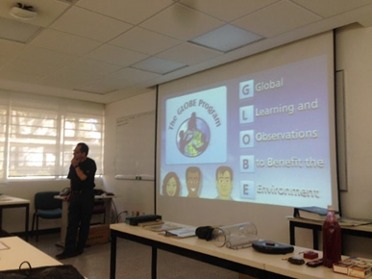
Biol. Pablo Sánchez and workshop attendees interacting through questions and answers on the subject
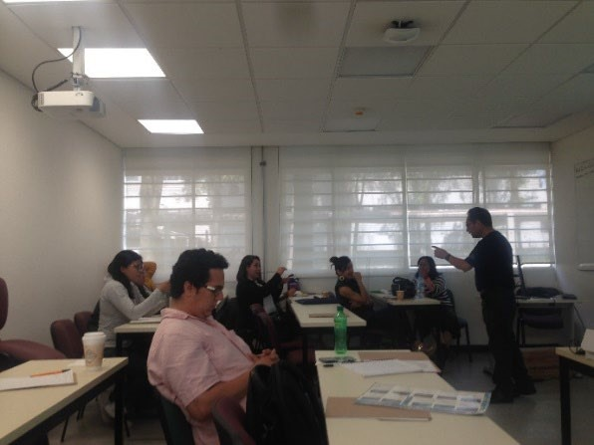
Participants in the workshop identifying and knowing the formats and materials for recording information
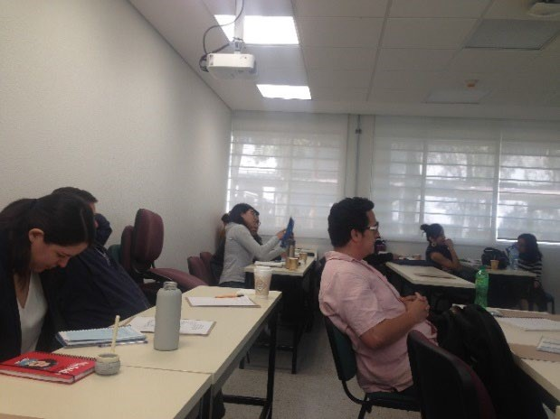
The Biol. Pablo Sánchez explaining the instruments with which the measurements were made and which are on display at the Center for Atmospheric Sciences.
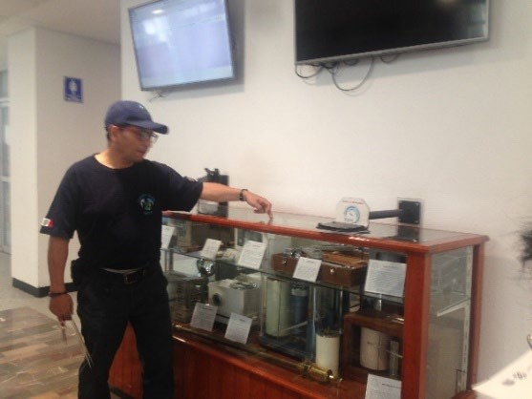
Workshop participants attentive to the explanation of the exhibited equipment.
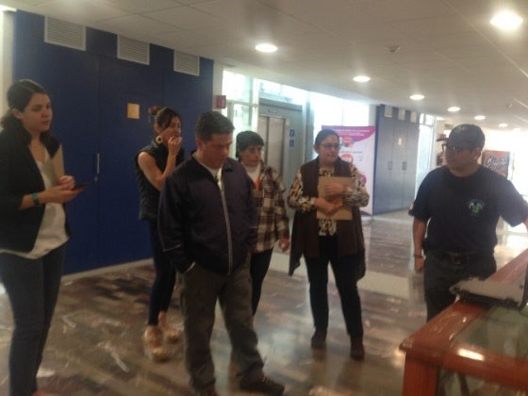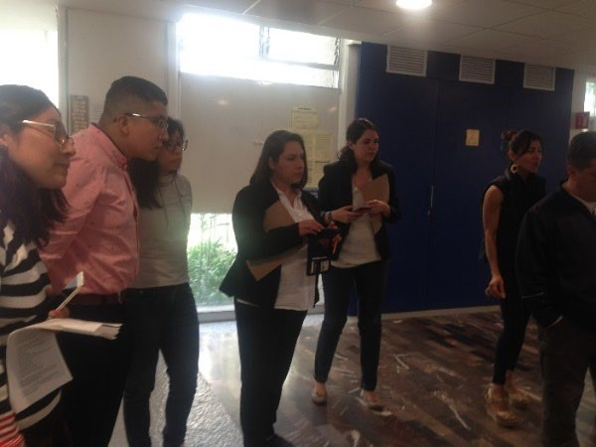
Group visit to the area where the equipment and instruments are currently installed to record the different parameters with which the Center for Atmospheric Sciences reports the weather and climate conditions in real time.
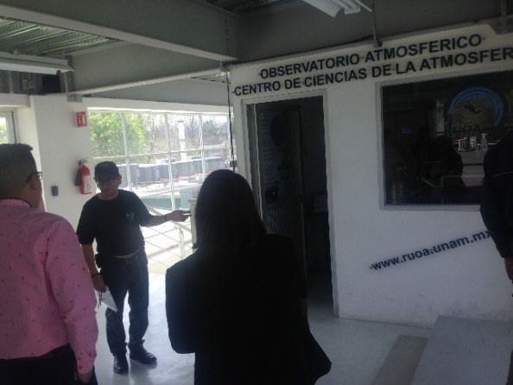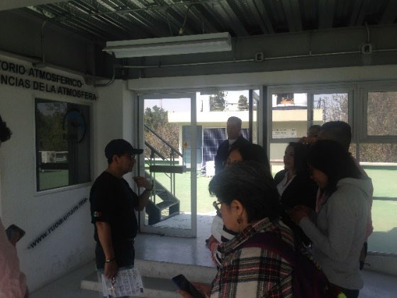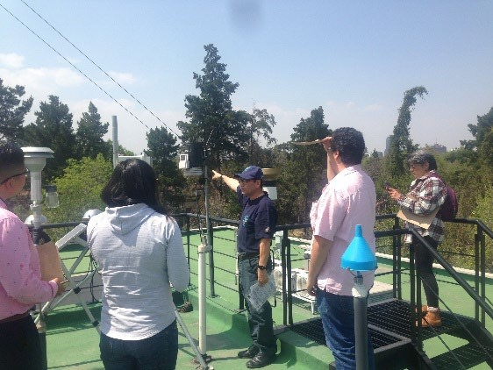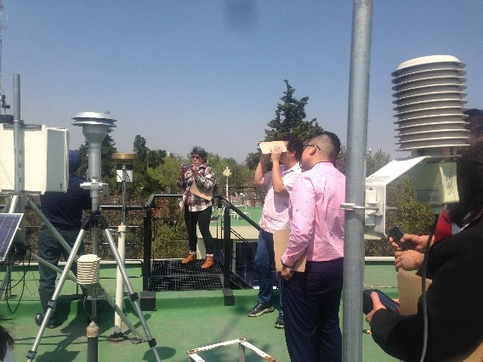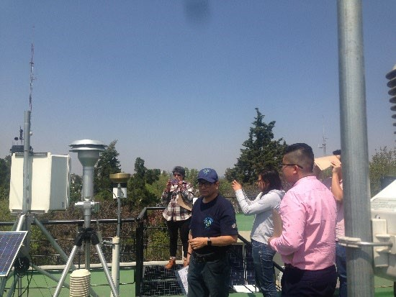

STAFF
GLOBE Program Coordinator in Mexico
Therese of the Child Jesus Maldonado Salazar
Responsible for Environmental Education, CECADESU-SEMARNAT
teresita.maldonado@semarnat.gob.mx
GLOBE coordination assistant in Mexico
Martha Ruth Chavez Enriquez
Head of Department
martha.chavez@semarnat.gob.mx
Master Trainer and GLOBE Professor at the Faculty of Higher Studies Cuautitlán Izcalli
Mr. Gustavo Mercado Mancera
gmanmer@yahoo.com.mx
Master Trainer and GLOBE Professor at the Center for Atmospheric Sciences, UNAM
Biol. Pablo Sanchez Alvarez
pass@unam.mx

