Republic of Macedonia

Name: Svetlana Gjorgjeva
Function: Country Coordinator Macedonia
Organisation: Ministry of Environment and Physical Planning
E-mail: S.Gjorgjeva@moepp.gov.mk
Tel: (+389) 02 3 251 500
Skype: svetlanagj
Website: http://www.moepp.gov.mk/default-mk.asp?ItemID=04F0547036CE0C4C986385EF0D162CB0

Name: Katerina NIkolovska
Function: Deputy Country Coordinator Macedonia
Organisation: Ministry of Environment and Physical Planning
E-mail: K.Nikolovska@moepp.gov.mk
Tel: (+389) 02 3 251 482
Skype: katerinanikolovska2
Website: http://www.moepp.gov.mk/default-mk.asp?ItemID=04F0547036CE0C4C986385EF0D162CB0

Cooperating organizations: Ministry of Education and Science, Faculty of Civil Engineering, Faculty of Forestry (University “St.Cyril and Methodius, Skopje), Hydrobiological Institute-Ohrid.etc)

Participating schools: 19

Funding by: Ministry of Environment and Physical Planning

GLOBE protocols: Earth as a System, GPS Protocol, Land Cover, Atmosphere, Water, Phenology, Soil and GLOBE at night

Description of the program and recent activities:
The GLOBE Program in Macedonia started in 1998. Activities concerning the GLOBE Program implementation are carried out by the Ministry of Environment and Physical Planning (MoEPP) through the Macedonian Environmental Information Center. During the period of the GLOBE Network presence in Macedonia, it has raised great interest among students and teachers in primary and secondary schools. Until now, we have included 19 schools, 14 secondary schools and 5 primary schools. Seven GLOBE seminars have been organized so far, resulting in 71 GLOBE teachers trained and participating in the Program in their schools on voluntary basis.

Since the commencement of the Program in our schools, the following Protocols have been applied in the schools: Earth as a System, GPS Protocol, Land Cover, Atmosphere, Water, Phenology, Soil and GLOBE at night.

In 2008, the MoEPP prepared and published the GLOBE Teacher's Guide in Macedonian based on the GLOBE Teacher's Guide and it is available to all teachers and students also on the new web site of the GLOBE Program.

In 2010, Macedonia hosted the 6th Annual Conference of the GLOBE Europe/Eurasia (1-6 June, Ohrid). The event gathered around 70 participants from 23 countries of Europe and Eurasia.

Based on the requirements of the GLOBE Protocol, the schools have so far delivered impressive amount of observations. The achievements of schools could be much higher given the interest existing among students and teachers in working with the Program; however, the emerged financial crises in the country, as well as wider, has induced certain stagnation in their activity. Bigger input from the authorities responsible for education and science could significantly improve the status and the achievements in our GLOBE schools.

Despite the difficulties they cope with, Macedonian GLOBE schools have made respectable achievements at European and global levels, having won several GLOBE Stars and Chief Scientist’s Honour Rolls, as well as prizes for individual projects. Also, it has to be underlined that GLOBE has been an inspiration and contributed knowledge and data for student’s participation in many national competitions in other subjects, like physics and astronomy, as well as GLOBE teachers’ participation in international scientific gatherings.

In brief, the latest achievements worth mentioning include:

- The GLOBE team of SOU, “Orde Copela”, - Prilep, participated in the Catch a Star contest held as a result of the collaboration between the European Association for Astronomy Education (EAAE) and European Southern Observatory (ESO). Students Aleksandar Pusoski and Frosina Koneska developed the project “Using sky quality meter to measure sky Brightness “ and won 12th position among 86 teams from other European countries.
- GLOBE teacher Karolina Damjanovska took part in the IX Conference of the Society of Physicians of the Republic of Macedonia and Institute of Physics, Faculty of Natural Science and Mathematics, University “St.Cyril and Methodius” - Skopje (20 - 23 September 2012) with a paper inspired by “Globe at night”, titled “Light pollution a tool for physics and astronomy education". At this occasion, “Globe at night” was presented to all participants of this international conference, attended by university professors and scientists from all over the world.
- In 2012, student Roberta Aceska won the first prize at municipal and third prize at the national level, in the contest in Astronomy. The theme of the project was inspired again by “Globe at night” titled “Use of Leo constellation in light pollution measurement”.
- From 15 to 20 October 2012, GLOBE teacher Karolina Damjanovska attended study tour in Hamburg – Germany on “Renewable energy sources and energy saving in general”. There, in front of the international group of participants, she made presentation on possibilities for energy saving based on the awareness of light pollution issue, making reference to GLOBE programme.
Macedonian GLOBE schools have well established cooperation with the GLOBE schools from the countries in the Region, especially Croatia and Bulgaria.

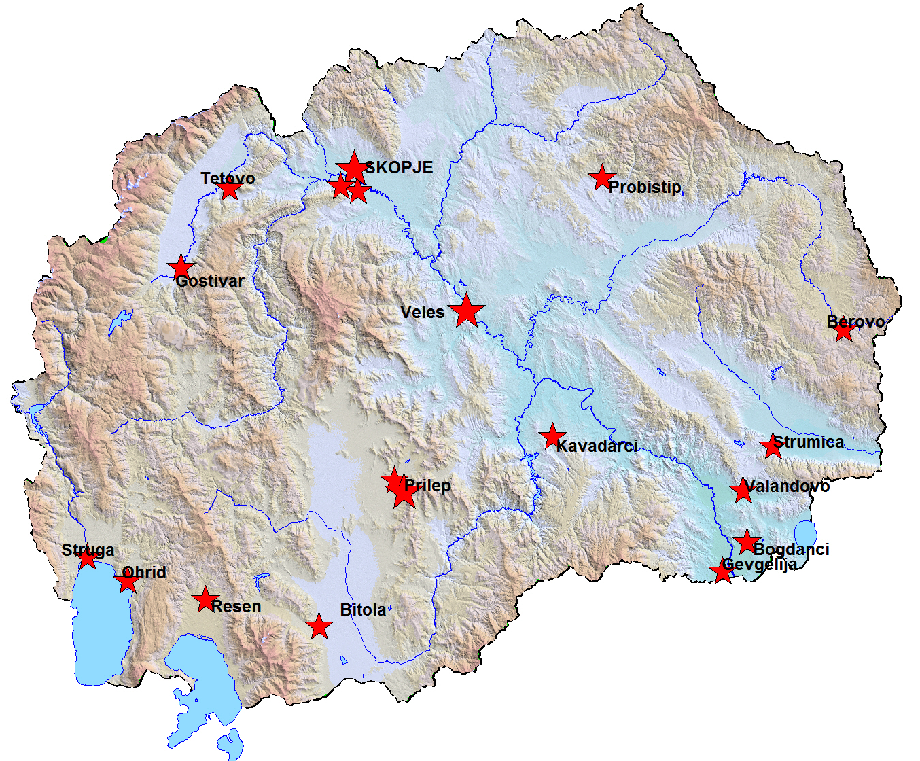
GLOBE schools in Macedonia

The efforts of GLOBE students in Macedonia enjoy the support of their fellows “real” scientists from the Universities and scientific institutions in the country. Yet, it has to be stated that there is much more room and much greater interest in GLOBE activities in Macedonia and stronger support could bring in valuable results.

