Class Green-Up Cards

School Name: Al Faruk elementary girls school.
School location (Country, State, City): Israel / Jerusalem/ Jabal AL Mukkaber
Teacher’s Name: Samah Abu Snainih
Class: 6th grade
Plant Type (Genus, Species): The cherry tree:/ /Genus: Prunus /Species: P. avium
Describe Plant’s Location: It is native throughout the UK and Europe, except the far north. It grows best in full sunlight and fertile soil. P. avium originated in the area between the Black and Caspian seas of Asia Minor. Birds may have carried it to Europe prior to human civilization. Cultivation probably began with Greeks, and was perpetuated by Romans. Sweet cherries came to the USA with English Colonists in 1629, and later were introduced to California by Spanish Missionaries.

Latitude: 31.7552292 Longitude: 35.2416086 Elevation: 689 m

Photo/Sketch 1
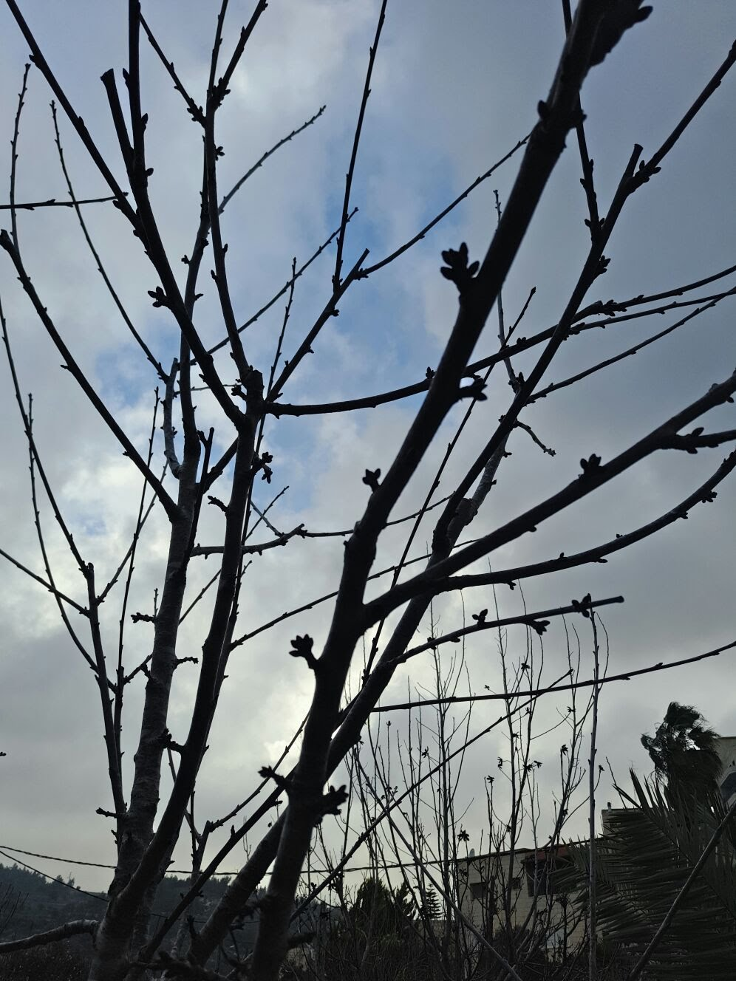
Date: 27 of February
Time: 4:30 PM
Green-Up Phase or Length: Swelling

Photo/Sketch 2
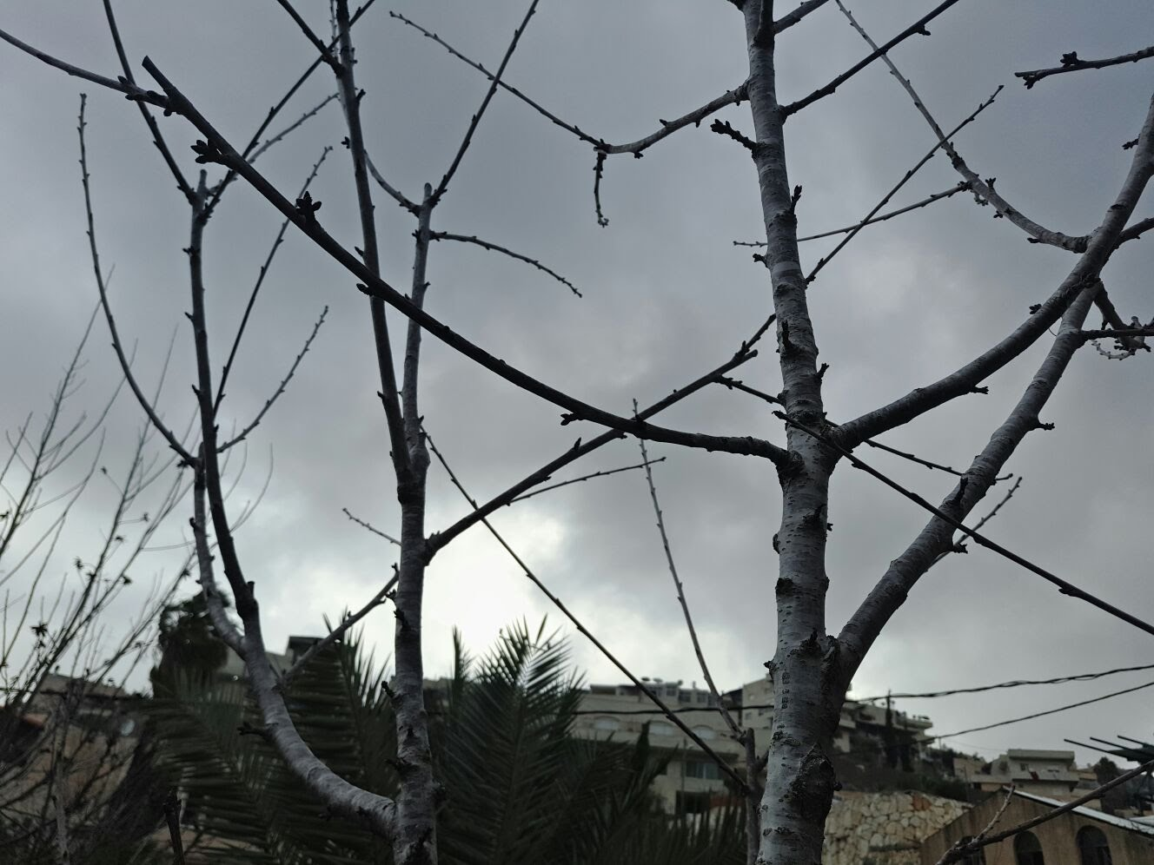
Date: 27 of February
Time: 4:30 PM
Green-Up Phase or Length: Swelling

Photo/Sketch 3
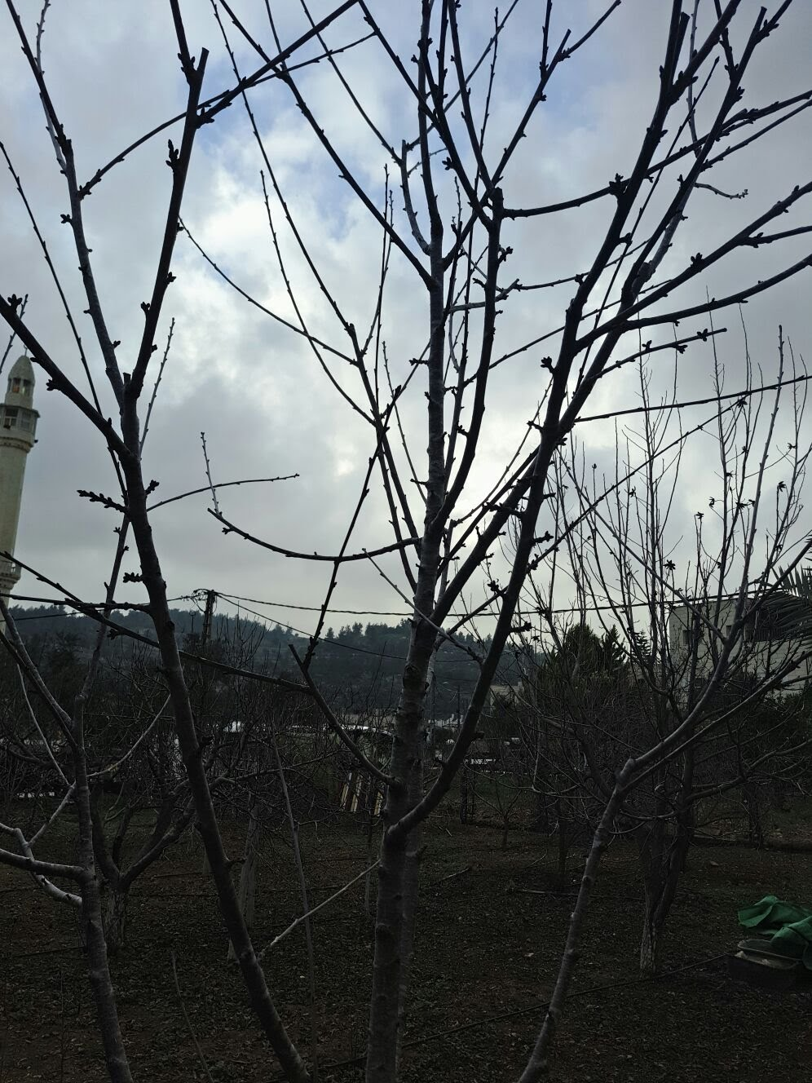
Date: 27 of February
Time: 4:30 PM
Green-Up Phase or Length: Swelling

Photo/Sketch 4

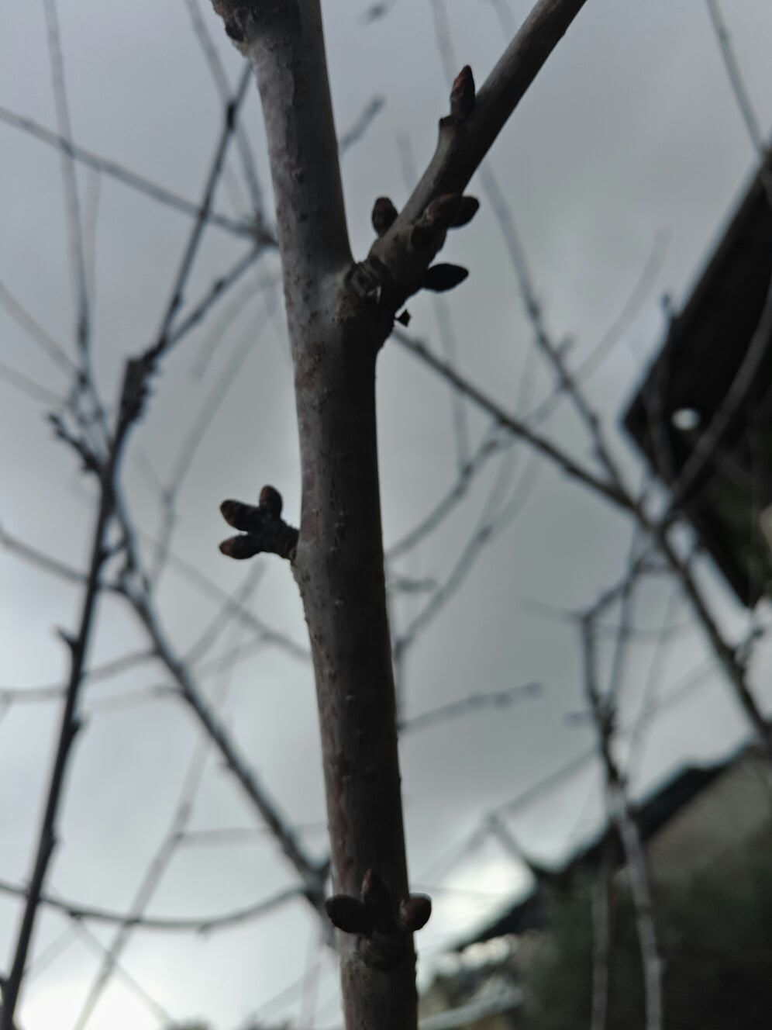
Date: 27 of February
Time: 4:30 PM
Green-Up Phase or Length: Swelling

Photo/Sketch 5
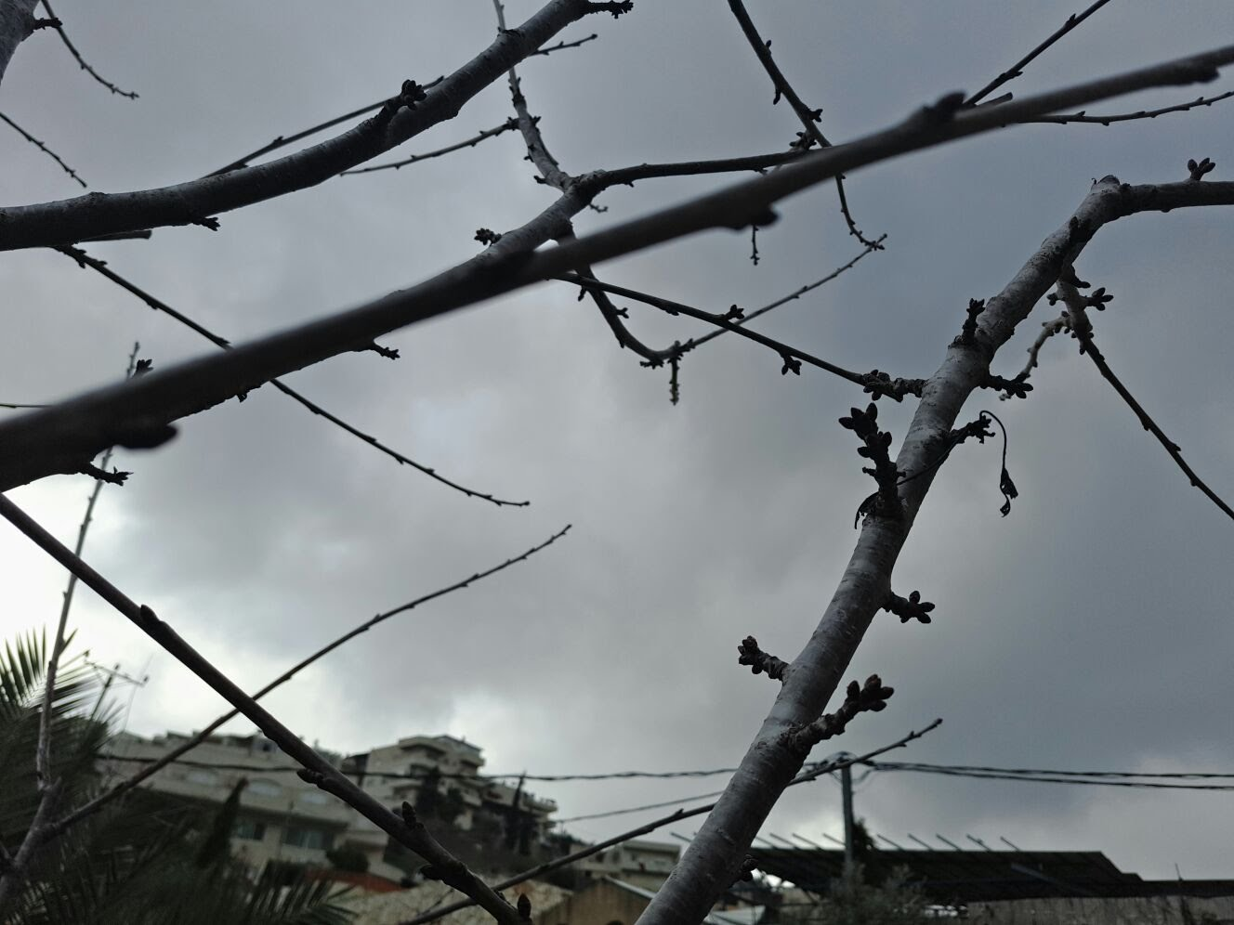

Date: 27 of February
Time: 4:30 PM
Green-Up Phase or Length: Swelling

