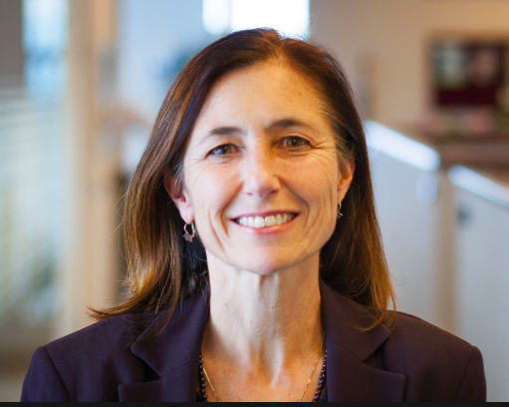  Svetlana Darche  Co-Principal Investigator  GLOBE Mission EARTH West  WestEd  sdarche@wested.org |  | 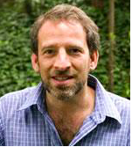  Ron Cohen  Co-Principal Investigator  GLOBE Mission EARTH West  College of Chemistry UC Berkeley  rccohen@berkeley.edu
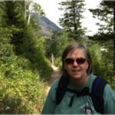  Tracy Ostrom  Project Coordinator, GLOBE Master Trainer  GLOBE Mission EARTH West  Graduate School of Education UC Berkeley  tostrom@berkeley.edu |  | Jonathan Boxerman  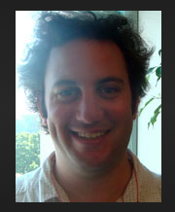  Science Education Research Associate  GLOBE Mission EARTH West  WestEd  jboxerman@wested.org
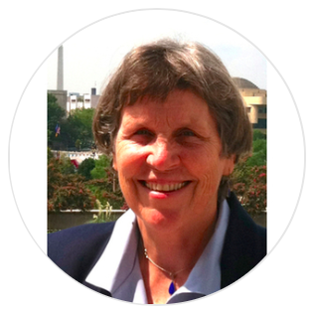  Marcia Barton  STEM Teacher PD Specialist  GLOBE Mission EARTH West  New Mexico Public Education Department  marcia.barton@state.nm.us |  | 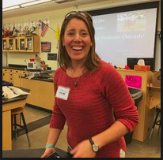  Dr. Christy Wall Kuhlman  NM Project Coordinator  GLOBE Mission EARTH West  New Mexico Public Education Department  christywall125@gmail.com

